Vorlesung 2012-05-22
Algorithm 10.14, p 10.24, ... set of Edges not traversed

Perform Tarry's Algorithm, but choose in Step 1 such that .
Trivially, outcome is a bidirectional double-tracing.

Theorem: Let G be a connected eulerian graph, and W bidirectional double-tracing of G.
() subsequence of W obtained by listing edges of G according to their second traversal. eulerian trail of G.

Fraenkel's algorithm
Hypothesis: as in preceding algorithm + counter
matching mapping into positive integers + zero
.
In file: = but should be
Rule 1) As long as proceed as in preceding algorithm.
Rule 2)

a) If , set
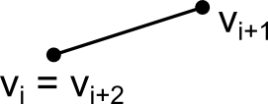
b) If for some j < i + 1 and if but for same then set (if you have at least one edge incident to but not traversed by W as you have arrived in , but after arriving in you have at most one edge which has not been traversed)
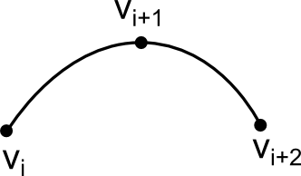
b') If and then set When you left you have increased by one and immediately decrease
c) If neither a), b), b') applies set

Means: you increase by one if you reach a vertex for the first time and then you continue. If it is a vertex of a degree then you leave the counter unchanged if upon leaving I still have an unused edge in , but if I have no such edge I decrease. So you increase every vertex one and decrese once you have traversed all edges incident of the vertex at least once.

Rule 3)
Suppose c(W) = 0. If then proceed as in preceding algorithm.
Otherwise set if and algorithm terminates if

You decrease only if you have traversed all edges incident to the vertex at least once - if you come back to the vertex again, you leave the counter unchanged. You decrease the counter when you have just traversed the last untraversed edge at .
Therefore, since you start with counter 1 you never become negative so .

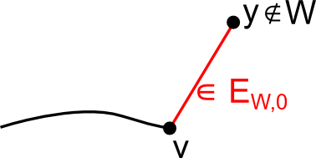
Suppose c(W) = 0 for some W starting at and ending at v.

If at v.

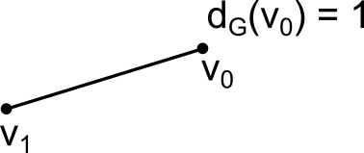
→ Closed covering walk where all edges are traversed at most twice and if twice once in both directions.

Chinese Postman problem
G connected, you associate a positive cost function (nonnegative real - maybe the length) - if you look at the roadmap, you have a number between two markpoints, but might only stand for cost of fuel to pass through this bit of road.
Cost-Function . Closed covering walk W such that , where is called a Postman-Tour or PT.
Windy Postman problem: Different edge cost for different orientations
?? Postman problem: One-Way-Streets. Assignment problem. You should find a matching assigning one machine at each of the workers so total efficiency is optimal. In the case of directed postman problem it can be transfored into that, in case of undirected: Until 1970s until ?? Johnson produced polynomial-time algorithmn to solve this problem: It rests under factor that can produce eulerian trail and thus closed covering walk in polynomial time and also: I can find minimum cost matching in polynomial time.
Theorem: (G,c) given as above (G connected, c positive cost function), a closed covering Walk W is a PT iff
1) ( counts number of traversals of edge e in W)
2) For every cycle C: (look at cost of edges which are traversed twice.
Proof: (replace every edge by as many parallel edges as number of edges in walk is)
in
W in G
T is eulerian trail in which is eulerian graph
Suppose such that

corr. to e
still eulerian, connected. eul. trail in → in G
closed covering walk

Contradiction to W being a postman tour (minimum cost) - therefor we know that no edge is traversed more than twice.

... Paths - actually forests

(delete all doubled edges when producing G^"+" and double all edges which are traversed only once)
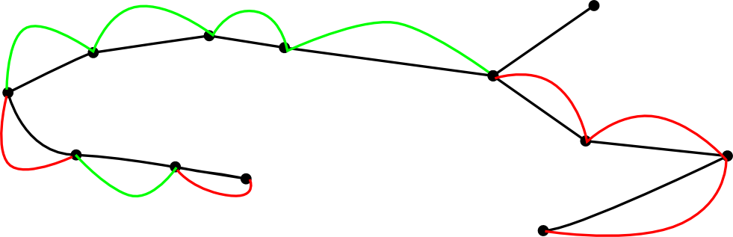
surely connected because contains G as subgraph, and eulerian → closed covering W in G

