Alt Prüfungen

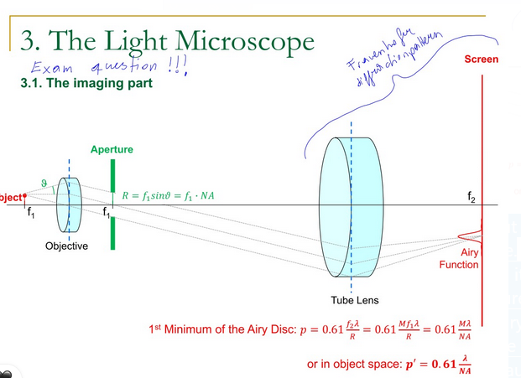

He always asks a question About this diagram, as he often mentions in his lecture.
You should construct it, explain it, know what happens if you put in an aperture, and expain what happens in the Image plane (Airy funtion etc). And I think usually he asks one more Question. For me it was very Physics realted, because of my Background, and not something that was really covered in the lecture. But he said its just a thought excercise, not contributing to the grade.
Understanding is more important than simple recounting of Facts. I recommend watching the lectures. It helps to get a feel for whats important

Exam March.2025

He also briefly asked about the fourier perspective and otf/mtf

Then how we can still get better resolution even though it seems limited
Basically describe techniques of super resolution microscopy
I started with confocal microscopy but as this is still limited he asked where we basically get rid of any restrictions so I also explained STED
Was very chill, he is super nice and I got a „sehr gut“

