Software Architecture
Disclaimer: This summary was created within a timespan of ~24 hours. The impact this might have towards the quality of the content is up to the viewer☺.
After-Test-Notice: Even though I wrote this summary and it did help me to understand the content of the course, it did not help as much for the exam. The questions did require much more detailed knowledge.

Architecture
Definition: Architecture is a set of principal (=important) design decisions about a software system.
- Every application has an architecture
- Every application has at least one architect
- Architecture is not a phase of development
Architectural concerns are: stakeholder issues, COTS components, overall style + structure, deployment issues…
Additional Architecture-driven Tasks are: Analysis (Security), Testing (What test strategy?), Planning (Time and (human) resources), Evolution and Maintenance.
Prescriptive Architecture | Descriptive Architecture
The as-intended architecture, captured during design time. | The as-implemented architecture

Architectural Evolution | Architectural Degradation
Ideally prescriptive Architecture is modified first.  If not, often because of:  - Developer sloppiness  - Short deadlines prevent documenting  - Bad prescriptive Architecture  - Bad tools | - Architectural drift: new design decisions are added to the descriptive (but not p. A.) architecture, but do not violate it (p. A.).  - Architectural erosion: Same as drift, but they do violate the prescriptive Architecture.

Architectural Recovery
Process of determining the system’s architecture from its implementation. (E.g. Source code, Executables, Java-Class-Files…)

A great architecture is: ticket to success, reflects deep understanding of the domain, and probably combines aspects of > 1 simpler architectures.

Design
Definition: Design (or Design Phase) is an activity that creates part of the system’s architecture. It addresses concerns about: system’s structure, component identification, communication…
Techniques:
- Separation of concerns
- Abstraction
- Modularity
Strategies used to perform above techniques: OOD, DSSA

Architectural Style
Definition: An architectural style is a named set of (architectural) design decisions. It may not explicitly help to solve a problem (it’s not as problem-oriented as architectural pattern and less domain specific).
Examples:
- Traditional: OO,
- Layered: Client-Server, Virtual Machines
- Data-flow styles: Pipes and filter
- Shared Memory: Blackboard
- Interpreter: Interpreter
- Implicit invocation: publish-subscribe, event-based
- Peer-to-Peer
- “Derived” Styles: C2, REST, SOA, CORBA
Properties:
- Design vocabulary: Component and Connector types (e.g. pipe, filter, object…)
- Configuration rules: topological constraints (e.g. component only connected to 0…2 other components).
In other words: the valid structural patterns in a style are connections.
- Semantic interpretation: design elements have well-defined meanings
Benefits:
- Design reuse
- Code reuse
- Understandability of the system’s organization (e.g. “client-server” is a well-known style), Visualization
- Interoperability
Object-Oriented Style | - Components are objects  - Connectors are messages and method invocations  - Invariants: Objects are responsible and hide their internal state  - Advantages:  - “infinite” formability of object  - decomposes system into sets of interacting agents  - Disadvantages:  - Objects must know identities of server  - Side effects in object method invocation  Use when:  - Many complex and related data structures  Avoid when:  - Application is distributed in a heterogeneous network  - Strong independence between components necessary
Layered Style | - Hierarchical system  - Each layer exposed interface to be used by above layer(s)  - Each layer is service provider (server) to above layers  - Each layer is service consumer (client) to below layers  - Connectors are protocols of layer interaction  - Advantages:  - Increase abstraction  - System can change (add/edit/remove layers)  - Change in layer affects max. the adjacent two layers ➔ reuse  - Different implementations of layers possible  - Disadvantages:  - Performance  - Layers may have to be skipped  Use when:  - Many applications can be based on a common layer of services.  Avoid when:  - Many layers required (inefficiency)  - Data structures must be accessed from multiple layers
Client-Server Style | - Components are client(s) and server(s)  - Connectors are protocol interaction (e.g. RPC)  - Client knows server’s identity. Server does not know identity of the client(s).  Use when:  - End-user processing limited to data + presentation  - Centralized computation of advantage  Avoid when:  - Single point-of-failure risk not arguable  - Network bandwidth limited
Pipe and Filter Style | - Components are filters. Transform input data into output data (streams)  - Connectors are pipes. Channel for data streams  - Invariants: Filters are independent (no shared state). Filter have no knowledge about previous/upcoming filters  - Advantages:  - Order of filters may be modified to change functionality  - Filter may be added/removed/modified to change fun.  - Analysis: throughput, latency  - Concurrent execution  - Disadvantages:  - Batch organization of processing  - Not really interactive  - Slowest filter defines data transmission  - Examples: UNIX shell, signal processing, parallel computing  Use when:  - Filters are useful in >1 applications  - Data structure easily serializable.  Avoid when:  - Interaction between components required
Blackboard Style | - Components:  - Blackboard: central data structure  - Components operating on the blackboard  - The blackboard’s state controls the system  - Examples: AI systems, compiler architecture  Use when:  - All computation centers a common, changing data structure  - Dynamic order of processing  Avoid when:  - Programs deal with independent parts of the common data structure  - Complex interaction between components
Interpreter Style | - Components: Command interpreter, interpreter state, user interface  - Connectors: usually procedure calls and shared state  - Highly dynamic behavior; set of commands can dynamically change.  Use when:  - Highly dynamic behavior required  Avoid when:  - High performance required
Publish-Subscribe Style | - Components: publisher, subscriber, proxies for managing distribution  - Connectors:  - Data elements: subscriptions, notifications, published information  - Topology: subscribers connect to publishers  - Very low coupling of components  Use when:  - Components need to be very loosely coupled  - Messages are small and efficiently transported  Avoid when:  - Middleware not available
Event-Based Style | - Components: event generators and/or consumers (independent)  - Connector: event bus/busses  - Data Elements: events  - Topology: communication over event bus, never directly  - Variants: communication may be pull or push based  - Highly scalable, easy to change, distributable  Use when:  - Components are concurrent and independent  - Components are heterogeneous and distributed  Avoid when:  - Real-time processing of events required
Peer-to-Peer Style | - Components: peers (independent)  - Connectors: Network protocol  - Date elements: network messages  - State and behavior are distributed among peers, which can act as client or server.  - Topology: redundant connections may exist. Can change dynamically  - Supports decentralized distributed computing.  - Highly robust in case of peer failure  - Scalable  - Protocol may be difficult to realize  - Examples:  - Napster (central directory node)  - Gnutella (no central node)  - Skype (super nodes, “hybrid”)  Use when:  - Peers are distributed, heterogeneous, independent  - Robust in case of peer failure  - Highly scalable  Avoid when:  - Trust issues with peers  - Resource discovery inefficient

A single architectural style does not fully determine the resulting architecture, but can even result in different architectures

Heterogeneous (Architecture) Styles
Definition: A more complex style based on composition of simpler styles.
Examples:
- C2 (Component + Connector): Implicit invocation + Layering + other constraints
- REST (Representational State Transfer)
- P2P
- SOA
- Sensor Networks
C2 Style | - Indirect invocation style where components communicate through message routing connectors. Strict rules on connections induce layering  - Components: Independent message generators/consumers (potentially concurrent)  - Connectors: Message routers. They may filter, translate, broadcast messages.  - Data Elements: Messages (basically POJOs)  - Notification messages announce change of state  - Request messages perform an action  - Topology: Layers of components and connectors have a “top” and “bottom” defined. Notifications flow downwards, requests upwards.  - Advantages:  - Easily changeable  - Supports product lines, concurrency, distribution  - Can be “used” as MVC with very strong separation between model- and UI-elements  - Typical use: reactive, heterogeneous applications  - Disadvantages:  - Event routing across multiple hierarchies is inefficient  Use when:  - Independence of substrate technologies required  - Heterogeneous application  - Product lines desired  Avoid when:  - High-performance across many layers  - When multiple thread become inefficient
SOA/Web Services | - Suitable for heterogeneous platforms  - Hierarchical composition + reuse (BPEL)  - Precisely defined interfaces  - Typical use: B2B, e-commerce  - Caution: WS-* standards and protocols are overload/complex.

Big Ball of Mud Style
Definition: Strong coupling of a lot of components. Change in one component will highly affect a significant amount of other (unrelated) components.

Architectural Pattern
Definition: An architectural pattern is a set of (architectural) design decisions which is a widely recognized and reused solution for recurring design problems. It helps to solve a problem.
Examples: 3-tier, MVC, Sensor-Controller-Actuator…

Domain-Specific Software Architecture
Definition:
- a bundle of software components specialized for a task/domain
- generalized to be used across the domain
- composed in a standardized structure (for effective implementations)
Properties:
- Design Technique
- May provide reusable application parts
Examples: Product lines…

Components
Definition: A (software) component is an architectural entity:
- Encapsulates functionality and/or data
- Restricts access via defined interface
- Has defined dependencies

Connectors
Motivation: within a complex System the interaction between components may become more important than the components themselves.
Definition: A (software) connector is an architectural building block responsible for the interaction between components.
Examples: procedure calls, shared data access, messaging services…
Connectors may provide application-independent communication between components.
“Implemented” connectors:  - Frequently no dedicated code  - Frequently no identity  - Distributed implementation (across multiple modules) | “Architectural” connectors:  - First-class entities (~POJOs)  - Have an identity  - Describe system interactions  - Have own specification & abstractions
Why Connectors:
- Components provide application-specific functionality
- Connectors provide application-independent communication functionality
  - Synchronous vs. asynchronous
  - Communication protocols
  - Add independence to components
  - May influence NFP

Roles of Connectors:
- Communication: main role of connectors. E.g. procedure calls, RPC, message passing. Support of constraints (e.g. quality of service→persistence), structure (e.g. pipes).
- Coordination: Control delivery of data
- Converters: enables communication of mismatched components (based on communication). Examples: Adaptors, Wrappers
- Facilitators: e.g. load balancing

Types of Connectors:

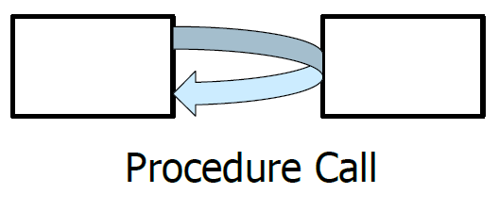 | 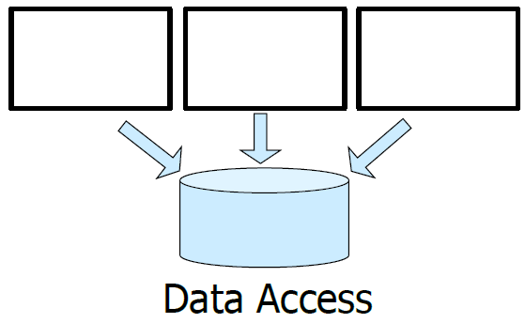 | 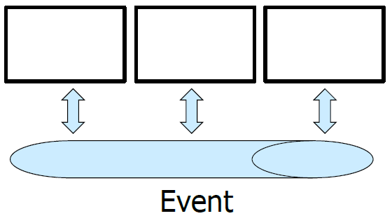
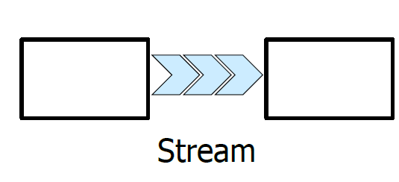 | 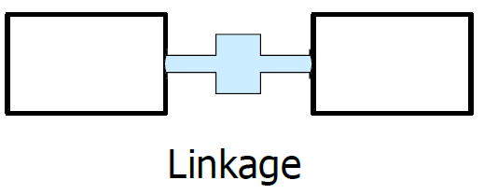 | 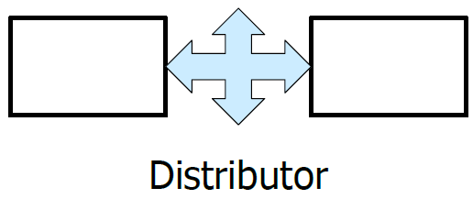
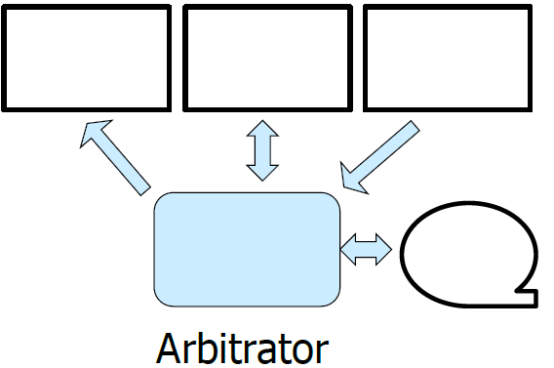 | 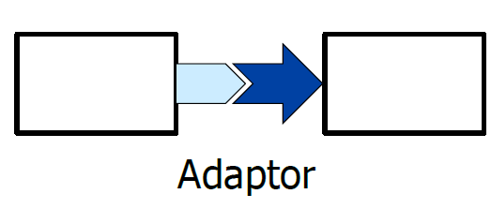

Examples for composite connectors: Enterprise Service Bus (e.g. Mule), Peer-to-Peer Connector (e.g. BitTorrent → Arbitrator, Data Access, Stream, Distributor)

System requirements
Definition: System requirements can be categorized as:
- Function requirement:
- Quality attribute requirement (non-functional requirement)
- Constraints

Functional requirements
Example: When the user presses the button X, a popup window Y appears.
Functional requirements do not determine the architecture.

Quality attribute requirements (non-functional requirements)
Example: Considering the above functional requirement, the following quality attributes might apply:
- Performance quality attribute may describe how quickly the popup appears
- Availability quality attribute may describe how often this function will fail
- Usability quality attribute may describe how easy it is to use the button.
There is a distinction between general QAs scenarios (system independent) and concrete QA scenarios.
To express a QA requirement, we need a scenario. A QA scenario looks like this: 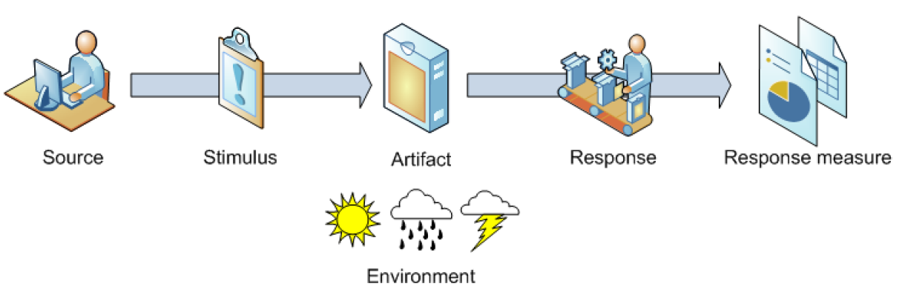
- Source: people, hardware…
- Stimulus: crash, incorrect timing…
- Artifact: process, communication channel…
- Response: Detect fault → log, notify; Recover fault → be unavailable, fix something
- Response measure: Repair time, availability percentage…
Quality Attributes are achieved through Tactics. Tactics are cataloged. Examples:
- Performance
- Usability
- Availability
- Modifiability
- Testability
Architectural Tactic:
Definition: An architectural tactic is a design decision that affects a QA response. One tactic focuses on a single QA response. Architectural Pattern can be seen as “packages” of tactics.
Explaining tactics for the “Modifiability”:
- Modifiability is about change and its risk and cost of this changes.
- To plan for Modifiability: check scenario:
  - Source: End user, developer…
  - Stimulus: a wish to add/delete/modify functionality
  - Environment: runtime, compile time…
  - Artifact: code, data, components…
  - Response: make modification, test modification, deploy modification
  - Response measure: Cost of duration, defects…
- Tactics to control “Modifiability” (goals):
  - control complexity of the change
  - control time of the change
  - control costs of the change
- Tactics to control “Modifiability” (actual):
  - Reduce size of a module
  - Increase cohesion
  - Reduce coupling
  - Defer binding
(Increase) Cohesion: A module should only be responsible for the same purpose.
Functionality belongs to components. Communication belongs to Connectors

(Reduce) Coupling: Modules should only depend on each other by an explicit interface (encapsulated). Restrict dependencies.

Architecture model
Definition: An architectural model is an artifact that captures some (or all) of the design decisions of the system’s architecture.
Architectural modeling: The architectural modeling is the documentation of those design decisions.

Architectural modeling notation: The architectural modeling notation is a language to capture design decision.
Evaluation of Modeling Approaches:
- Scope and purpose (does it help to show the correct scope)
- Basic elements (what are the atoms of the model. Can it capture this “atoms”?)
- Style (does the model show the underlying architectural style?)
- Static vs. Dynamic Aspects
- Non-functional aspects
- Ambiguity, Accuracy, Precision
- Viewpoints, Viewpoint Consistency

What can be modelled?
- Components  - Connectors  - Interfaces  - Configurations  - … | - Elements of the architectural style:  - Types  - Communication Constraints  - Behavioral Constraints  - …
Static Aspects (e.g. topologies, assignment of components/connectors…) | Dynamic Aspects (e.g. State of individual components/connectors, data flow…)
Functional Requirements | Non-Functional Requirements

Important Characteristics of Models:
- Ambiguity (open to >1 interpretations)
- Accuracy (model is correct and conforms the facts. Variance from correctness is within a limit)
- Precise (model is sharply bounded within a limits; lots of details)

View and Viewpoint
Definition: A view is a subset of a model organized around a particular concern. This concern or criteria is called viewpoint.
Component & Connector Viewpoint | - Capturing the logical (software) entities in as system and their communication  - Answers questions like:  - What are the major executing components?  - What are the major shared data stores?  - Which parts of the system are replicated?  - Views: package diagram, deployment diagram…
Concurrency/Behavior Viewpoint | - Capture how concurrency + threading will be managed in the system.  - Answering questions like:  - How does data progress through the system?  - What activities run parallel?  - Views: activity-, sequence-, state-, flow diagram…
Development Viewpoint | - Capturing decomposition, interfaces, uses, data model…  - Answering questions like:  - (Required/allowed) dependencies of modules  - Primary function of each module  - Views: class diagram
Deployment Viewpoint | - Closely related to Component & Connector view  - Answers questions like:  - What hardware elements are needed  - How are the hardware elements connected  - In what directory is each system located

To keep different views consistent they need to contain compatible design decisions. Because of overlapping views, incompatible design decisions will cause inconsistent views.
However, sometimes inconsistencies may occur during design time and/or cannot be fixed.

Modeling approach – UML
- 13 loosely-interconnected notations called diagrams. Capture static and dynamic aspects.
- Advantages:
  - Support lots of viewpoints focused on many engineering concerns.
  - Lots of documentation and tools available
- Disadvantages:
  - Difficult to keep consistency among views
  - Difficult to capture foreign concepts or views
- Ambiguity: many symbols can be interpreted differently (depending on the context)
- Accuracy: automatic constraint checking (e.g. DB class diagram)
- Precision: wide range possible
- (Generally applicable to software systems)

Modeling approach – SysML
- The system modeling language is based on and extends UML 2.0
- (Generally applicable to software systems)

Rapide
- ADL (Architecture Description Language) and tool-set to explore dynamic properties of a system.
- Advantages:
  - Expressive language to describe asynchronously communicating components
  - Tool-set may support simulation and graphical visualization of events
- Disadvantages
  - High learning curve
  - Tool support difficult on modern computers
- (Generally applicable to software systems)

Weaves
- An architectural style and notation. Suitable for small-grain fragments that communicate through data flows.
- Basic Elements: components, queues, directed connections
- Static aspects only
- Ambiguity: Meanings of elements are well-defined
- (Only for specific software systems applicable)

AADL
- Architecture Analysis & Design Language → notation and tool-set for modeling hardware/software system with embedded or real-time aspects
- Scope: interconnected multi-level system architectures
- Basic elements: components, threads, hardware, configuration…
- Primarily static aspects
- Advantages:
  - allows detailed specification of hard- and software
  - Automated analysis tools can check end-to-end properties of the system
- Disadvantages:
  - Verbose
  - Large amount of detail required to capture even simple systems

xADL
- Modular XML-based ADL

Implementing an Architecture
Implementing architecture is basically a mapping problem between design decisions and implementation artifacts. This is one of the phases of SW Eng. which cannot be skipped. The following elements appear during mapping:
- Components and Connector: Modules, Packages, Libraries, Classes…
- Interfaces: in programming-language e.g. APIs, method signatures; State machines or protocols are harder to map
- Configuration: Communication, references, dependencies…
- Design rationale: Often not directly visible in implementation → visible in comments/other documentation.
- Dynamic Properties (e.g. behavior): usually algorithms
- NFP: Extremely difficult as there NPFs are abstract but implementations are concrete. Achieved through manual tests…

One-Way vs. Round Trip Mapping
Because architecture will change during implementation (e.g. maintenance, time pressures, or new information) it makes sense to do iteratively switch between design decisions (descriptive arch.) and implementation (prescriptive arch.) → learning process for both sides (architects and programmers)
However one-way mapping is easier.
Strategies:
- One strategy: limit changes! If all system changes are done in the descriptive architecture first, only one-way mapping is needed (hard to achieve practice!).
- Alternatives: allow changes in architecture and implementation → round-trip mapping necessary.

Architecture Implementation Frameworks
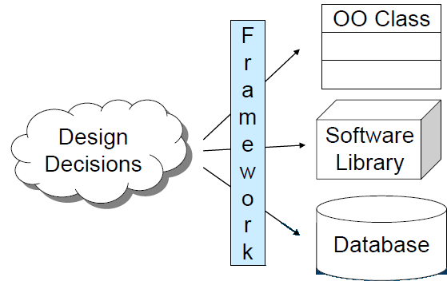
The ideal approach would be to directly map design decisions to the implementation. Unfortunately this is not always easy as programming languages and/or infrastructure (libs, OS…) often do not have support for styles.
Therefore we need an “Architecture Implementation Framework”:
Definition: An […] is a piece of software that acts as bridge between an architectural style and a set of implementation. It assists developers to implement the system according to the architecture specification.
However, keep in mind, for a given style there exist several architectures. (E.g. stdio, iostream, {java.io, java.nio}).
Examples: CORBA, JavaBeans, JMS (all these are closely related → provide service to developers which is not provided by OS and assist in implementing a certain aspect of an architecture (JMS=implicit method invocation...)
Be warned: Middleware (like above) induces an architectural style (e.g. RPC)

Role of an Architect
- Software development expertise
- Domain expert
- Communicator
- Consultant, Leader
- Politician
- …
Architects must understand the principles of software developments and its methods/tools. No need to be very good developer. Half of the job of an architect is communication. Listen to stakeholders, explain the architecture and negotiate compromises. In case of developers, these are the architects “customers”. Developers goals surround code (quality), documentation,… whereas the architect needs to make their intentions clear.
Pitfalls:
- Lack of software development skills
- Lack of domain knowledge
- Lack of authority
- Confusing techniques
- Procrastination
Enterprise Architect:
- From the company’s point of view
- Uniform hardware/software stack
- Same design patterns and pattern language
- Same quality attributes
- Communication between architects and the corresponding product development teams.

Agile Manifesto
- Individuals and interaction over processes and tools
- Working software over comprehensive documentation
- Customer collaboration over contract negotiation
- Responding to change over following a plan

Agile and Architecture
- Up-Front planning: Communication, Quality attributes, Design pattern/styles, Stack
- Storyboarding: Output: architecture-centric stories
- Sprint: Architect assists team in respect of Quality Attributes and Design Pattern. Necessary changes in stack as early as possible
- Working Software: promote architecture-centric refactoring, verify that solution meet quality attributes, verify that patterns are correctly implemented. Output: confirm correctness of implemented architecture

