Updated 20220303 to include exams: 15032021.rar, 2022 01 24 final exam.png
These are all exam questions and answers collected from 2020 Final Exam.png, 2021 01 18 Final Exam 2.png, 2021 01 18 Final Exam.pdf, 2021-03-15 Final Exam-partial.png, and InfoVis Exam.pdf. It could have missing questions or wrong answers, feel free to fix/update it and reupload it to vowi. Good luck :)
- Mark the correct statements about geospatial data
  - Area phenomena enclose a region, along with a set of attributes for each phenomenon.
  - Area phenomena have both length and width (but no height)
  - Examples of area phenomena are cities, and streets.
  - Examples of area phenomena are communication networks and roads.
  - Examples of point phenomena are buildings, il wells, aggregated measures, streets and communication networks
  - Examples of point phenomena are buildings, oil wells, aggregated measures, and cities
  - Line phenomena can be specified by a series of longitude and latitude coordinate pairs. (marked as correct in 15032021, 20220124 exams)
  - Line phenomena can be specified by an unclosed series of longitude values.
  - Line phenomena have length, but essentially no width.
  - Point phenomena are termed one-dimensional
  - Point phenomena are termed zero-dimensional
  - Point phenomena can be specified by an unclosed series of longitude and latitude coordinate pairs
  - Point phenomena have no spatial extent.
  - Surface phenomena are termed 2.5 dimensional
  - Surface phenomena are termed three dimensional.
  - Surface phenomena can be specified by a series of longitude, latitude and height.
- Which color scales are appropriate to communicate which information?
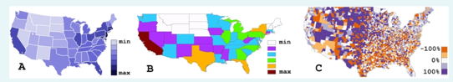
  - Map A is best suited to communicate population per square mile per state
  - Map A is best suited to communicate the bettering or worsening of average income per state since last year
  - Map B is best suited to communicate population per square mile per state
  - Map C is best suited to communicate the bettering or worsening of average income per county since last year
- Map projections are concerned with mapping the positions on the globe (sphere) to positions on the screen (flat surface).
  - Azimuthal projections do not preserve the direction from a central point.
  - Azimuthal projections preserve the direction from a central point.
  - Cone projections map the surface of the sphere to a parallelogram that is tangent to the sphere.
  - Conformal projection does preserve areas
  - Conformal projection does preserve shapes.
  - Conformal projection retains the local angles on each point of a map correctly.
  - Conformal projections do not retain the local angles on each point of a map correctly.
  - In cone projections the degrees of longitude and latitude are usually orthogonal to each other
  - In plane projections degrees of longitude are represented as circles around the projection center
  - Plane projections are azimuthal projections
- Mark the correct statements regarding text visualization.
  - are useful for browsing or non-specific information discovery
  - are useful to visualize terms in their context
  - Do not support in-depth exploration of the textual structure
  - Document preprocessing and interpretation of the semantics of text are a prerequisite to text visualization.
  - Long words and short words are treated equally
  - Support detailed queries
  - Text visualization is used to visualize patterns, as well as the formatting (e.g., the typography, the font) of a document.
  - Text visualization is used to get an idea about the content of unknown text.
  - Text visualization is useful to get the ""gist"" of a document.
  - The syntactic level of text representation deals with identifying and tagging each token's function inside the sentence.
  - ThemeRiver (stream graph) is a visualization of both term frequencies as well as their context.
  - Typically, in a Vector Space Model stop-words are removed.
  - Word clouds are layouts of raw tokens, colored and sized by their frequency within a single document
  - Word clouds are useful to visualize relationships among terms.
  - Wordle (word clouds) are better suited than Parallel Tag Clouds to visualize pair-wise relations of different words. (not selected in 20220124 but still full points)
  - Wordle (word clouds) can be used to visualize the evolution of multiple documents over time
  - Wordle (word clouds) is an effective way to show the frequency of terms in text documents.
  - Word clouds are visualizations of term frequencies as well as their context
  - The semantic level of text representation deals with identifying and tagging each token’s function inside the sentence.
  - Text visualization is useful to compare patterns in text documents
  - ThemeRiver (stream graph) is a visualization of thematic changes in a document collection over time
- Mark the correct statements
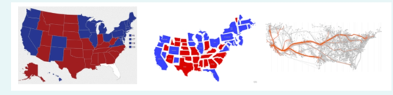
  - Cartograms are based on the assumption that the mapped attribute is uniformly distributed in the geographical region.
  - Cartograms communicate the geographical distribution of the represented statistical value better than choropleth maps
  - Cartograms distort the geography according to the displayed statistical value.
  - Choropleth maps are suitable to represent area phenomena.
  - Choropleth maps are suitable to represent ordinal area data
  - Choropleth maps communicate the geographical distribution of the represented statistical value better than cartograms.
  - Choropleth maps distort the geography according to the displayed statistical value.
  - Edge bundling is a suitable technique to effectively avoid overlapping in line maps.
  - Edge bundling is a suitable technique to effectively avoid overlapping in pixel maps
  - Line maps are based on the assumption that the mapped attribute Is uniformly distributed in the geographical region.
  - Line maps are usually created by placing symbols where the described phenomenon occurs
  - Choropleth maps are based on the assumption that the mapped attribute is uniformly distributed in the geographical region
  - Choropleth maps communicate effectively the precise statistical value to be visualized
  - Choropleth maps do not communicate the geographical distribution of the represented statistical value better than cartograms
- Concerning the layout of dynamic networks, mark the true sentences.
  - Animations are always made for online (streaming data) applications.
  - Animations map the „time” dimension to „space”.
  - Dynamic layout scalability does not consider the number of frames (graphs) to visualize.
  - Timeline node-link visualizations include juxtaposed, superimposed or integrated approaches
  - Timeline visualization can be applied on node-link visualization only.
- Dynamic graph visualization techniques can be categorized in “animation” and “timeline” based techniques: (0 points!)
Suggested answer: d
  - In online dynamic graph visualization, there is no knowledge about the previous timeslices of the graph (‘next frame is unknown’, search word ‘online’, slide 459)
  - Animation techniques map time to space (‘time to time’)
  - Timeline approaches can be fully categorized in superimposed, juxtaposed, and compound (There are juxtaimposed, superimposed, integrated, intracell, layered)
  - None of the others
  - By using careful and easy to follow animations, automatically the mental map of the user is preserved. (probably wrong. “placement of existing node and edges should change as little as possible” to preserve mental map. Search word “mental map”, slide 457)
- Mark the correct sentences about Nodetrix: (2 points) (maybe also e?)
  - It supports the overview of the graph
  - It’s an hybrid visualization technique for graphs in which communities are represented using cliques, and a feasible edge length puts them apart for easy recognition
  - Communities can share elements by duplicating and highlighting them
  - Better supports the path finding task than adjacency matrices alone
  - It partly overcomes the scalability issues of a node-link approach
- Relational data in the form of general graphs can be visualized as:
  - Icicle trees
  - Treemaps
  - Sunbursts
  - Node-link diagrams
  - Adjacency matrices
- Mark the true sentences about the juxtaposition algorithms for node-link visualization of dynamic graphs. (2 points)
Update 20220313: see slides 77+ from “graph trees” lecture, suggested answer: acde
  - When using anchoring, vertices are attracted to a reference position computed on a frame-by-frame basis.
  - When aggregating, vertices keep their position throughout all frames and other visual cues convey the time information (e.g. labels).
  - When anchoring, vertices are fixed in place, and their coordinates is calculated by aggregating all frames.
  - Linking proved to yield a favorable tradeoff between quality (stress) and stability (node movement through slices) when compared to Anchoring and Aggregation, but is more computationally demanding.
  - When using linking, vertices are stabilized by linking each frame to the last one, and computing the layout throughout all the timeslices simultaneously.
- Approaches for preserving the mental map in a dynamic layout include
  - Aggregation
  - Anchoring
  - Brushing
  - Linking
  - Slide and dice
- Mark the true sentences about Cliques.
  - A clique is "maximum" if does not exist as a part of a larger clique.
  - A clique is a subset of vertices such that its induced subgraph is incomplete.
  - Cliques have a number of vertices (k) equal to m(m-1)/2, with m the number of edges (in the undirected case)
  - Given a graph G, Finding a clique of size at least 6 is a NP-Complete problem.
- Which of the following are NOT drawing conventions? (1.5 points)
Suggested answer: ab
  - Keep some node(s) In the center of the layout
  - Minimize the number of crossings
  - Place nodes on a grid
  - Visualize edges as straight lines
  - Visualize sibling nodes on the same vertical position
- Which of the following ARE drawing conventions?
  - Keep some node(s) in the center of the layout
  - Place nodes on a grid
  - Visualize edges as straight lines
  - Visualize sibling nodes on the same vertical position
  - Minimize the number of crossings
- A force directed layout algorithm
  - Includes an energy maximization algorithm
  - is a graph-drawing method for node-link diagrams
  - is a method to reorder rows and columns of a matrix
  - is used to compute the colours of a heatmap
  - models the graph after a physical system
- A good layout for a node-link diagram should
Answer different in the slides (s30). Suggested answer: bcd
  - Exploit color coding
  - Maintain a pleasing aspect ratio
  - Minimize line crossings
  - Minimize node overlap
  - Not take into account the total area of drawing (but it would be preferable to minimize it)
- A spring embedder force directed layout algorithm (2 points) (maybe also e? s54)
  - Models the graph as a physical system
  - Aims at minimizing energy of the current layout
  - Always finds the global maximum of the energy function
  - Models vertices as opposite charged particles
  - Tends to create hairball layouts of scale free networks
- Concerning graph filtering and sampling, mark the true sentences.
  - Applying the MST technique on a graph yields a (possibly) cyclic sub-graph spanning al the vertices
  - Graph filtering techniques ensure that the filtered graph is a subgraph of the original
  - Graph sampling techniques creates ""samples of the graph so that those have the same properties of the whole graph
  - Pathfinder network scaling retains all edges that satisfy the triangle inequality
  - Stochastic filtering techniques, applied on the same input, aways yield the same result
- When designing a node-link graph visualization, particular attention has to be put on how to visualize the edges. Mark the correct sentences.
  - Curved approaches, such as Lombardi drawings, are usually preferred by the users even If they do not provide an advantage ln any observed task.
  - In the directed case, when arrows are used to indicate the direction, they should not overlap with other edges or arrow heads.
  - Polyline edges with multiple bends per edge can be used, but the number of bends should be minimized
  - Straight line node- ink representations allow bends to reduce the number of cross ngs In the layout.
- Node-link diagrams
  - a. scale better than adjacency matrices
  - are useful to convey an overview of the data
  - can not be used to visualize hierarchies
  - may suffer from occlusion and edge crossing
  - support path-finding tasks better than matrices
- Adjacency matrices
  - Do not suffer from occlusion
  - Do scale for large graphs
  - Make path-finding easy
  - Represent edges as table cells
  - Represent edges as table rows and columns
- Which of the following are treemap layout algorithms?
  - Circular
  - Multi-Level layout
  - Rectilinear
  - Slice-and-Dice
  - Strip
- Which of the following are (strictly) treemap layout algorithms
  - FMMM
  - Group-in-a-box
  - PFNET
  - SliceAndDice
  - Squarified
- Treemaps (rectangular) (2 points) (also d? slide108 ‘smallest article titles are not readable)
  - Have a better aspect ratio than indented lists
  - Make better use of display space than curlcular treemaps
  - Minimize crossings between edges
  - Suffer from occlusion issues
  - Use size and color to encode additional information
- A treemap
  - can be nested
  - can be squarified
  - is a non-space-filling visualization method
  - is used to visualize hierarchies
  - is used to visualize vegetation in a geographic area
- Containment diagrams include (2p) (c+e also reached 2p in 20220124 exam)
  - adjacency matrices
  - circular treemaps
  - rectangular treemaps
  - rectilinear graphs
  - Voronoi diagrams
- Hierarchies can be visually encoded by
  - adjacency matrices
  - containment diagrams
  - Icicle Trees
  - Indented lists
  - node-link diagrams
- Indentation
  - can be used to visualize hierarchies
  - can be used to visualize networks
  - is a text-based encoding
  - is simple and intuitive
  - scales well (keeping a good aspect ratio)
- Mark the true sentences about Group-in-a-box layouts (2 points) (maybe also b?)
  - Can only be applied on large graphs.
  - Combine grouping and labeling techniques on networks.
  - Combine relational data and hierarchical data.
  - Compute the layout of subgraphs independently and arrange them according
  - They are usually used to visualize network with natural strong communities
- Semantic zooming…
  - allows users to choose between a large scope (i.e., zooming out and seeing an overview of the big picture) or a more detailed view (i.e., Z00ming in and seeing all details about a limited range of the data).
  - relies solely on geometric zooming.
  - shows different visual representations depending on the color-coding chosen by the user.
  - shows different visual representations depending on the zoom level chosen by the user and the available space for the visualization.
- Interaction techniques are required to
  - discover new visualizations
  - enable data exploration and knowledge discovery
  - represent data and Information
  - support the dialogue between the users and the data
- This screenshot shows an application with multiple linked views.
  - ""Linked Views"" means that each city on the map has a hyperlink to the website of the city
  - 4 different datasets are shown
  - Different views of the same dataset help to connect and understand different information about it
  - The colors highlight same subsets of data items in the different views
- Where can user interactions be integrated according to the infovis reference model
  - Data tables
  - Data transformations
  - Raw data
  - View transformations
  - Views
  - Visual mappings
  - Visual structures
- Existing Focus+Context techniques can be done by ...
  - Disiorting Data: The data representation of the entire dataset is distorted to put the view focus on the contextualized regions.
  - Distorting Data: The data representation of the entire dataset is distorted to reduce the out-of-focus information from the view.
  - Eliding Data: Some items are omitted to give more contextual information to currently focused elements.
  - Superimposing Data Layers: Focused areas are locally overlaid with additional context information.
  - Superimposing Data Layers: The eniire visualization is enhanced with annotations, on-demand tooltips and navigation overlays.
- How does the use of Focus+Context techniques Impact usability?
  - Focus+Context techniques are easy to follow and can be used without prior knowledge
  - Overview+detail and fisheye Interfaces are beneficial for specific tasks
  - Overview+detail and zooming Interfaces Impact users' performance negatively
  - the effectiveness of Focus+Context techniques depends on the users' tasks and goals
- What levels of the Info-Vis Reference Model are influenced by interactive linking?
(why not c,g as well?)
  - Raw Data - The raw data is changed by the selection.
  - Views - The selection switches the views for a different representation.
  - Data Transformations - The data to produce the visualization is filtered.
  - Visual Mappings - The mapping to emphasize the selected data is changed.
  - View Transformations - The view is transformed to emphasize the selected data.
  - Data Tables - The data tables are filtered by the selection.
  - Visual Structures - The selection changes the visual structure.
- What levels of the Info-Vis Reference Model are influenced by dynamic queries? (1.5p)
Suggest: bcd
  - Data transformations
  - View transformations
  - Visual structures
  - Views
  - Data tables
  - Raw data
  - Visual mappings
- What levels of the Info-Vis Reference Model are influenced by visual encodings? (1.5p)
(maybe beg?)
  - Data tables – the data table is transformed to properly match the required data
  - Views – the views are replaced
  - Data transformations – the data is transformed based on the selected encoding
  - View transformations – the view is transformed based on the selected encoding
  - Visual structures – the visual structures encode the data differently
  - Raw data – the raw data is clanged to match the selected encoding
  - Visual mappings – the visual mappings are changed to represent the data
- Interaction design in visualizations is employed to: (1.5p)
(maybe abe?)
  - Speed up users’ understanding of the visualization interface
  - Recreate task-specific visualization pipelines
  - Integrate well-known concepts of established visualization interactions
  - Help users fining hidden features of the interface
  - Appropriately map a user’s mental model
- Interaction modeling is employed to ... Select one or more:
(maybe also c?)
  - Capture requirements the system can be developed and evaluated against.
  - demonstrate interactions and tasks to users.
  - validate effectiveness and user guidance of different interaction approaches.
- Interaction modeling is used to (2 points)
  - automatically generate data
  - .. capture requirements the system can be developed and evaluated against.
  - automatically generate UIs
  - capture interaction behavior of the users.
  - validate effectiveness and user guidance of different interaction approaches.
- Coordinated Multiple View systems ... Select one or more:
  - always support semantic zooming
  - are often supported by brushing & linking techniques
  - can not be supported by Brushing & linking techniques
  - combine different visualization techniques and apply them on different data representations
  - use color-coding for trend detection
  - use two or more distinct views to support the investigation of a single conceptual entity
- Dynamic queries
  - always show results as Scatterplots
  - gives an Interactive representation of a query's current configuration
  - select value ranges of variables via controls with real time feedback in the display
  - show Incorrect Information for false user Input
- Tamara Munzner: Examples of analysis’ actions are ... Select one or more:
  - annotate
  - discover
  - enjoy
  - listen
  - present
  - read
  - say
- Tamara Munzner (book: visualization analysis and design) distinguishes 4 levels In her analysis framework:
  - Abstraction
  - algorithm
  - domain
  - Idiom
  - Images
  - patterns
  - search
- Tamara Munzner: The nested model of visualization design and validation captures
  - data/task abstraction
  - algorithm
  - search functionality
  - visual encoding/interaction idiom
  - domain situation
  - patterns characteristics
  - images properties
- tamara munzer 3 questions: what why how
- Assign the correct titles to the numbered stages / transitions of the InfoVis reference model
  - 1=Raw Data; 2=Data Tables; 3=Visual Structures; 4=Views; 5=Visual Mappings
  - 1=Raw Data; 2=Visual Structures; 3=Data Tables; 4=Visual Mappings; 5=Views
  - 1=Visual Mappings; 2=Raw Data; 3=Data Tables; 4=Visual Structures; 5=Views
- lnfoVis Reference Model: User Interaction can feed back Into ...
  - data transformation
  - Image manlpulatlon
  - table structure
  - text generation
  - view transformation
  - visual mapping
- The "Visual Information Seeking Mantra" reads as.
  - overview first, zoom and filter, then details-on-demand
  - zoom and filter first, overview, then details-on-demand
  - details-on-demand first, zoom and filter, then overview
- the first action of knowledge crystallization loop: forage for data
- the goal of knowledge crystallization loop: get the most compact description possible for a set of data relative to some tasks
- the last action of knowledge crystallization loop: create, decide, or act
- The visualization design triangle [Miksch & Aigner 2014] specifies..
  - data
  - Environment
  - hardware
  - software
  - task
  - user
- Information Visualization is defined as... Select one:
  - the use of computer-supported, interactive, visual representations of abstract data to amplify cognition.
  - the use of computer-supported, static representations of data to amplify cognition.
  - the use of paper-based, visual representations of abstract data to amplify cognition.
- Anscombe's Quartet Illustrates
  - high level goals, correct measures
  - random variables, different graphs
  - same statistics, different graphs
- Why visualization?
  - increasing cognitive resources
  - manipulating images
  - perceptual monitoring of a large number of potential events
  - reading images
  - reducing search
  - storing data
- Chernoff Faces:
  - are composed of features (eyes, mouth, nose...) which are likely to be not perceived equally strong
  - are glyphs
  - are not suspected to convey emotions
  - are suited to communicate complex data effectively
  - are suspected to convey emotions
  - are well understood and appropriate to communicate complex data effective y
  - encode data values with properties of a face
  - encode multiple data values with different graphical features
  - encode only one data value with multiple graphical features
  - their features are likely to be perceived equally strong
  - their features are not likely to be perceived equally strong
  - use facial features to communicate data values
- Glyph or icon based techniques
  - are composed of graphical primitives
  - are graphical objects whose graphical primitives represent data values
  - can only encode one data value as a whole
  - cannot represent multiple data values at once
  - do not represent one meaning as a whole but encode multiple data values
- Parallel Coordinates
  - are better suited to visualize complex relations between two dimensions than scatterplots
  - are less suited to visualize complex relations between two dimensions than scatterplots
  - are suited to represent a maximum of 3 dimensions
  - are suited to represent many dimensions
  - are usually arranged in a matrix to enable the visualization of multiple dimensions
  - re-ordering of the axes can reveal relations between two data dimensions
  - represent each data dimension on one of multiple parallel axes
  - represent each data item by a (polygonal) line
  - the ordering of the axes does not influence the visibility of relations between two data dimensions
  - the ordering of the axes influences the visibility of relations between two data dimensions
- Pixel-Based Techniques
  - are suited for low-dimensional data sets only
  - data attributes are mapped to color
  - represent a data item by (at least) one pixel
  - represent attributes of a data item by (at least) one pixel
  - represent one data item as a polygonal line connecting different axes
  - use color to visually encode attributes of data Items
  - value ranges of attributes are mapped to a color map
- Visual variables of marks...
  - color hue is well suited to represent nominal values
  - color hue is well suited to represent quantative values
  - include length
  - include linking &brushing
  - include position
  - include shape
  - include texture
  - length is well suited to represent nominal values
  - position is well suited to represent quantitative values
  - shape is well suited to represent quantitative values
  - size is well studied to represent nominal values
- Semantic depth of field
  - can be used to guide attention
  - Is best suited to visually represent differences of quantitative values
  - Is not suited to visually discern relevant from non-relevant data Items
- The fovea is
  - a location in the eye where the optic nerve is connected
  - a region in the back of the brain
  - a region where rods and cones are most densely packed
  - an area corresponding approximately to the size of a thumb at arms length
  - the region in the eye with the sharpest vision
- Which of the following statements regarding color perception are true?
  - Color Is a preattentive attribute
  - Color is perceived depending on the surroundings
  - Color vision Is adaptive to ambient light
  - Colors can be perceived absolute y (objective measurement)
  - Most of the photoreceptive cells on the retina are for color vision.
- Visual perception is: a combination of bottom-up and top-down processes
- The Gestalt principle shown is called:
  - Closure (dashed circle and square)
  - Enclosure
  - Proximity (6x6 square consisting of dots, next to it the same thing but in three columns)
  - Similarity
  - symmetry
- The examples shown in the image are
  - 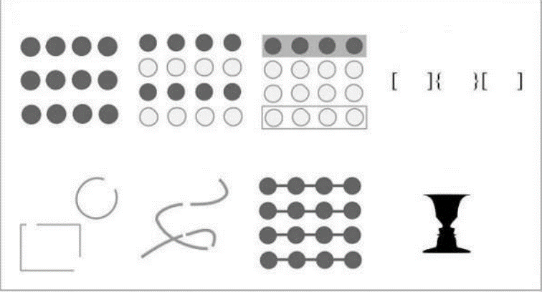 gestalt principles
  - 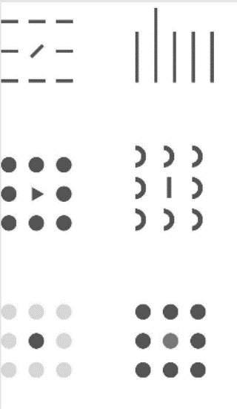 or 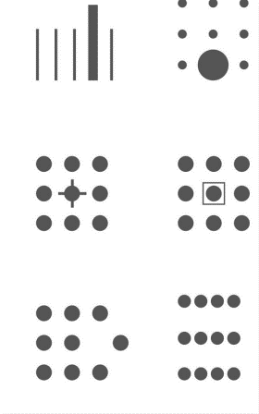pre-attentive attributes
- Which of the following statements regarding preattentive processing are true? (2 points)
  - Preattentive attributes are features of a visual scene that pop-out. (probably correct)
  - Preattentive attributes are perceived very quickly because they don't need to be learned but are "hardwired" In the brain.
  - Preattentive processing is fast and Is performed in parallel, within 250ms.
  - Preattentive processing requires attention and works with short-term memory.
  - The combination of two preattentive attributes Is again perceived preattentively. (not this one)
- Along which scale are T-Shir sizes measured?
  - nominal
  - ordinal
  - quantitative – Interval
  - quantitative - ratio
- Along which scale are lastnames measured?
  - nominal
  - ordinal
  - quantitative - interval
  - quantitative - ratio
- along which scale are body weights measured: quantitative - ratio
- along which scale year of birth: ordinal (0P in 20220124), I think it’s quantitative-interval
- the lie factor/perceptual distortion of a graphic is: size of effect shown in graphic / size of effect in data
- which of the following statements are correct
  - 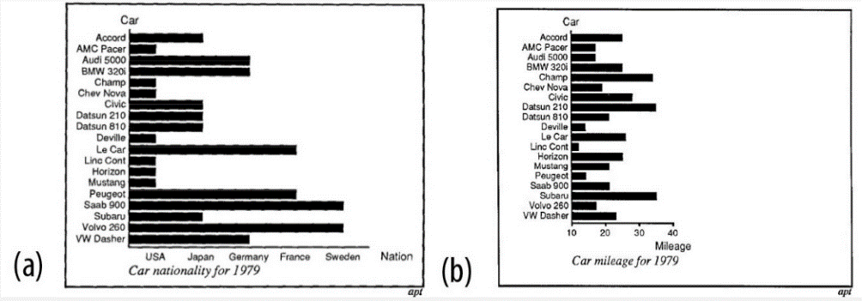a is not expressive, b is expressive
- Which of the following statements about animation (mapping time to time) are correct?
  - direct comparison of parameters between different points in time is possible
  - not well suited for analytic and explorative tasks
  - probably the most natural form of mapping
  - remembering trends and changes
  - well suited for following trends and movements
- Which of the following statements about mapping time to space are correct?
  - direct comparison of parameters between points in time is possible
  - mapping of time to visual features
  - not well suited for analytic and explorative tasks
  - well suited for following trends and movements
- Which of the following statements about visual mapping of time are correct?
  - animation (time to time) mapping is the simplest mapping
  - animation (time to time) mapping is well suited for explorative tasks
  - animation (time to time) mapping supports to follow trends and movements
  - static (time to space) mapping is well suited for explorative tasks
  - static (time to space) mapping support direct comparison
- What are the three key questions for visualizing time-oriented data?
  - How is it presented?
  - How often Is It presented?
  - What has to be presented?
  - When is It presented?
  - Why has it to be presented?
- Which of the following task are time-oriented
  - lookup
  - rate of change
  - sequence
  - temporal location
  - Value of a data element
- How can we visualize time
  - animation
  - shape
  - texture
  - time to space
  - visual variables
- Scale is (for modeling time-oriented data, possible scale are)
  - alphanumeric
  - continuous
  - discrete
  - ordinal
  - qualitative
- Scope is
  - branching
  - Continuous
  - Interval-based
  - Point-based
- Which of the following statements about time and space are correct?
  - an interval is anchored
  - in time, you cannot move back to where you came from
  - space can be traversed ""arbitrarily""
  - time is bidirectional
  - time is unidirectional
- Viewpoints are
  - branching
  - Cyclic
  - interval-based
  - multiple perspectives
  - ordered
- Examples for time primitives are
  - an instant, which is a single point in time
  - an instant, which is unanchored
  - an interval, which is anchored
  - an interval, which is a single point in time
  - a span, which is a duration of time
- The shown techniques are well suited to represent:
  - 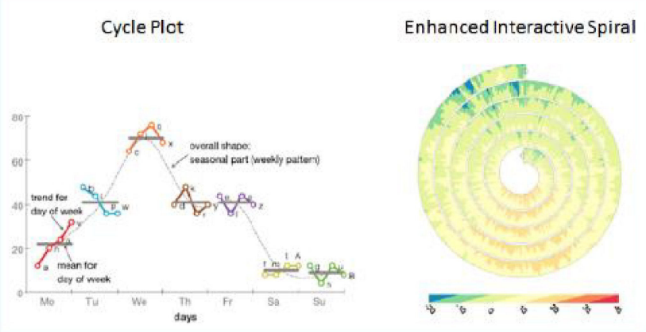
    - cyclic time
    - multivariate data
    - time instant
    - time interval
    - univariate data
  - 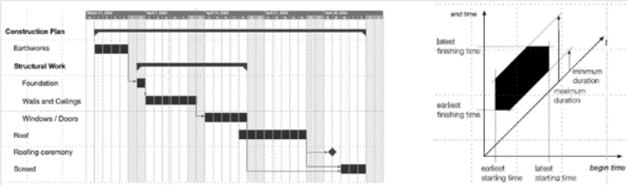
    - Cyclic time
    - linear time
    - multivariate data
    - time interval
    - univariate data
  - 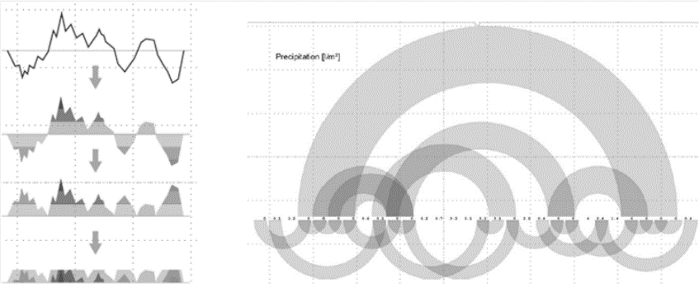
    - cyclic time
    - linear time
    - multivariate data
    - time instant
    - univariate data
  - 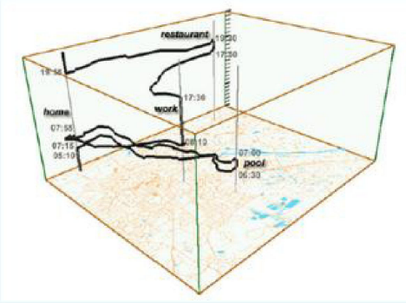
    - cyclic time
    - multivariate data
    - spatial
    - time instant
    - univariate data
  - 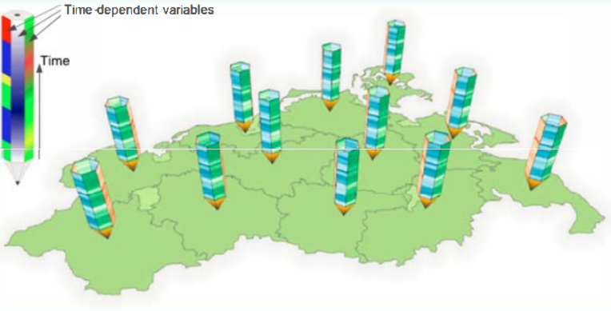
    - cyclic time
    - Multivariate data
    - Spatial
    - Time instant
    - Univariate data
- For data aggregation and data summary representations, which statements are correct? (1.5p)
  - Box-plots as summary representation show enough detail to distinguish different raw data (I think this one’s not right)
  - Scatterplots of 2 dimensional data allow to confirm expected patterns
  - Summary statistics of 2 dimensional data (mean, variance, correlation) are always different for different datasets
  - Violin-plots as summary representation show more details about the structure as box plots
- According to Jack van Wijk, good design
  - cannot be learned.
  - Is not minimalistic, rather like a xmas tree.
  - Is primarily about usability.
  - Is thorough to the last detail
- The design space of possible visualization idioms is huge, and include the considerations of
  - human cognition idiom
  - human perception idiom
  - interaction idiom
  - visual encoding idiom
- According to the design study methodology (Sedimair et al. 2012), when does a visualization design study offer a good solution for a given problem?
  - Area "A": all the required information is in the head of the user
  - Area "Z": the required information is available to ihe computer and the task is defined in a clear way.
  - Area “Y": either some of the required information is in the head of ihe user, or the task is not defined in a very clear way, or both.
- Which statements regarding design studies (Sedlmair et al. 2012) are correct?
  - Design studies do not require a reflection about the lessons learned.
  - Design studies fall Into the problem-driven research category.
  - Design studies try to solve a specific real-world problem.
- Which statements regarding the nine-stage design study methodology framework (Sedlmair et al Volstandig 2012) are correct?
  - is a linear process without iterative dynamics
  - the analysis phase goal is to learn from the design process and communicate the findings to the scientific community
  - The core phase basicaly matches the human-centered design cycle
- Summative evaluation
  - describes assessment methods after the implementation phase.
  - describes assessment methods during analysis and design phases.
  - is used for problem analysis.
- Which of the following statements about paper prototypes/ low-fidelity prototypes are true:
  - they are easy to Change In response to feedback
  - they are quick and inexpensive to build
  - they are working software Where a certain functionality Is Imp emented In detail and the rest of the system Is on y roughly shown
  - they shOuld have a finished look and are best drawn usng software
  - users are more Inclined to give feedback about the structure of the system because they are hand-crafted and rough
- The conceptual design can be evaluated by
  - Cognitive walkthrough
  - Document analysis
  - Ethnographic observation
  - Expert review
  - Participatory workshop / focus group
- For ethnographic observations / in situ observational studies it is true that
  - an interview guideline has to be created upfront
  - observations might also be collected using video and audio recordings
  - the observer is not allowed to ask questions
  - they are primarily conducted after the new tool is used by users
  - users are observed in their working environment in practice
- The central questions of problem analysis are:
  - How many software develOpers and designers are needed?
  - What are the tasks of the users?
  - What k i nd of data are the users working w th?
  - What will the develOpment method for the lmplementatlon phase be?
  - Who are the users of the system?
- Participatory workshops / focus groups are
  - a method applied for problem analysis
  - a method for evaluation of a conceptual design
  - a method for rapid prototyping using real data
  - used to address data quality issues and transform source data into a usable form
- Data wrangling is used to address data quality issues and transform source data into a usable form
- What is required for the ISO standard for human-centered design processes
  - a clear understanding of the users, their tasks, and their requirements.
  - An iterative design process with active involvement of the users.
  - Require an multidisciplinary design team.
  - The users provide the requirements and are only asked in the final evaluation after deployment.
- What are the benefits of user centered design/human-centered aspects?
  - product quality, aesthetics, and Impact are reduced.
  - productivity of users Is usually Improved
  - systems get more complex and the discomfort Is Increased.
  - training and support costs are reduced.
- Components of Visual Analytics: Assign the correct terms to A, B, and C (in red letters)
  - 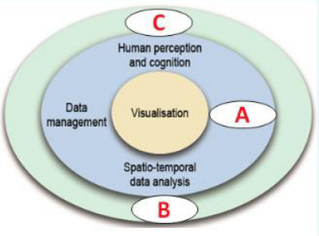
    - Data Mining
    - Evaluation
    - Infrastructure
    - Management
    - Planning
    - Virtual Reality
    - Workflow
  - 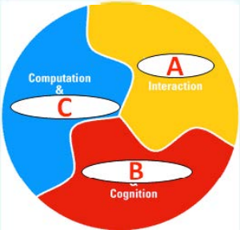
    - Evaluation
    - Human Perception
    - Mining
    - Process Mining
    - Visualizallon
    - Workflow Management
- The visual analytics Mantra reads as
  - analyze first, show the important, zoom filter & analyze, then details-on-demand
  - show the important, zoom filter & analyze, analyze first, then details-on-demand
  - zoom filter & analyze, analyze first, details-on-demand, then show the important
- Selected goals of Visual Analytics are designing and creating methods to enable users
  - detect the expected and discover the unexpected
  - merge images in an efficient way
  - provide timely, defensible, and understandable assessments
  - render realistic images in an expressive way
  - synthesize information and derive insight from massive, dynamic, ambiguous, and often conflicting data
- Guidance is
  - a computer-assisted process that aims to actively resolve a knowledge gap encountered by users during an interactive Visual Analytics session
  - a computer-assisted process that aims to harmonize heterogeneous information sources
  - A computer-assisted process that aims to interplay argument mining and visualization
  - a computer-assisted process that aims to intertwine machine learning and visualization
  - a computer-assisted process that aims to investigate the expressiveness and effectiveness of Visual Analytics solutions
  - a computer-assisted process that aims to merge multivariate networks and text
  - a computer-assisted process that alms to ease data quality exploration
- VISSECT - Activity Recognition by Visual Analytics enables
  - enables visual exploration and interplay analysis of visual exploration of trail-and-error procedures.
  - visual exploration and interplay analysis of parameters and segmentation and labeling algorithms
  - visual workflow management
- Eva interlinks
  - bar chart, line chart, parallel coordinates, scatter plot, row charts, and a table
  - heatmaps, parallel coordinates, scatter plots, networks, maps, and time lines
  - maps, line chart, parallel coordinates, scatter plot, row charts, and networks
- Visual Analytics - Process (Kelm, et al. 2008): Assign the correct terms to A and B (In red letters)
  - 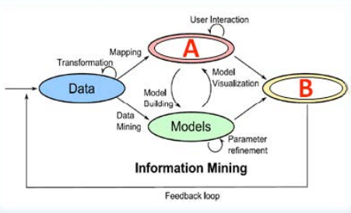
    - Guidance
    - Knowledge
    - Statistics
    - Visualization
  - 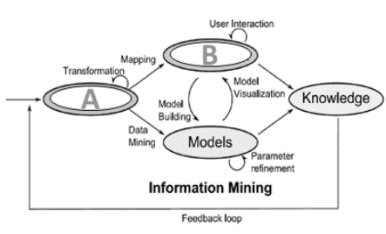
    - Data
    - Guidance
    - Information Retrieval
    - Visualization
- A good design to identify outliers in one-dimensional periodic time series data uses the following plots: line plot and cycle plot side by side
- Which of the following tasks require the highest level of interactivity in a visualization system, such as filtering certain data items, zooming to a specific range, showing details on demand: Exploration/explorative analysis (undirected search to get insight into the data, come up begin extracting relevant information, with hypothesis, etc)

