Questions for Information Economics 2018

### Login
http://www.econ.tuwien.ac.at/hanappi/Lehre/L035HH18.html
Username: student
Password: HH
###

1. How did Charles Babbage solve the difficulty of his difference engine that occurs if a sum passes 9? Which professorship did Babbage finally win? 5
2. What were the three qualities that Ada Lovelace considered to be her most important characteristics? Did she program the difference engine? 6
3. Discuss Shannon’s view that ‘pattern equals redundancy’. What was ‘Shannon’s maze’? 6
4. Compare Turing’s results (using the Turing computer) with Gödel’s result on Decidability. 7
5. Discuss the differences between Norbert Wiener and Claude Shannon with respect to the concept of entropy. 7
6. What is the von Neumann architecture of a computer? 8
7. Define: The different types of variables in an economic model (include examples and distinguish stocks and flows). The different types of equations in an economic model (include examples). 9
8. Discuss: With the help of a Tinbergen Diagram the difference between static and dynamic models. The role of econometrics in economic modelling. 10
9. Explain the use of exponential functions in economic models and give an economic interpretation of Euler’s e. 11
10. Distinguish the use of discrete time models and continuous time models and state some advantages and disadvantages (include an example). 11
11. Discuss the rate of growth of a combination of functions (see Chiang chapter 10). 12
12. Construct a simple economic supply-demand model and discuss its stability. 13
13. What is the role of expectations in a simple economic supply-demand model? Introduce three different expectation formation processes and show their stability properties. 14
14. Construct a simple macroeconomic model including a consumption function, an investment function, a tax function, an import function, an export function, and an equilibrium condition. Discuss the shortcomings of such a model. 15
15. Derive the concept of information content with a simple binary search example. 16
16. Which five plausible axioms should be fulfilled by a function that describes information content dependent on event probability only? 17
17. What is the axiomatic approach? Describe advantages and short-comings. 17
18. Define information gain and use examples to discuss self-fulfilling prophecies as well as self-destructing prophecies. 18
19. How can the measurement of income distribution according to Theil be accomplished? Is this a useful measure? 19
20. Provide a short summary of Shannon’s seminal paper ‘A Mathematical Theory of Information’; use his schematic diagram (figure 1). 20
21. Describe the development of the world income distribution. To which extent should equality be a goal of economic policy? What are the difficulties and can they be overcome? 21
22. Is information a commodity? Expand the view of Robert Babe and give your personal view. 21
23. How does George Stiegler argue to determine the price of a commodity given different prices and search? 22
24. What is “moral hazard” and “adverse selection”? Provide examples. 22
25. Discuss the fundamental difference between a market process and a communication process, following Robert Babe. Give examples where the two processes are mixed up. 23
26. Explain the concept of information that C. Weizsäcker put forward, using ‘form’, ‘matter’, and ‘language’. Can information be measured if this concept is accepted? 23
27. Give your view on the discussion of endowment/prices (Walrasian approach) versus reversibility (theoretical physics) in the Smith-Foley paper. 24
28. What is entropy? 25
29. What is cognition? Give examples for the mind as a fast-pattern completer. (compare Brian Arthur) 25
30. Does the formation of associations in the education of economists produce prejudices? (compare Brian Arthur) 26
31. How did evolutionary approaches in biology stimulate the application of computer simulation in economics? How did Richard Nelson and Sidney Winter contribute to this development? 26
32. Characterize briefly why network theory and game theory were asking for simulation approaches. 27
33. Describe three important features of an agent-based model (according to [Hanappi,2017]). 27
34. What are the 7 steps of a recipe for constructing an ABM? 27
35. How can the concept of intelligence be understood in the context of agent-based modelling? (refer to the Chen & Wang paper) 28
36. What is modularity and why is it important for simulations. How large should modules be, and what limits the number of modules (from below, and from above)? 29
37. Discuss the relationship between simulation methods and evolutionary theory referring to (Hanappi, 2013b). 29
38. Debate some special properties of formalization by algorithmic languages as compared to standard mathematics referring to (Hanappi, 2011). What is ‘truth’? 30
39. Explain the term ‘substitution type of puzzle’ used by (Turing, 1954). Are there unsolvable decision problems, and if so, why is this important? 30
40. What is computational complexity (see (Newman, 2010, chapter 9))? 31
41. Give your thoughts on the project of John von Neumann and Oscar Morgenstern to produce a new formal language for the social sciences (Game Theory). Use (Hanappi,2013a). 31
42. What was Schrödinger’s motive to write his book ‘What is life?’? 32
43. Is Artificial Life as described by Farmer & Belin a desirable vision? Compare Lamarck’s hypothesis to Darwinian evolution. 32
44. What does the statement of Stuart Kauffman that ‘order can emerge at the edge of chaos’ mean? 34
46. What is mechanism design? Describe the Groves mechanism. 34
47. What are the economic implications of the availability of ‘big data’? 35
48. Distinguish between correlation and causality. How can the difference be bridged? 36
49. What is cognition? What are in your view the essential points in Brian Arthurs paper on cognition? 36
50. Give a brief description of the ‘small world structure’ of a network. Has human language such a structure? 36

1. How did Charles Babbage solve the difficulty of his difference engine that occurs if a sum passes 9? Which professorship did Babbage finally win?
Long:
Babbage made a system of figure wheels. All the wheels were marked with the numerals 0 to 9, placed along an axis to represent the decimal digits of a number: the units, the tens, the hundreds and so on. The wheels would also have gears and the gears along each axis would mesh with the gears of the next, to add to the successive digits. The problem was when one gear went to the number 9 and then a next digit would need to be added.

To manage this, Babbage placed a projecting tooth on each wheel between 9 and 0. The tooth would push a lever which would in turn transmit its motion to the next wheel above.

He won a university post at Cambridge: Lucasian Professorship of Mathematics, formerly occupied by Isaac Newton.

Short:
Babbage placed a projecting tooth on each wheel between the 9 and 0. The tooth would push a lever, which would in turn transmit its motions to the next wheel above.

The problem was that when any sum passed 9, then a unit had to be carried to the next decimal place. To manage this, Babbage placed a projecting tooth on each wheel between 9 and 0. The tooth would push a lever which would in turn transmit its motion to the next wheel above.

He won a university post at Cambridge: Lucasian Professorship of Mathematics, formerly occupied by Isaac Newton.

Notes:
* Triangular numbers are the sums of the first n whole numbers (e.g 1,3(1+2), 6(1+2+3), 10 (1+2+3+4), 15(1+2+3+4+5), 21, 28 and so on).
* Elie de Joncourt wrote that in 1762 registering 19999 first triangular numbers.
* Any triangular number can be generated with this formula: multiply n by n + 1 and divide by 2
* n*(n+1) / 2
* The problem with common logarithm tables (to help people do mathematical calculations faster) was that they were full of mistakes.
* Babbage formulated the idea that only by mechanical fabrication of tables such errors can be rendered impossible
* The structure was to compute differences between one sequence and another
* The machine was based on “calculus of finite differences”
* Reduced high-level calculus to simple addition.
* He then named the machine "Difference Machine"
* He first offered the table of triangular numbers
* He made tables of differences for example to triangular numbers:
| # of the grp | # of the sum in each grp | 1st difference | 2nd difference |
| ------------ ------------------------ -------------- ---------------
| 1 | 1 | 1 (1-0) | 1
| 2 | 3 | 2 (2-1) | 1
| 3 | 6 | 3 (3-2) | 1
| 4 | 10 | 4 (4-3) | 1
* Another table was for table of third differences (also the column 3 in pascals triange)
* The difference engine would run this process in reverse instead of repeated subtraction to find the differences, it would generate a sequence of numbers by a cascade of additions.

2. What were the three qualities that Ada Lovelace considered to be her most important characteristics? Did she program the difference engine?

- First, she considered that, owing to some peculiarity in her nervous system, she had “perceptions of some things, which no one else has—or at least very few, if any”. She meant that she had “an intuitive perception of hidden things”.
- Seconds, she considered that she had “immense reasoning faculties”.
- And third, she had the faculty “The power not only throwing my whole energy and existence into whatever I choose, but also bring to bear on any one subject or idea, a vast apparatus from all sorts of apparently irrelevant and extraneous sources. I can throw rays from every quarter of the universe into one vast focus.”

Lovelace did not program the difference engine. Charles Babbage designed that engine and Ada Lovelace was fascinated with the machine. The DIfference engine first got manufactured a long time later.

3. Discuss Shannon’s view that ‘pattern equals redundancy’. What was ‘Shannon’s maze’?
Every language has some kind of pattern. This, Shannon saw it, equals redundancy. For example, in English, wherever the letter q appears, the u that follows is redundant. This redundancy can be seen in two ways:
- We can reduce the message without losing any information.
- If we don't vanish recognizable patterns, a code breaker can easily look for a recurring pattern that might match common words or letter combinations.

“Shannon’s maze” was a five by five grid, and any partitions could be placed around between any of the twenty-five squares to make maze in different configuration.
The maze was a sensing rod driven by a pair of little motors, one for east-west and one for north-south. Under the hood lay an array of electrical relays, about seventy-five of them, interconnected, switching on and off to form the robots “memory”. The rod had the goal to reach the destination. If the rod hit a partition, the motors reversed and the relays recorded the event. The machine made each decision based on its previous knowledge. If the rod was placed into an already discovered area, it could find the goal without making any wrong turns.

Notes:
https://www.youtube.com/watch?v=vPKkXibQXGA

4. Compare Turing’s results (using the Turing computer) with Gödel’s result on Decidability.
Gödel showed that mathematics could not be both complete and consistent. But he
had not definitely answered if mathematics is decidable or not.
But Turing computer (an imaginary machine) led him to a proof parallel to Gödel. He went even further by defining the general concept of a formal system, by proving that any formal system must have undecidable propositions. Mathematics its not decidable. Incompleteness follows from uncomputability.

5. Discuss the differences between Norbert Wiener and Claude Shannon with respect to the concept of entropy.
Shannon's entropy measures the information contained in a message as opposed to the portion of the message that is determined (or predictable).

Wiener considered entropy as the physical functioning of the living individual and the operation of some of the newer communication machines are precisely parallel in their analogous attempts to control entropy through feedback.

Notes:
Entropy is defined in the context of a probabilistic model. Independent fair coin flips have an entropy of 1 bit per flip. A source that always generates a long string of B's has an entropy of 0, since the next character will always be a 'B'.

The entropy rate of a data source means the average number of bits per symbol needed to encode it. Shannon's experiments with human predictors showed an information rate between 0.6 and 1.3 bits per character in English.

From the preceding example, note the following points:
The amount of entropy is not always an integer number of bits.
Many data bits may not convey information. For example, data structures often store information redundantly, or have identical sections regardless of the information in the data structure.

6. What is the von Neumann architecture of a computer?

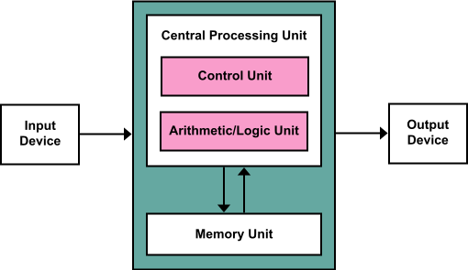

The Von Neumann Architecture is a computer architecture based on the 1945 description by John von Neumann and others in the First Draft of a Report on the EDVAC.

It describes a design architecture for an electronic digital computer with parts consisting of a processing unit containing:
- an arithmetic logic unit and processor register
- a control unit containing an instruction register and program counter
- a memory to store both data and instructions
- External mass storage
- Input and output mechanisms

It is a stored-program digital computer, this means it keeps data and program instructions in RAM.

Basically, Von-Neumann-Architectures is the architecture how modern computers work.

Notes:
- Earlier computing machines had fixed programs. Like calculators. If the program should have been changed a rewiring of the whole machine needed to be done
- With the proposal of stored-program digital computer (Von Neumann Architecture) this problem changed.
- A computer like this includes, by design, an instruction set and can store in memory a set of instructions (a program) that details the computation.
- Some high level languages such as LISP leverage the von Neumann architecture by providing an abstract, machine-independent way to manipulate executable code at runtime, or by using runtime information to tune just-in-time compilation (e.g. in the case of languages hosted on the Java virtual machine, or languages embedded in web browsers).

7. Define: The different types of variables in an economic model (include examples and distinguish stocks and flows). The different types of equations in an economic model (include examples).
Economic models are used by economists to communicate current economic conditions - causes and effects on the future of the economy.

Variable is something whose magnitude can change, i.e., something that can take on different values. Variables frequently used in economics include price, profit, revenue, cost, national income, consumption, investment, imports, and exports.

Flow variables refer to variables that are measured over a period or per unit of time. The time can be whatever it is defined as in the system that is being measured. It could be hours, days, weeks, months, or years.
Examples of flow variables include income, budget deficits, investment expenditure, sales revenue and gross profit. When thinking about these variables, these are things that change frequently and may have substantial rates of changes over time as well as large amounts of change over time. Income, both on the national level and on the individual level, is a flow variable. National income is earned as a flow over a year. The individual earns personal income over the course of the pay period, which may be a week, two weeks or a month.

Stock variables, on the other hand, mean those variables that are measured at a point in time. At any given time as we measure our system, we may take a snapshot, so to speak, of variables such as debt, wealth, employment, money supply and capital stock (such as factories, inventory and infrastructure).

Three types of equations:
- Definitional
- Behavioral
- Conditional

Definitional:
Set up an identity between two alternate expressions that have exactly same meaning. For example total profit is defined as the excess of total revenue over total cost:

Behavioral
Specifies the manner in which a variable behaves in response to changes in other variables. This may involve human behaviour or nonhuman. It can be used to describe the general institutional setting of a model including the technological and legal aspects.

Conditional:
States a requirement to be satisfied. For example, in a model involving the notion of equilibrium we must set up an equilibrium condition.

8. Discuss: With the help of a Tinbergen Diagram the difference between static and dynamic models. The role of econometrics in economic modelling.
Difference static dynamic models → ?

The role of econometrics in economic modelling
Models play a major role in all econometric studies, whether theoretical or applied. Defining econometrics as the branch of economics concerned with the empirical estimation of economic relationships, models, together with data, represent the basic ingredients of any econometric study.

The investigation of economic and econometric models indicates that there is a wide range of models and applications. There are many approaches to modeling, and even in the standard linear stochastic algebraic model of econometrics there are many alternative specifications available. These models have been applied in many different areas - in fact, in virtually all areas of economics and in some related social sciences. The models have been used for various purposes, including structural analysis, forecasting, and policy evaluation.

9. Explain the use of exponential functions in economic models and give an economic interpretation of Euler’s e.
Exponential functions, as well as the closely related logarithmic functions, have important applications in economics, especially in connection with growth problems, and in economic dynamics in general. The particular application relevant to the present part of the book, however, involves a class of optimization problems in which the choice variable is time. For example, a certain wine dealer may have a stock of wine, the market value of which is known to increase with time in some prescribed fashion. The problem is to determine the best time to sell that stock on the basis of the wine-value function, after taking into account the interest cost involved in having the money capital tied up in that stock. Exponential functions may enter into such a problem in two ways. First, the value of the wine may increase with time according to some exponential law of growth. In that event, we would have an exponential wine-value function. Second, when we consider the interest cost, the presence of interest compounding will surely introduce an exponential function into the picture.

An Euler equation is an intertemporal version of a first-order condition characterizing
an optimal choice as equating (expected) marginal costs and marginal benefits.

Notes:
Chiang_2005_Chpt-10.pdf - Page 255

10. Distinguish the use of discrete time models and continuous time models and state some advantages and disadvantages (include an example).
In mathematics and in particular mathematical dynamics, discrete time and continuous time are two alternative frameworks within which to model variables that evolve over time.

Discrete time views values of variables as occurring at distinct, separate "points in time", or equivalently as being unchanged throughout each non-zero region of time ("time period") - that is, time is viewed as a discrete variable. E.g., the size of an insect population in year X.

In contrast, continuous time views variables as having a particular value for potentially only an infinitesimally short amount of time. Between any two points in time there are an infinite number of other points in time. The variable "time" ranges over the entire real number line, or depending on the context, over some subset of it such as the non-negative reals. Thus time is viewed as a continuous variable. E.g., the change of the amount of liquid in a tank over time.

Discrete time models - advantages:
- Computers work in discrete
- Empirical (real-life) data comes in discrete forms
- Needs only algebra (most of the time)

Continuous time models - advantages:
- Can be used to approximate discrete time models
- More mathematical tools are available for continuous models

Notes:
continuous or discrete?
1. experimental data is discrete, but large amount of data is almost continuous
2. more mathematical tools are available for continuous model, computer can only analyze discrete model
3. continuous model can be discretized, and discrete model can be approximated by continuous one
4. continuous model needs calculus, discrete model needs only algebra (most of the time)

11. Discuss the rate of growth of a combination of functions (see Chiang chapter 10).
The instantaneous rate of growth of a product is the sum of the instantaneous rates of growth of the components.

Example: Compound interest effect in investing. This is a prime example of exponential growth where the rate of growth is the sum of the previous rates of growth.

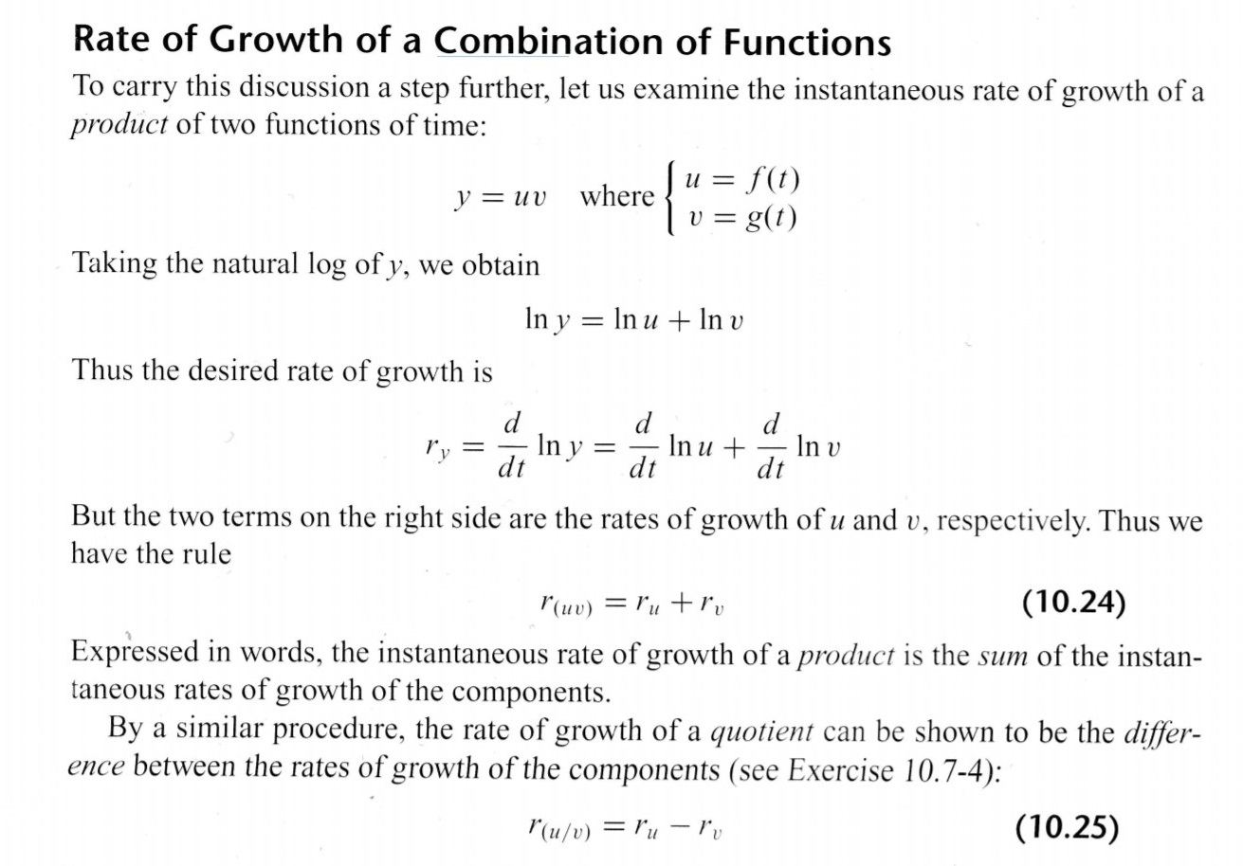
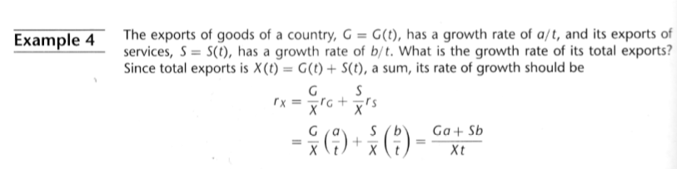

12. Construct a simple economic supply-demand model and discuss its stability.
Simple economic supply-demand model is a model of price determination in a market. It postulates that, holding all else equal, in a competitive market, the unit price for a particular good, or other traded item such as labor or liquid financial assets, will vary until it settles at a point where the quantity demanded (at the current price) will equal the quantity supplied (at the current price), resulting in an economic equilibrium for price and quantity transacted.

Changes in market equilibrium: Practical uses of supply and demand analysis often center on the different variables that change equilibrium price and quantity, represented as shifts in the respective curves. Comparative statics of such a shift traces the effects from the initial equilibrium to the new equilibrium.

When consumers increase the quantity demanded at a given price, it is referred to as an increase in demand. Increased demand can be represented on the graph as the curve being shifted to the right.

If the demand decreases, then the opposite happens: a shift of the curve to the left.

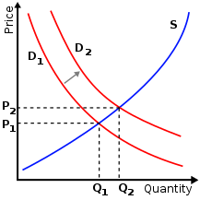

13. What is the role of expectations in a simple economic supply-demand model? Introduce three different expectation formation processes and show their stability properties.
Expectations describe the behaviour of the entrepreneur
- Which amount they are willing to supply and at which expected price
- Which price they are expecting depends on the manner in which they process information of previous periods

Naive expectations
That is, the prediction equals the last observed price: p^e = p_(t-1). This model does not allow any learning of the participants.

Adaptive expectations
The expected price is adapted in the direction of the most recently observed actual price p_(t-1) with the expectations weight factor w. This more refined expectation process leads to higher stability compared to naive expectations. Problem: only backward looking.

Rational expectations
Makes use of all available information. Producers subjective expectations price equals the objective conditional mathematical expectation of the market price. Production volatility and price volatility are minimized.

Notes:
// FROM CSS EXERCISE //
- Cobweb Expectation
assumes that the expected price is the same as the (realized) price of the previous period.
The equilibrium price p^E is determined by the parameters of the demand and supply function. Fluctuations around it will additionally depend on the initial distance from equilibrium (p0 - p^E).
- Natural Expectation
assumes that the expected price is the same as the (realized) price of the previous period, corrected by a percentage of deviation from a “naturally” expected price 𝑝.
If this price, which is regarded as natural, is indeed the real equilibrium price, we can immediately see that the model is more stable.
- Adaptive Expecations
assumes that the expected price is the same as the (realized) price of the previous period, corrected by a percentage of the expectation error of the previous period.
Since this condition is less strict than the one from case 1, this more refined expectation process also leads to higher stability.
- 2nd Order Expectations
finally shows how the expectation process could be formulated as a 2nd order difference equation: the price developments of the last two periods are used for the prognosis.
As the following diagram indicates, this results in a specific range for the three parameters where the model will be stable.

14. Construct a simple macroeconomic model including a consumption function, an investment function, a tax function, an import function, an export function, and an equilibrium condition. Discuss the shortcomings of such a model.
The IS-LM model, which stands for "investment-savings, liquidity-money," is a Keynesian macroeconomic model that shows how the market for economic goods (IS) interacts with the loanable funds market (LM) or money market. It is represented as a graph in which the IS and LM curve intersect to show the short-run equilibrium between interest rates and output.

IS curve:
In turn, total demand (Y^{d}) can be broken up into the sum of consumption demand, investment demand, government demand, and net foreign demand:
Y^{d} (Y, r) = C^{d} + I^{d} + G^{d} +NX^{d}
where NX stands for net exports (that is, exports minus imports), so how much more foreign countries demand from us than we demand from them. C is aggregate consumer spending (a difference between disposable income and taxes), I is planned investments, and G is government spending.

LM curve:
The LM curve tells you all combinations of Y and r that equilibrate the money market, given the economy’s nominal money supply M and price level P. That is, the LM curve is the set of all Y and r combinations that satisfy the money market equilibrium condition, real money demand must equal the given real money supply:
M^{d}(Y,r) =M/P

Shortcomings:
(a) It is a comparative-static equilibrium model. It ignores the time-lags which are important in examining the effects of economic policy changes.
(b) It has been called the fix-price model. The model does not enable us to examine the effects of changes in aggregate demand on both output and prices. If we take the Keynesian version of the model, then we have to assume a constant price level and so we cannot analyse the problem of inflation. On the other side, if we take the neoclassical version of the model, which applies when full employment is reached the price level is determined by the nominal money supply and output is assumed to be determined exogenously.

15. Derive the concept of information content with a simple binary search example.
Binary search is one of the most basic algorithms to look for an element. Having a sorted list of comparable elements and a target element, binary search looks to the middle of the list and compares the value with the target element. If the value is not the target element, we repeat with the smaller or higher half of the list, depending on the target element being lower or higher than the observed one.

We can use such an algorithm to make yes/no questions and gain information by doing so. For example, consider someone draws a king of diamonds from a deck and we want to know which card it is. We can proceed as follows: Is the card black? No. Is the card a heart? No. Is the card 7 or higher (using ace as value 1)? Yes. And so on and so on.
With each step, we gain information about the actual value. This allows us to “sample” the random variable (which is in this case the drawn card). This allows to retrieve the information content.

16. Which five plausible axioms should be fulfilled by a function that describes information content dependent on event probability only?

- A 1 - h(x) only depends on the probability of an event
- A 2 - h(x) is a continuous function of x, 0<x<=1
- A 3 - h(0)=inf, h(1)=0
- A 4 - h(x) is monotonically decreasing (h(x1) > h(x2) if 0<=x1<x2<=1)
- A 5 - Additive in the case of independent events: h(x1x2) = h(x1) + h(x2) if 0<=x1<x2<=1) --> reason Logarithmic

17. What is the axiomatic approach? Describe advantages and short-comings.

Various approaches have been used to define the probability and few approaches among them have certain drawbacks when using them in real life applications. Broadly they can be divided into two categories, namely objective and subjective. The objective approaches rely on the priori knowledge of the experiment. The subjective approaches also rely on the priori knowledge of the experiment but it is subjective to the individual dealing with the experiment. Some individuals may have full knowledge of the experiment and some may have partial knowledge.

An axiomatic approach is taken to define probability as a set function where the elements of the domain are the sets and the elements of range are real numbers. If event A is an element in the domain of this function, P(A) is the customary notation used to designate the corresponding element in the range.

+On this basis, it is possible to construct a logically perfect structure of the modern theory of probability and at the same time to satisfy the enhanced requirements of modern natural science. The axiomatic development of mathematical theory of probability relies entirely upon the logic of deduction.

-you can only prove that a finite number of programs are elegant if you are using a fixed formal axiomatic theory.

/from Internet/
Axiomatic approach is a way of describing probability of an event. In this approach some axioms or rules are depicted to assign probabilities.

Example: Throwing Dice (what is the probability to get a pair of even numbers)
A = [(2,2),(4,4),(6,6)]
n(a) = 3
n(S) = 36 (S = sample)
P(A) = n(a)/n(S) = 3/36 = 1/12
We have an axiom that probability is calculated this way

18. Define information gain and use examples to discuss self-fulfilling prophecies as well as self-destructing prophecies.

/from: http://www.saedsayad.com/decision_tree.htm /
The information gain is based on the decrease in entropy after a dataset is split on an attribute. Constructing a decision tree is all about finding attribute that returns the highest information gain (i.e., the most homogeneous branches).

H(x0) – h(x1) = log(x1/x0) describes the information gain
●The numerical value of the information gain is positive when the conditional probability exceeds the climatological chance

●Information gain = change of information entropy from a prior state to a state that takes some info as given
●IG = Log(probability ex post/probability ex ante)
●Regarded as a measure of the value of the prediction.

A self-fulfilling prophecy occurs when the adoption of a belief affects behavior in such a way, that this belief becomes a reality. For example, stock market fluctuations: When it is predicted that a stock will go up or down, investors often react accordingly, either selling if it’s going down or buying if it’s going up. This behavior then causes the stock to change as predicted. If that prediction hadn’t been made, however, the stock would not have changed as it did. A self-defeating prophecy (self-destroying or self-denying in some sources) is the complementary opposite of a self-fulfilling prophecy: a prediction that prevents what it predicts from happening. the unintended consequences of a company announcing a future product, unaware of the risks involved or when the timing is misjudged, which ends up having a negative impact on the sales of the current product. This is often the case when a product is announced too long before its actual availability. This has the immediate effect of customers canceling or deferring orders for the current product.

19. How can the measurement of income distribution according to Theil be accomplished? Is this a useful measure?
In economics, income distribution is how a nation’s total GDP is distributed amongst its population. Income and its distribution have always been a central concern of economic theory and economic policy.

Theil invented the “Theil Index”, which is the same as redundancy in information theory, which is the maximum possible entropy of the data minus the observed entropy. It can be viewed as a measure of lack of diversity, isolation, inequality, etc.

A key feature of Theil Index is that it is fully decomposable, i.e. inequality may be broken down by population groups or income sources or using other dimensions, which can prove useful to policy makers. Another key feature is that researchers can choose a
parameter α that assigns a weight to distances between incomes in different parts of the income distribution.

Disadvantages are that results are not directly comparable across populations with different sizes or group structures, and that is it relatively mathematically complex.

http://eprints.lse.ac.uk/2288/1/Theil,_Inequality_and_the_Structure_of_Income_Distribution.pdf

20. Provide a short summary of Shannon’s seminal paper ‘A Mathematical Theory of Information’; use his schematic diagram (figure 1).
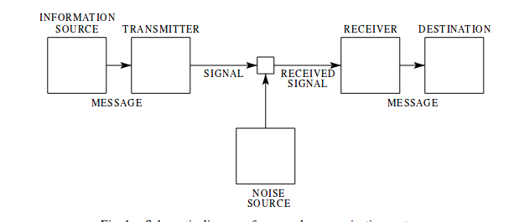

By a communication system we will mean a system of the type indicated schematically in Fig. 1.
It consists of essentially five parts:
1 an information source which produces a message or sequence of messages to be communicated to the receiving terminal. The message may be of various types: (a) A sequence of letters as in a telegraph of teletype system;(b) A single function of time f(t)as in radio or telephony;
2. A transmitter which operates on the message in some way to produce a signal suitable for transmission over the channel.
3. The channel is merely the medium used to transmit the signal from transmitter to receiver. It may be a pair of wires, a coaxial cable, a band of radio frequencies, a beam of light,etc.
4. The receiver ordinarily performs the inverse operation of that done by the transmitter, reconstructing the message from the signal
5. The destination is the person (or thing) for whom the message is intended.
We wish to consider certain general problems involving communication systems. To do this it is first necessary to represent the various elements involved as mathematical entities, suitably idealized from their 2 physical counterparts. We may roughly classify communication systems into three main categories: discrete, continuous and mixed.
We first consider the discrete case. This case has applications not only in communication theory, but also in the theory of computing machines, the design of telephone exchanges and other fields.

21. Describe the development of the world income distribution. To which extent should equality be a goal of economic policy? What are the difficulties and can they be overcome?
The evolution of the distribution of income among individuals within countries and across the world has been the subject of considerable academic and popular commentary in the recent past.The last few decades have seen a sharp increase in global integration with its attendant benefits and anxieties. Concerns about the distributional effects of cross-border flows of trade and finance have grown and are central issues in political debates worldwide. At the same time, massive global inequities, dysfunctional polities, and the most egregious outcrops of these-civil breakdowns and mass migration have become the staple of mass media.

Inequality is a key challenge and not only holds implications for economic growth and redistribution, but also translates into power asymmetries that can endanger democratization and human rights, engender conflict, and embed social exclusion so that chronic poverty persists. Extreme economic inequality is corrosive to our societies. It makes poverty reduction harder, hurts our economies, and drives conflict and violence. Reversing this trend presents a significant challenge. What we can do is we can:Stop Illicit Outflows, Enforce a Living Wage, The right of workers to organize, Open and Democratic Trade Policy, well-designed wealth taxes would go a long way towards combating extreme inequality. Etc.

22. Is information a commodity? Expand the view of Robert Babe and give your personal view.
The information commodity possesses some unique characteristics:
- “Satiation” occurs at one unit of information of any given type, since identical copies of the same information (the normal requirement for “commodity") are worthless unless the duplicates can be sold.
- How can someone determine whether it is worthwhile to obtain information? In other words: Information's value for the purchaser is not known until he has the information itself.
- Information is “indivisible,” which means that partial information can be useless.
- Since information can be reproduced at little or no cost while the cost at transmitting a given body of information is frequently very low. Information can be difﬁcult to appropriate; but capacity to be appropriated is a condition for commoditization. Market exchange entails, after all, the transmittal of property rights.

Due to this characteristics, the information market is very special.

Notes:
Information is by nature a heterogenous commodity. There is no single definition of information that embraces all aspects of the primary sector. Information cannot be collapsed into one sector - like mining - but rather the production, processing, and distribution of information goods a services should be thought as an activity

23. How does George Stiegler argue to determine the price of a commodity given different prices and search?
Since prices are continually in flux, Stigler advised there must exist at any given time and place ignorance as to what prices are. Buyers confronted with an array of prices for even homogeneous goods must “search” in order to find the lowest price. A search will entail a cost, but also will produce a benefit. The “value of information” in the face of this uncertainty, Stigler wrote, is “the amount by which the information reduces the expected cost to the buyer of his [sic] purchases” (pp. 183—184).Stigler concluded that the “optimal amount of search” would be found “if the cost of search is equated to its expected marginal return”.

24. What is “moral hazard” and “adverse selection”? Provide examples.
Moral hazard and adverse selection are two terms used in economics, risk management and insurance to describe situations where one party is at a disadvantage. Adverse selection occurs when there's a lack of symmetric information prior to a deal between a buyer and a seller, whereas moral hazard occurs when there is asymmetric information between two parties and change in behavior of one party after a deal is struck.

Adverse selection describes an undesired result due to the situation where one party of a deal has more accurate and different information than the other party.

Moral hazard occurs when a party provides misleading information and changes his behavior when he does not have to face consequences of the risk he takes.

I'm/from wikipedia/
Moral hazard
In economics, moral hazard occurs when someone increases their exposure to risk when insured. This can happen, for example, when a person takes more risks because someone else bears the cost of those risks.

Adverse selection:
Adverse selection is a term commonly used in economics, insurance, and risk management that describes a situation where market participation is affected by asymmetric information. When buyers and sellers have different information, it is known as a state of asymmetric information. Traders with better private information about the quality of a product will selectively participate in trades which benefit them the most, at the expense of the other trader.

25. Discuss the fundamental difference between a market process and a communication process, following Robert Babe. Give examples where the two processes are mixed up.

Robert E. Babe names the engaged participants "buyer" and "seller," and the elements bringing them together are called "commodities" and "money." These constituents, when combined and interacting, constitute a market. The communication scholar, on the other hand, names those engaged in communicatory processes "sender" and "receiver," and the elements bringing them together "messages" and "media of communication." When combined and functioning, these elements constitute a communication system. Both market and communication system are characterized by circular flow. However, these surface similarities obscure profound differences in the ways whereby the economist and the communication scholar approach and interpret their respective domains. Buyer and seller do not inform one another. Communication scholars, on the other hand, conceive sender and receiver as engaging in dialogic interaction. Communication, to them, comprises interpretation and signification. Messages are both sent and received in anticipation of subsequent response. Information, for communication scholars, is active, cumulative, and transformative.
These processes mix up in marketing strategies, where both the market and communication processes are mixed to get better results.

26. Explain the concept of information that C. Weizsäcker put forward, using ‘form’, ‘matter’, and ‘language’. Can information be measured if this concept is accepted?
According to Weiszäcker, there is consequently a productive or hermeneutic circle between language and information, language being a precondition of scientific thinking. Weizsäcker shows also that biological structures or even evolution itself can be conceived as a growth of forms measured as growth of information. Forms can be considered as potentially knowable which is what the second concept of information addresses. An organism can be understood as a product of genetic information. Weizsäcker calls these generative forms objectified semantics. Also he regards the concept of information as something that is different from matter and consciousness, because according to him information is just information.

Notes:
This “form” can refer to the form of all kinds of objects or events perceptible to the senses and capable of being shaped by man: the form of the printer’s ink or ink on paper, of chalk on the blackboard, of sound waves in air, of current flow in a wire.

27. Give your view on the discussion of endowment/prices (Walrasian approach) versus reversibility (theoretical physics) in the Smith-Foley paper.
Smith-Foley argue that measurements are always made in the context of some kinds of transformations, and the choices of transformations made in economics differ from those made in thermodynamics. They argue that “prices” are fundamentally different from temperatures or pressures at a practical level for two reasons:
- There is no counterpart in physics to the way neoclassical economists attach importance to transformations respecting initial endowments.
- Conversely, there seems to be no counterpart in economics to the importance thermodynamicists attach to reversible transformations.
An emphasis on reversibility extends the definition of equilibrium to transformations in a natural way, but is generally incompatible with making interesting statements about completely closed systems. On the other hand, transformations that assign consequences to initial endowments generally cannot be made reversibly, and in admitting irreversibility, a fundamental departure is made from the uniqueness properties of equilibria.

Notes:
In the Walrasian Approach, the different agents take only prices as signals, and decide on their plans on the basis of these. If the signals are appropriate the plans that the different agents make will be mutually compatible. Walrasian methods consider only that configuration where plans of agents are compatible and the only transactions that are made are those that match.

The basic point of departure from the Walrasian approach is that if markets do not clear, i.e. the plans are not mutually compatible, is there any way of devising constraints on transactions so that once these constraints are taken into account, the constrained transactions match?

https://drive.google.com/open?id=1-rbZSuYmE8r172vczdL3ieaJnDXK9tXE
https://www.cs.dartmouth.edu/~rockmore/Econ_Thermo_CSSS_08.pdf

28. What is entropy?

● Entropy was a central concept in information theory
● Theil introduced it in economics with the Theil-index, which is a measurement for economic inequality (such as the Gini coefficient).
● Furthermore, entropy is used in the following applications
○ Measurement of income inequality
○ Multidimensional welfare analysis
○ Tests of hypotheses and model selection
● In general useful goods and resources tend to be low entropy, and the economic process increases their entropy.
● concept of entropy for economics implies that activities should be encouraged that increase the entropy as least as possible, since this results in less costs on the future. Conserving low entropy = saying that we should minimize the use of inputs and minimize waste.

29. What is cognition? Give examples for the mind as a fast-pattern completer. (compare Brian Arthur)

/wikipedia/
Cognition is "the mental action or process of acquiring knowledge and understanding through thought, experience, and the senses". Brian Arthur thinks that our brains are “associative engines”. He states that “We're wonderful at association and in fact, in cognition, association is just about all we do. [...] We are fast-pattern completers.” He means that we associate things we perceive with things we know, and we do that fast, due to evolutionary reasons.
For example, economic agents look for ways to frame the situation that faces them. They associate temporary internal models or patterns to frame the situation. This happens step-by-step, i.e. as further evidence from the environment comes in, they may strengthen or weaken their beliefs in their current models or hypotheses.

http://tuvalu.santafe.edu/~wbarthur/Papers/Colander_Cognition_Web.pdf

30. Does the formation of associations in the education of economists produce prejudices? (compare Brian Arthur)
A great deal of education is the formation of associations; and the spectrum ranges from collections of narrow but precise theories on one side to wide but suggestive and imprecise pictures on the other. There are two types of associations according to Brian Arthur : experience and theory. theories are thin associations: the theory fits if a narrow and precise set of conditions is fulfilled; and the entailments are also narrow and precise.
Experience in the form of a wide collection of memories and pictures of situations, Its power lies in its width of coverage and its suggestiveness. But even though associations are a powerful source we still need to be cautious of them because, Premature association without going through the richness of a wide set of pictures may be disastrous. We need to be conscious of our associations and where they come from. We need to be suspicious of them. Because if we don't have all the information needed and if we don't know the history of economics then this can lead to the production of prejudices.

Notes:
We need both types of association: the theoretical, quantitative, precise frameworks and the dream-like, vivid pictures in their tens of thousands

31. How did evolutionary approaches in biology stimulate the application of computer simulation in economics? How did Richard Nelson and Sidney Winter contribute to this development?
Outside standard economic, theory economic simulation got a first boost from a completely different side. In biology, mathematical modelling and in particular game theory models began to be applied with increasing success (Smith,1982). Darwin’s idea of evolutionary dynamics was simulated by computer programs and the results were compared to the developments in actual biological populations. This inspired two economists, Sidney Winter and Richard Nelson, to use computer simulation to mirror market dynamics. Their ‘animals’ were firms and instead of by Darwinian traits, they were characterized by a set of ‘routines’ they used. Then, a simulation of market dynamics was used to study how the worst ‘routines’ were weeded out by some kind of ‘survival of the fittest’. This type of dynamic of economic processes never coming to rest in an equilibrium had been described by Joseph Schumpeter 70 years earlier (Schumpeter, 1911). Richard Nelson is a famous representative of standard microeconomics and worked for the inclusion of Schumpeter, a thought in economic theory. Nelson and Winter started an economic school of the same name, evolutionary economics (Nelson and Winter,1982). It still relies heavily on the techniques of computer simulation, today under the label of agent-based simulation. It is remarkable that with this type of methodological approach the meso level, situated between traditional micro-and macro level topics can emerge as a decisively important element of political economy.

32. Characterize briefly why network theory and game theory were asking for simulation approaches.
Some decades ago, analytic treatments were essentially the only tool available for understanding the behavior of theories and models. Today, however, we can go further and study the operation of theories and models explicitly by performing computer simulations. In addition to providing a useful check on solutions for various problems, such simulations also allow us to generate real examples of networks on our computer. We can then measure these networks to determine the values, within the model, of any network quantities we like - path lengths, correlations, clustering coefficients, and so forth - including ones for which we do not at present have an analytic solution.

For these reasons, ‘Games on networks’ as well as the evolution of networks in the form of dynamic games are part of a scientific sub-discipline that attracts an ever growing community of researchers.

33. Describe three important features of an agent-based model (according to [Hanappi,2017]).

- an agent’s structure has to be described by a program that is sophisticated enough to allow for the sequence:(i) perception,(ii) embedding in an internal model, (iii) choice of an action (including the action ‘communicate’);
- agents and the programs representing them will typically be different, i.e. the standard case of ABM will typically be heterogeneous ABM;
- there has to be a main program, which is not an agent, and which provides a description of the environment in which the agents can perceive and influence this environmental dynamics through their actions.

34. What are the 7 steps of a recipe for constructing an ABM?
Step 1: Choose a topic that is closed enough with respect to its environment to allow for an independent consideration of its internal dynamics.
Step 2: Identify the major agents in your model.
Step 3: Construct the internal models of the agents.
Step 4: Empirical data for all used variables has to be found.
Step 5: Econometric estimation and calibration of the suggested relationships.
Step 6: Software implementation of the model
Step 7: Systematic results generation by a large number of steadily improved simulation runs.

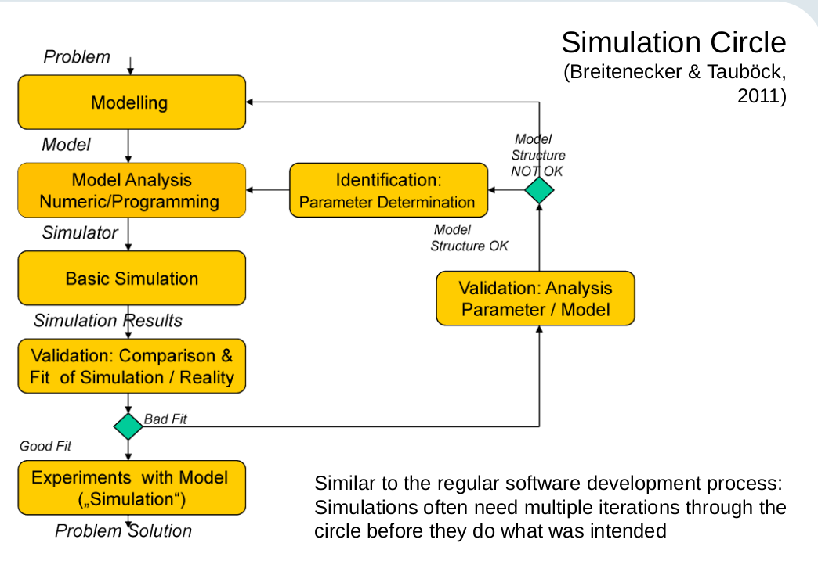

35. How can the concept of intelligence be understood in the context of agent-based modelling? (refer to the Chen & Wang paper)

Chen & Wang say that in prior work, agents were modelled with the same intelligence. This design principle obviously contradicts our understanding of human agents. If the society of software agents can reasonably reflect the dispersion of human intelligence, then any resultant social simulation would be of little help to us in gaining insights into the emergent complexities, such as the perplexing relationship between IQ and social development (Lynn and Vanhanen, 2002; Lynn, 2006). Therefore, designing software agents with heterogeneous intelligence is the next step in exploring the emergent complexities of agent-based computational economics.
Intelligence contains cognitive tasks, namely, the depth of reasoning, judgements and learning, and cooperation.

36. What is modularity and why is it important for simulations. How large should modules be, and what limits the number of modules (from below, and from above)?

[Chen & Wang, 2010]

Broadly speaking, modularity is the degree to which a system's components may be separated and recombined, often with the benefit of flexibility and variety in use.[1] The concept of modularity is used primarily to reduce complexity by breaking a system into varying degrees of interdependence and independence across and "hide the complexity of each part behind an abstraction and interface."[2] Hierarchy is a general principle of such modular structures, and hierarchical structures are considered as relatively stable. However, the concept of modularity can be extended to multiple disciplines, each with their own nuances. Despite these nuances, consistent themes concerning modular systems arise.[3]

IMPROVE second question

https://drive.google.com/open?id=17xQZekI_tjlQE3pUTx7T8nEBDA2zMbbR

37. Discuss the relationship between simulation methods and evolutionary theory referring to (Hanappi, 2013b).

/IMPROVE - [Hanappi, 2013b] /
Evolutionary theory is held together by two distinct elements: On the one hand it is the object of investigation – the emerging forms of life – that defines the scope of this scientific discipline, on the other hand the topic studied feeds back on the toolbox of methods, which the researchers in evolutionary theory use: there emerges an evolutionary research approach.

This evolutionary toolbox, can help - as the simulation methods - to understand the current revolution-loaded state of the global economy.

38. Debate some special properties of formalization by algorithmic languages as compared to standard mathematics referring to (Hanappi, 2011). What is ‘truth’?
‘Pure’ mathematics was identified as the profoundest of all sciences. In this view science resembles a discovery process with researchers rediscovering with experiments what the mathematical sign system predicts. The natural phenomena studied became nature, and finally were thought to be representative for everything outside the sign system of mathematics, they became equivalent to ‘reality’. Standard mathematical expressions also typically represent timeless tautologies.

Algorithmic languages transform these mathematical expressions into time consuming procedures represented as changes of electrical states of bit-strings. The fact is important that that in this language – contrary to standard analytical mathematics – time actually takes place.

In mathematical logic and algorithmic formalizations, a Boolean truth concept is used. But we need a more sophisticated concept of truth, being something measured on a continuous scale based on adequate perception. This contradicts the Boolean truth concept.

Notes:
Algorithmic languages attempt to go beyond this prevailing relationship - and this necessarily implied that not only the perception of the object of investigation changed, it rapidly became evident that the formal apparatus, the sign system itself had to change too.

39. Explain the term ‘substitution type of puzzle’ used by (Turing, 1954). Are there unsolvable decision problems, and if so, why is this important?

From[Turing_1954.pdf]
Another type of puzzle which we shall find very important is the 'substitution puzzle', In such a puzzle one is supposed to be supplied with a finite number of different kinds of counters, perhaps just black (A) and white (W. Each kind is in unlimited supply. Initially a number of counters are arranged in a row and one is asked to transform it into another pattern by substitutions. A finite list of the substitutions allowed is given. Thus, for instance, one might be allowed the substitution

Example:
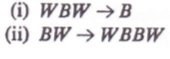
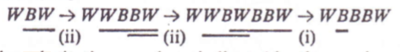
It will be seen that with this puzzle, and with the majority of substitution puzzles, one cannot set any bound to the number of positions that the original position might give rise to.

Yes. These are important, because we can reduce a problem to the unresolvable problem, to check if it is solvable or not.

40. What is computational complexity (see (Newman, 2010, chapter 9))?

From: [Newmann chapter 9]
Computational complexity is a measure of the running time of a computer algorithm. Consider a simple example: how long does it take to find the largest number in a list of zt numbers? Assuming the numbers are not given to us in some special order (such as largest first), then there is no quicker way to find the largest than simply to go through the whole list, item by item, keeping a running record of the largest number we have seen, until we get to the end.

41. Give your thoughts on the project of John von Neumann and Oscar Morgenstern to produce a new formal language for the social sciences (Game Theory). Use (Hanappi,2013a).

From: [Hanappi, 2013a]
For the Neumann-Morgenstern project it implies that the rule set for a formal language of social interaction might mimic a large amount of heterogeneous internal models, only partly stratified by communication and mass media, which nevertheless can lead to an aggregate behavior of the system that exhibits law-like features. A theory of such emergent properties thus is possible; indeed Schrödinger proposes that all theory even in the natural sciences is of precisely this type.

42. What was Schrödinger’s motive to write his book ‘What is life?’?
From: [Schrödinger, 1944].
Max Delbrück's thinking about the physical basis of life was an important influence on Schrödinger. From Delbrück's general picture of the hereditary substance it emerged that living matter is likely to involve 'other laws of physics', because it is not eluding the second law of thermodynamics - according to which all order in the universe tends to break down. Schrödinger’s key aim was to explain how living things apparently defy this second law of thermodynamics.

http://www.whatislife.ie/downloads/What-is-Life.pdf

43. Is Artificial Life as described by Farmer & Belin a desirable vision? Compare Lamarck’s hypothesis to Darwinian evolution.

From: [Farmer & Belin, 1990].
It is easy to imagine nightmare scenarios in which cold, malevolent machines or vicious genetically engineered creatures overwhelm humanity. Viewed in this way, artificial life becomes a threat to our survival to which we must respond, something that must be eliminated so that human beings can continue to prosper without competition.
We should, however, use care before automatically taking such a view. We may also surmise that this moment in cosmic history was arrived at through an evolutionary process of change which will replace us at the next moment. The natural order of evolution is change. No species has persisted forever .Individual species are altered and replaced through an evolutionary process of modification and succession that continually alters the composition of the flora and fauna of earth. There is no reason to believe that we are immune to this. It seems quite natural that we, too, will evolve and change with the passage of time, giving rise to new species in the genus homo. With artificial life this evolutionary change may not follow such a continuous path; although we give rise to new species, they may be our own direct conscious creations and radically different in form from we ourselves

We now have the possibility to create cultural and biological diversity. With the advent of artificial life, we may be the first species to create its own successors. If we succeed, they may be glorious, enlightened creatures that far surpass us in their intelligence and wisdom

Lamarckism:
- This theory states that there is an internal vital force in all organisms.
- It considers that new needs or desire produce new structures and change habits of the organism.
- According to this theory if an organ is constantly used it would be better developed whereas disuse of organ results in its degeneration.
- It does not consider struggle for existence.
- All the acquired characters are inherited to the next generation.
- Lamarckism does not believe in survival of the fittest.

Darwinism
- This theroy does not believe in the internal vital force.
- It contends that needs and/ or desires do not form part of Darwin’s natural selection theory.
- An organ can develop further or degenerate only due to continuous variations.
- Struggle for existence is very important in this theory.
- Only useful variations are transferred to the next generation.
- Darwin’s natural selection theory is based on survival of the fittest.​

Notes:
Darvin:
Darwinian evolution, a process of random mutation and natural selection. Under that process, small changes take place during the process of reproduction, producing random variations in the offspring. If these changes are not favorable then the offspring may die out. If these changes are favorable, however, then the offspring reproduce more frequently, passing these changes on so that they propagate. Only genetic information is transmitted. Acquired characteristics, such as good muscles developed through exercise or the wisdom acquired in one's lifetime, cannot be transmitted to subsequent generations directly. Darwinian evolution is the fundamental mechanism that has designed the flora and fauna of earth

Lamarck:
An alternate mechanism of biological evolution was postulated by Lamarck. He believed in the transmission of acquired characteristics to subsequent generations. He believed, for example, that if a giraffe stretched its neck and made it longer, then its offspring would have longer necks. We now know that this is not true for biological organisms. However, there is an important context in which it is true: the evolution of culture

44. What does the statement of Stuart Kauffman that ‘order can emerge at the edge of chaos’ mean?

* THIS IS ONE OF THE HARDER QUESTIONS
* It is generally impossible or know all of the points in a system
* This question is more of rhetorical one. Try to read about it and make your own mind
* The zone between order and disorder is called the "edge of chaos".

The term edge of chaos is used to denote a transition space between order and disorder that is hypothesized to exist within a wide variety of systems. This transition zone between the two regimes is known as the edge of chaos, a region of bounded instability that engenders a constant dynamic interplay between order and disorder.
Stuart Kauffman has studied mathematical models of evolving systems in which the rate of evolution is maximized near the edge of chaos.

45. Write down the simplest version of the definition of fractal dimension (according to Mandelbrot) and interpret it.

* Deterministic chaotic systems is a hit "fashion" these days
* Emerging phenomena have been studied only after 1962
* With different equation systems (without a stochastic term) you can create random results
* After this the research on differential equation systems exploded

fractal dimension is a ratio providing a statistical index of complexity comparing how detail in a pattern (strictly speaking, a fractal pattern) changes with the scale at which it is measured.

Fractal geometry is the study of the form and structure of a rough and irregular phenomena. Fractals are sets defined by three related principles:
- self -similarity
- Scale invariance
- Power law
When these principles converge fractal patterns form.

46. What is mechanism design? Describe the Groves mechanism.

* It is an inversion of game theoretic approach
* Inversion:
* In game theory we have players
* Players are optimizing outcomes using internal models
* There are internal models to the rules of the game
* like a card game: Players who want to win and the Q is who will win?
* can we devise optimal strategies?
* Example: game of rock, paper, scissors
* what is the optimal strategy of a player?
* Optimal strategy is to choose random result and try to find with that if you can find out a pattern (from the opponent)
* Rules of the game is fixed BUT strategy is to be optimized
* Mechanism design does the **inverse** method
* "I want the players to use this strategy, what rules I need to make for the players to use this strategy?"
* This is why mechanism design became important
* In a nutshell mechanism design is to devise and optimal strategy and with that optimal strategy you try to design the game so that players will follow that optimal strategy

47. What are the economic implications of the availability of ‘big data’?
- According to Hal Varian the technological advantages’ economic implications are a mixed bag.
- GDP might actually decrease since a lot of these “intangible” profits won’t be measured in the GDP (like money generated via advertisements)
- On the other hand every small store owner or even each person has access to more data than ever before
- Productivity of the human beings have already risen tremendously and it will just keep on growing
- Robotics and automation might take away some jobs but the decrease in costs of manufacturing products and/or services will decrease the prizes so overall the humankind will gain more prosperity

Big Data is beginning to have a significant impact on our knowledge of the world. This is important because increases in human knowledge have always played a large role in increasing economic activity and living standards. Continued improvements in the price and capacity of tools for collecting, transmitting, storing, analyzing and acting upon data will make it easier to gather more information and to turn it into actionable knowledge of how systems work.

48. Distinguish between correlation and causality. How can the difference be bridged?
Correlation suggests an association between two variables. Causality shows that one variable directly effects a change in the other. Although correlation may imply causality, that’s different than a cause-and-effect relationship. For example, if a study reveals a positive correlation between happiness and being childless, it doesn’t mean that children cause unhappiness. In fact, correlations may be entirely coincidental, such as Napoleon’s short stature and his rise to power. By contrast, if an experiment shows that a predicted outcome unfailingly results from manipulation of a particular variable, researchers are more confident of causality, which also denotes correlation.

49. What is cognition? What are in your view the essential points in Brian Arthurs paper on cognition?

29 & 30

50. Give a brief description of the ‘small world structure’ of a network. Has human language such a structure?
A small-world network is a type of mathematical graph in which most nodes are not neighbors of one another, but the neighbors of any given node are likely to be neighbors of each other and most nodes can be reached from every other node by a small number of hops or steps. Specifically, a small-world network is defined to be a network where the typical distance L between two randomly chosen nodes (the number of steps required) grows proportionally to the logarithm of the number of nodes N in the network, that is:

L ∝ log N (read as: number of steps required to go from node i to node j is proportional to the logarithm of the total number of nodes in the graph).

Mental example: Wikipedia’s Hitler Game (reaching the article on Adolf Hitler is possible from any random page, in less than 7 clicks).

Human language inherits all the statistical features of properties of complex networks and the SW structure is one of the easiest to identify. Words are nodes and they are connected via vertices. The more common the word is, the more vertices connect it to the rest of the graph.
#########################################################
* Small world hypothesis (examples):
* biologies
* cells
* food chains
* structures of the internet
* Brain research should find something about small world structures
* Small-world network is a mathematical graph where most nodes are not neighbours with eachother, but the neighbours of any given node are likely to be neighbours of eachother and most nodes can be reached from every other node by a small number of hops or steps.
* This results in a small world phenomenom of strangers being linked by a short chain of acquintances
* famous example: "six degrees of separation"
* all living things and everything else are six steps or less away from eachother
## Has human language such a structure?
* Short answer: YES
* Long answer:
* If all small-features derive from optimal navigation needs two predictions can be formulated:
1. Words' purpose is to speed-up communication (navigation)
2. deriving from the first, the existence of brain disorders characterized by navigation deficits in which such words are involved.
* In particular, the average distance between two words d (i.e. the average minimum number of jumps to be made from an arbitrary word to another) is shown to be d ~= 2-3, in spite human brain can store thousands).
* Sentences behave in a non-random way
* This means that language structures can be modeled
* this means that we can create graphs of words and their rate of occurence in sentences.
* this means that we can create a network of commonly used words and seldomly used words and draw connections between them
* = small world structure
* Graphs with Small World structure are highly clustered but d (average distance between two nodes) will be small

