Vorlesung 2012-05-08
Last time we showed every connect graph has a bidirectional double-tracing and every tree has ??.
If I have a connected graph I have a detachment which is a tree and even there we have a bi-directional double-tracing.

Algorithm Idea: Connected Graph, want to construct a closed covering walk (every edge traversed at least once) and end up where stated. Wieners algorithm was the first one: Historically the same time when Hierholzer's paper was published - but he died already. Wieners algorithm is modeled after the greek mythology (Theseus walk with arbritary ?). That gives you a certain global information: You know which walk you have performed already. Disadvantage: Certain edges can be traversed more than twice.
Frankel's algorithm: you need a counter to traverse any edge at most twice, some less than that.
Both algorithms give bidirectional double-tracing, choice of start node is irrelevant

Tremaux's algorithm:
Given connected graph G
Hypothesis: At any reached in the construction of walk W the number (number of traversals of e in the walk W up to the point where you reach W) is known for every e in .
Step 0: Set i = 0, choose . Set
Step 1: Beginning at walk along . Set where . Set i = i + 1.
Step 2: Suppose has ben constructed.
If v_i is not an end vertex + go to step 1. Otherwise go to Step 3.
(That can be decided: This is only the case if the lambda for the coming edge is 1 and all others 0.
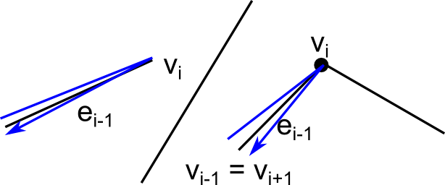
Step 3: ( is an end vertex OR for some j < i)
If > 1 go to step 4. If set and set . Set i = i+1, go to Step 4.
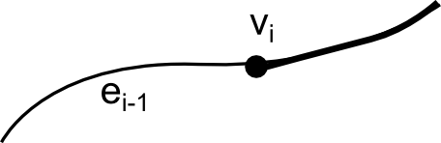
Step 4. If , go to Step 5. (Then you have performed a bidirectional double-tracing). Otherwise, choose with .
Define where if e is a loop, otherwise.

Set , i = i+1, go to Step 2.
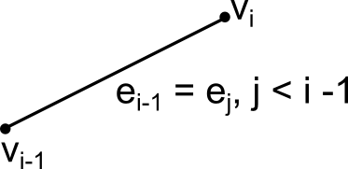
Step 5: W is a bidirectional double tracing.

No edge is traversed more than twice.

end vertex: (underlined equal!)

W' can be seen as obtained by Tremauxs algorithm operating on .
By induction W' is bidirectional double-tracing of is a bidirectional doubletracing of G.

If only 1 vertex: closed covering trail → trivial.
Conncected graph with one edge:
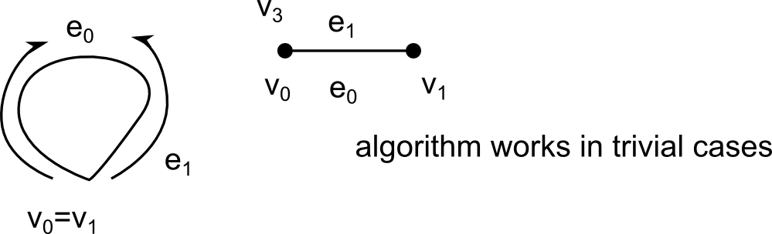

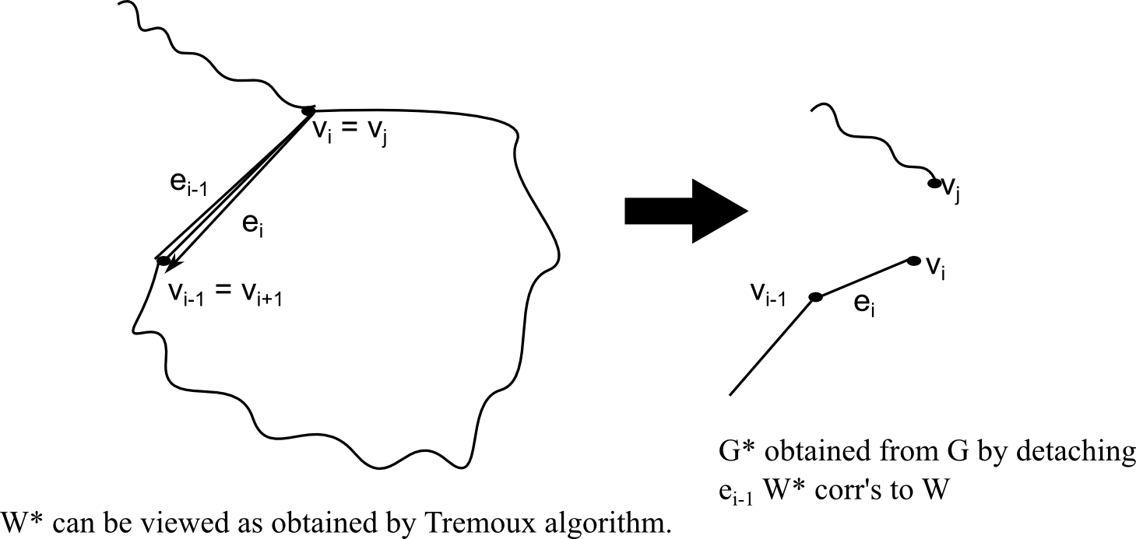
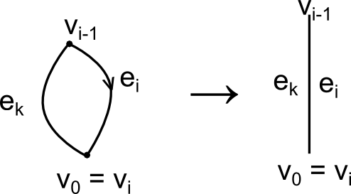
By induction: (delete in first) is bidirectional double-tracing in W is bidirectional doubletracing in G.
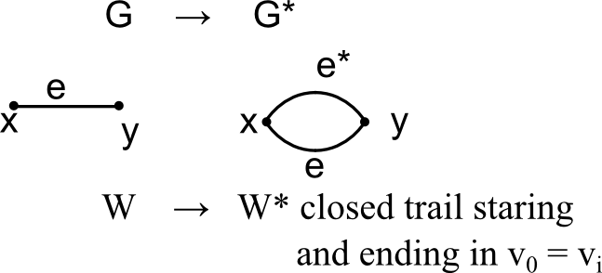
We can view W* like obtained by Hierholzer's algorithm. Consider

In W acts bidirectional in every edge [[deleted]of. Let , r > 0]
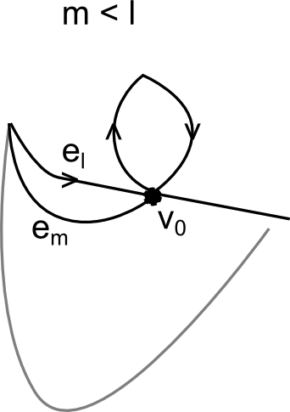
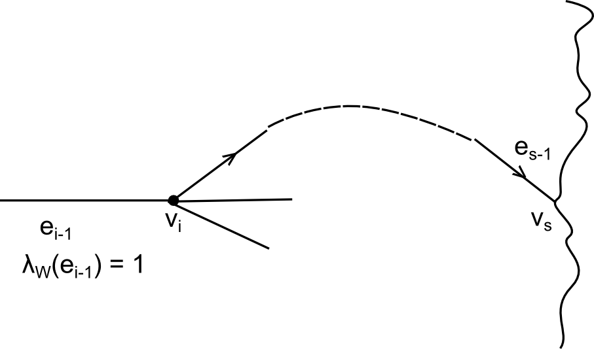
Ad Exercise
G = ...
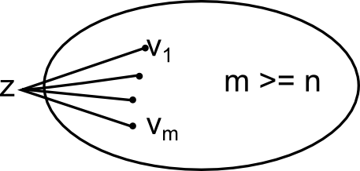
.

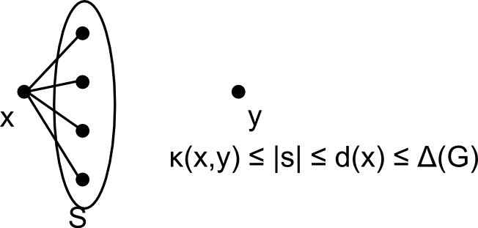
G simple,

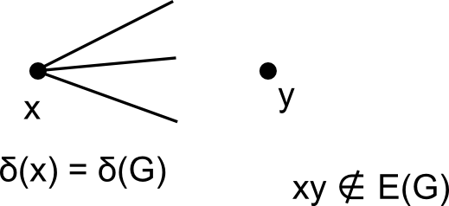

Vorlesung, 15.05 2012

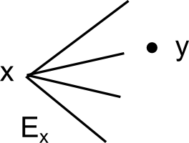
folgt aus der Definition: Lambda (G) ist immer Minimum über alle Knoten

6)
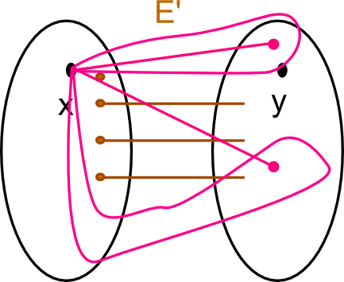
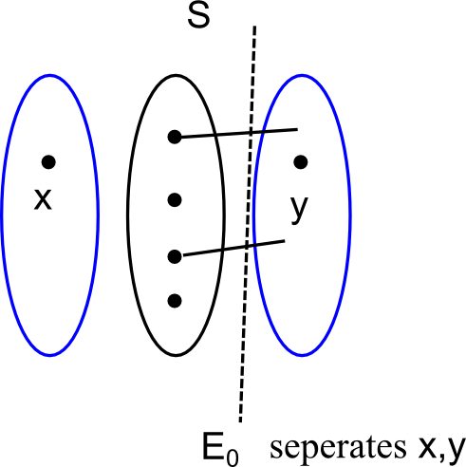
x,y indiff. components of G - S
(V purple),

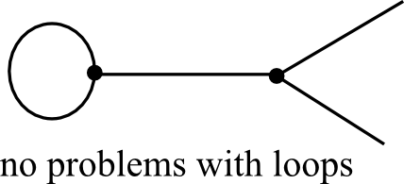

In case of a non-complete graph, is the minimum over all
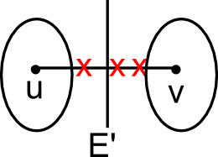

uv is smallest edge cut

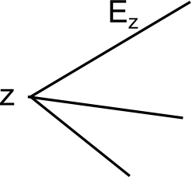
seperates z from other vertices in G

9) G nonseperable,
Suppose both have cut vertices

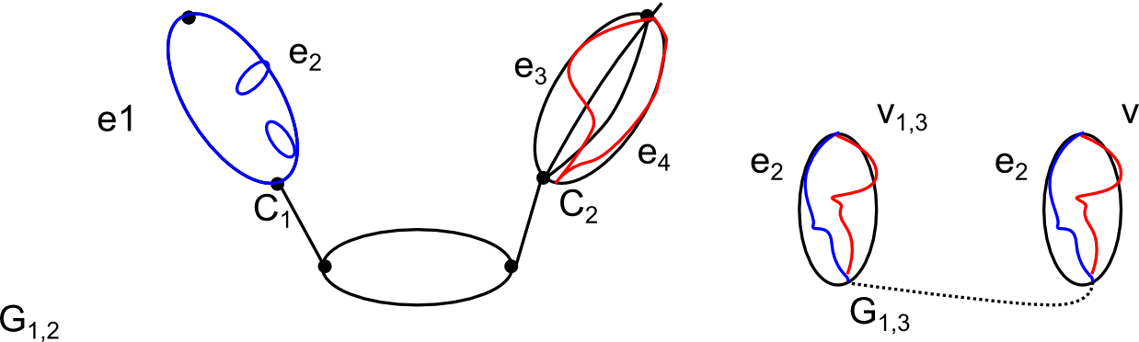

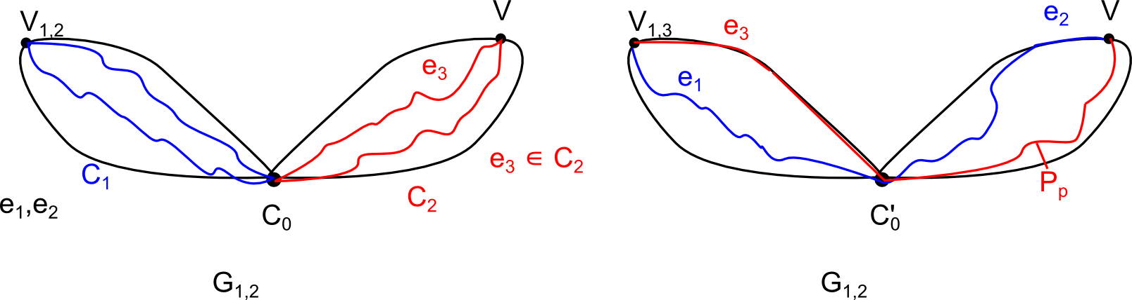

Exercise 10)
has bridges nonseperable
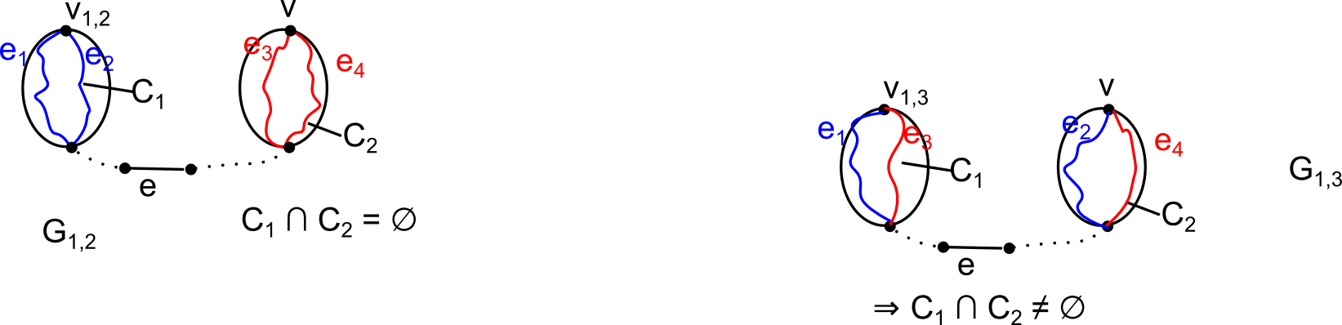

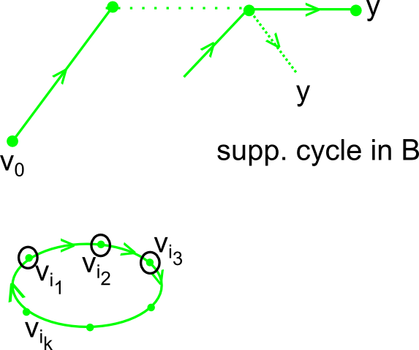
------
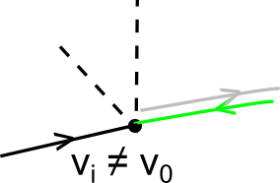
conn., acyclic Tree
Suppose cycle in B.
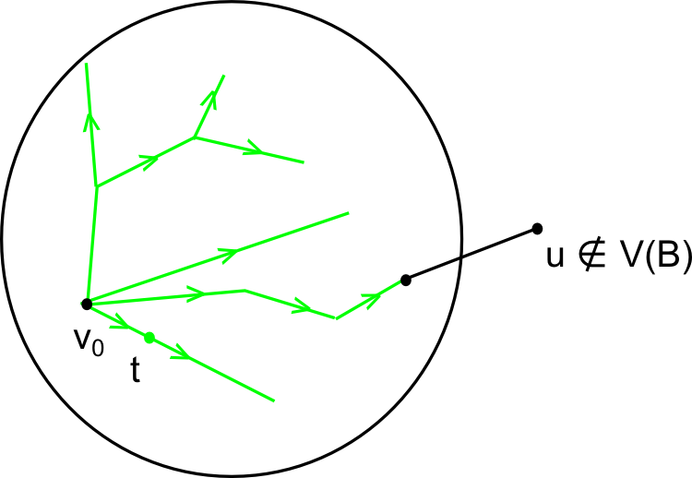

Suppose B not spanning

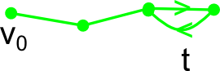

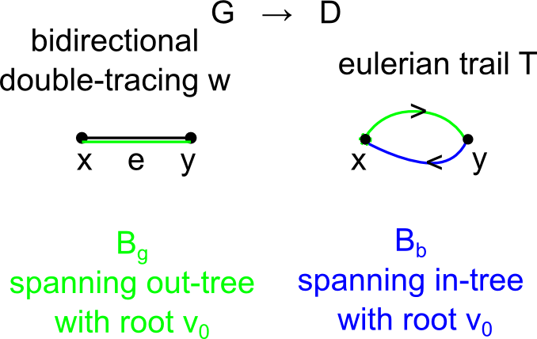
[Next meeting: next tuesday Besprechungsraum 186]

