04.05.2012
Proof of characterisation theorem in eulerian diagraphs.
For digraphs, we have absolutely analogous statement.
Theorem: (Characterisation Theorem for eulerian digraphs) (WH: eulerian: For every vertex: id(v) =od(v)) The following are equivalent for weakly connected digraphs D.
1)
2) D has an eulerian trail T (i.e. T is a closed covering trail of D)
3) D has a cycle decomposition
2→3 more or less trivial, 3 →1: At every vertex: If vertex is on cycle, the cycle contributes one unit to the in and one to the outdegree.
The only thing hard is 1→3.
Proof analagous to proof for graphs.

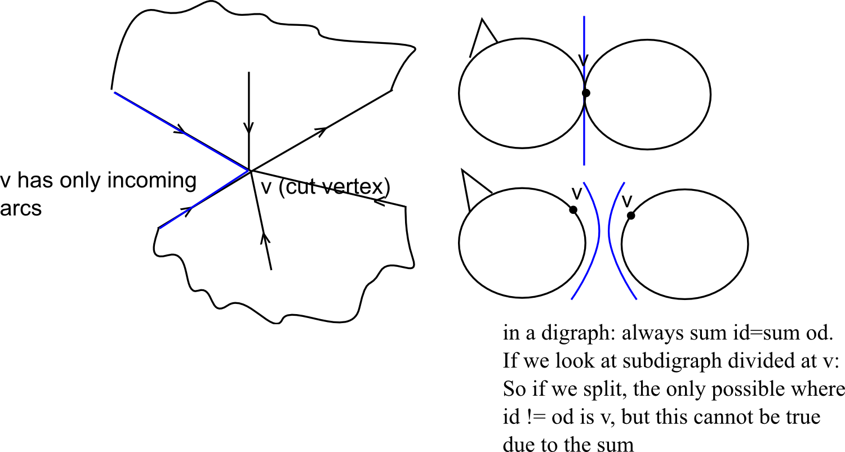
If v is not a cut vertex, we can take arbirarily incoming and outgoing arcs and nothing bad will happen.

Theorem: Let D be a weakly connected (w.c.) eulerian digraph D and let T be an eulerian trail of D starting & ending at . For every v in let be arc in T by which one leaves v.for last time .
We proof that B is a spanning in-tree of D with root z.
Proof
Property still missing: weakly connectedness.
If B is weakly connected, then B is a spanning in-tree with root z by definition. Suppose B is not weakly connected w.c. component B' of B such that
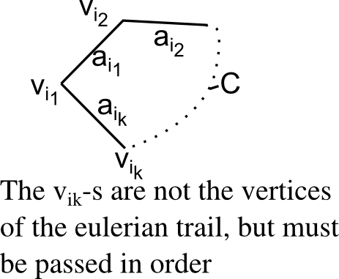
(otherwise, B' had a sink called [Contradiction])

arcs in eulerian trail are , etc.
Therefore, B is weakly connected.
B is a spanning in-tree with root z. ■
D eulerian, B spanning in-tree with root z. A eulerian trail D can be obtained as follows:
Starting at z, traverse at every an arc if and not yet traversed or else traverse the arc if , or else stop.
Let T be the final trail.
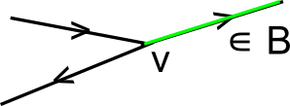
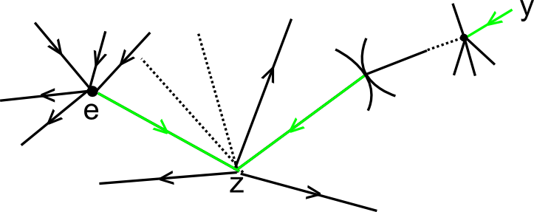
starts and ends in z

Algorithm 1. «Splitting Algorithm»
Step 0: Given connected eulerian graph G of size q > 0, choose an initial vertex in V(G) and let be the initial trail. Set H = G, i = 0.
Step 1: Suppose has been constructed by a (possibly empty) sequence of splitting away pairs of edges so that appears as a path or cycle (in H) whose inner vertices are 2-valent (?) in H. If i = 0, choose arbitrarily; go to (1.2). If , set .
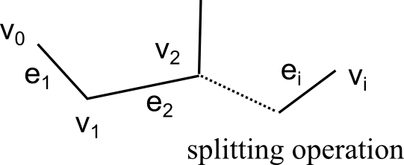
(1.1)

Choose
: j = 2,3. Set if is connected and set otherwise. If , H remains unchanged.
Case where all edges belong to the same block and v is a cut vertex:
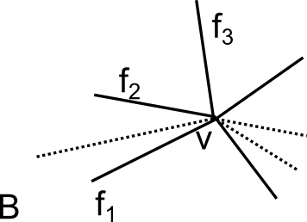

or is connected (bridgeless. anyway)
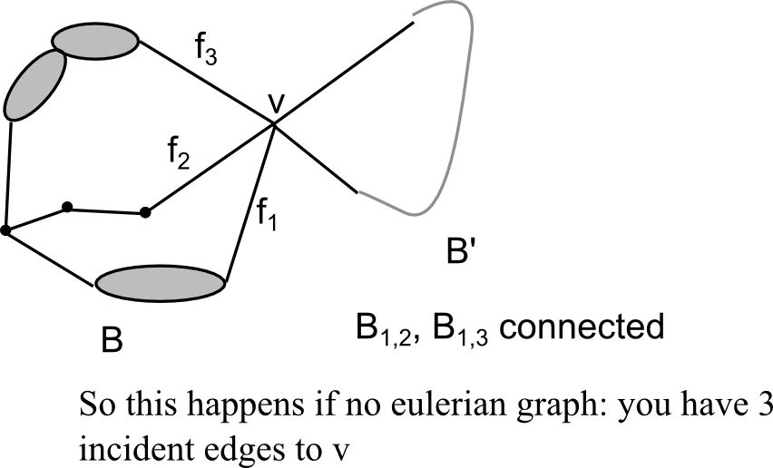
If graph was not eulerian:

In new H the vertex

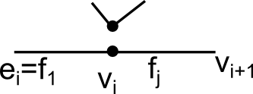
(1.2) Set not in but incident with in H.

(1.3) Set i = i+1
Step 2: If (I don't yet have all edges in ) then go Step 1; otherwise go to Step 3.
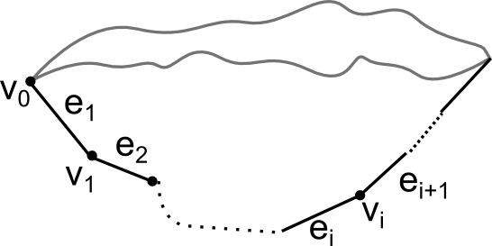
Step 3: is an eulerian trail of G.

Algorithm 2: Fleurys Alg.
Step 0. as in Step 0 of the Spl. Algorithm.
Step 1: Suppose has been chosen. Set .
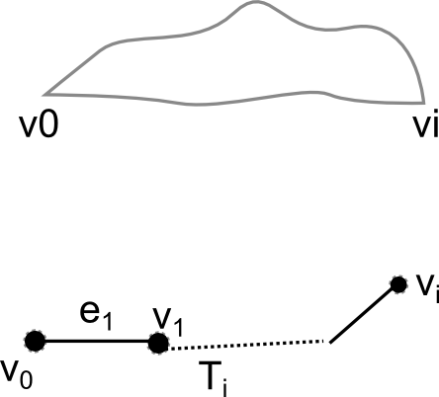
(1.1) Choose e_{i+1} in E_{v_i} intersection E(G_i) s.t. e_{i+1} is not a bridge of G_i unless e_{i+1} is an end-edge of G_i.
Multiple cases ...
continue basically just as before
Algorithm 3: Hierholzers algorithm
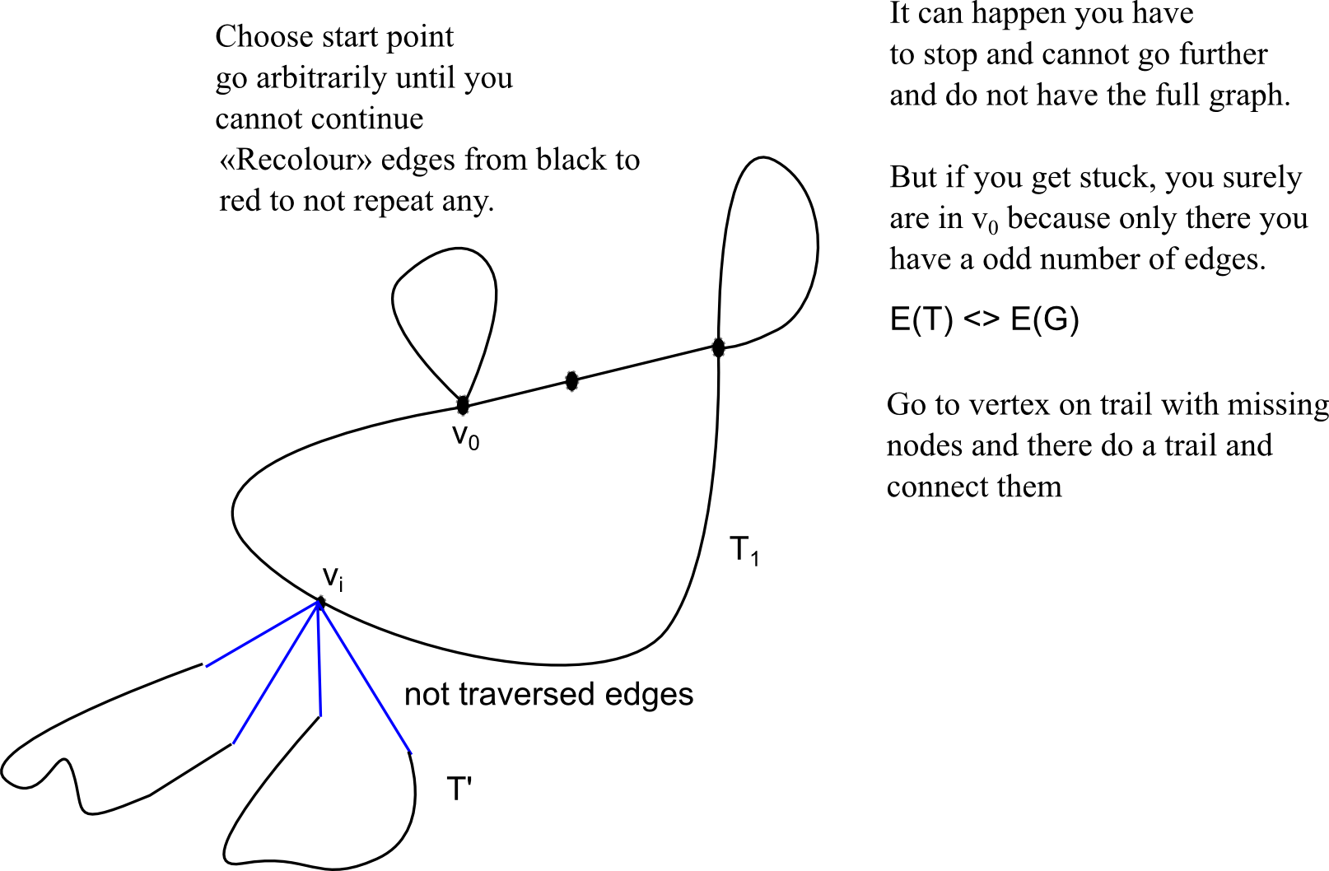
Algorithms running time:
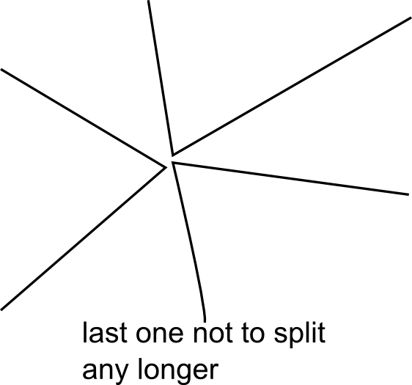
Checking if one is connected can be done in linear time (and if one is not connected, the other one is).
How often you produce splitting operation? Produce times

q ... Number of edges («size»)
p ... Number of vertices («order»)
Hierholzers algorithm has a better running time than the both algorithms: backtrack in linear time - linear or, in worst case, quadratic.

Algorithm 4: Tucker's Algorithm
Tucker produces 2-regular attachment of Graph G - split pairs of edges away arbitrarily. It splits q-p splitting operations, but doesn't check anything → produces it in q-p steps. He leaves the names of the vertices - so a vertex with degree 6 then appears 3 times. Counts components in 2-regular detachment: If number of components is one → 2-regular attachment is cycle and running through cycle equals to running in the graph. If more than one: Then we find two components with a vertex in common since whole graph is connected.
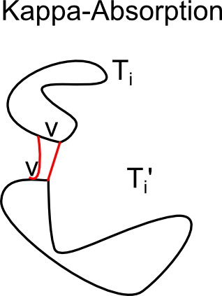
-absorptions correct the mistake you made. Finding two components done in linear time, kappa-absorption not more than q-p, so you have polynomial time as well.
A maze is basically a graph. Idea: want to visit every edge and come back to where you start. Even egyptians know about the problem. cf. classical greeek mythology.
G → D
For every edge e → replace e by two oppositely directed arcs like in network flows.
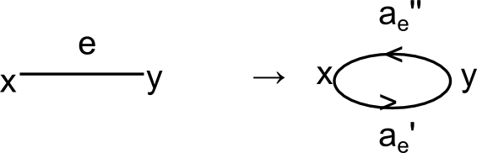
→ D eulerian digraph, weakly connected if G is connected
Supp. G is connected has eulerian trail closed covering walk using every edge 2x, 1x in each dir.
is called a bidirectional double-traceing of G.
If G is a tree, then every double-tracing of G is bi-directional.
Proof: If you have atree: no edges → every edge is visited twice.
If you have at least one edge, then you have an end edge.
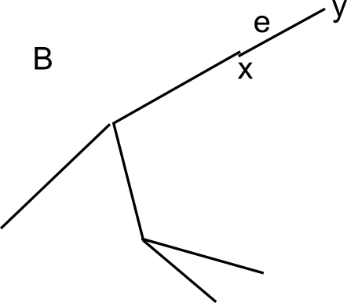

double tracing in B.

is a double-tracing in B' by induction, W_{B"'"} is bidirectional is bidirectional double-tracing.
(deleting xe,y,e,x)

