E-Commerce
Contents
Introduction 3
Context 3
Information Society 3
Information Technology 3
E-Commerce 4
Types of E-Commerce 5
Information as economic good 6
Business Models 7
Business Model Canvas 7
Types of business models 9
The Enterprise 9
Competition and Strategy 9
Competition 10
SWOT 11
Pricing 11
Pricing Models 11
Platforms 12
Platform business models 12
Enshittification 14
Platform failure 14
Platform Challenges 14
Customers 15
Personalization 15
Levels of personalization 15
Recommender System 16
Digital Marketing 17
Terms 17
Instruments and concepts: 18
Markets and Network 19
Markets, Hierarchies, Networks 19
Markets 19
Hierarchy 20
Networks 20
Intermediaries 21
Intellectual Property 21
Copyright 21
Creative common licences: 21
Patents 22
Trademark 22
Digital Rights Management 22
Social, Political, Regulatory & Economic Environment 23
Data 23
EU Strategy for Data 23
Open Data 24
Data Ecosystems and Data Markets 24
Data Ecosystems 24
Data Markets 25
EU AI Act 25
Cryptocurrencies 26
Digital Currencies 26
Cryptocurrency 26
Bitcoin 27
Altcoins 28
Criticism 28
Privacy and Ethics in E-Commerce 29
Personal Data 29
Personality profile 29
Emotion profile 29
Ethics 29
Dark Patterns 29
Price steering & discrimination 30
Influencing Users 30
Micro-Targeting 30
Regulations and standards 30

Introduction

Context
Definitions
- Platforms = brings together individuals/organizations so they can innovate and interact, with potential for non-linear increases in utility and value
  - Examples: Facebook, willhaben, Spotify, YouTube
- Uberisation = Act of changing the market for a service by introducing a different way of buying/using it, especially using mobile technology
  - Uber: taxi company owns no vehicles
  - Facebook: media owner creates no content
  - Airbnb: Accommodation provider owns no real estate
Also has downsides, e.g. taxi drivers lose job, hotels have no guests but Airbnb doesn’t pay taxes

Information Society
= Society where creation, distribution, use, integration and manipulation of information is a significant economic, political & cultural activity
Refers to changes in society and structure (Wiener, Bell, Drucker):
- Information as a product, Knowledge as strategic resource
- New technologies
- Flexibility and division of labor
- Move to service industry
- Production cost to marketing cost (-> value of customer)

Also leads to virtualization: companies rely on information (data), not infrastructure!

Information Technology
- Basis of Information Society
- provides global infrastructure aka the Internet/Web with ~5bn users -> 63% penetration
- Enables digitalization with “transparent” technology and access
- Mobile computing accelerates development

Evolution of computer (in terms of distribution):
- Automaton: manipulation of well formalized and mathematical models
- Tool: modeling of work process
- Medium: representation & processing of unstructured information
- Ubiquitous (Omnipresent): devices are everywhere, connects everything, e.g. IoT

Ubiquitous Computing
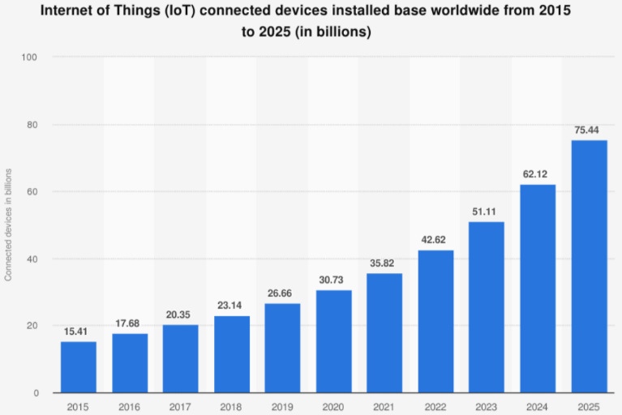
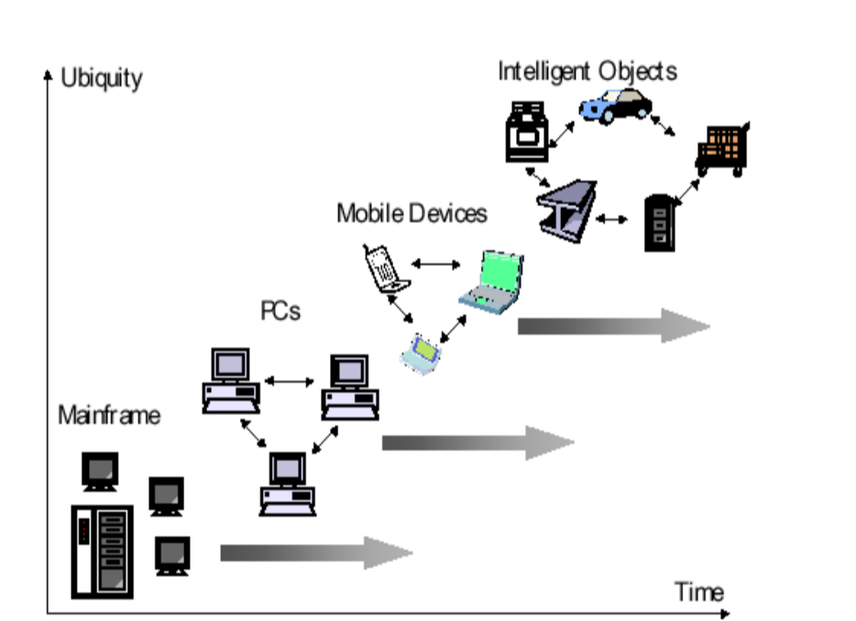
Internet is not just Technology:
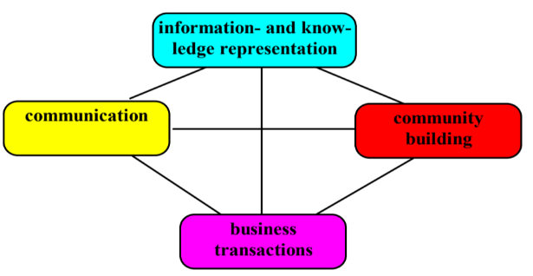
- Economic Transformation: Uberization
- Social Expansion: Social networks
- Psychological Change: attention span
- Political Impact: Arab Spring, US Election
- Legal Aspects: Multiple EU laws
- Data Act
- Data Governance Act
- Artificial Intelligence Act
- Digital Services Act
- Digital Markets Act

E-Commerce
Electronic Commerce -> Doing business electronically: “Sharing business information, maintaining relationships and conducting business transactions using IT networks”
Completed transaction (agreement) over computer mediated network (transfer of ownership)
E-business: any process that a business org. conducts over computer mediated network (external or internal)
We’ll navigate through the “E-commerce Framework”
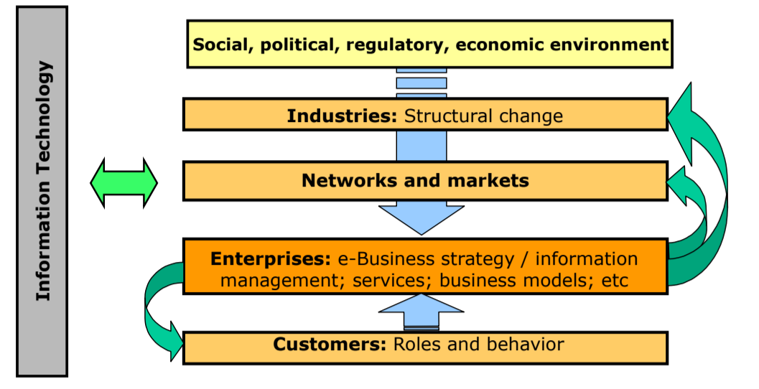
Reasons for the success & popularity of E-Commerce:
- Globalization (with alliances - mergers) and differentiation
- On political and economic level, or also w.r.t. science
- Convergence (technologies and industries)
- Technology part of more and more daily businesses
- Convergence = “when two+ things come together to form a new whole”
- Networked economy and customer integration
- Crowdsourcing, personalization
- “Prosumption” - from “Customer-focused” to “Customerdriven” (also Prosumer)
- Consumer consumes and produces
- Rise of the Platforms (Facebook, Android, …)
- Network effects of platforms make them bigger and bigger
-> Those factors also increase complexity of market
Business transaction phases:
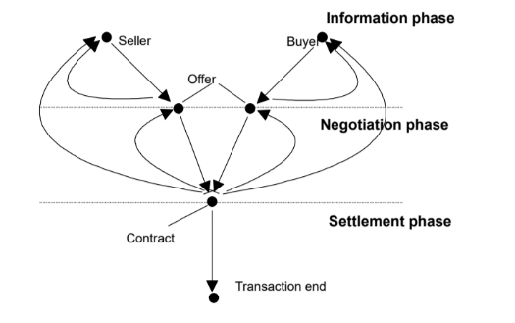
Like a funnel, comparable with AIDA

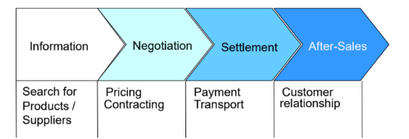

Types of E-Commerce
Actors: A=Public Administration (-> Government), B= Business, C=Customer
Types of E-Commerce | Customer | Business | Administration
Customer | C2C: Sharing Platforms, E-auctions | C2B: Crowd-funding, product evaluation sites | C2A: Repair-demand services, Citizens’ organizations
Business | B2C: E-Retailing | B2B: Supply chain management, planning | B2A: Public Procurement
Administration | A2C: E-Services (tax declaration, citizen administration) | A2B: E-Services (tax declaration, start-up services) | A2A: Data sharing, workflows

E-Commerce helps company optimize their objectives:
- Increased turnover by enabling new customer groups, products and services with better customer relationships and more targeted & individualized marketing
- Reduced costs due to electronic distribution and maintenance and 24/7 self-service
Value propositions (benefits or economic value which it promises to deliver to the current and future customers) to customers are for example
- Transparency: Reduced information cost
- Price: price incentives compared to traditional sales
- Information: detailed product/service descriptions
- Interaction: asynchronous communication with suppliers
- Customization/Personalization: individual product and service designs
- Convenience: 24h shopping from everywhere

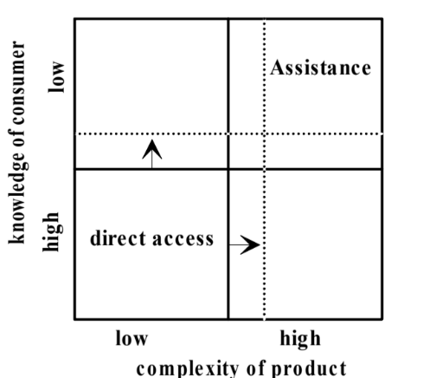
However: Not all products fit all customers: some need assistance -> hard to provide in electronic room -> special solutions required

Digital products and digital economy:
Different layers of E-Commerce, from traditional to e-commerce
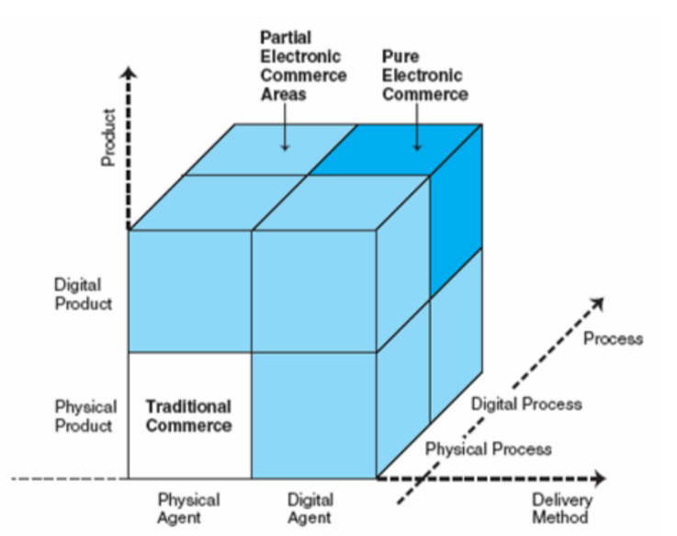
Product, Process and delivery can all be physical or digital

Information as economic good
Information good=anything available in digital form which is regarded as useful by electronic agent -> High significance in Pure E-Commerce
- Costs: Initial costs as usual, barely any marginal costs
- Information asymmetries cause Information Paradox ( Before purchasing or using information, a consumer cannot fully determine its value because they haven't accessed it yet. However, once the consumer has the information, its value is often fully revealed, and the buyer may no longer want to pay for it. -> ways needed to monetize information)
- Nature of information: Indestructible, Transmutable, Reproduceable
- Frequency: similar information goods are often regularly consumed, like daily news or software updates.
Examples: Digitalized music was thought to “kill” music industry, digital access to publications makes monetizing harder (-> scihub),

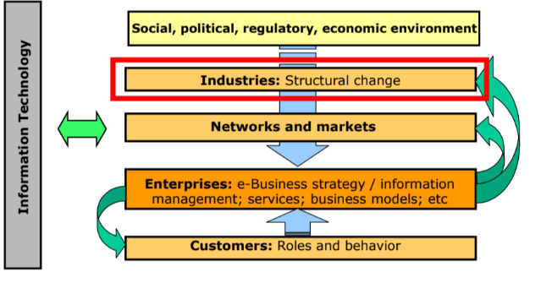
Business Models
Business Models change, comparison Blockbuster -> Redbox -> Netflix
Business Model is how an organization creates, delivers, captures and defends value.
“The architecture with which an organization creates value for customers, how it delivers that value, how it captures the value” -Osterwald(+ defend)
Business Plan is the detailed implementation of business model
Contains:
- Company goals
- Resources and methods to achieve goals
- Timeline
- Market analysis: Size, competitor analysis, market fit
- Sales strategy, financial planning

Company can have multiple Business Models, e.g. traditional and digital, at the same time:

 | 
 | 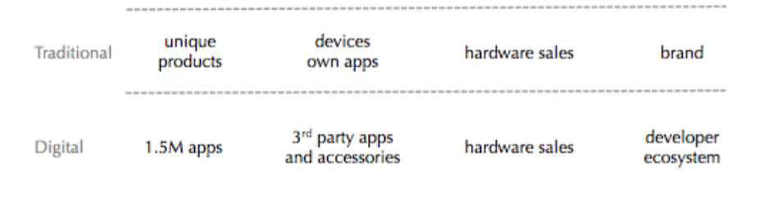
 | 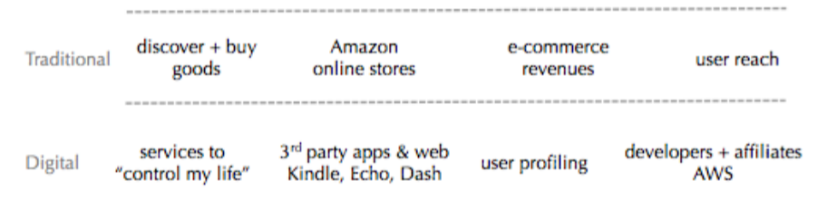
Good technology is not a guarantee of success but is largely driven by non-technological factors. Getting these in place is usually more work than the technology itself.

Business Model Canvas
Created by Osterwalder
A Canvas to describe, discuss, design, challenge, improve, innovate, invent, pivot and choose a business model
Canvas helps to communicate, categorizes in 9 blocks
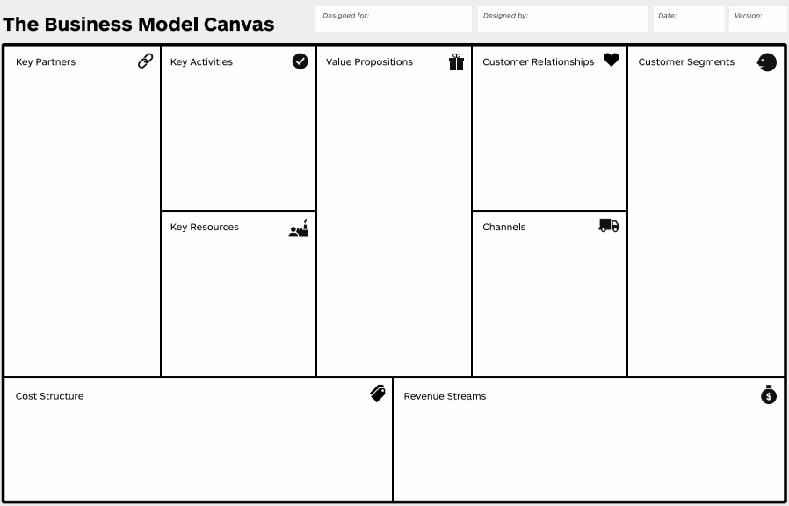
Customer segments | Who are we created value for? Who are our most important customers?
Value Proposition | What value do we deliver? Which problems are we helping to solve? Which customer needs to we satisfy? Which bundles of products & services are we offering to each customer segment?
Channels | Through which channels do our customer segments want to be reached? How are we reaching them now? Which one works best? Which ones are most cost-efficient?
Customer relationships | What type of relationships do our customer segments expect us to establish and maintain? Which one do we have now? How costly are they?
Revenue Streams | For which values are customer willing to pay? For what do they pay now? How are they paying? How would they prefer to pay? How much does each revenue stream contribute to overall revenues?
Key Resources | What key resources (physical, intellectual (patents, data), human financial) does our value proposition require?
Key Activities | Which key activities (Production, Problem solving, Platform/Network) does our value proposition require?
Key Partners | Who are our key partners? Who are key suppliers?
Cost Structure | What are the most important costs inherent in our business model? Which Key resources and activities are most expensive?

Can be used to analyze problems with business model, example Nespresso with wrong Customer segments (offices instead of households).

Types of business models
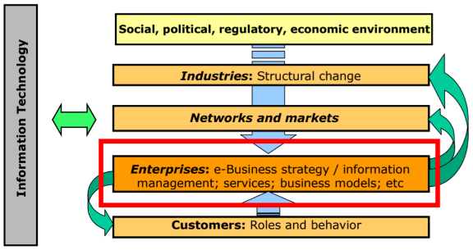
One company can run multiple business models!!
Freemium | Offers basic services for free while charging for advanced features or functionalities to monetize user upgrades, often used in SaaS or apps. Acquire customers with free model, get them hooked to upgrade license | Spotify
Subscription | Provides recurring services for a fixed fee, often with tiered plans for varying levels of access | Netflix
Hidden revenue | Users access services for free, but the company earns revenue indirectly with advertising or partnerships. | Google
Razor and blade | Sells a primary product at a low price to drive demand for high-margin complementary products. | Printer, Razors
Reverse razor and blade | Offers premium-priced primary products while generating long-term revenue from lower-priced secondary items. | Nespresso
User-generate content | Leverages community-generated content (e.g., reviews, posts) to engage users and attract businesses through ad revenues or data sales. | YouTube, Stackoverflow
Data licensing | Monetizes collected data by licensing it to other companies for operational or strategic purposes, | X
Aggregator | Consolidates information or services under a single brand to streamline customer access (e.g., hotel booking platforms). | Booking.com, Airbnb
Multi-sided platform | Own chapter

The Enterprise

Competition and Strategy
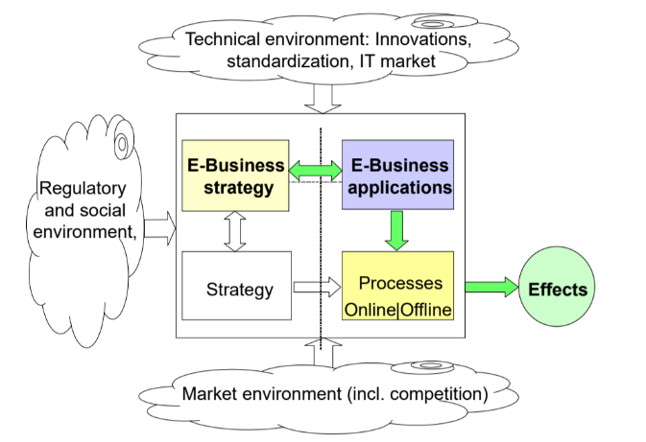
Strategy defines how business is going to compete, what its goals should be, which plans and policies will be needed to achieve goals, in e-commerce “E-Strategy” with E-Business Strategy Framework:

Dimensions for strategic positioning are: Medium, Scope, Market, Cooperative Relations, Competitive Environment

Competition
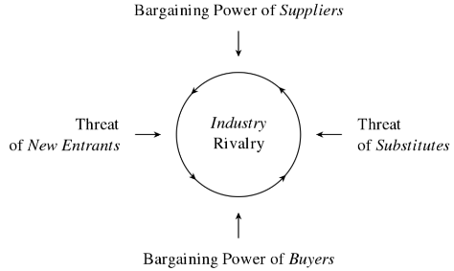
Competition can be evaluated with SWOT and Porter
Analyze competitive environment with 5 Forces of Porter:
Threat of New Entrants | The ease or difficulty for new competitors to enter the market, influenced by barriers like capital requirements, brand loyalty, or economies of scale. | − lowers entry barriers by simplifying access to sales channels, reducing capital requirements, and providing platforms for new entrants.  − Proprietary advantages become harder to maintain
Bargaining Power of Buyers | The ability of customers to influence pricing or terms by demanding higher quality, lower prices, or better services. | + eliminates or weakens powerful distribution channels, giving buyers better bargaining power over traditional setups.  − shifts more bargaining power to end consumers and reduces switching costs, increasing buyer demands.
Bargaining Power of Suppliers | The control suppliers have over pricing and terms, especially if they provide unique or scarce resources. | + reduce supplier bargaining power by increasing transparency and competition between suppliers.  − Suppliers gain easier access to end users, potentially bypassing intermediaries
Threat of Substitutes | The risk posed by alternative products or services that can fulfill the same need, potentially reducing demand for existing offerings. | + internet can expand the market and make the industry more efficient by increasing accessibility and options  − more substitution threats, challenging existing players
Industry Rivalry | The intensity of competition among existing players, driven by factors like the number of competitors, market growth, and differentiation. | + Digital markets expand geographic reach, giving opportunities to businesses to grow.  − reduces differentiation between competitors, migrates competition to price, and increases the number of players, intensifying rivalry.

SWOT
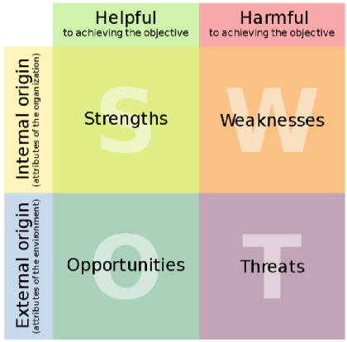
Analyze single competitors with SWOT Analysis:
Strengths  (Internal, Helpful) | Internal attributes or resources that provide an advantage in achieving objectives (e.g., strong brand, unique technology).
Weaknesses  (Internal, Harmful) | Internal limitations or deficiencies that could hinder progress toward objectives (e.g., lack of expertise, outdated technology).
Opportunities  (External, Helpful) | External factors or trends in the environment that can be leveraged to benefit the organization (e.g., new markets, favorable regulations).
Threats  (External, Harmful) | External challenges or risks that could negatively impact success (e.g., increased competition, economic downturns).

Pricing
Directly influences revenue stream. Web increases transparency -> eases price comparison for buyer, enables differentiated pricing (price discrimination)
Issues:
- Supplies want to price discriminate (maximizes sales)
- Customer looks for best deals

Pricing Models
Customer Characteristics | Micro-segmentation of market, customer specific prices
Product features | Pricing based on product features, eventually w.r.t. region/time
Volume Discounts | Aggregation of discounts (loyalty points) or group discounts (early bookers)
Value-based pricing | Customer-initiated service customization, e.g. car customization

Web enables differentiation with low communication costs/response time and customer information based on:
- Micro-segmentation
- Service differentiation
- Efficient coordination and negotiation mechanisms

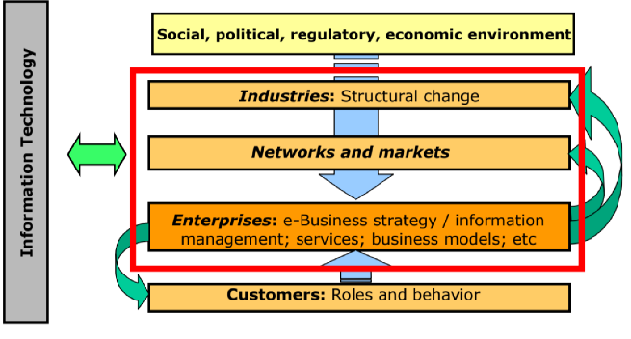
Platforms
Brings together individuals and organisations so they can innovate or interact in ways not possible otherwise with potential for non-linear increases in utility and value. Already before the internet: malls (shops and customers), newspapers (subscribers and advertisers)
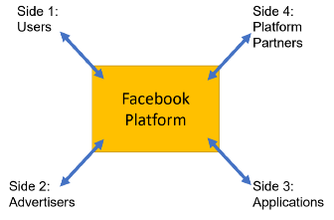
Traditional value chain very straightforward: Design, manufacture, offer for sale, customer buys (or not)
Platforms however
- engage multiple sides of a market
- Not only buyer/seller but more sides, sometimes incrementally (e.g. facebook)

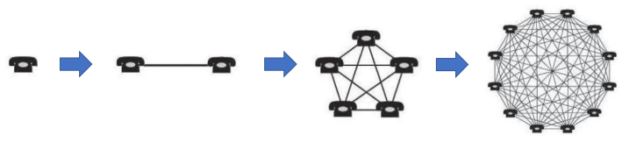
- generate network effects
- Enables non-linear growth
- Same-side effect: more users on messaging app attract more users
- Cross-side effect: more users attract more advertisers
- Too many advertisers can also cause negative network effect

- Chicken-egg-problem
- One-sided: users for social media
- Two-sided: payment platform need stores and credit card companies at the same time
- Challenge for business: where and how to start? Get momentum, scale bigger

Platform business models
Platforms and their core transactions can be differently categorized, but often not distinct
Categorization 1: Transaction/innovation
- Transactions Plattforms: intermediary for direct exchange/transactions, subject to network effect, e.g. Snapchat, Airbnb, Instagram
- Innovation Plattforms: Technological foundation where other firms develop complementary innovations, e.g. Steam, PlayStation store
- Hybrid: Apple, Facebook, Google
Categorization 2: Exchange/Maker
- Exchange Platforms:
- Marketplaces: Platforms for buying or renting products, services, or assets (e.g., Airbnb for services, Amazon for products, PayPal for payments, LendingClub for investments).
  - Social Platforms: Enable social or interactive exchanges:
  - Social Networking: Building social connections (e.g., Facebook, X/Twitter).
  - Communication: Focused on messaging (e.g., Discord, Snapchat).
  - Gaming: Foster gaming interactions and communities (e.g., Minecraft).
- Maker Platforms:
  - Content Platform: piece of content (Instagram, Youtube)
  - Development Platform: software program

Building a platform business

Building an platform:
 | Innovative Platform | Transaction Platform
1. Market sides: | - Complementors: Need to be encouraged or subsidised  - End Users | Start with 2 sides, eventually add over time, can be one-sided for social networks
2. Chicken-or-Egg | - Launch application before start, can be own applications/ subsidise key complementors before | - Bootstrap one side  - Subsidise one side, e.g. photographers  - Offer useful service
3. Business Model | - Do not subsidise forever!!  - Increase customers’ willingness to pay or take portion of value of every sale | 5 ways to generate profit:  - Matchmaking  - Reducing transactions  - Complementary services  - Complementary technology sales  - Advertising
4. Ecosystem rules | - Ensure quality, define openness, especially with competitors | - Curation (background check)  - Community guidelines  - Reviews and evaluations  - Guarantee services  - Limit liabilities

Enshittification
Prioritize profit maximization at the expense of users and creator value, leading to a decline in quality and fairness on the platform
- User-centric growth: Lure users in
- Creator incentives: Bait in business customers
- Profic maximization: Rug-pull both sides, allocate value to shareholer
Possible due to lack of platform interoperability
- High switching costs
- Lock-in

Platform failure
First-mover have a higher risk, some have been successful (Amazon, Apple), but a lot more have failed.
Uber is also said to be a failure, artificially kept alive: they still subsidize drivers

Platform Challenges
- Mispricing or poor subsidiary strategy (Uber, WhatsApp)
- Building sufficient trust (ebay failed in China)
- Right timing (Windows Phone)
- Underestimating the competition (Microsoft lost to Google (Edge vs. Chrome)

Future is foreseen to be even more fixated on platforms, “will be way we organize new IT such as AI, VR, AR, IoT, healthcare and quantum computing”

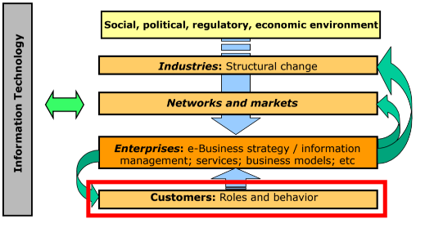
Customers
Business Model Canvas Segments: Customer Relationships, Channels
We have more choices available, e.g. supermarkets, but also services, news, work, love, be
-> more freedom, autonomy and self-determination
Vast number of choices should increase well-being, but decreases it: decision overload caused by Information overload when making decisions -> hard to distinct between trivial and relevant information upon exploratory search
Channels to reach customers: Personalization & Digital marketing with the goal of acquiring and keeping customers -> Customer Lifetime Value (CLV)

Personalization
Set of “tailor-made” services: Interface customization, recommendations on other products, … enabled by internet
- Adaptability: User modifies parameters on his own: e.g. language, newsletters, presentation, filtering, individual services (alarms), product configuration (car)
- Adaptivity: System modifies parameters to user’s needs, a system that adapts automatically to its users: e.g. recommendations based on customer profiles: “I will offer what you are looking for”
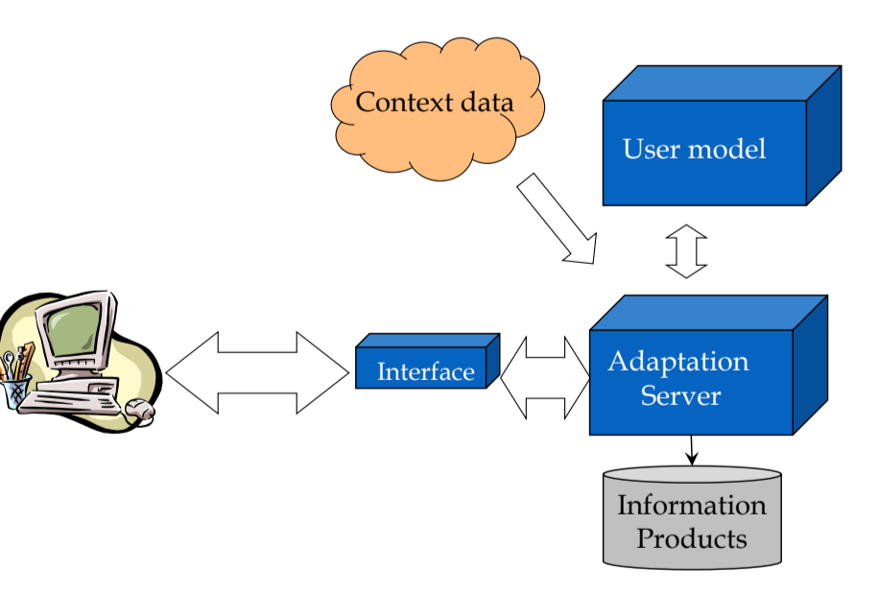
Aims for “the long tail” -> selling of the non-hits which are sometimes even greater than the market for big hits

Levels of personalization
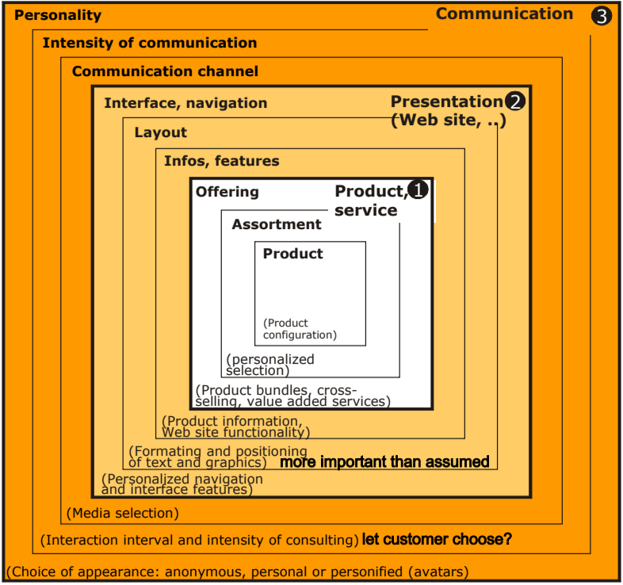

Recommender System
Helps to make choices without user having sufficient personal experience of alternative -> eases information search process. Goal: recommend items that are relevant to users & serve business purpose
Goal reached for supplier when business goal reached, measure by KPI and for customer, when accuracy leads to satisfaction (“unplanned fortunate discovery)
Preferences of users are input to model, there are some standard classes:
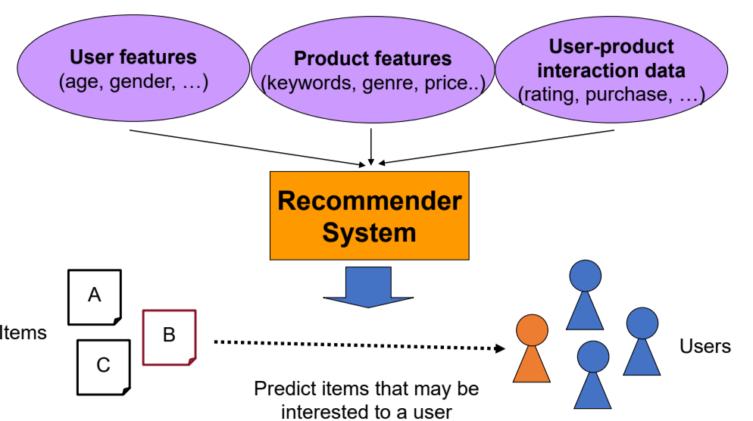
Non-personalized: popularity | 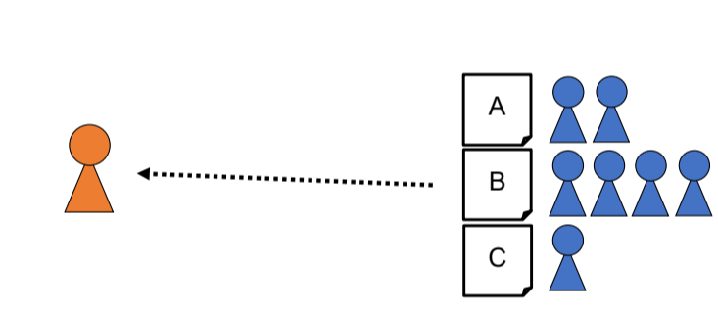
Demographic: user features | 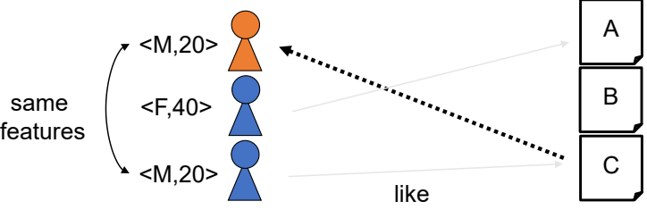
Content-based: item features | 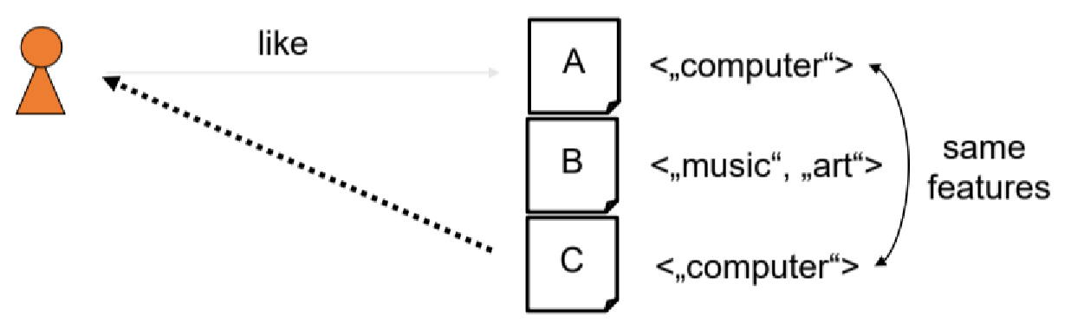
Collaborative Filtering: User – item features | 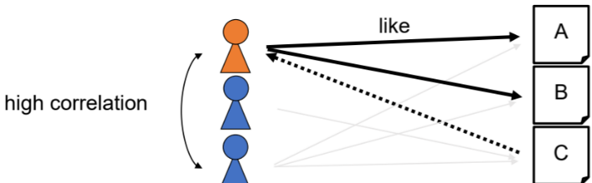
Knowledge-based: build model that reflects user-item preferences | 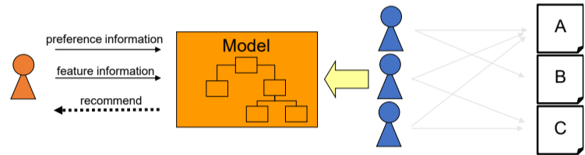

Context-Aware
Context-aware computing: consideration of situational and environmental information about people, places and things used for computing
- Physical context: time, location, activity, light, weather
- Social context: presence and role of other people around user
- Interaction media context: devise used to access media and type of media
- Modal context: state of mind of user, his goals, mood, experience and cognitive capabilities

Digital Marketing
Marketing via digital channels
Marketing is the activity, set of institutions and processes for communicating, delivering and exchanging offering that have value for customers, clients ,partners, and society at large
Customer is the focus of marketing with the goal of creating new and keep existing customers via loyalty, trust & brand awareness
Marketing mix defines broad categories of marketing decision with 4 Ps (McCarthy):
- Product: The goods or services a business offers to satisfy customer needs, including features, design, and quality.
- Price: The amount customers pay for a product, influenced by costs, competition, and perceived value.
- Place: The distribution channels and locations where the product is made available to customers.
- Promotion: The communication strategies used to inform, persuade, and remind customers about the product, such as advertising and sales promotions.
Advantages of Digital Marketing over traditional marketing:
- Targeted marketing
- Lower costs
- Performance metrics

Terms
- Page View: Every view of a page
- Visit: User with at least one page view
- Landing Page: Site on which customer started visit (does not have to be homepage)
- Bounce Rate: Share of visitors with only one page view (measured on total number of visitors)
- Time on Site: Time between first and last visited page of one domain
- Event: Measurement point for one, user triggered action (e.g. start of a video, click on a link)
- Channel: Paid search, direct access, links, organic search

Instruments and concepts:
- Online advertising: Funneling Impressions to Actions (Views -> Clicks -> Action)
- Pricing can be derived from performance KPIs (impressions, reached): CPM Costs per Mille, PPC Pay Per Click or CPC Costs per Click, PPA Pay per Action, CTR Click Through Rate, Conversion Rate, ROAS (Revenue/Cost, cp. ROI)

- Search Engine Marketing and Advertisement (SEM/SEA): Paid methods, like PPC, to improve visibility and traffic through search engines.
- Services like Google Ads, associated with keywords, but are not as good as organic results. Google uses “CPC Bidding” where max CPC bid is specified, only actual CPC charged. Relevance still plays role

- Search Engine Optimization SEO: Website gets enhanced to grow visibility in organic search engine results
- On-page: keywords, meta tags, content of website
- Off-page: social signals, link building

- Web Analytics: Monitoring and analyzing website data to optimize user engagement and marketing campaigns
- e.g. CRO Conversion Rate Optimization to improve conversion rate with feedback loop and testing it

- Remarketing & Retargeting: Re-engaging users who have already interacted with your website or content by showing tailored ads.
- Remarketing to re-engage e.g. shopping cart abandoners, typically via email
- Retargeting off-site targeting users that visited one’s own website

- Affiliate Marketing: Collaborating with affiliates who promote your brand in exchange for a commission on generated sales using affiliate links
- Opens new channels for low cost, since payment only relative to generated sales
- Google AdSense, Amazon Affiliate Program
- Email Marketing: sending targeted and personalized emails to engage audiences, build relationships, and drive conversions to increase Customer Lifetime Value
- Transactional, newsletter or stand-alone e-mails

- Marketing Language: Crafting clear, persuasive, and relevant messaging to align with your audience's preferences and goals.
- Five major elements: Emotional, functional (call to action), descriptive (offered product), formatting (style), positioning (structure)

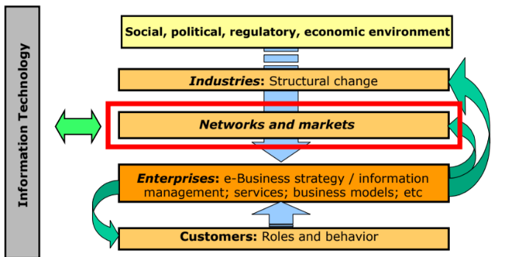
Markets and Network
Business Model Canvas segments: Key Partners & Customer Segments

Markets, Hierarchies, Networks
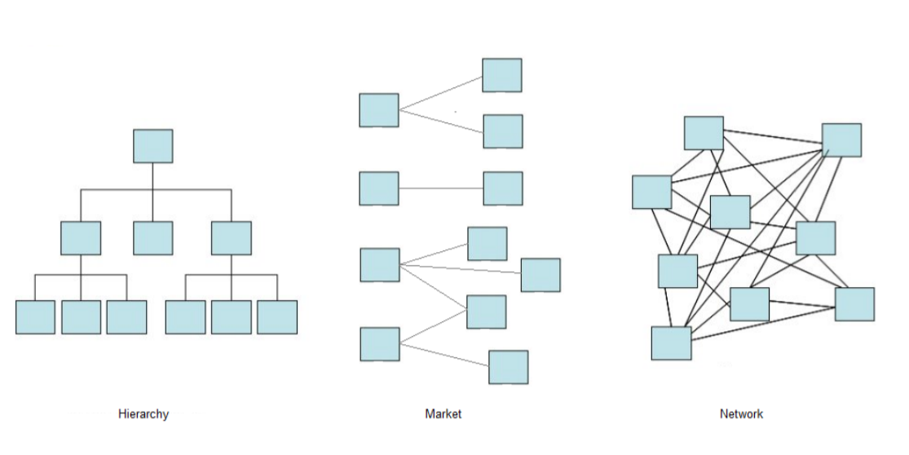

Markets
Markets are medium that allows buyer and sellers to interact to facilitate transactions, e.g. stock market, Willhaben, Brunnenmarkt, Apple App Store
Characteristics of markets:
- Spontaneous coordination mechanisms based on rationality and self-interest of economic agents
- Open to everybody
- Straightforward, volatile, non-repetitive transaction
- Controlled by prices which contain/carry information

Electronic markets
E-Markets match buyers and suppliers, facilitating exchange of goods/services and payment and provide institutional frameworks (rules)

In idealized market structure, certain assumptions hold to assure perfect competition resulting in an equilibrium price (demand and supply in balance):
- Large number of buyers and sellers
- Perfect information; minimal risk-taking
- Rational actors (homo oeconomicus)
- No entry/exit barriers
- Homogeneous goods (substitutes of each other)
- Zero transaction costs
- No government regulations/price setters

Transaction cost theory
Transactions are agreements between buyer and seller to exchange goods, causing transaction costs (time, labor, communication, …) -> not necessarily money. They are determined by asset specificity (the more specific, the more difficult to reuse), frequency (expensed are amortized over transaction, economies of scale) and uncertainty (caused by complexity)
Perfect competition doesn’t exist in real markets -> cannot explain emergence of firms, while transaction cost theory by R. Coase and Williamson tries to: Transaction are done within firms to minimize transaction costs

Hierarchy
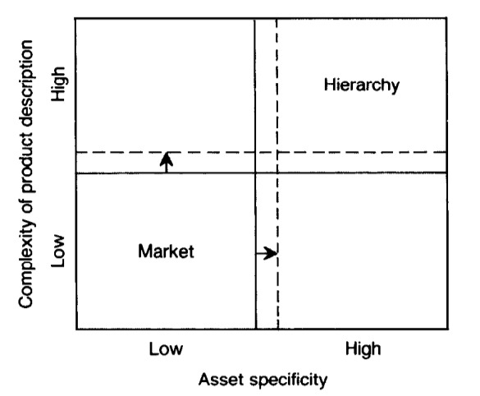
Hierarchy > Market when highly complex form of exchange: hierarchy is coordinated by central power instance, based on longer lasting plans, regulated by internal control system and authority. Hierarchy causes control cost but avoid coordination problems.
IT lowers communication cost (lowers uncertainty) and reduces asset specificity -> questions use of hierarchical organizations (solid to dashed line)

Networks
Hybrid form between loose markets and tight hierarchies, e.g. market matches while hierarchy controls project. IT eases outsourcing. Long-lasting relationships protect against loss of critical resources and enable integration of activities. Cooperation + competition = coopetition
Example: Network of contractor and sub-contractors (trust), long-term relations of company to law and banking firms
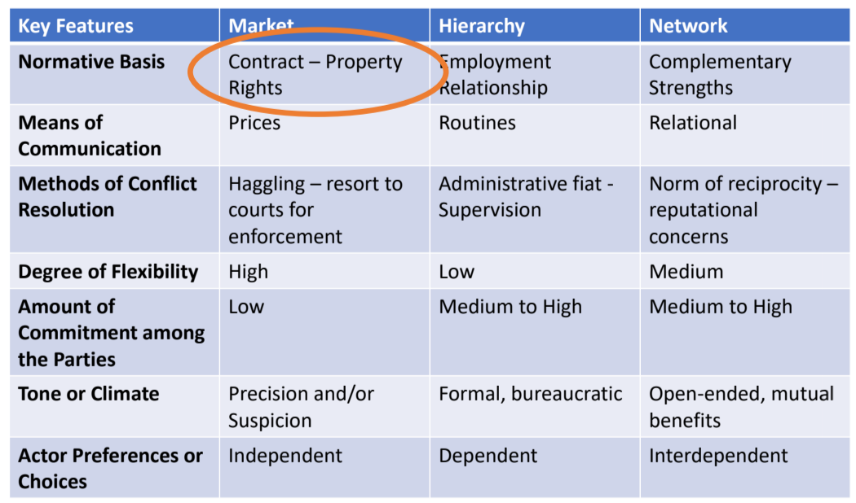

Intermediaries
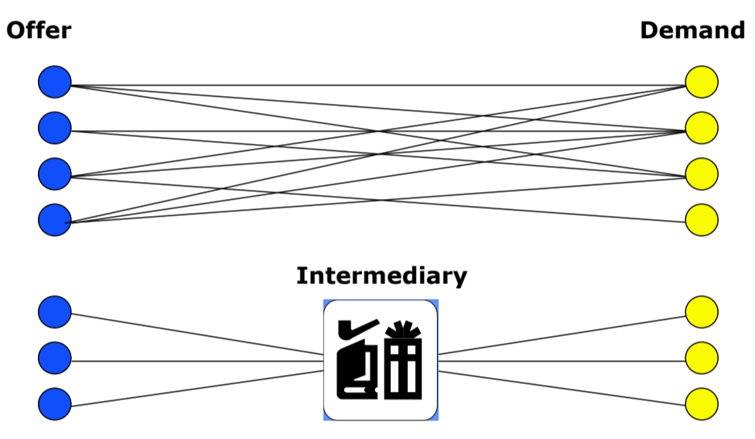
Increased number of participants might require an intermediary to reduce number of connections and takes sales commission in exchange for risk disintermediation (both), additional revenue (supplier) and increased transparency (customer).

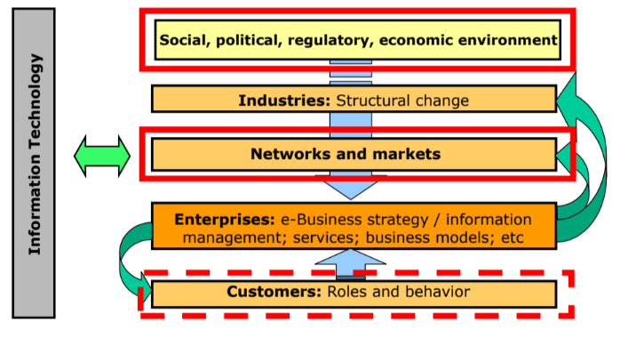
Intellectual Property
Creations of the mind; inventions, literacy, art, designs, symbols, names, images -> protected by law with for example patents, copyright & trademarks
“IP is any law that I can invoke that allows me to control the conduct of my competitors, critics, and customers.”

Copyright
Copyright applies automatically to creative work for life of author + 70 years, aims to give incentive to create new art. Either moral ri ght (prohibits reproduction which offends creator) or economic right (reproduction, distribution, display/performance & transformation of work) -> transferrable
Also protects code: Open Source/Open Code (still requires open-source license attached), closed copyright

Creative common licences:
- CC BY: Use freely with credit.
- CC BY-SA: Use and modify freely, but share changes under the same license.
- CC BY-ND: Share only unchanged, with credit.
- CC BY-NC: Use freely for non-commercial purposes, with credit.
- CC BY-NC-SA: Non-commercial use; share changes under the same license, with credit.
- CC BY-NC-ND: Most restrictive; share unchanged for non-commercial use only, with credit.

Abbreviations:
- CC: Creative Commons
- BY: Attribution (credit must be given to the creator)
- SA: ShareAlike (derivatives must use the same license)
- ND: NoDerivatives (no modifications allowed)
- NC: NonCommercial (only non-commercial use allowed)

Patents
Patents incentivize inventors to reveal working of their inventions: exclusive right granted for an invention, that provides a new way of doing something. Must be of practical use, show novelty, show an inventive step, and be accepted as “patentable” -> need to be accepted by patent office. Usually valid for 20 years, technical information must be disclosed to public (trade secret, no information is released). Owner may give permission/license the patent or sell right to the invention to someone else.

Trademark
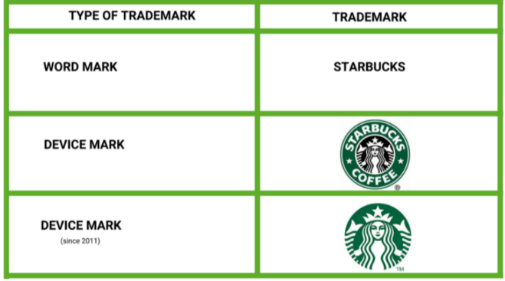
Exist as consumer protection to punish rivals who want to cause confusion among consumers. Needs to be registered with relevant authority but can be rejected. Can consist of:
- Word or combination of words, letters and numerals
- Drawings, symbols
- Three-dimensional features
- Non-visible signs (sounds, fragrances)
- Color shades (only when used as distinguishing features)

Digital Rights Management
DRM tools control access to proprietary hardware and copyrighted works. They use technologies like product keys, copying restrictions, persistent online authentication. Controversy since you don’t own the product upon purchase -> you could lose access to it. Additionally, companies like HP use it for restricting cheap ink: HP Instant ink lets you only print limited amount of pages, even though ink is available.

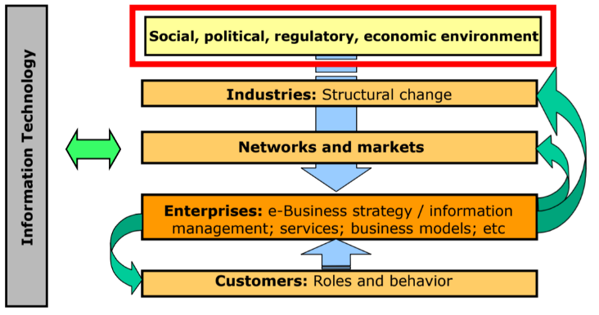
Social, Political, Regulatory & Economic Environment
Markets are not in price equilibrium -> imperfection in terms of public goods and market control (mono-/oligopoly for seller side and Mono-/Oligopsony for buyer side) -> could lead to market failure -> government needs to regulate market:
- Consultation & Funding: e.g. for Startups & new concepts like data markets
- Policy: e.g. Digital Services Act forces VLOP and VLSE (Very Large Online Platforms/Search engines to publish information about user traffic), General Data Protection Regulation (GDPR), Data Governance Act, Data Act, AI Act
- Taxation: Fair taxation of digital economy (ad revenue, digital services)
- Legal actions: companies held accountable for violations, e.g. legal breaches or monopoly

Data
Data is not persistent on its own -> needs to be stored properly to not “rot” like data from NASA
“Data is new gold” is not true, “Insights are the new gold” would be more accurate: Leads to increased productivity & cost savings

EU Strategy for Data
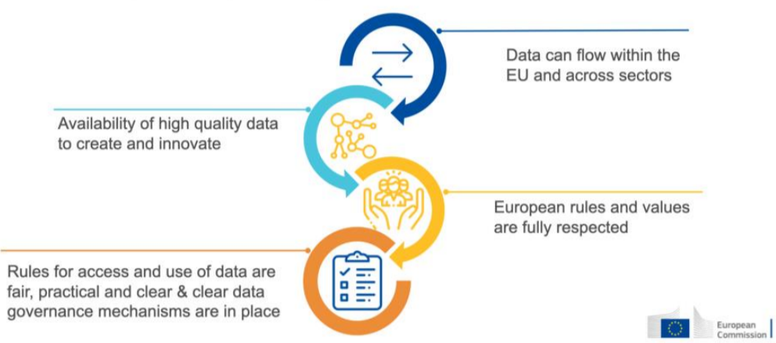
Ruled & addressed in Data Governance Act, Data Act and GDPR

EU Data Governance act
Mechanisms to facilitate data sharing & reuse of public sector data to benefit society that cannot be made available as open data. Intermediaries function as trustworthy organizers within Common European Data Space.
Public sectors: Health, Industrial & Manufacturing, Agriculture, Finance, Mobility, Green Deal, Energy, Public Administration, Skills
Provides technical tools, standards & interoperability, Sectoral data governance and IT capacity with full respect to GDPR

EU Data Act
Allows users of connected devices to gain access to “self-generated” data, to rebalance negotiations power for SMEs and allowing public sector to access data held by private sectors, primary for emergency only. Allows users to switch between cloud data-processing services, safeguarding unlawful data transfers

Open Data
“Open means anyone can freely access, use, modify, and share for any purpose (subject, at most, to requirements that preserve provenance and openness).”
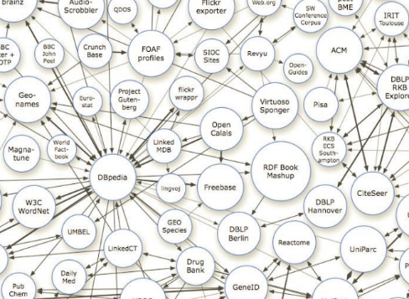
Open Government Data promotes transparency, accountability and value creation by making government data available to all -> promotes business creation & innovative, citizen-centric services, using the provided APIs. Accessible via the EU Open Data Portal and data.gv.at
Problem: Data quality is sometimes not consistent, out of date, no guaranteed data sources. Data quality is categorized in 5 classes, rated with stars where 1 star=whatever format, 5 start=context provided -> “Linked data”
Linked Data is about connecting related data which was not previously linked.

Data Ecosystems and Data Markets
“Data wants to be free, but not for free”

Data Ecosystems
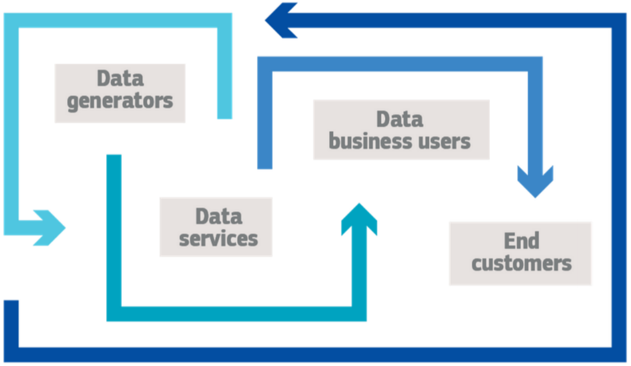
Data Generators | Source of data, e.g. users of the internet, consumers paying with credit card, location data from GPS readings | + own data is a commodity  - security/privacy breaches
Data Services | Processing of the generated data -> Collection, Transmission, Preparation, Storage | + Profit generation  - Bottle necks in data flows  - Compliance costs
Data Business Users | Companies using the outcome of data to improve performance, e.g. for marketing strategies, efficiency increase, overhauling business models | + Improvement of services, innovation  - investment cost and barriers of integration
End Customers | Consumer of services of data business users, often data generators themselves -> vulnerable to price discrimination! | + Lower prices  + tailored offers  + new services  - Price distrimiation

Data Markets
Online store, where you can sell and buy data
- Property Market: data sale negotiated between buyer and seller
- Consumer market: data bought off-the-shelf, e.g. demand map for taxi company

Challenges:
- Uncertainty about value of data
- Data selling not seen as business
- High overheads to start selling data

Personal Data Markets
Personal data involves Government Records, Financial & Health information, browser and real-world activities, identify properties, relationships, communications, …
Open secret: Personal Data is recorded and sold on the internet

EU AI Act
EU AI Act tries to regulate AI with Risk-Based approach
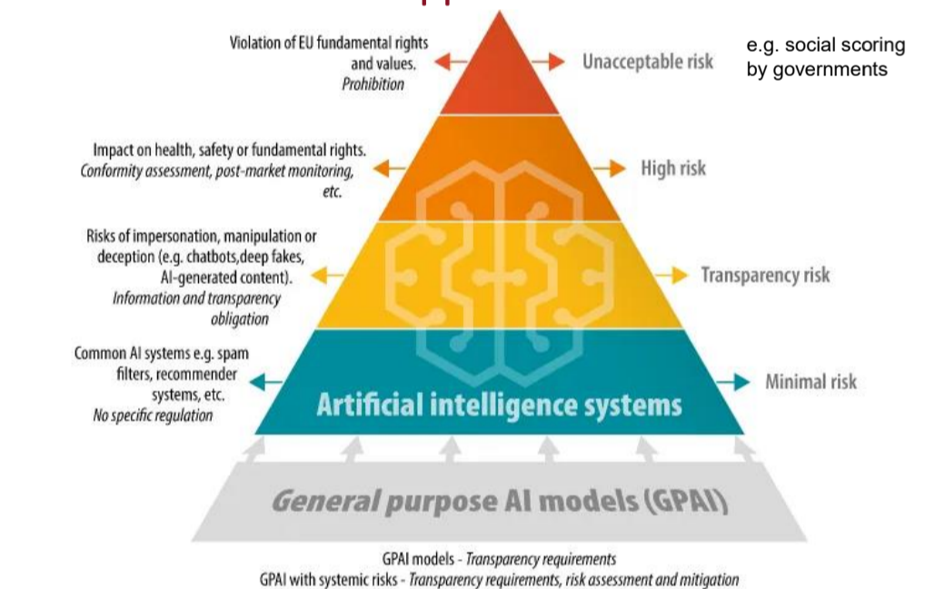

Cryptocurrencies
Evolution of trading: Barter -> Credit -> Cash
- Barter was very inefficient; you had to find someone that needs what you have and has what you want -> Coordination problem
- Credit -> Owing someone something, being owed something is not good
- Cash -> financial mean, intermediary good: needs bootstrapping
To pay on the internet, originally services like Paypal, Gift Cards, Online-Banking and primarily Credit Cards were used.
Problem: Originally no HTTPS -> no secure transmission of information, no proof of vendor’s trustworthiness
Direct Payment | 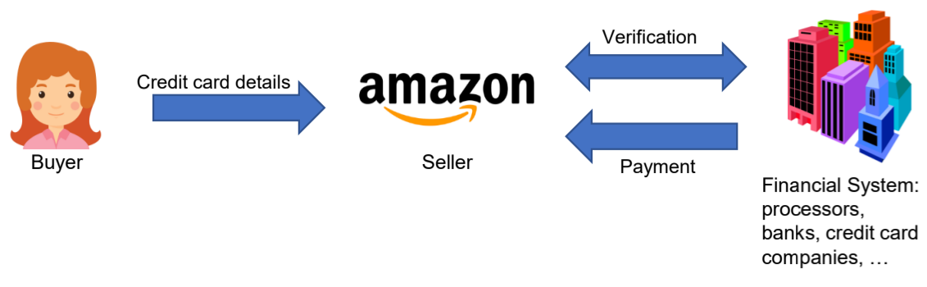 | Details stored by seller
Payment through Intermediary | 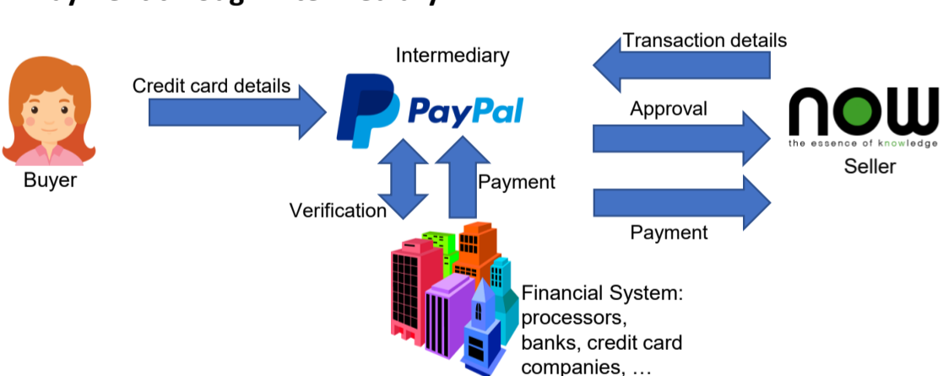 | Seller doesn’t get credit card details, buyer doesn’t have to deal with financial setup

Digital Currencies
Idea of “digital cash”, acts like physical cash but should eliminate banking institutions from transaction process:
- No transaction fees
- Fast exchange of funds
- Confidentiality
- No after-the-fact revocation of payment
Original “Ecash "still needed banks to implement protocol. Merchants are not anonymous (need to return coins to bank to get money) -> failed

Cryptocurrency
Only exists digitally, no central issuing/regulating -> uses decentralized system to record transactions/manage issuance of new units -> relies on cryptography to prevent counterfeiting and fraud
Oxford definition: “A digital currency in which encryption techniques are used to regulate the generation of units of currency and verify the transfer of funds, operating independently of a central bank”
Challenge: no double-spending, solved with (decentralized) Ledger (record of transactions), get consensus about rules, history and value of coins
Benefits: no intermediaries -> greater level of autonomy & no middleman fees, no frozen accounts, more privacy, international transactions without exchange rates
Fundamentals of cryptocurrencies:
- Cryptographic hash functions: maps data to fixed-sized values
- Collision resistance: infeasible to find two values with H(x)=H(y)
- Hiding: no way to find out x from H(x)
- Puzzle friendliness: no solving strategy better than random values
- Digital Signatures: Analogue of handwritten signature: only you can make it, everyone can verify you
- Algorithms needed are generateKey (private and secret key), sign and verify
- Hashes get signed instead of messages to increase limit of signable messages
- Public Key = identity, can only be sign with if you have secret key

To timestamp documents, you should store hash of whole chain decentral, e.g. AbsoluteProof publishing hashes in New York Times

Bitcoin
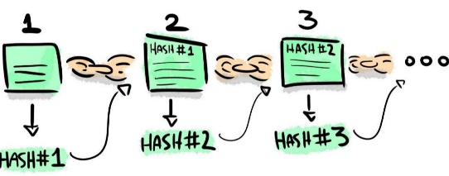
First cryptocurrency, invented in 2009. Utilizes blockchain to make ~500k transactions per day.
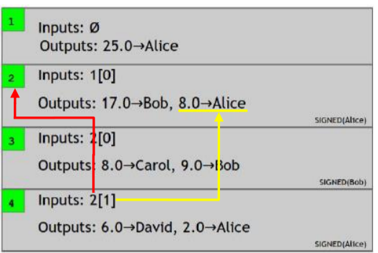
Blockchain is a publicly available record of all transactions ever made with BTC and reveals who owns how many BTC. Consists of linked blocks: Each block contains many transactions and is linked to the previous block. New block validated and added every 10 mins, once entered cannot be changed anymore. No central authority; uses SHA-256.
Transactions have unique id and must be confirmed (signed) by other BTC users, no private information involved.
Users are connected in P2P network, where the nodes are devices connected to BTC network. Each node contains own copy of whole blockchain, share update with other nodes (consensus)

Bitcoin Mining
Comparable with gold rush; Process of adding new legitimate blocks performed by miners running mining software -> requires a lot of processing power with expensive hardware & electricity; competition against each other – only first miner gets reward (currently 3,125 BTC)
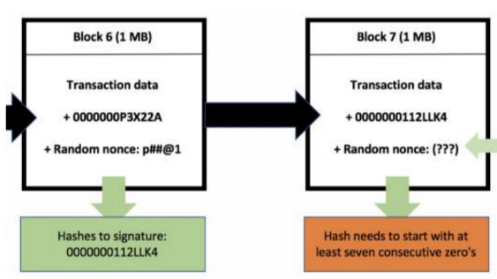
Tasks:
- Listen to transactions and validate them
- Maintain the blockchain and listen for new blocks
- Assemble candidate block (and provide Proof of Work PoW)
- Find a nonce to make block valid (most work) and broadcast the block
- Hope your block is accepted
- Profit
Stakeholders: Core developers, miners, merchants+customer, investors, payment services

Altcoins
1000s of alternative coins available, a lot of them are just “trash”
Biggest alternative: Ethereum: “is a decentralized platform that runs smart contracts: applications that run exactly as programmed without any possibility of downtime, censorship, fraud or third-party interference.”. Also runs on a blockchain, distinguished by smart contract (“Automatically executable lines of code that are stored on a blockchain which contain predetermined rules”, e.g. transaction of certain amount on certain date) executed my Ethereum Virtual Machine (EVM)
Other altcoins:
- Ripple, Dogecoin, Cardano, Litecoin

Criticism
- Undermines capital control (flow of capital) in or out of country
- No identity -> crimes like tax evasion and illegal stuff easier than ever, e.g. Silkroad & Ransomware
- Value only based on speculation: instability
- Environmental impact: Electricity & E-Waste
- Pump-and-Dump

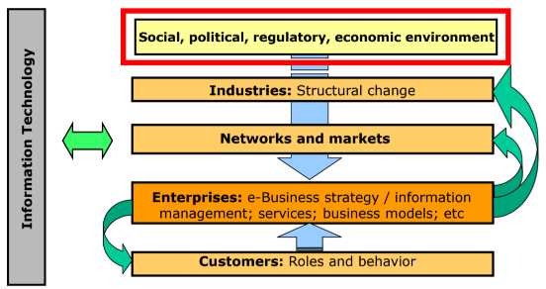
Privacy and Ethics in E-Commerce
Increase of collected data and environmental impact causes a need for restrictions

Personal Data
To protect personal data, General Data Protection Regulation GDPR (Datenschutzgrundverordnung DSGVO) was introduced in 2018. Fines up to 20Mil €. There are many prominent cases of companies breaching GDPR, resulting in high fines.
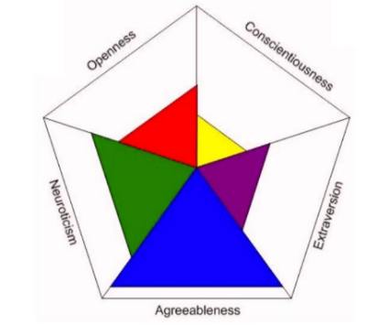
If Data is anonymized and it cannot be “traced to who it is from”, it is not directly affected by GDPR. Example: Anonymized Query Log logs without IP and other personal information was thought to be anonymous, but due to search queries it still can be traceable to individuals -> even forms challenges, like Netflix Prize to predict user ratings based on previous ratings, even revealing political preferences and other sensitive information.

Personality profile
Personality can be described with the traits (big five personality traits):
- Openness to experience: Curious, artistic, insightful
- Conscientiousness: Efficient, organized, responsible
- Extraversion: outgoing, enthusiastic
- Agreeableness: Appreciative, sympathetic, kind
- Neuroticism: Anxious, unstable, Worrying
With those traits, the personality can be predicted -> also gives away other information

Emotion profile
Users self-reported stress & happiness, with big five personality traits and weather data as background data and mobile phone data (General phone usage, diversity, active behaviors, regularity) it could predict happiness.

Ethics
GDPR also prohibits algorithmic discrimination: “Every data subject should […] have the right to know and obtain communication [...] (of) the logic involved in any automatic personal data processing“.
Algorithms are used in a lot of different fields: justice, job applicant selectin, credit and insurance assessments.

Dark Patterns
GUI choices made to deceiving users into making unintended, potentially harmful, decisions.
- Sneaking: mispresent user action/delay information (sneak into basket)
- Urgency: Imposing a deadline to accelerate user-decision (countdown timer)
- Misdirection: Steer users away from making particular choice (opt-out instead of opt-in)
- Social proof: Influencing behavior by describing behavior of others (“x saved this on that”)
- Scarcity: likeliness of unavailability increases desire (low-stock message)
- Obstruction: Making it easy to get into situation but hard to get out (hard to cancel)
- Forced action: Forcing user to do something in order to complete task (forced enrolment)
GDPR restricts deceiving and nudging.

Price steering & discrimination
Price steering=Changing order of search results to highlight specific products
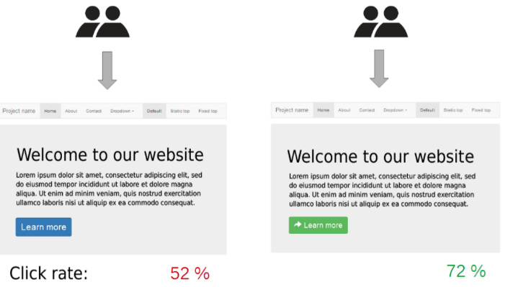
Price discrimination=Customizing prices for some users

Criteria like end device (type, battery level) and user activity (logged in, regular) affect prices and ordering

Influencing Users
A/B testing: 2 alternatives are testes and compared -> better one wins

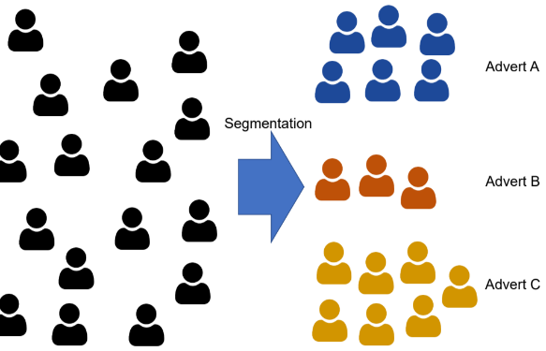
Micro-Targeting
Segmentation of target group into smaller groups

Regulations and standards

GDPR
Main effects:
- Data processing and profiling: organization only allowed to use information as intended, otherwise additional permission needed
- Right to an explanation: not clear which decisions are subject
- Bias and discrimination: Ensure fair and transparent processing

OECD Fair Information Practices
Defined in 1980, still applicable
- Collection limitation
- Data Quality
- Purpose specification
- Limitation
- Security Safeguards
- Openness
- Individual Participation
- Accountability

