Algorithms in Graph theory
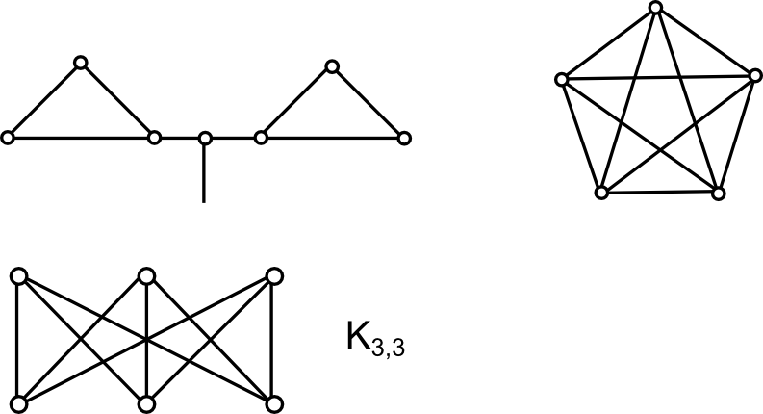

V endliche Menge von Knoten vertices
E multiset of edges - kanten

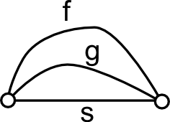
e = xy, f = xy s = xy - multiedge

: number of edges joining x and y

28-6-8+2=16
e = [x,y] = [y,x]
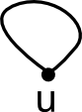
loop - Schlinge

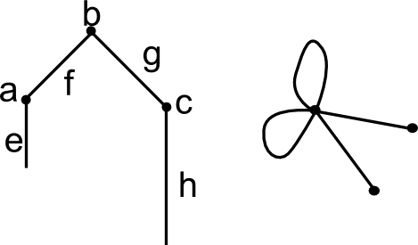
HANDSHAKING L

: In a graph, the number of vertices of odd degree is even.

Simple Graphs
Degree of v in V, d(v) = "#" of edges
Grad v in V incident with v, counting loops witce.

od ... out degree
id ... in degree

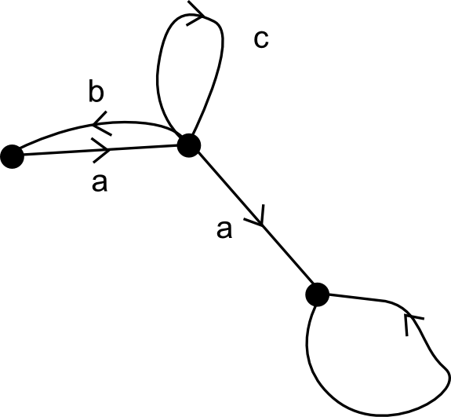
a = (x,y)
b = (y,x)
BÖGEN
: od(v) = (v) = Number of arcs indicent from v
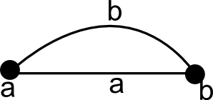

Subgraphs
Gegeben: Graph G:
is a subgraph of G if and G' is a graph.
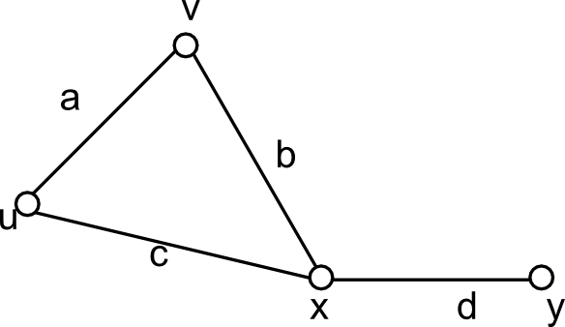
subggraph of G
is not a subgraph

Graph orientation

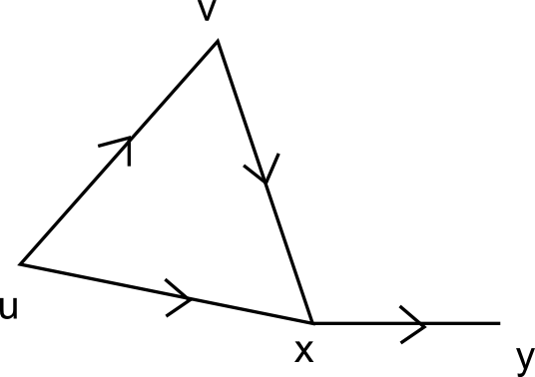
You choose what is head and tail for each edge

Walking through a graph

A Walk W is defined as:
such that
If in a walk all edges are different, then this walk is called a trail (Kantenzug) joining .
A walk is called a covering Walk if it contains all edges of G.
If a covering trail is closed, then its called eulerian trail.
[Already euler in 1736 produced arguments starting with the problem of "7 bridges of Königsberg" and explained why it is not possible.]
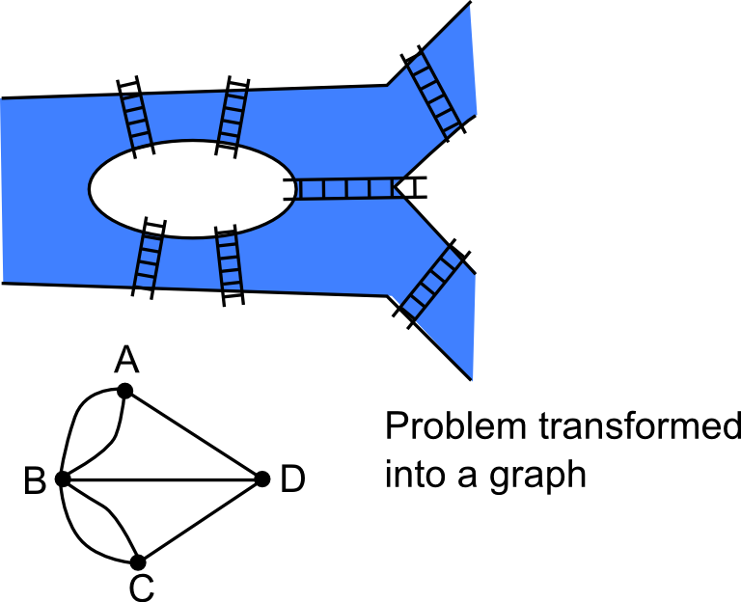

For a walk, you traverse the arc in the correct direction.
If however, then W is called a chain. It is called a siple chain, if no point is repeated.
I the ??-algorithm we will construct a special chain starting at the entry and ending at the exit of the network.

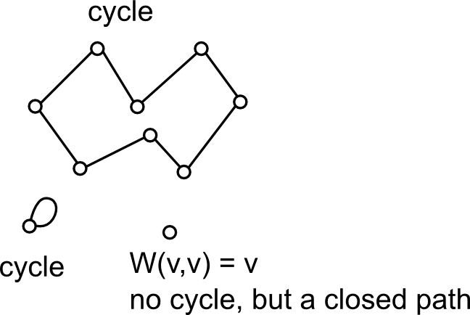
An open trail T is a path (Weg) if no vertex is traversed more than once (so all vertices are different)
A closed trail is a cycle (circuit) if all vertices are different except for and it containes at least one edge.
Proposition: In a walk there is a subsequence which is a path.
Proof:
Let be the largest index such that
So we know that
Let j_1 be the largest index such that

Continue this construction of a path as long as has not be reached. If in the course of this construction , then stop. is a path. []

Names of special types of vertices/edges
G (capital letter G means digraph)
isolated vertex: d(v) = 0 in a digraph G
end vertex: d(v) = 1 in a digraph G
You cannot go beyond an end vertex.

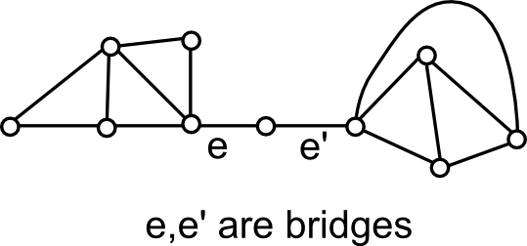
And edge is called a bridge if it is not contained in any cycle.

Connected Graphs
is called connected if all P(v,w) in G .
Note: .
A graph which is not connected is called disconnected.
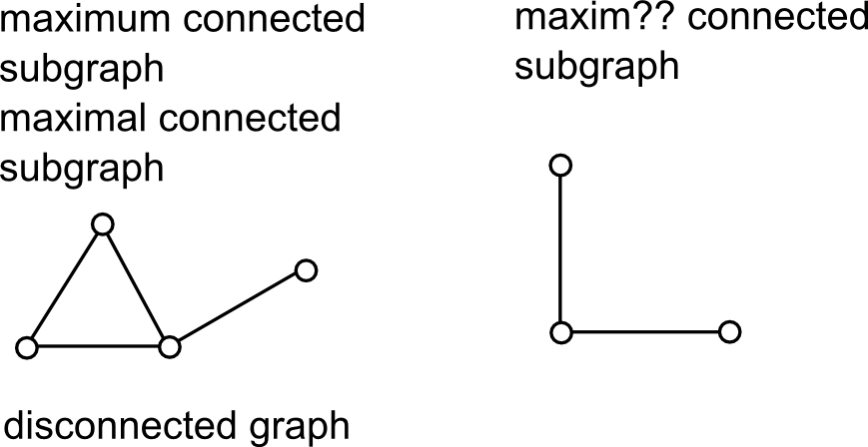
A subgraph of G is called component of G if it is a maximal connected subgraph of G.
Maximal subgraph: If it cannot be enlarged by adding vertices/edges. A maximum subgrapph is the largest possible subgraph. A maximum connected subgraph would be the largest possible component.

Exercise: Given a graph
relation: for
Show that this is an equivalent relation. Equivalent clases are the components of the graph G - Partitions.

2. Vorlesung
Show the equivalence relation:
The sequence starting at x and stopping at the same point is a path, so therefore x is in Relation to itself.
Symmetriy: You have an undirected graph.

both give a W(x,z) - but we have proved:
Equivalence-Relation gives you a partition.

We can say: all are connected subgraphs. So any vertex in is joined to x

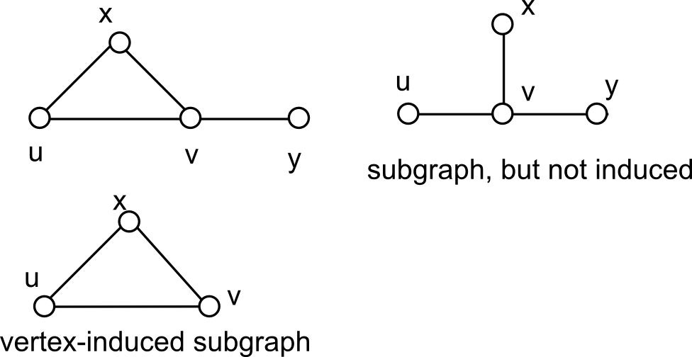
Subgraph of G induced by : <> =

Connectedness in case of digraphs

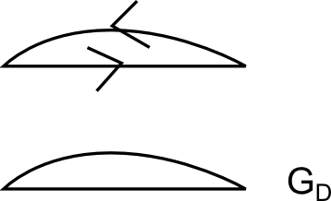
Chain: In a digraph, we don't care about orientation when searching for connected
A graph is called weakly connected if is connected
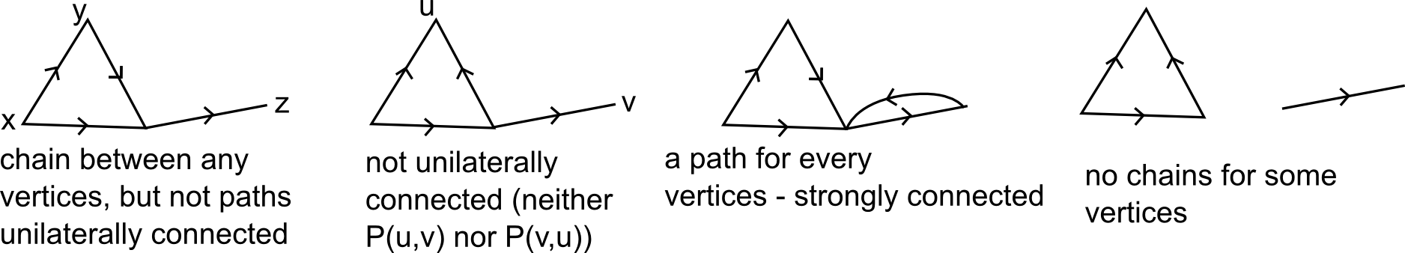
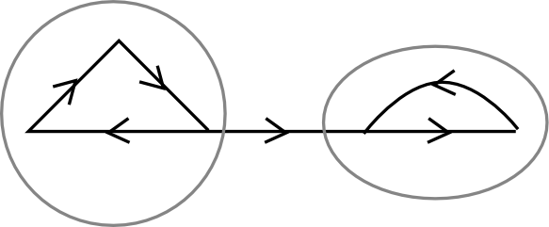
D is called strongly connected if - also an equivalence relation (more or less same arguments as before). A strongly connected component is a maximum strongly connected subgraph. In the case of undirected graphs, every edge belongs to exactly one component - not the case here.

D is called unilateraly connected if . It does not induce an equivalence relation because transitivity is missing - so unilateral connected components would not be disjoint.
A graph G,D is called acyclic if it contains no cycle.
An acyclic graph G is called a forest. A forest with preciecly one (!1) single component is called a tree.
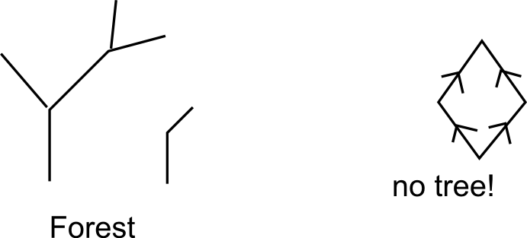
A digraph D is called a tree if is a tree - so a connected acyclic digraph is a tree

then you say: is a spanning subgraph of G or spans G.
Theorem: A graph is connected contains a spanning tree.
A tree is connected and thus the Graph must be connected so trivial
G connected. If no edge belongs to a cycle is acyclic is a tree

Suppose:
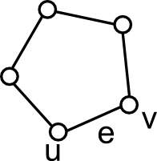
. Look at arbitrary Path If
Suppose

is a Walk in
Finally arrive connected acyclic
so therefore this is a spanning tree.
Induction: start: Single node. ...

G (loopless) is called nonseperable if G is connected and G -v connected
A vertex (loopless) is called a cutvertex if G-v has more components than G.
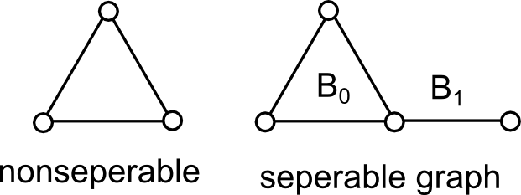
A maximal (by set inclusion) nonseperable subgraph of G is called a block of G.
is called a bridge if it is not contained in any cycle of G.
A tree is a connected subgraph where every edge is a bridge.

is a complete subgraph with 2 vertices and 1 edge (so n vertices and edges between every vertice). If we habe a graph with , then the edge is necessarily a bridge.
If a block B of G is a , then the edge of B is a bridge of C.
Exercise: Graph G = V union E, let be blocks of G, is a cutvertex of G.
Hint: Suppose you have two different blocks with more vertices in common - both must have the property: B_1 must contain an edge not in B_2 and vice versa - then one must be a subgraph of the other - contradiction with definition - then you can find a path joining two vertices in B_1 and all the edges lie in B_2 but not in B_1 and then you can add the path and still get a nonseperable subgraph and then.

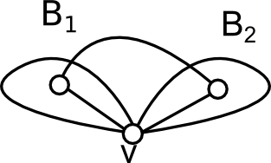
G -v is connected

Block-Cutpoint graphs
G ... bc(G) is a block-cutpoint graph
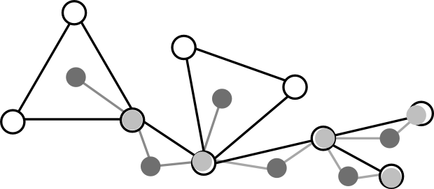
B ... Block of Every block is represented by a vertex in a block-cutpoint graph.
c is a cutvertex of
is cutvertex of G contained in B.

bc(G) is acyclic and the number of components of G equals the number of components of bc(G)
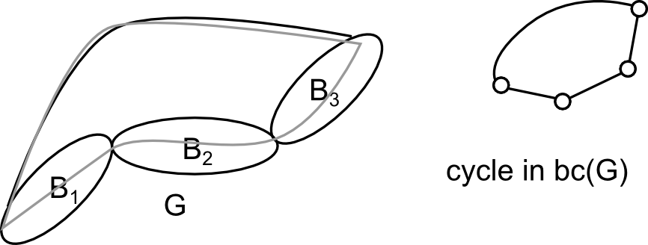

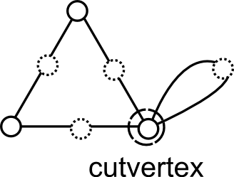
If you subdivde an edge, then some vertices can become cutvertexes. I want to make sure: A cutvertex remains a cutvertex if I reverse the procedure of subdividing edges.
Extend definition:
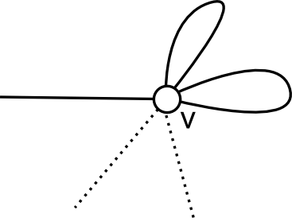
cutvertex is called cutvertex. Then each loop is considered a block.
G, bc(b) is a path is called block-chain.

Vorlesung 23.03.2012
Ex ... irgendwas mit Bridge
e in E(G) is a bridge if it is not contained in any cycles
THM connected so that every Path from
Suppose i is not a bridge → = Path joining x & y. But that doesn't work because x & y are only connected by e, no other edge connects and
Ass e = (x,y) is a bridge. G-e is disconnected if it has exactly 2 components.
Choose .
Let be the last vertex in so that in
. Note that since e is the only edge in G with a Vertex in and a vertex in
Theorem: Connected is a cut vertex iff V - v can be partitioned (Partion is not unique) into (V - {v} = ) so that every Path contains v.
Empty Graph 8 is connected.
... is called out-tree if D is weakly connected and id(z) = 0 (indegree) for some z in V and id(v) = 1 . z is called root of the out-tree.
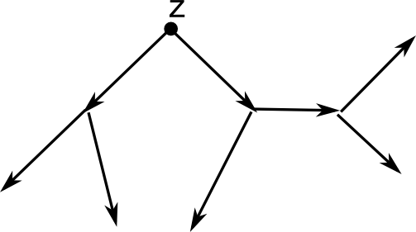
is called in-tree if D is weakly connected and od(z) = 0 for some z in V and od(v) =1 ...
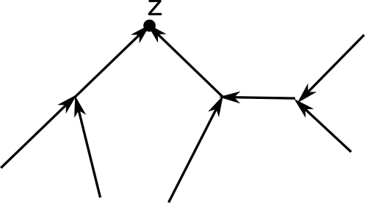
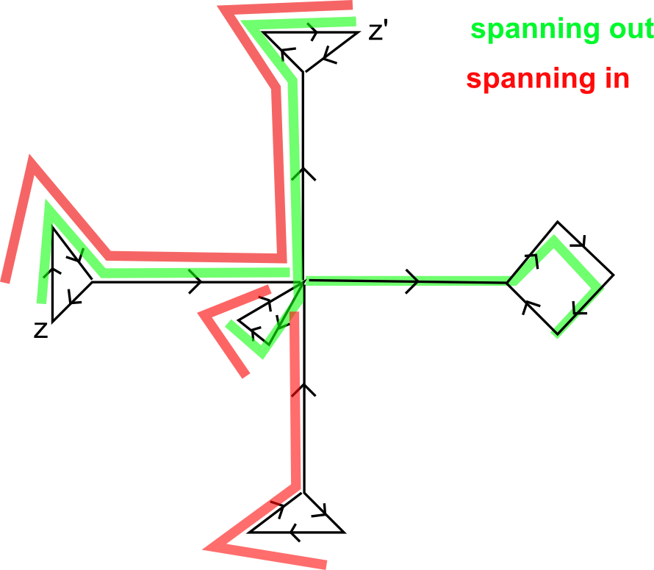

Graph neither has
Theorem: D = V union A strongly connected z in V arbitrarily exists spanning in-tree with root z, spanning out-tree with root z.
Proof: Alg. spann-out-tree erzeugen. Ich weiß für forall v hab ich ein P zu forall z
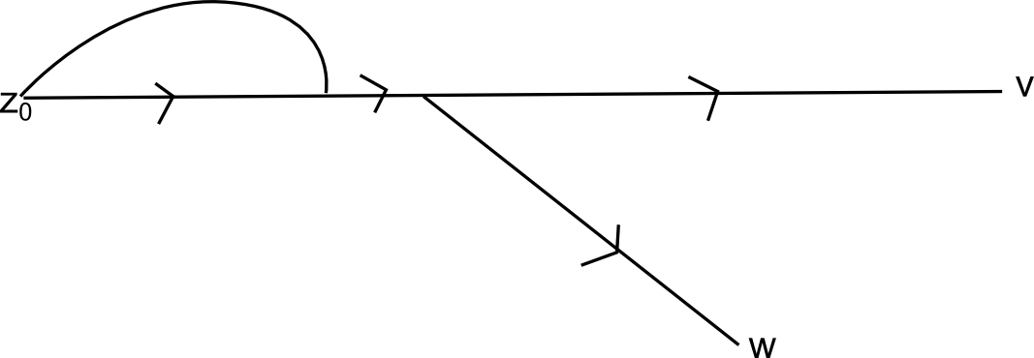

out-tree with root z.
out-tree with root z (but doesn't need to be spanning).
Suppose . Let so thathas only v with in common . is out-tree with root z repeating this procedure we obtain out-tree with root z and P(u,y) where , and = and outtree with root z and is spanning.
G nonseperable, . Assume G is bridgeless (auto if ). Let e = (x,y) in E(G). G-e connected, because e is not a bridge.
[Zeichnung 5]
Supp. endblock in G Widerspruch!

If endblock of G Widerspruch! every endblock B of G-e contains exactly 1 of x,y = c_b (cutvertex)
exactly 2 endblocks in is block chain.
---
G nonseperable, no brdiges, no loops.
Suppose with . ( ... edges incident with v)
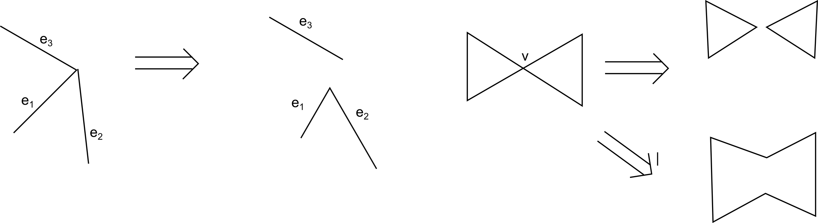

where v_1"'", v_2"'" are incident with and resp. where
is block chain x,y not cut-vertex of G-e and belong to different end blocks if G-e is seperable
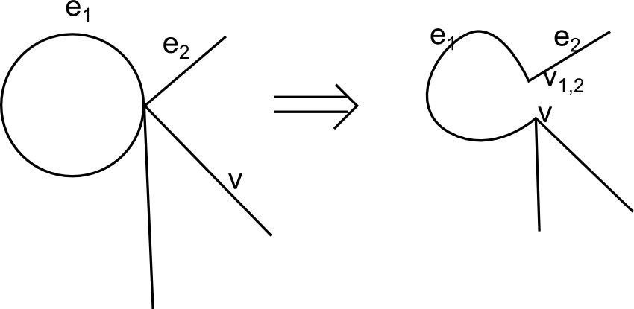

Vorlesung 30.03.2012
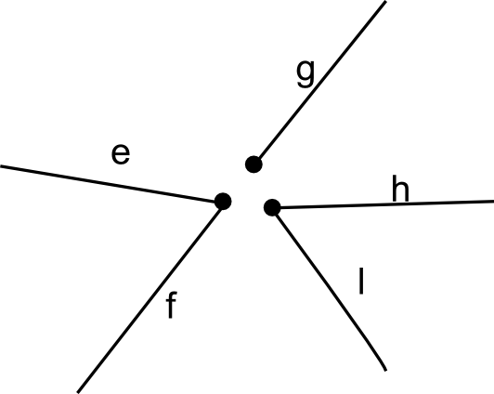

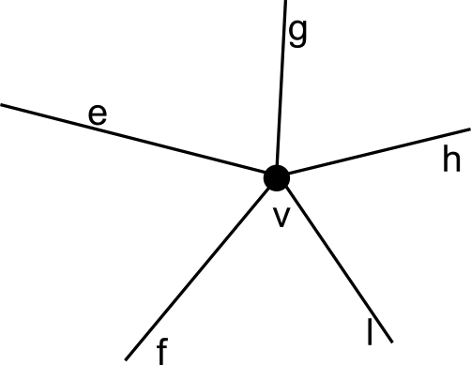

is detachment of G at v, if
detachment of G at .
are new vertices
Theorem: G connected G has a detachment which is a tree. - Proof: Exercise
Theorem: is a tree G is acyclic and is connected and
Proof exercise.
First: If G is connected and bridge, then graph self is detached - empty set.
If you have an edge which belongs to a cycle, at one of the two ends detach this edge.
In the last case if you have a tree, trivial case: no edge, second case: at least one edge → at least two end vertices → apply induction. Other way around: if a tree, clearly acyclic. Other way: This equation would give you that graph has necessarily be connected.

Digraph

entry arcs of D, exit arcs of D.
is called capacity. Mapping: from arc to nonnegative integers
Network with integer capacity -s.
arbitrary digraph.

flow (vector) if
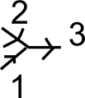
D Network, feasable flow if forall a in a -
Clearly, (zero vector) is a feasible flow in any network.
---
How to find a feasible flow in network D with integer capacities so that (flow in return arc) is maximum, is maximum flow.
feasible flow in D. Marking procedure.
1) Mark overline a
2) a) Suppose v is marked, but w not marked, .
If , then mark w.
b ) Suppose v is marked, but w is not marked, . If , then mark w.
(So mark either head or tail ...)
Claim: If is marked, then can be enlarged; if is not marked, then is max flow

Suppose has been marked .
to . weakly connected. The next marked vertex is adjacent.
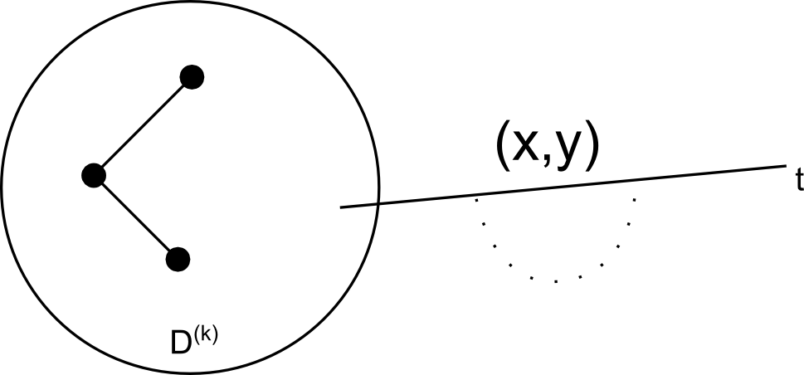
w.c. Suppose by induction induced by the first k arcs induced by the working proc., w.c. The next steps in the marking procedure involes a unique arc (x,y) (either not in ). where
weakly connected.
If has been marked, then weakly connected, so exists elementary chain in ,

%phi_(s,t) < c_(s,t)

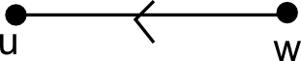

For every where
set
Likewise, For every , but
Set
; for all arcs in
set feasible.
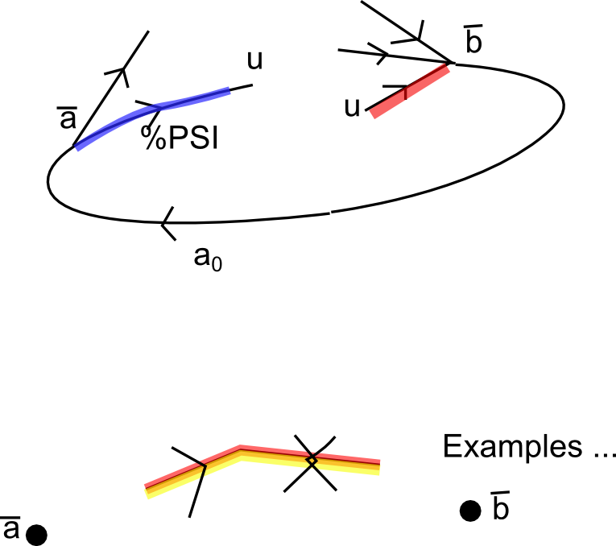
flow.
Suppose not been marked.
, .
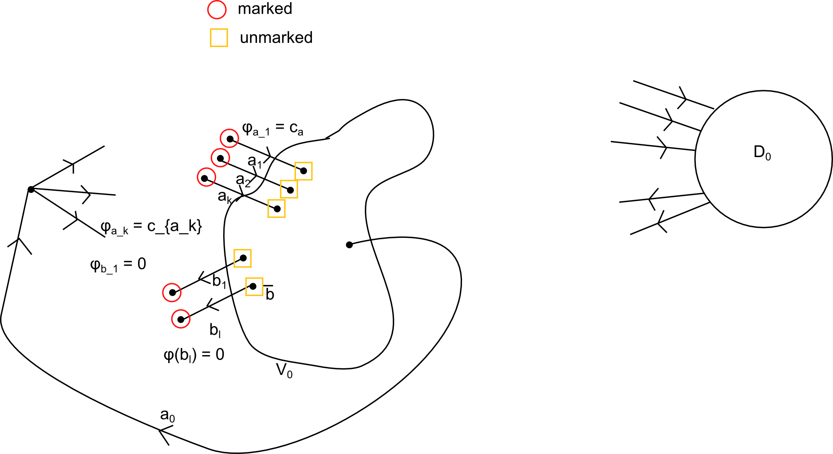
in D

Network D,
cut of D.
capacity of the cut .
For every flow & every cut

Max-Flow: Flow Cut Theorem
The max flow in Network D = min cut capcities take overall cuts in D.
Ford-Fulkerson-Algorithm yields maximum flow in polynomial time.

Vorlesung 17.04.2012

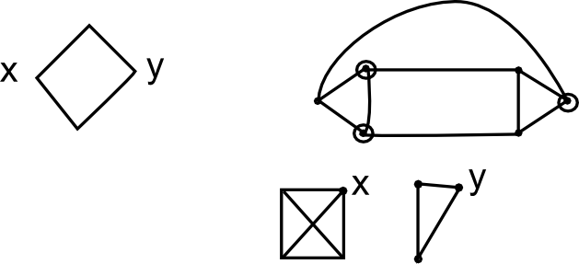
local edge connectivity
in G-E, x,y in different components

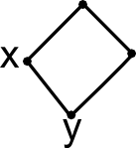

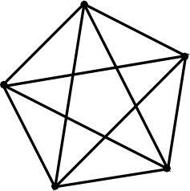
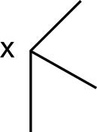

G loopless

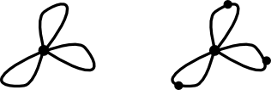

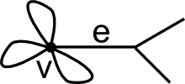

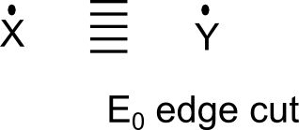

Theorem: connected, arbitrarily chosen,

Proof:

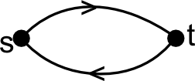

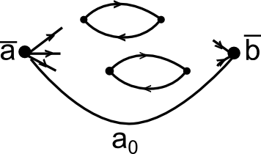

D network w. capacity s max flow in
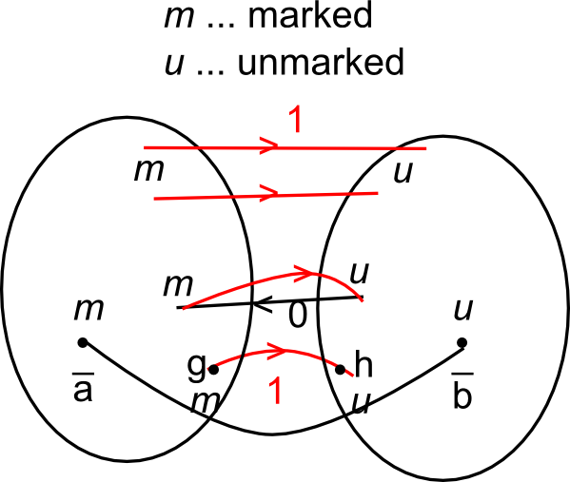
W.l.o.g. (With loss of generality) we assume that is acyclic.
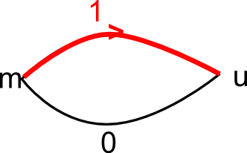
Suppose we have a cycle: Replace what is zero by a one (of loops (?)), and the result is still a flow

cut of D corresponding to edge-cut in G.

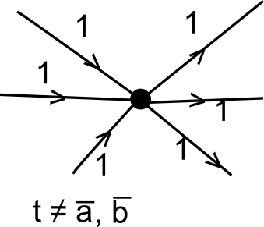

=

W.l.o.g.
is a path corresponding to

■.
----
MENGER's Theorem
who are internally disjoint
Proof: Construct network D as before. Construct a network from from D by forming a detachment at every as follows:

Add , all other arcs in D"*" have same capacity 1 as the corresponding arc in D.
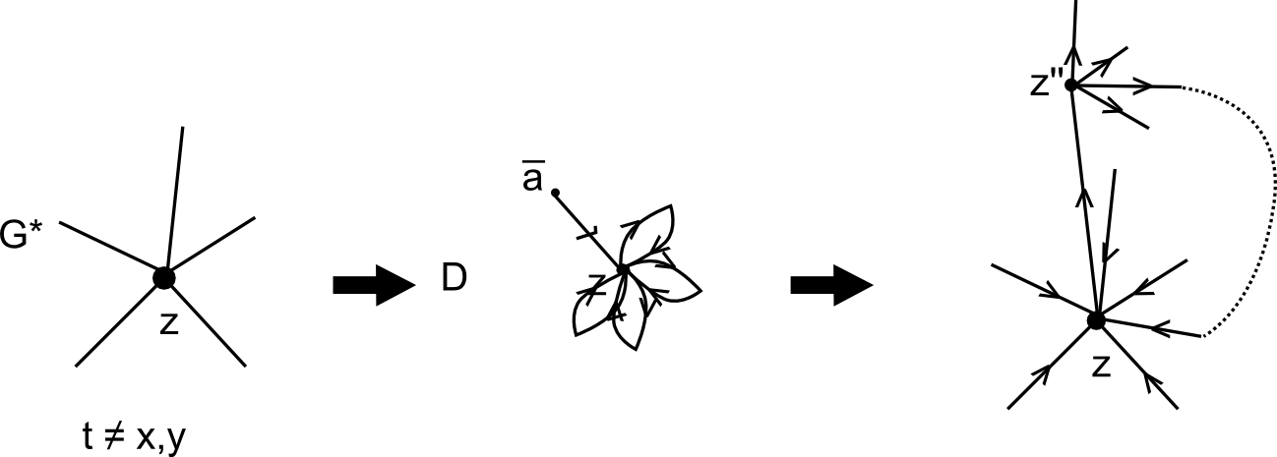
claim:

