- Construct the image of an object in a system of two lenses, the object is in the front focus of the first lens. (f2>f1)
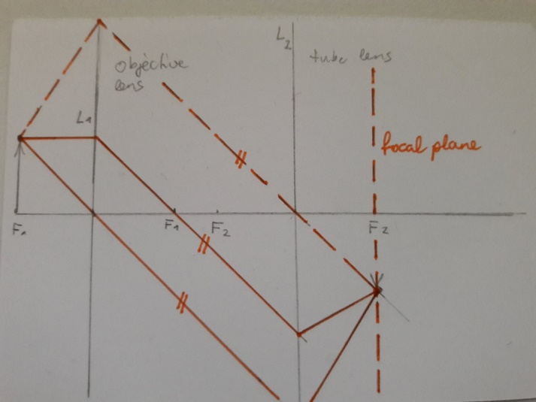
- Drawing of rays:
  - Ray 1: Parallel to axis → through focal point of L1
  - Ray 2: Through center of L1 → this ray passes straight through L1 without bending
  - Between L1 and L2: all rays are parallel to each other, because the object is on the first focus
  - Ray 3: goes through the center of the second lens, the ray does not bend, and must be parallel to the other rays
- Rays are parallel, because the object is at the front focal point of L1!
- So, the images forms at the back focus of L2

- What happens if you make the distance between the two lenses bigger (object stays the same)?
- The image would shift, for example L2 shift to the right, the image would also shift to the right

- What do you call the lens?
- L1: objective
- L2: tube lens

- What kind of wave between the lens?
- Parallel rays = plane wave
- Equipahse surface are plane
- Wave vector (which tells you the direction the wave is moving) is the same everywhere, pointing in one direction
- Can be seen as a small part of spherical wave, observed from very far away

- What will be the consequense, if we introduce a circular pinhole in the back focus of the objective lens?
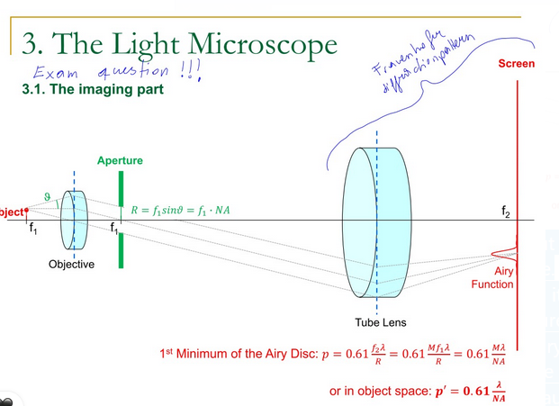
- Not all rays are included and only the ones which goes inside the pinhole and this causes diffraction
- Marginal ray is just able to cross the aperture and is independent of the position of the object
- Aperture radius: $R=f_{1}*sinϑ=f_{1}*NA$
- $ϑ$ = angle of a certain k-vector, with respect to the optical axis
- NA = numerical aperature; quantity that measures, how much light we actually calculate in a microscope
- Diffraction: rays outside of the aperture are not included

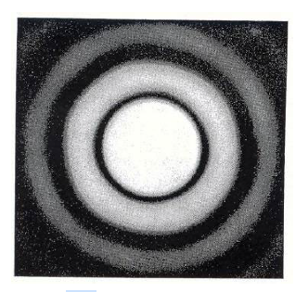
- What does the image with the introduced cirlucar pinhole looks like? 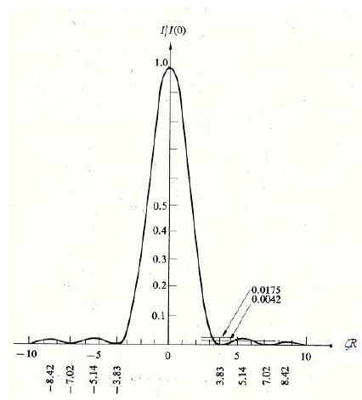
- Airy function: pattern, which we get after a circular aperture
- Airy disk: that’s how the Airy function looks, if we look from the top; concetric dark and bright rings
- Airy-function is linked to the definition of resolution and mathematically this looks like: size of the airy function: $p=0.61*\frac{λ}{NA}$
it is the width of the central maxium to the first minimum
- The larger the aperature size, the sharper the image
- The smaller the $λ$, the sharper the image
- p should be small as possible for a better resolution!
- If the radius gets bigger, our Airy-function gets smaller -> higher resolution! Or by making the NA bigger!
- if we have an isotropic (= same properties or behaviour in all directions) emiiter of light, the lens ideal, we don’t have any lens errors, then we get on the back focus of the second lens the airy function
- airy function: ideal image of the idel point, which isotropically emites light
- Rayleigh-Criterion:
  - 2 dots that are moved close to each other, where you are just able to resolve it; you can just about to keep them apart, distinguish them
  - The center of the point is exactly in the first minimum of the intensity distribution of the other one

- What would happen if you make the pinhole infinitely large?
- All rays are included
- NA = $sinϑ*n$
- If we open the aperture, $ϑ$ reaches maximum -> maximum of $ϑ$ = 90°, sin(90°) = 1
- This means with a infnitely large aperaute NA = n

- The airy-function is mathematically linked to the shape of the aperature, how?
- Fourirer Transformation gives us the amplitude of the distribution
- But we need the intensity distribution, so square the fourier transformation
- Fraunhofer diffraction

- Optical transfer function:
- We can fourier transform the point spread function (psf) back, we then arrive on the optical transfer function (otf)
- That’s convinient, because then we know precisely from which special frequency, the object information is not supportes anymore
- There is a clear cutt-pff frequency, where we get 0 in the optical transfer function
- If we take the product of the fourier transform of our object and of the otf, we don’t support the region anymore
- Ans we are allowed to use the product, because in Fourierspace the product correspond to convolution in real space and image formation is nothing else then the convolution of object information and psf

- Heisenbergs uncertainty principle
- $Δx*Δp≥\frac{ℏ}{2}$
- $Δx$ = standard deviation of the particle position
- $Δp$ = standard deviation of momentum of photon and is related to the k vector, so it directly relates to $Δk$ (the uncertainty of the k vector)
- If $Δp=0$ (this means, we have plane waves, because all k vectors are parallel), $Δx$ has to go to ∞, to fulfill, the heisenbergs uncertainty relationship
- There is a linkage between positional accuracy of photons or the the position at which we can tell that the photons arrive and the type of wave
- In other words: if we have a plane wave, we don’t know where the photons com from, a plane wave is infinitely large, it has to be
- If we want $Δx$ very small, $Δp$ has to go to ∞
- For $Δp>0$, we have to focus the light, place the k vectors in a way that they meet eachother on one spot
- $Δp$ can not go to ∞: we are limited by the length of the k vector $\left(\frac{2π}{λ}\right)$

- Stimulated emission depletion microscopy (STED)
- Sample is stained with fluroscent molecules: flurophores
- 2 lasers and the process: stimulated emission process
- Excitation laser: energizes the flurophores in sample
- The molecules absorb photons from the laser and are raised from their ground state to the first excited single state
- Normally what would happen, is that an excited flurophore would return to the ground state spontanously by emitting a fluroscent photon
- But what we do here is: immediately apply the second laser
- This second laser forces excited flurophores to return to their ground state without emitting fluroscence collceted by microscope
- We seletively prevent most flurophores from fluroscing, so only tiny subset emit light
- The second laser is shaped like a doughnut: zero intensity in the center, high intensity at edges
- So, in the middle we have an excited state, because of stimulated emisson, we move the molceules down
- We need a non-linearity in the system: small incerase in laser power, causes big change
- So, when laser power is high, circle (center) gets smaller

