Sample questions for preparing to the oral exam
Contents
Datalog 2
Datalog with Deterministic Negation 11
ASP Paradigm 19
ASP Extensions 26
ASP Computation 31
Description Logics (DL) 32
Existential Rules 42
Hybrid Knowledge Bases 49
Answer Set Programming - External Evaluation 50
ASP Stream Reasoning 51

Datalog
- Which feature(s) are missing standard relational query languages?
In general, recursion is not available (can be proven - only first-order logics) following extensions: SQL3 (limited recursion), Datalog (logic-programming style language)
- Which approaches are available to define the semantics of Datalog, and how do they work? 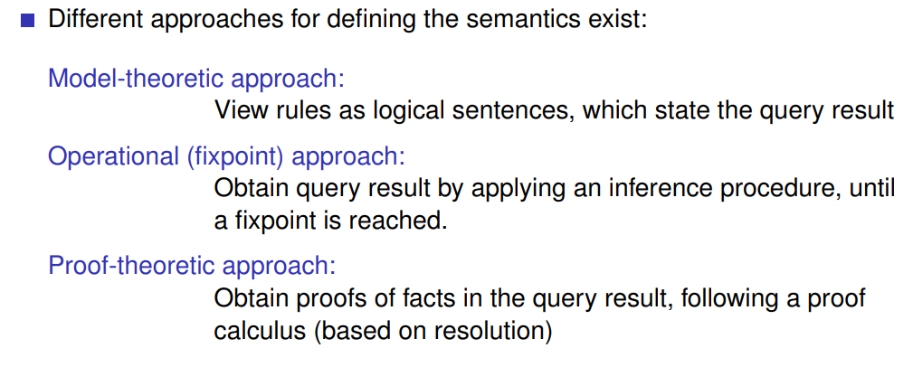
Apply rules stepwise to derive from initial information some further information
no algorithms involved pure definition; model of sentences
Take proof strategy + calculus to derive information
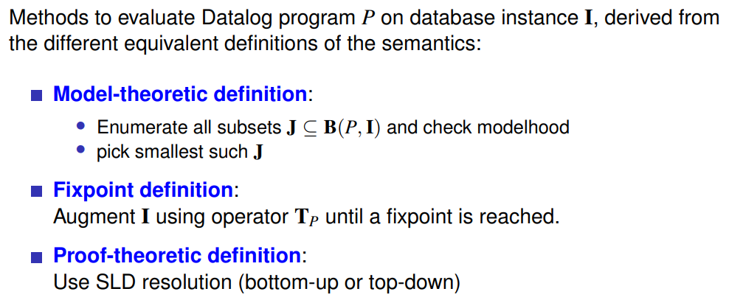
- What is active domain semantics, and how can it be ensured?
This is a syntactic ensurance to prevent infinite query results, it’s called rule safety;
it’s a prevention of introducing new values.
- Datalog syntax: how do Datalog rules and programs look like?
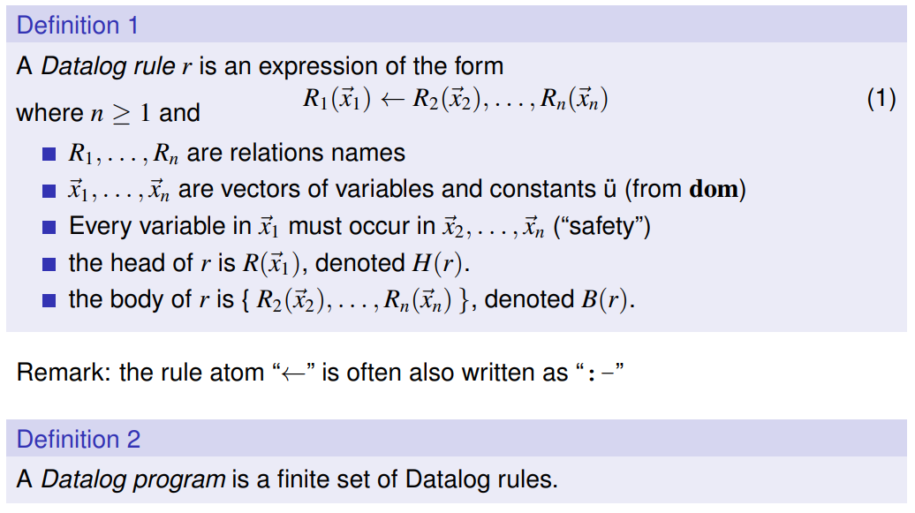
Note:
relation (SQL) == predicate (logic programming)
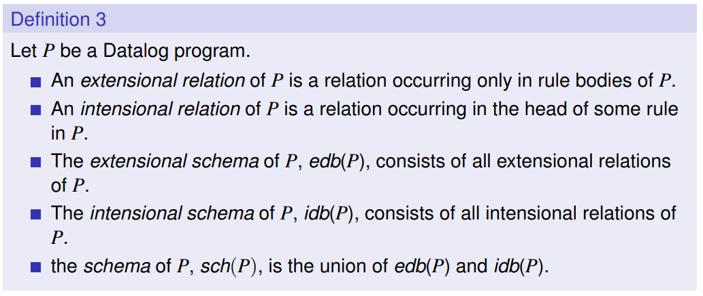
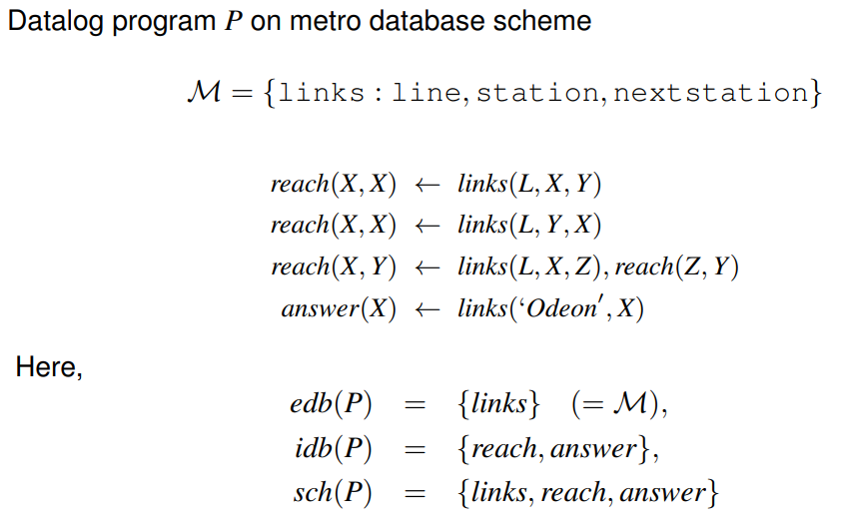

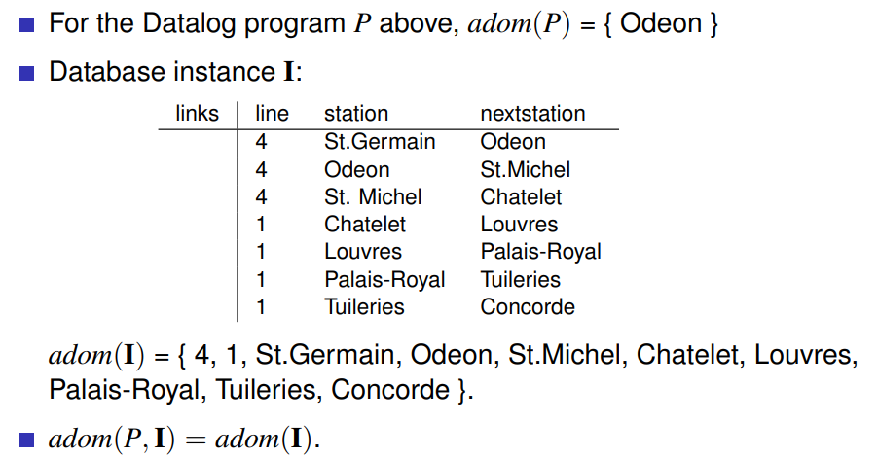
- How is the least model semantics of Datalog conceptually defined, and why is one choosing the least model?
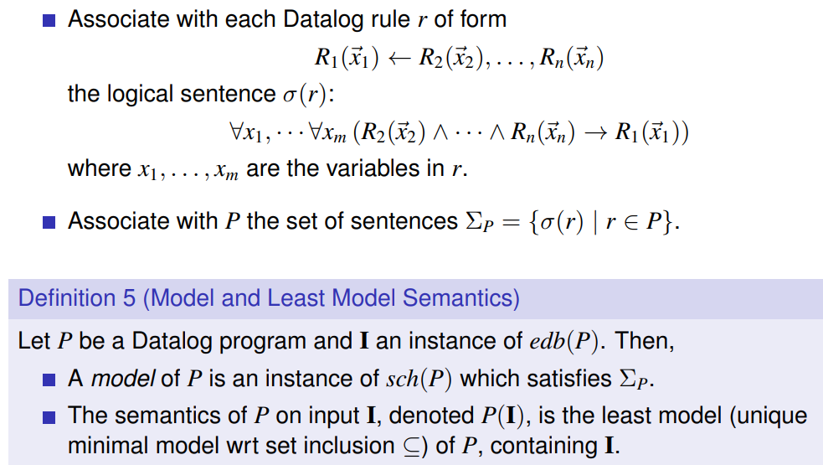
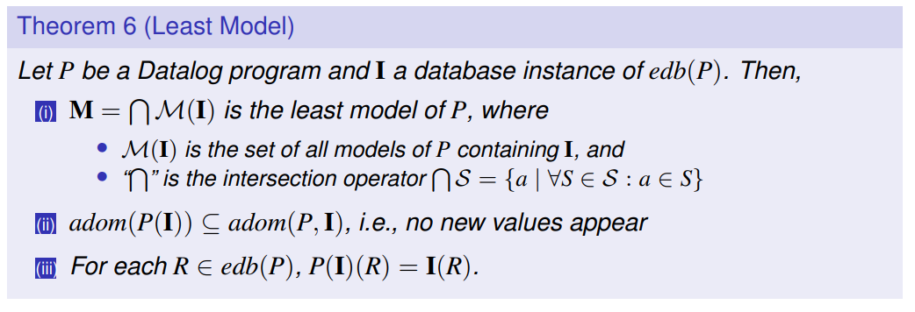
existence from fund-amental property (intersection property)
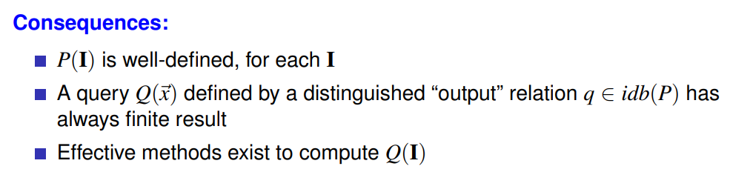
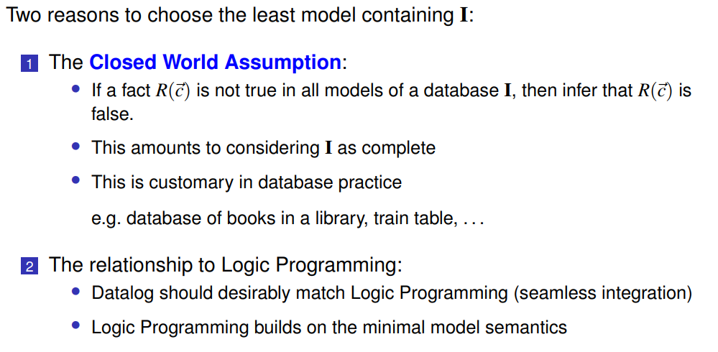
- What is Program Grounding, and what is the role of Herbrand models for Datalog?
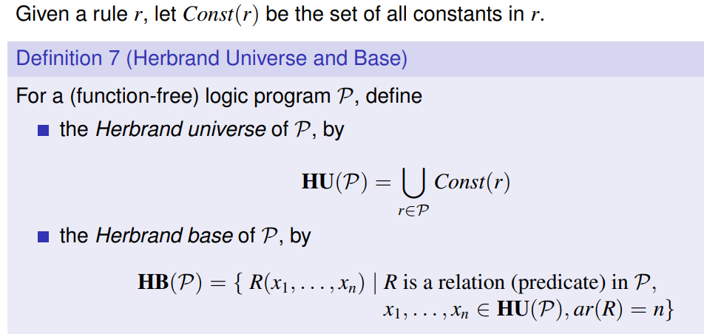
In LP: Reduce rules to ground rules by replacing the variables with constant symbols.
Program Grounding = do this in all possible ways (union of all rules)
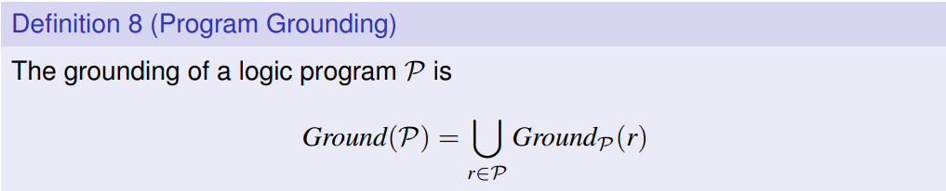
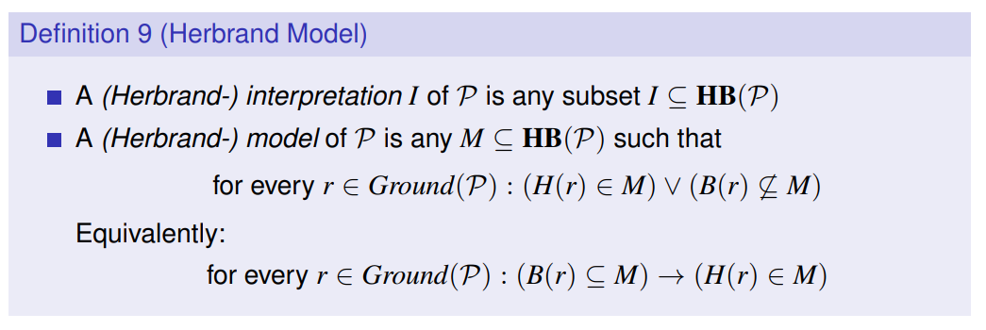
LP semantics: HB(P) … “everything is true”; MM(P) … unique minimal model
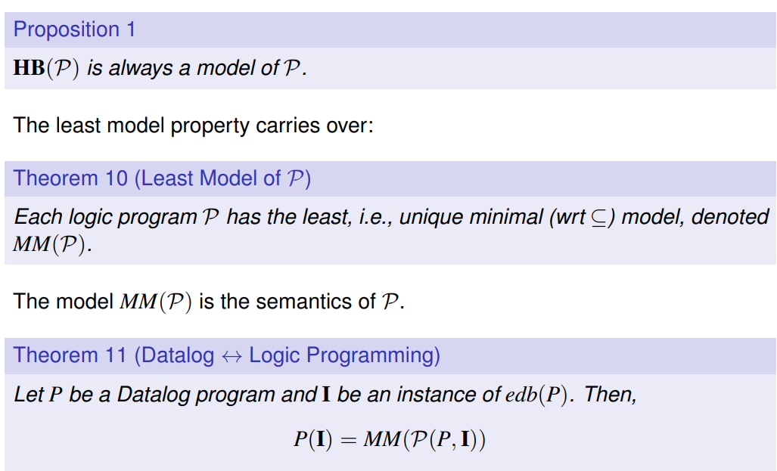
- What is the difference between Datalog and logic programming, and how can the two be reconciled (put together)?
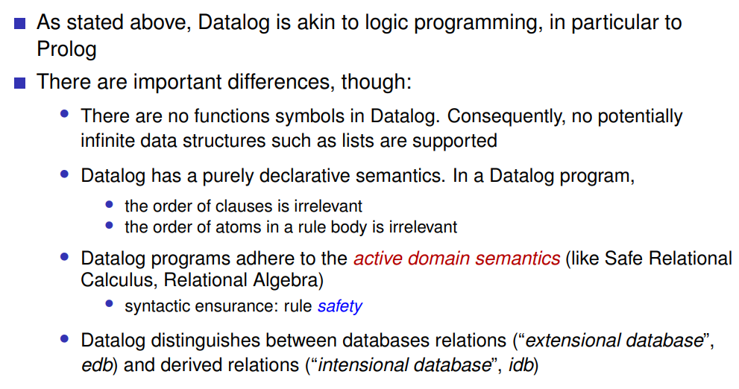
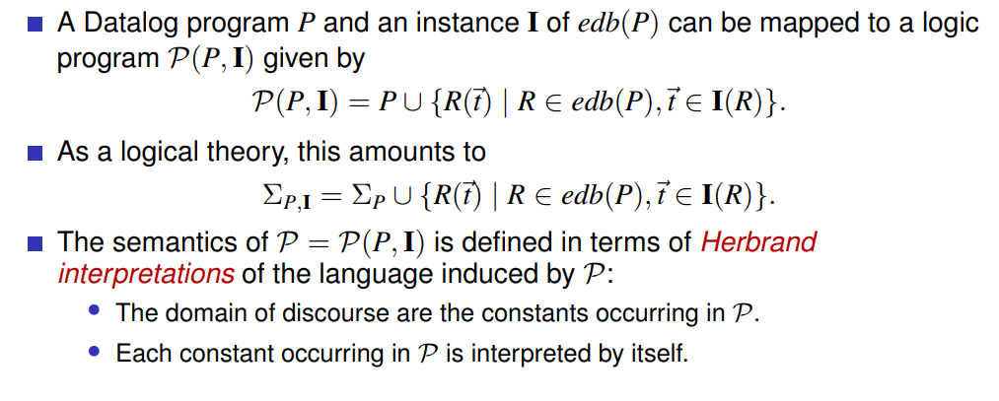
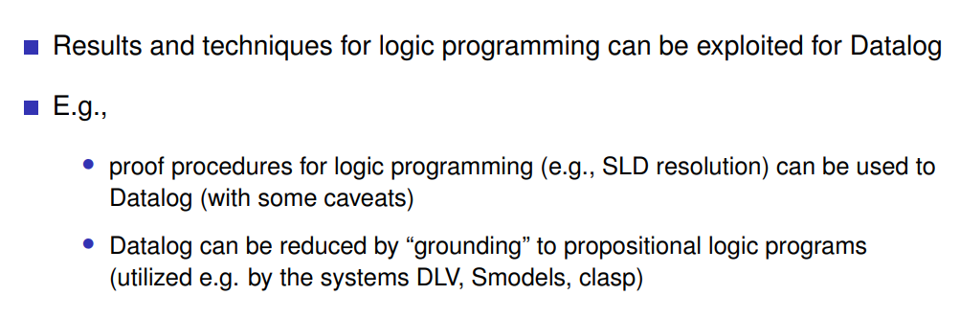
- How is fixpoint semantics for Datalog conceptually defined, and which important result of algebra is used for that?
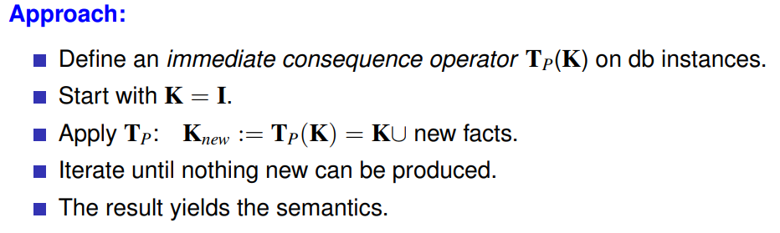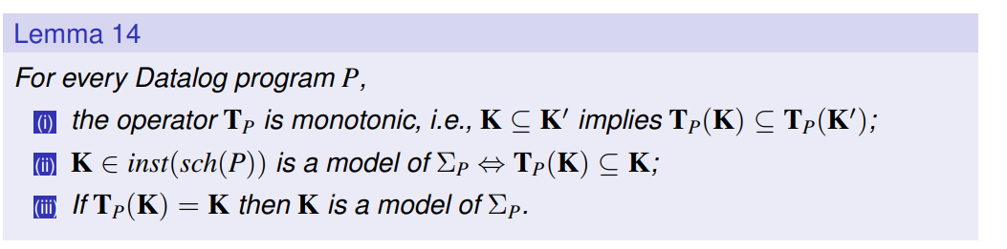
= fixpoint
iii) follows from ii)
- What is the benefit of the fixpoint semantics for Datalog?
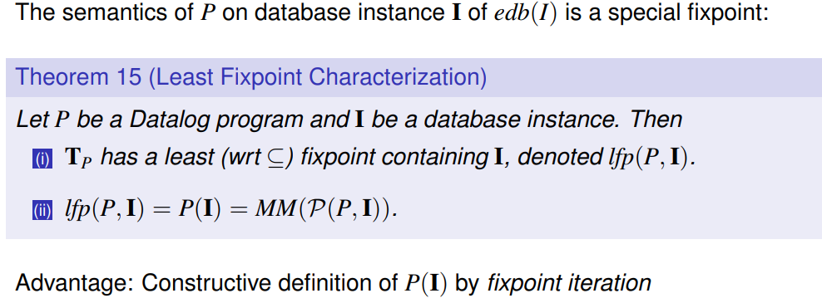
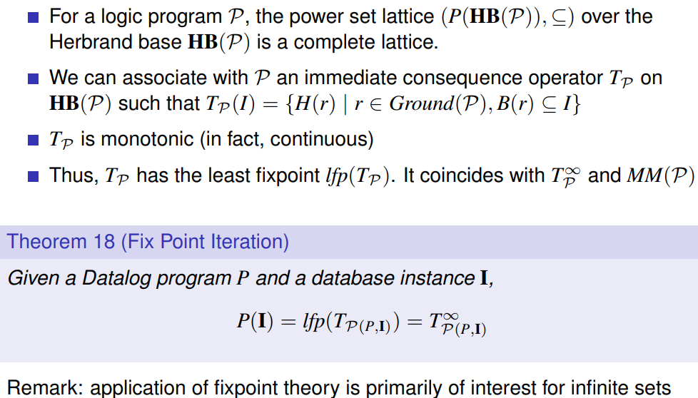
- What would happen under fixpoint semantics if not active domain semantics would be used?
The procedure would never terminate!
- How is the proof-theoretic semantics for Datalog conceptually defined?
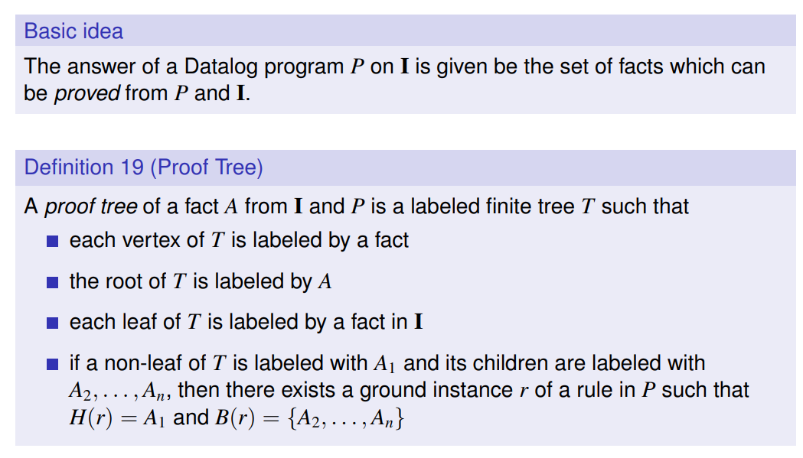

- How can proof trees in Datalog be constructed in principle?
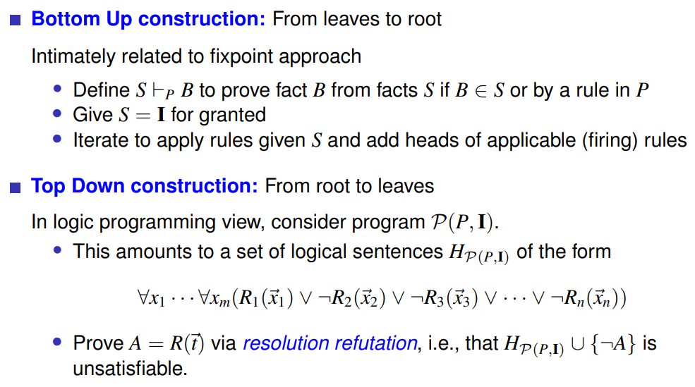
= fixpoint approach
= proof of inconsistency
- Explain how conceptually SLD resolution works. What kind of problems come with it, and how can they be resolved?
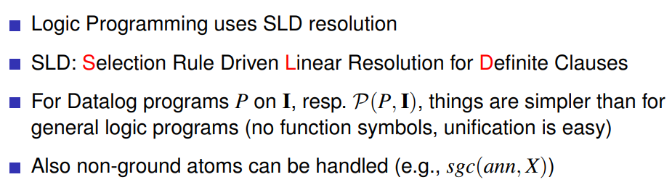
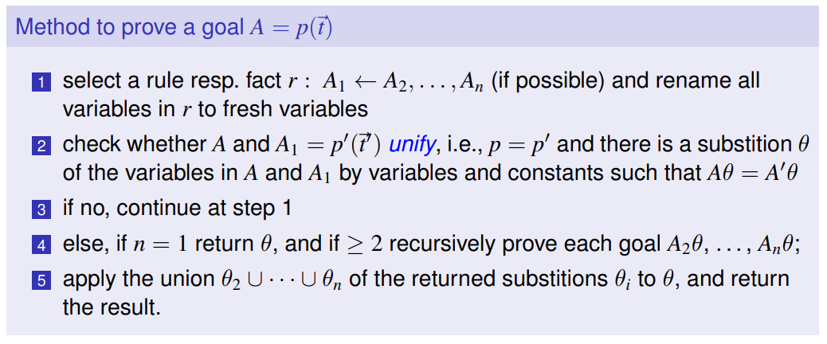
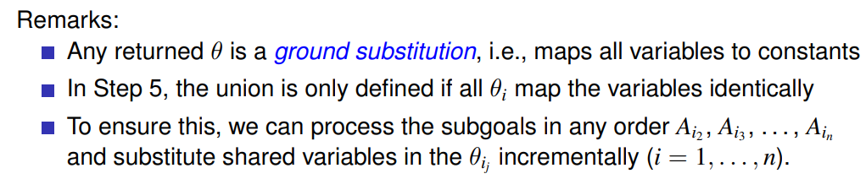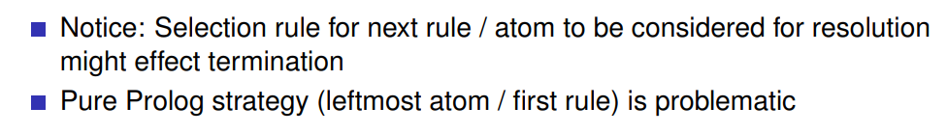
Problems:
Head recursion -> could miss answers, no termination
non-linear recursion -> all answers, no termination
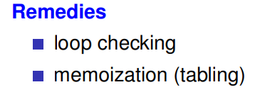
- Name some Datalog systems.
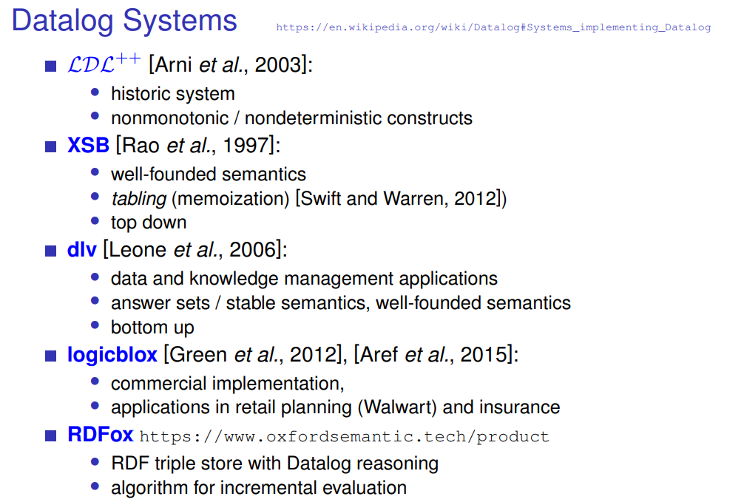

Datalog with Deterministic Negation
- What problem surfaces when adding negation to Datalog?
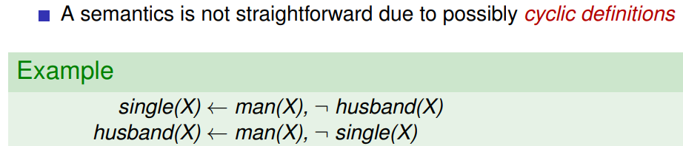
- What is rule safety, and why is this adopted?
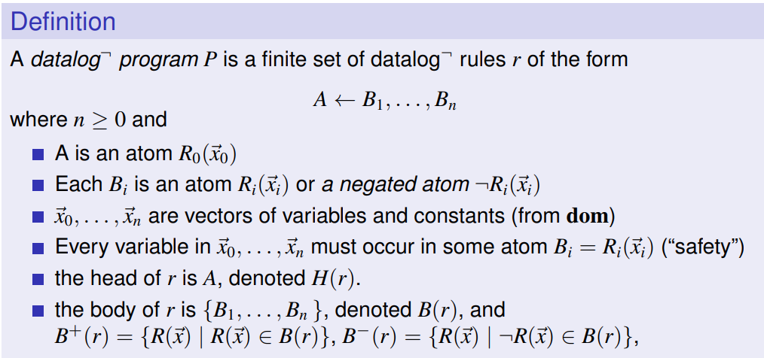
in positive atom
(NOT only in an atom under negation)!
- What problems do the fixpoint semantics and least model semantics of Datalog have when it is (naively) extended to negation?
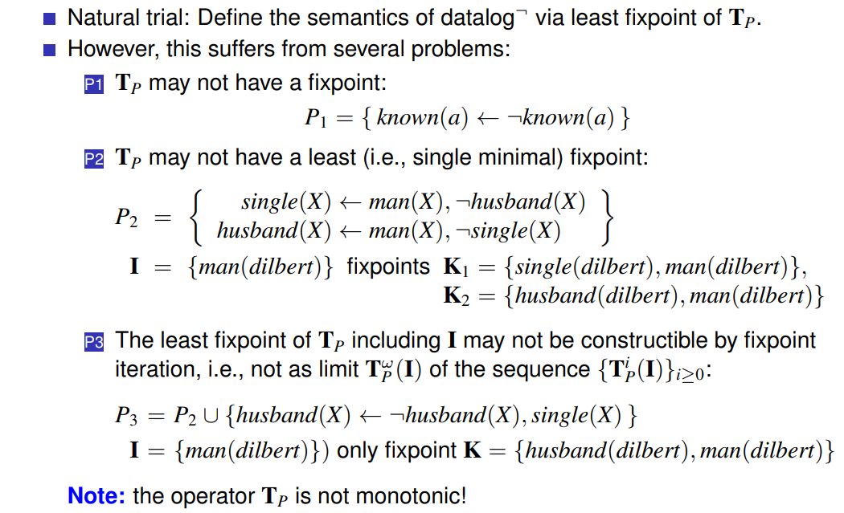
cyclic definition -> no fixpoint
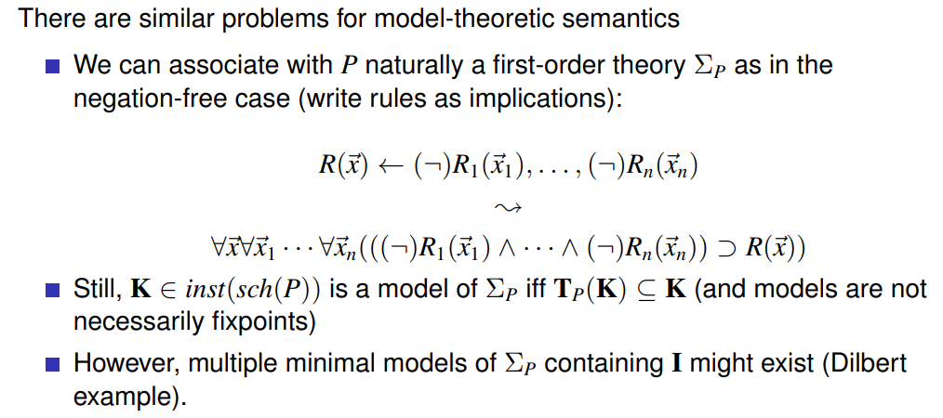
- What solution approaches exist to remove these problems?
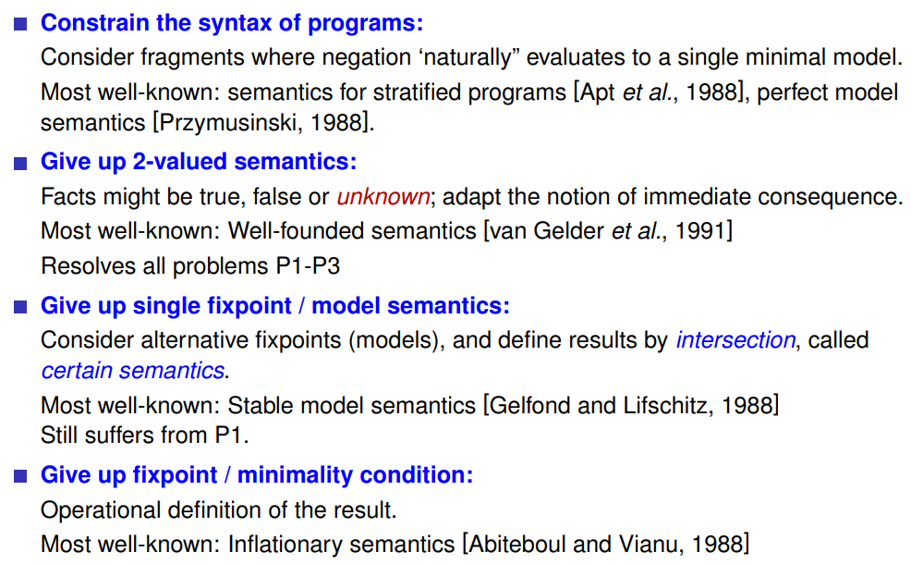
- Explain conceptually what stratified semantics of Datalog is.
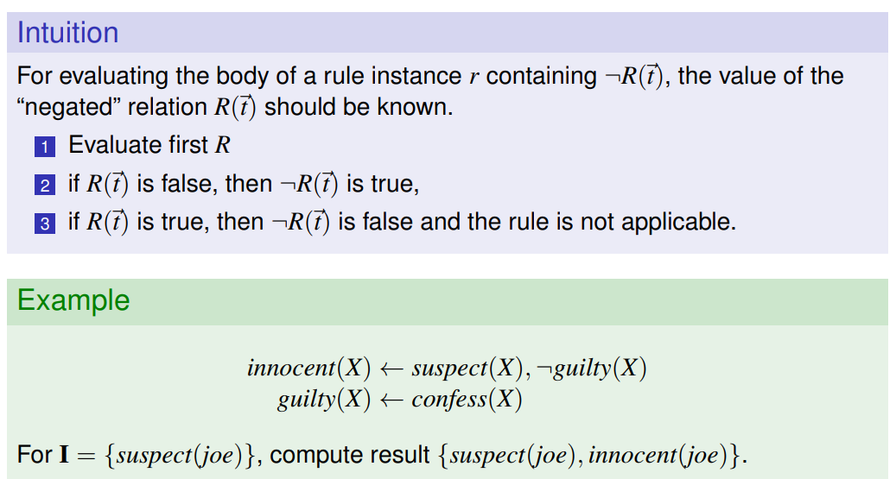
Note: this introduces procedurality (violates declarativity)!
- How is stratified semantics formally defined (just the idea, not the details)?
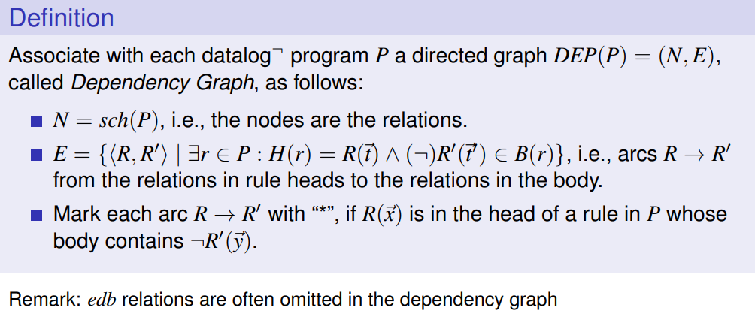
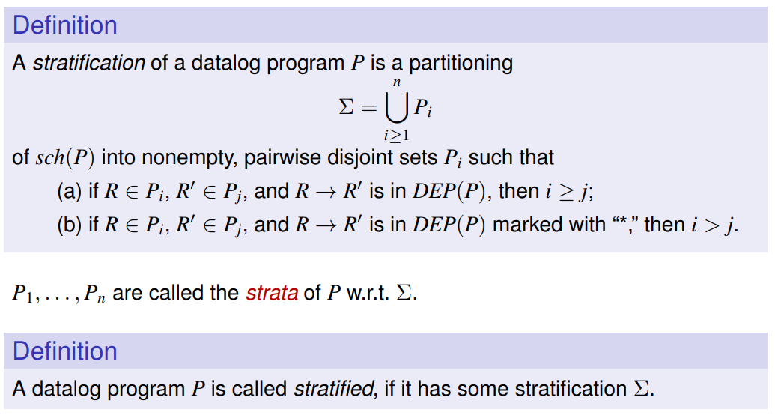

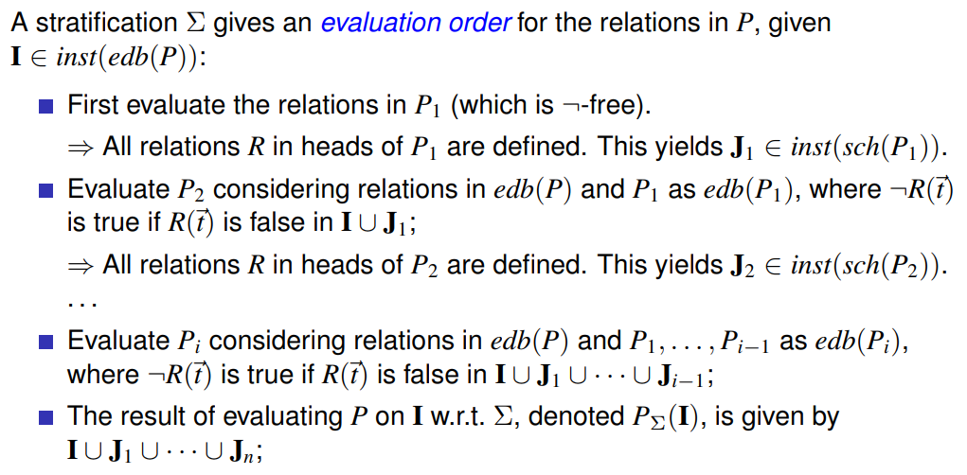

- What does the Stratification Theorem informally say, and is this important?
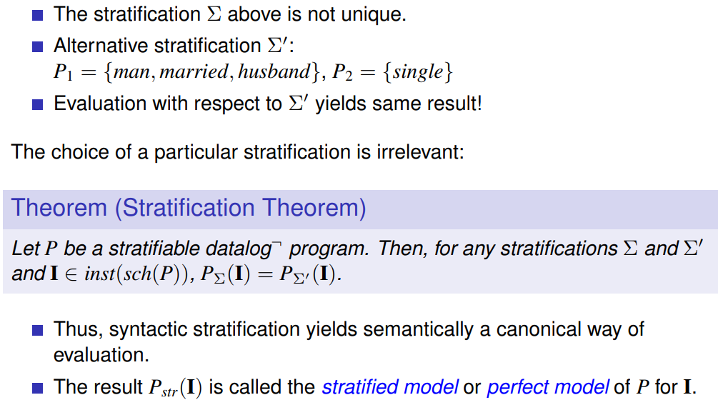
- How can we test whether a Datalog program is stratified, and how expensive is that (polynomial or intractable)?
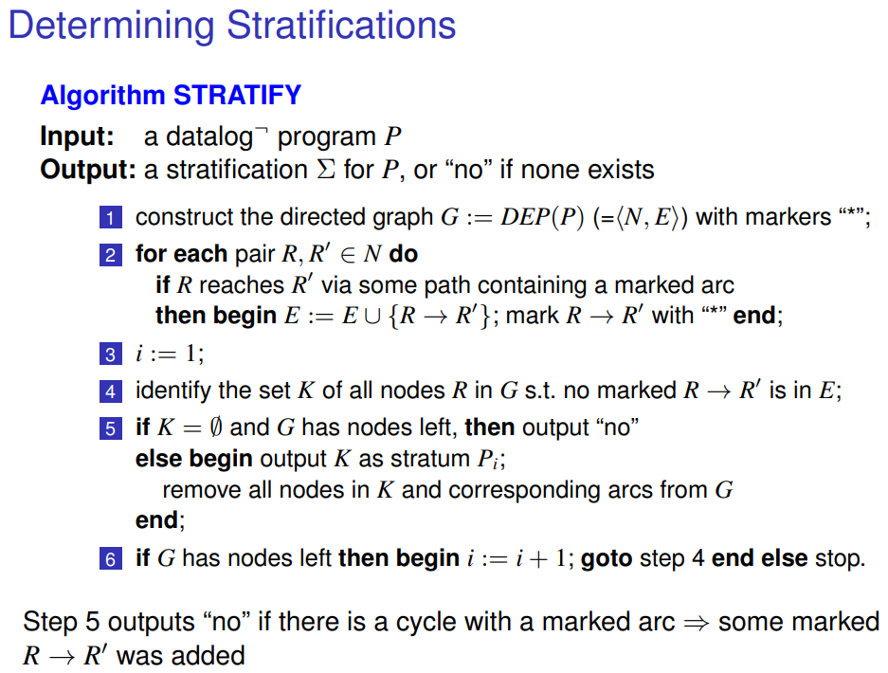
This algorithm correctly works in polynomial time!
- What is the idea of three-valued semantics for the evaluation of atoms and rules?
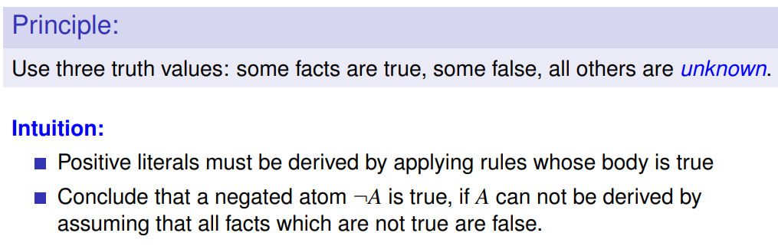
!
- Which two ways for defining the well-founded semantics of Datalog programs did we discuss?
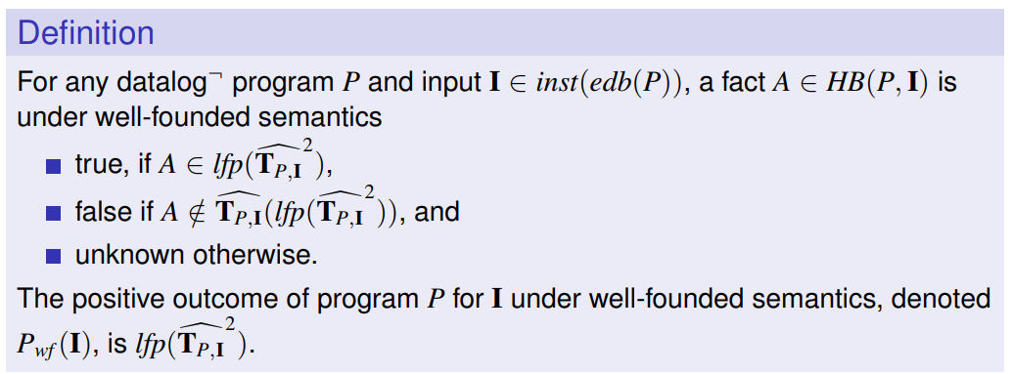
First way:
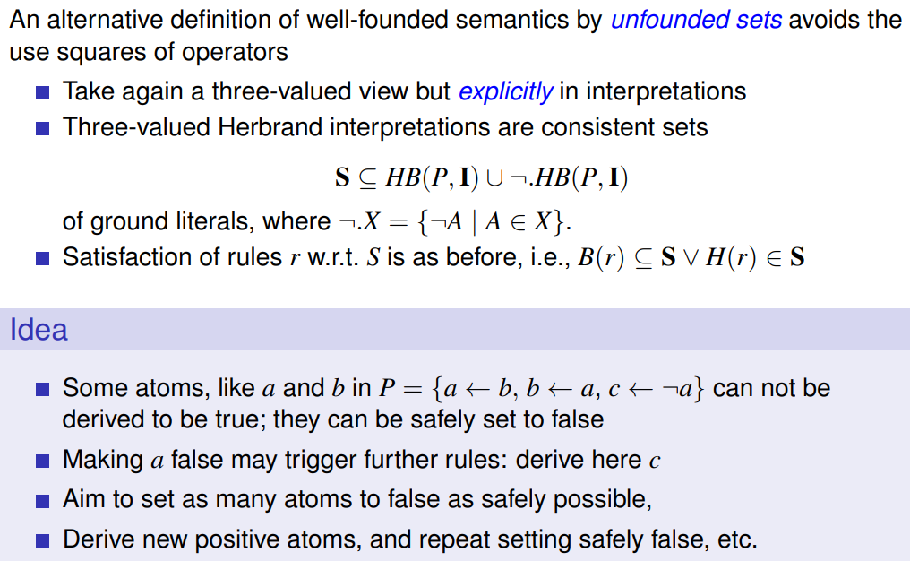

!
Second way:

- How is the immediate consequence operator T_P conceptually extended in order to define well-founded semantics? What is the technical "recipe" that is used?
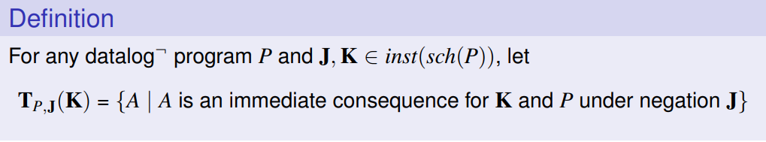
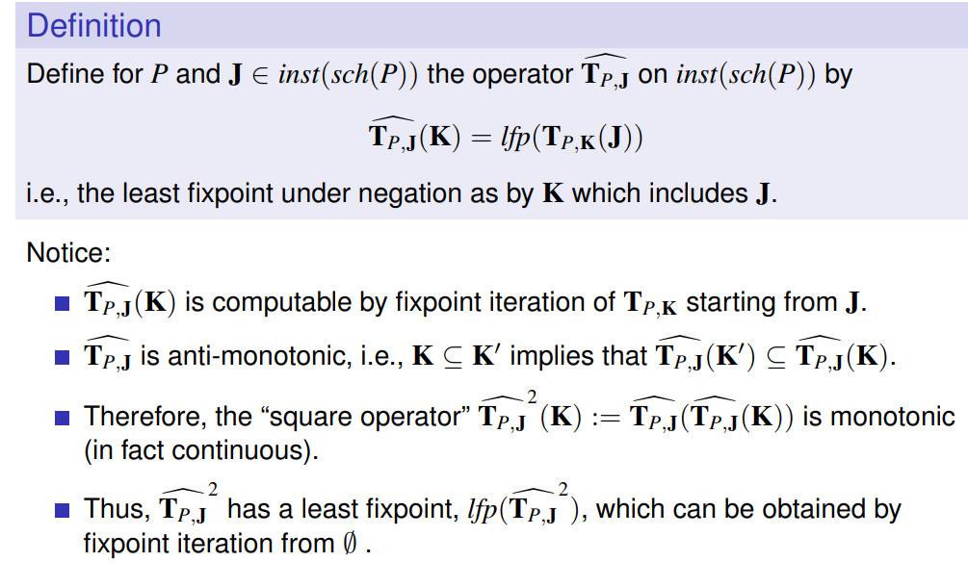
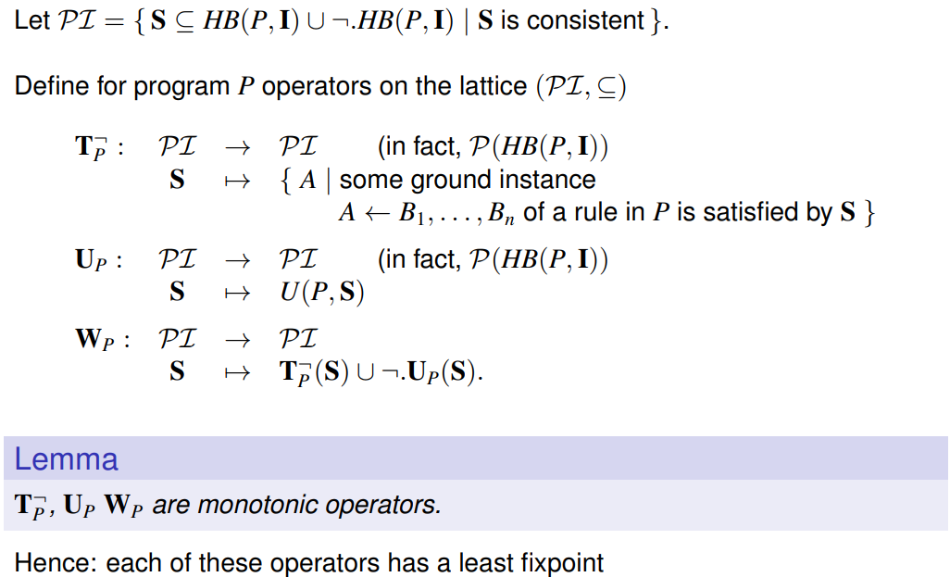
= set of consistent interpretations

- What is an unfounded set, and why does a greatest unfounded set exist?
Unfounded when:
- atom does not appear in any H(r)
- B(r) only consists of unfounded atom -> H(r) unfounded
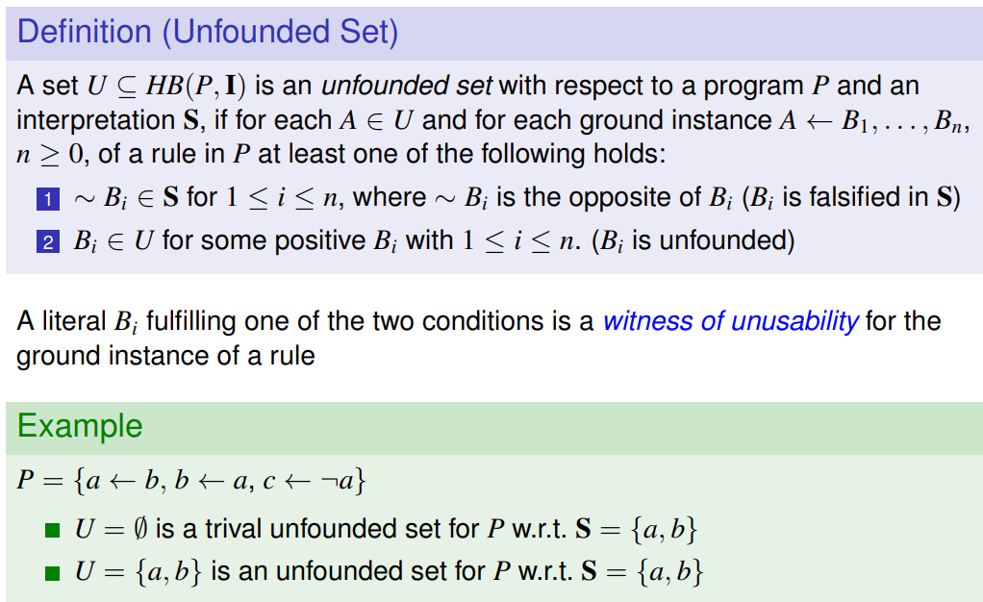
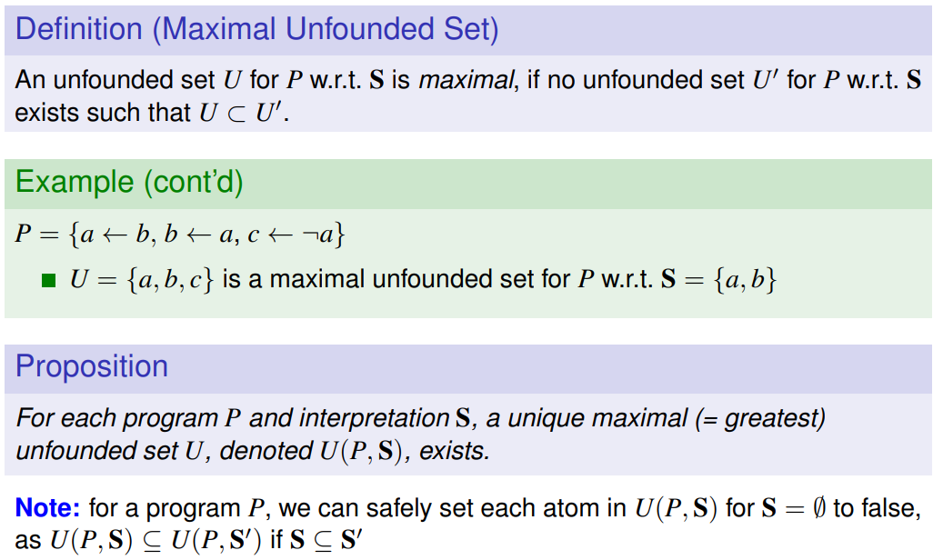
Union of two unfounded sets is again an unfounded set!

- What is the idea to define well-founded semantics using unfounded sets?
- Does every program have a well-founded model?
???

ASP Paradigm
- What is the idea for the stable model semantics, if one looks at the extended immediate consequence operator T_{P,J}?
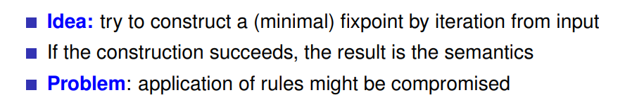
gefährdet/beeinträchtigt
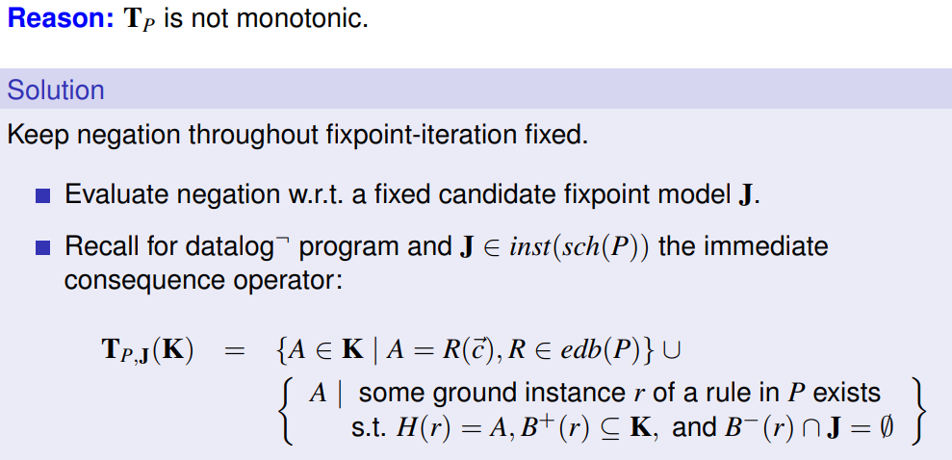

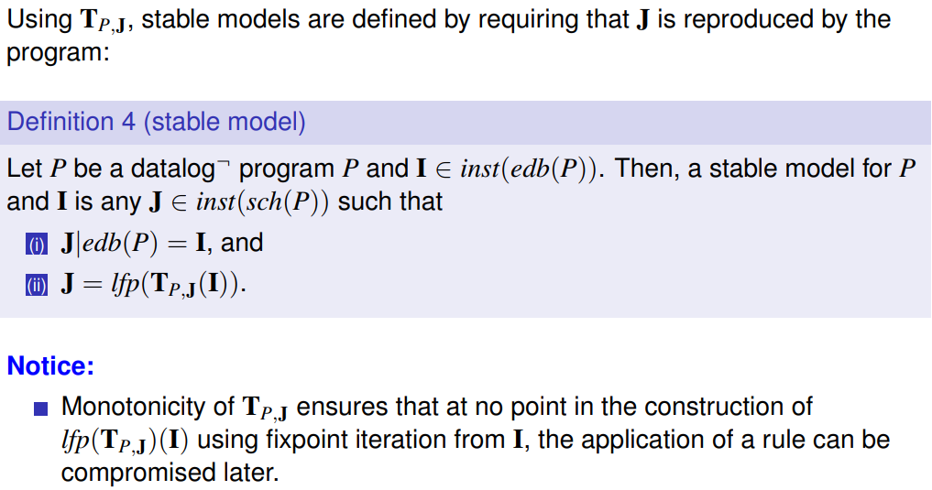
-> take output J as part of the definition wrt. the negation
-> J coincides with input I (übereinstimmen)
- What does one mean with "nondeterminism" in stable semantics?
That a Datalog program may have multiple stable models (no uniqueness).

- How is certain semantics informally defined?
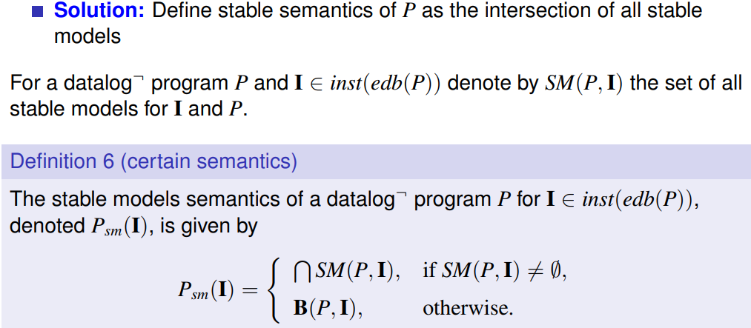
“everything is true” (every positive and negative inference is true)
- Describe the ASP idea (ASP Paradigm).
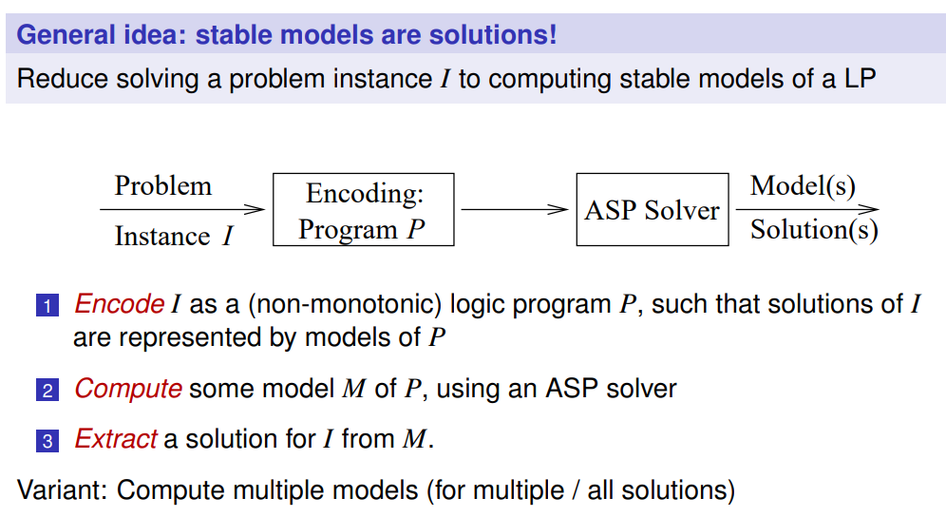
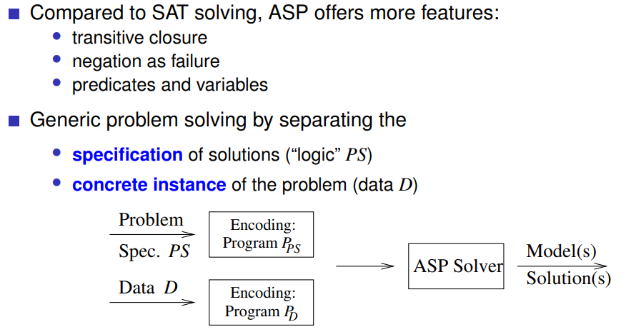
- Which form do disjunctive answer set programs have? Why is disjunction added?
more natural reading; can shift negation into head of rules
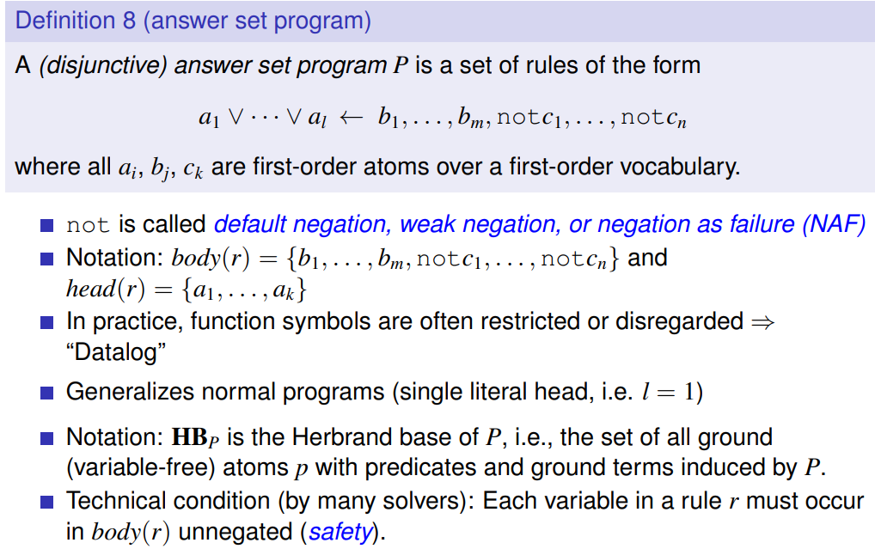
- How is the semantics of disjunctive answer set programs defined?
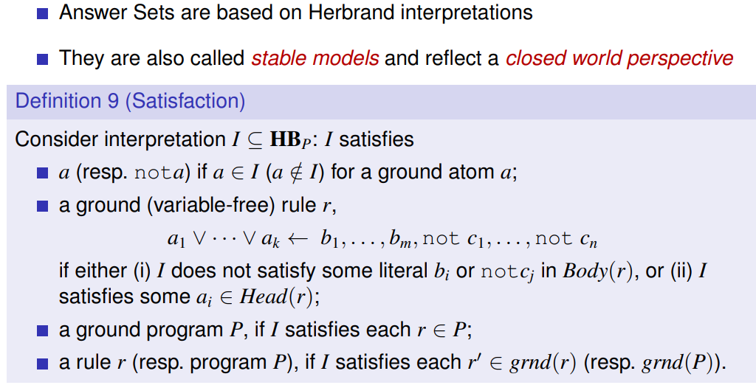
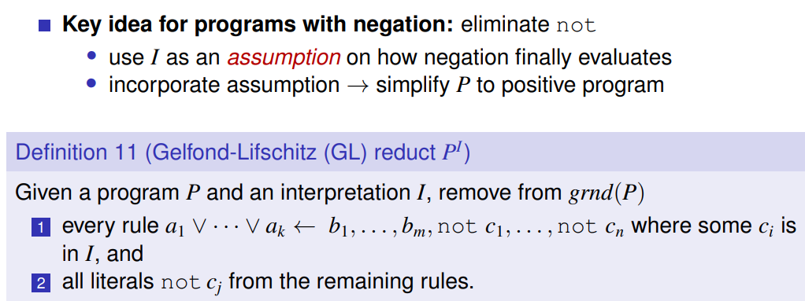
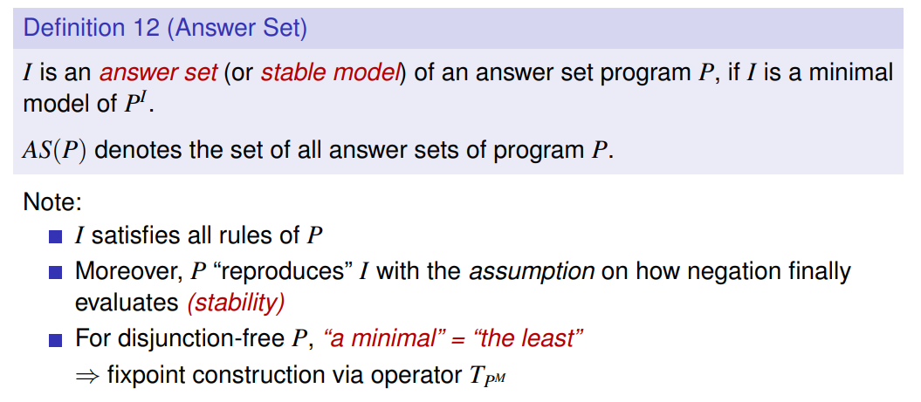
- Can disjunction in rule heads, like in in(X) v out(X) :- node(X)., be always easily eliminated, by rewriting the rules?
???
- Given an example of an ASP program that has no answer sets.
- Which basic properties of answer sets of a disjunctive answer set program do you know?
- Inconsistency and Constraints:
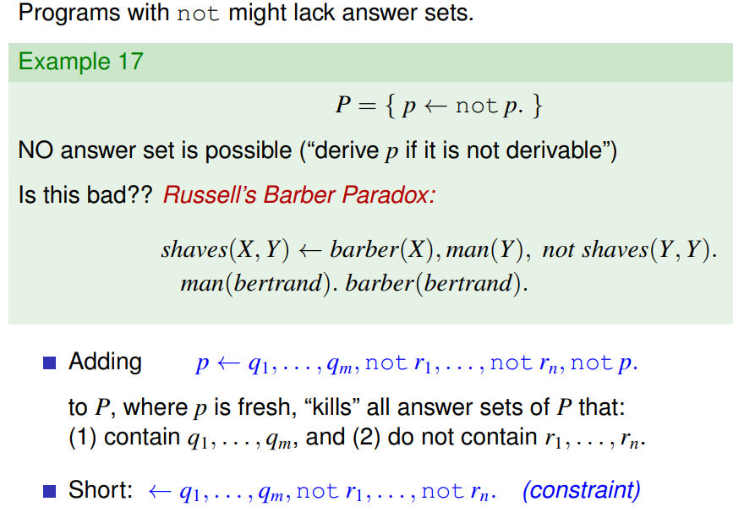

- Incomparability and Minimality
x ⊨ y:
x models (semantically entails) y
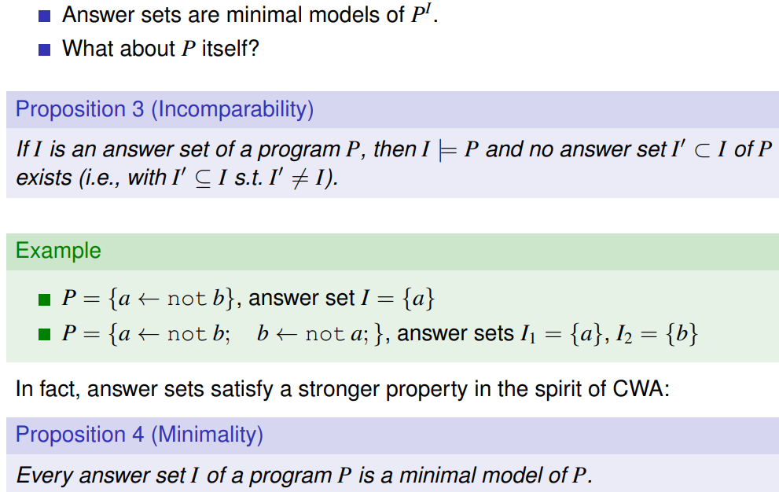
- Non-Monotonicity
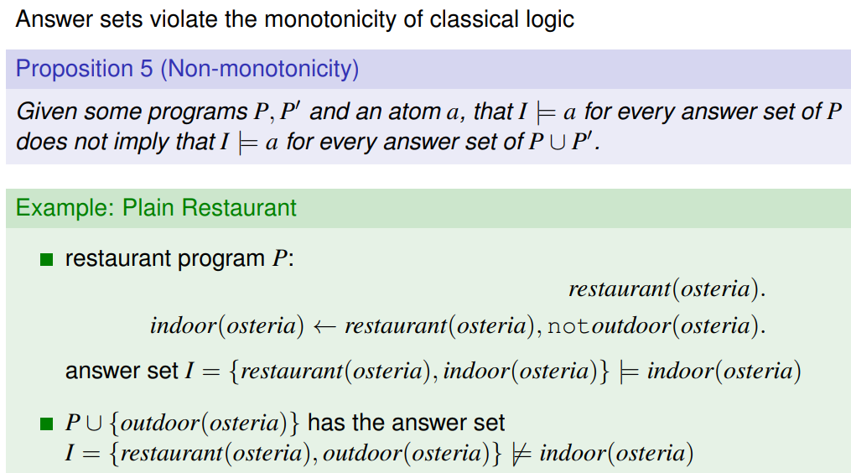
- Supportedness
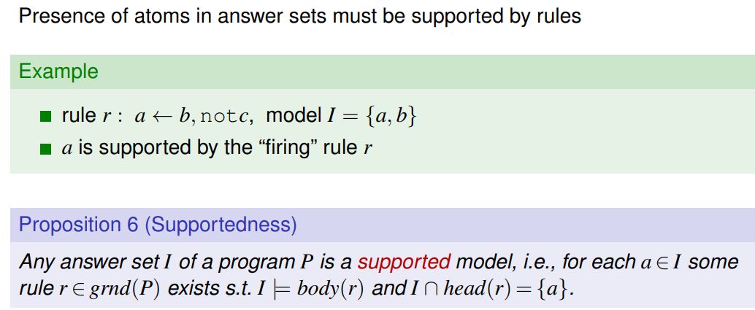

- Non-Cumulativity
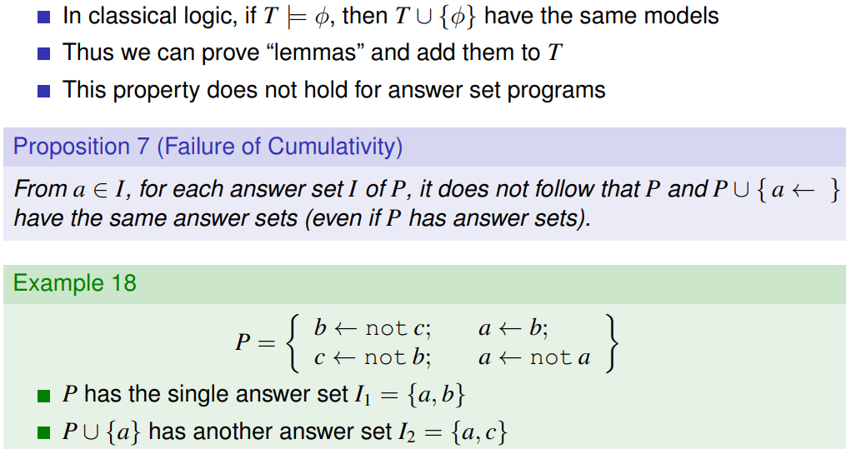
- Stratified Semantics
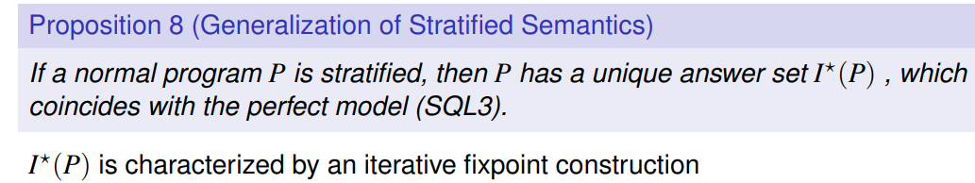
- How do well-founded semantics and answer set semantics relate to each other?
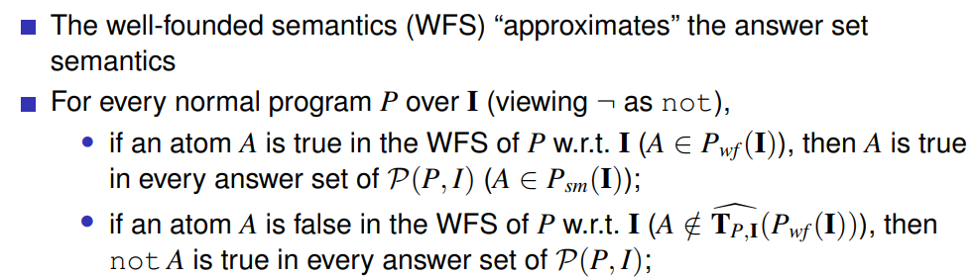
However, the WFS is not the intersection of all answer sets of P. WFS coincides with answer set semantics if it is total (no atom is unknown).
- Suppose given program has a single answer set. Do then answer set semantics and well-founded semantics coincide? -> NOT always
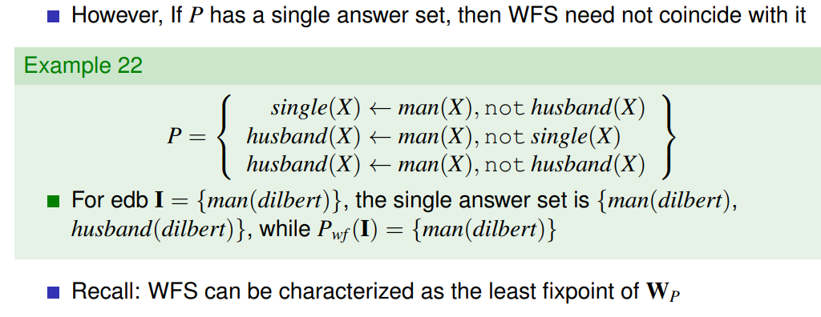
- Describe the Guess and Check Methodology.
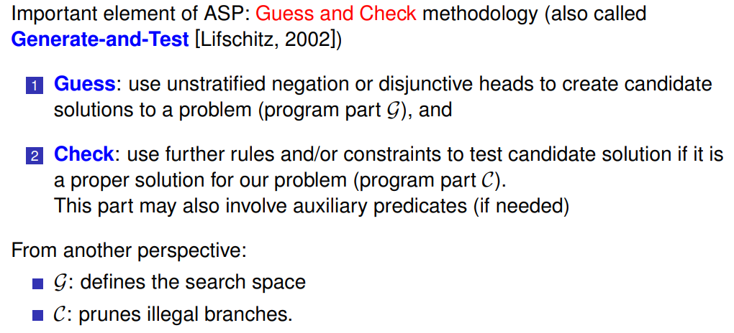
- Would a (fixed) stratified ASP program allow for deciding 3-colorability of a graph (which is given as data)?
- Would a (fixed) ASP program under well-founded semantics allow for deciding 3-colorability of a graph (which is given as data)?
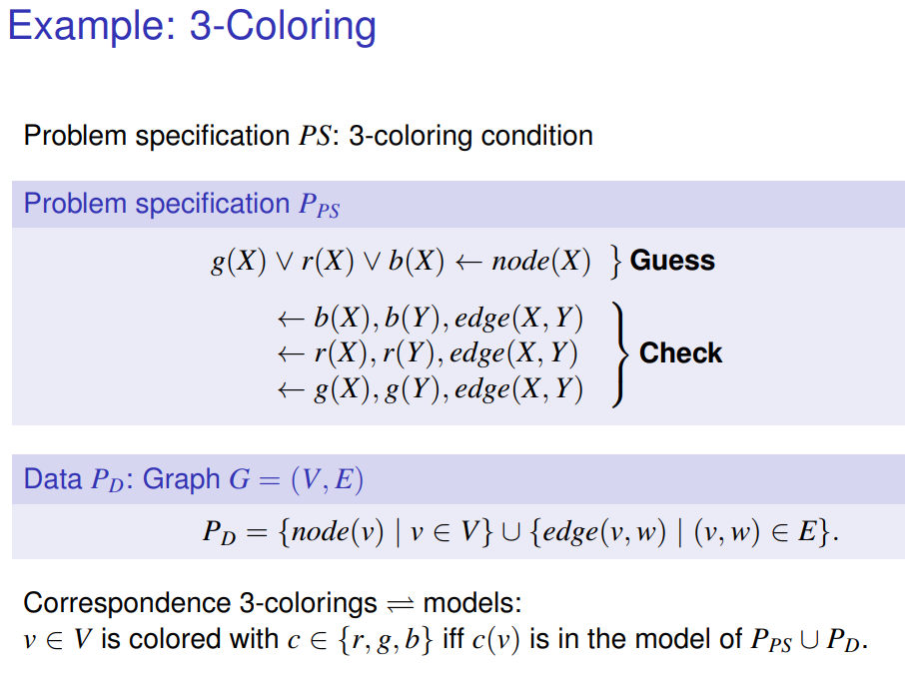
- Name some application areas of ASP. What makes the use of ASP beneficial?
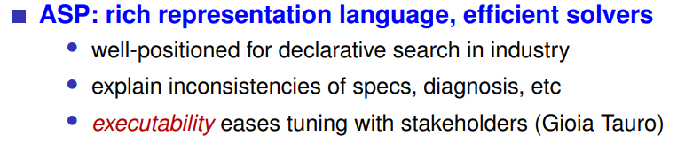
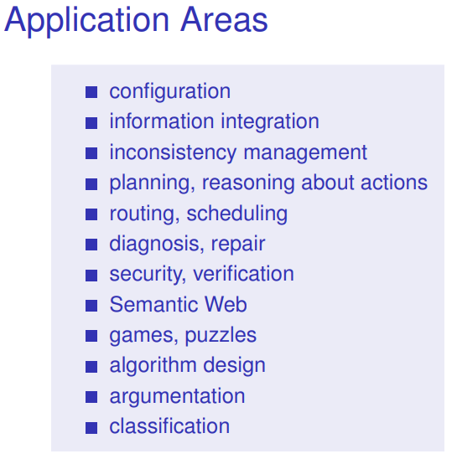

ASP Extensions
- Which kinds/types of ASP extensions do you know?
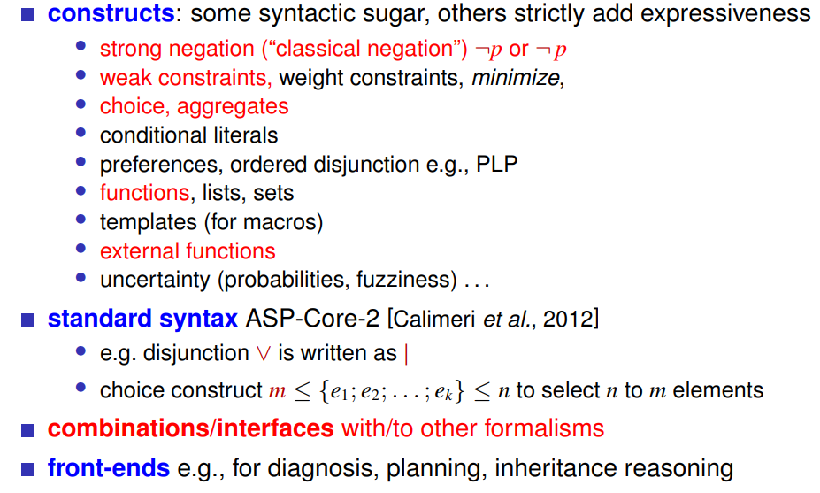
- What is strong negation, and is it needed?
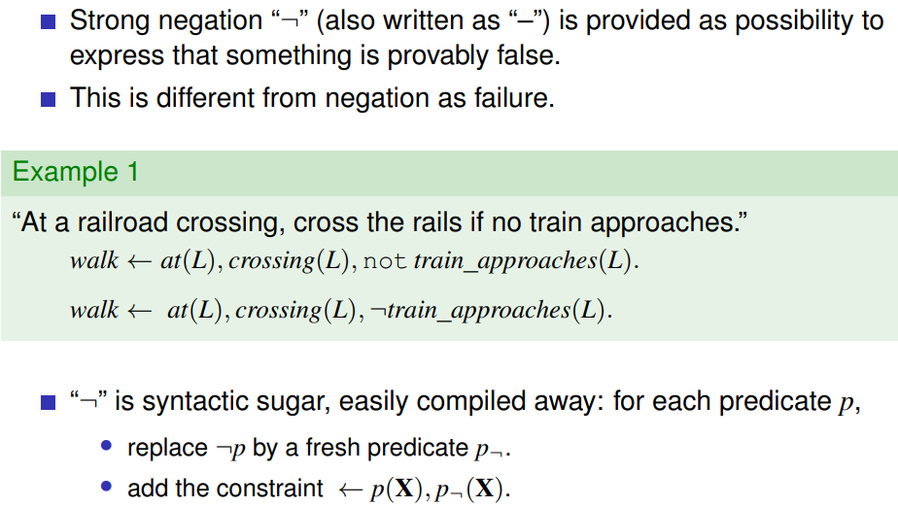

- What are choice constructs in ASP, conceptually?
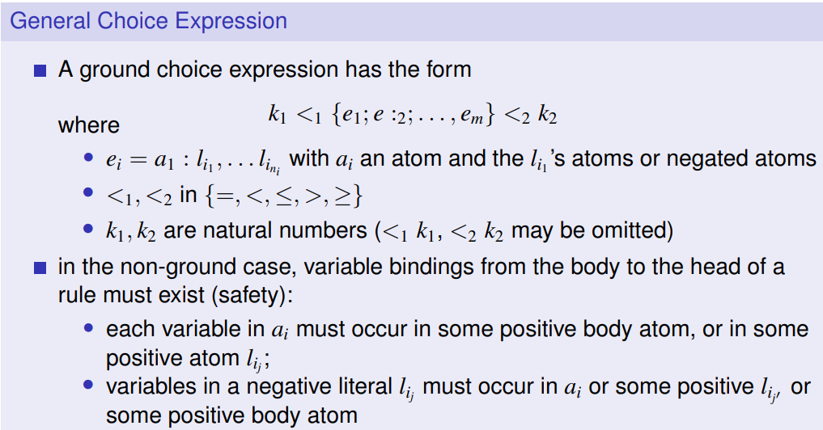
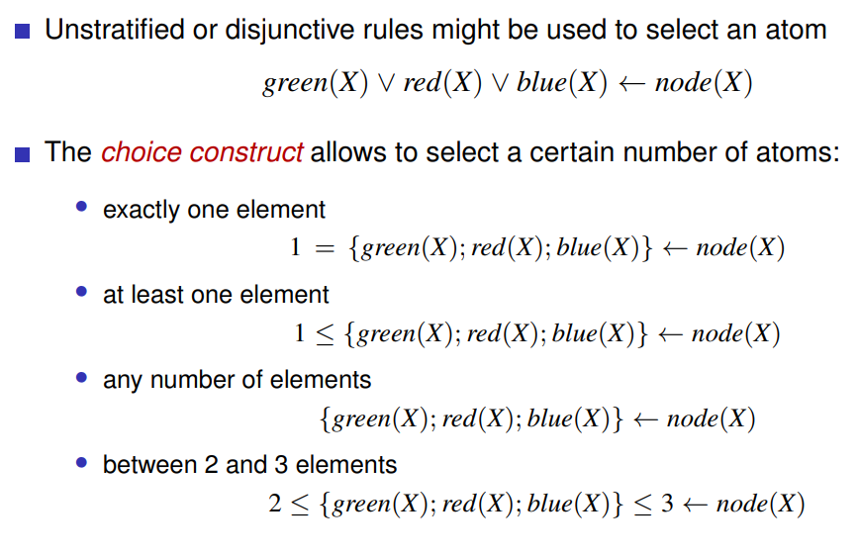

- Describe the notion of a weak constraint, and how such constraints are informally used for defining program semantics.
should be satisfied, but if not, have to pay a penalty
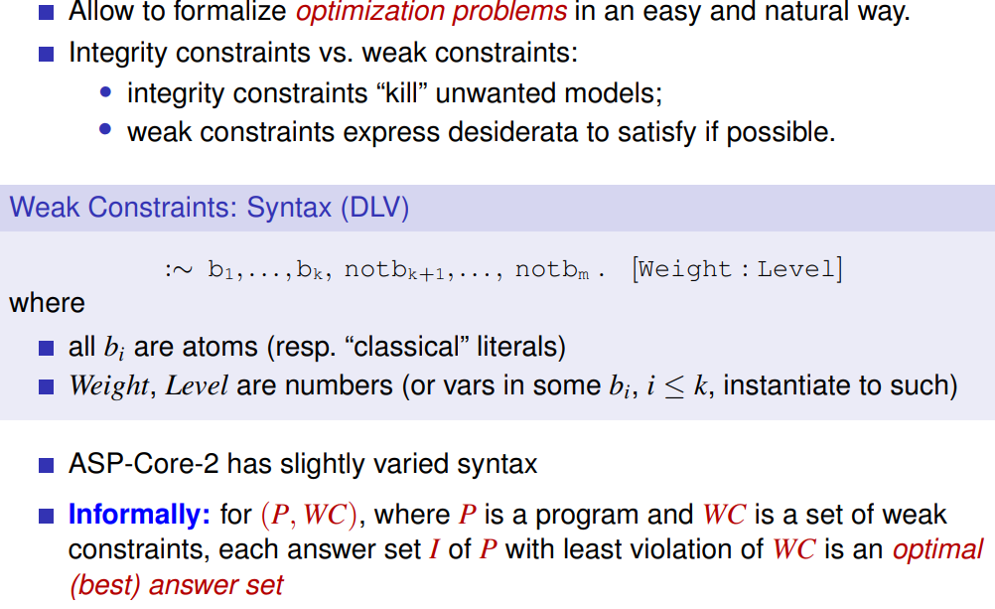
some constraints have more weight than others
“Erwuenschtes”
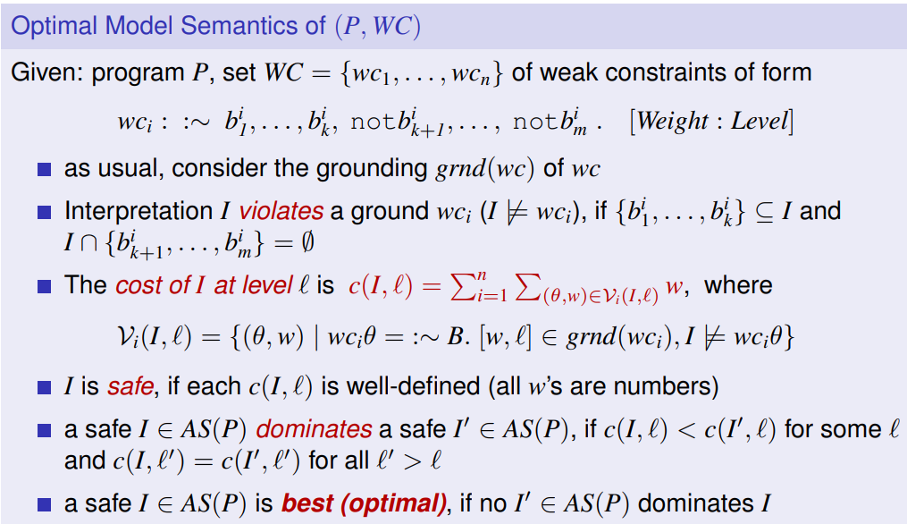
Highest Prio level, then smallest weight -> lexicographical order
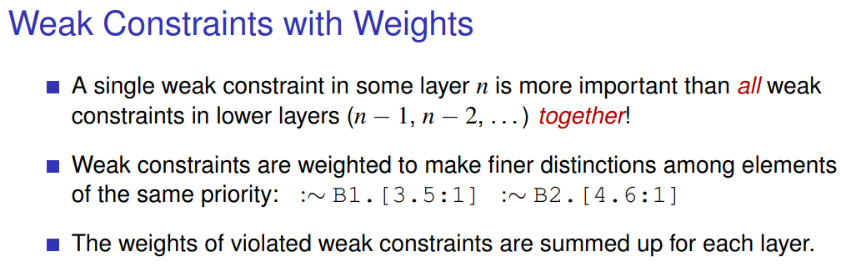
weight = penalty
- What is the Guess Check and Optimize Methodology?
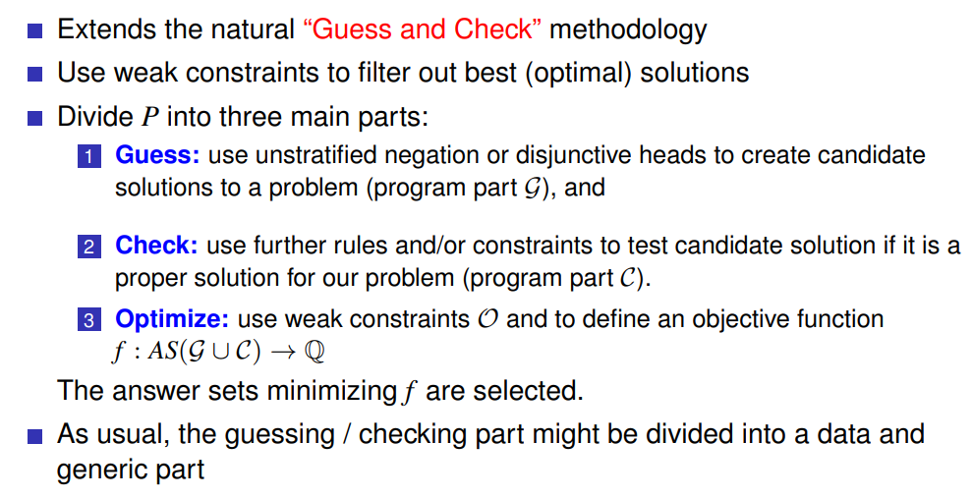
e.g. path cost
- What are aggregates, and what is the challenge to provide them in ASP?
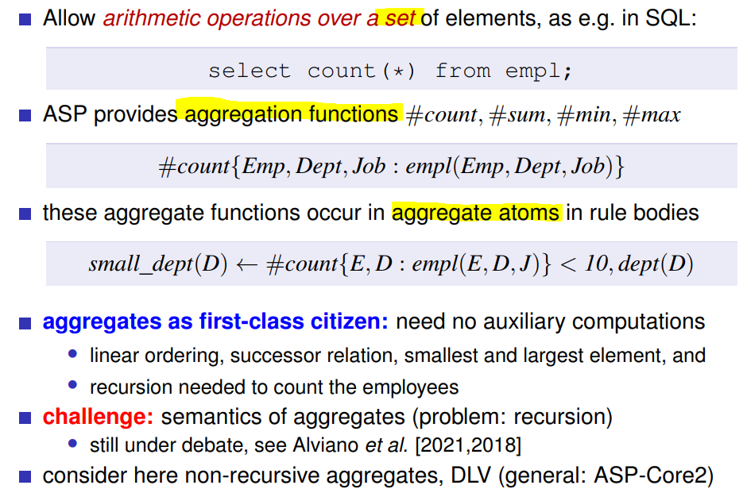
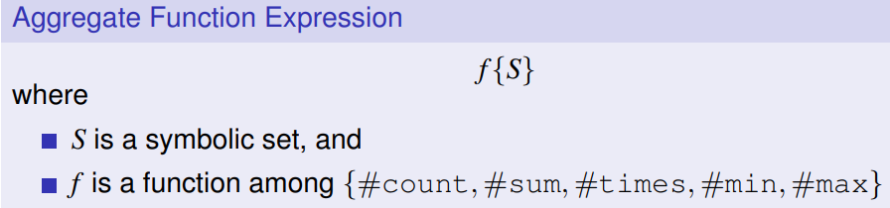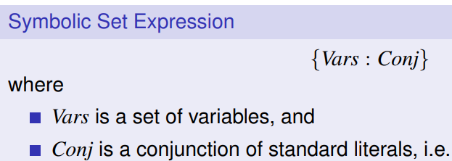

- How does an aggregate atom look like?
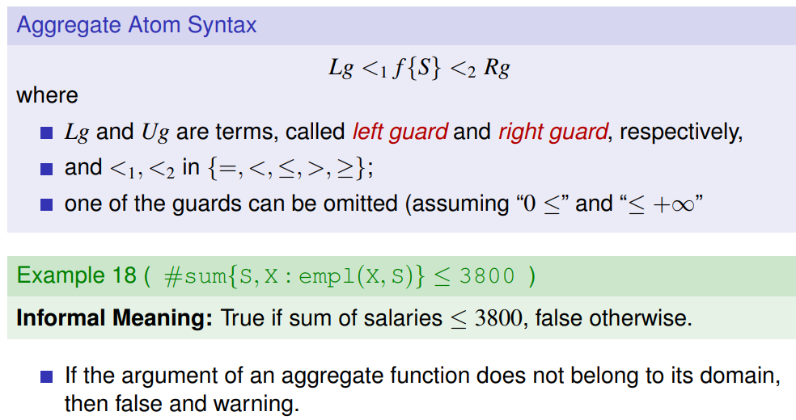
- How can answer semantics be extended to programs with aggregates?
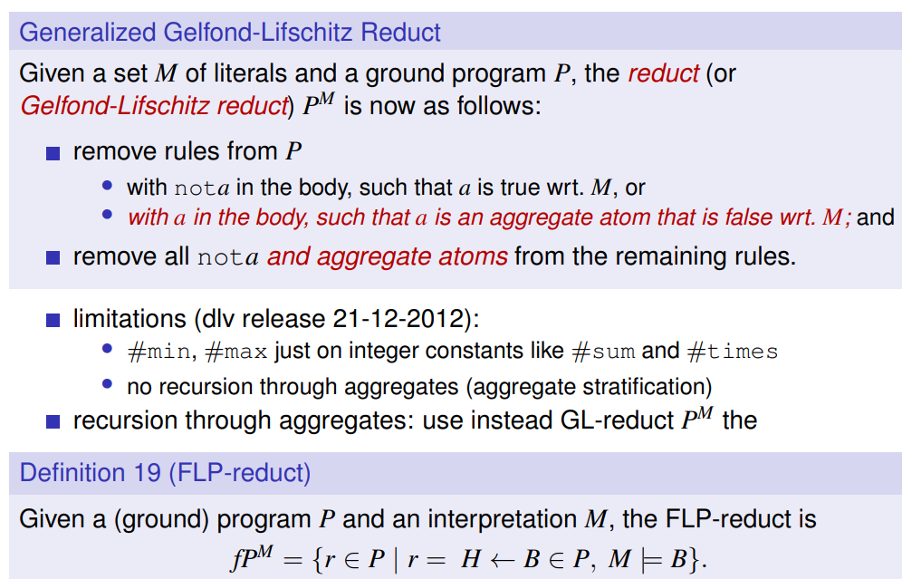

ASP Computation
- Name some reasoning tasks for ASP programs.
- What complexity does satisfiability for ASP programs (i.e., deciding whether some answer set exist) have for normal logic programs?
- What complexity does satisfiability for ASP programs (i.e., deciding whether some answer set exist) have for disjunctive logic programs?
- Is under answer set semantics evaluating disjunctive logic programs more difficult than evaluating normal logic programs?
- Is the Grounding & Solve approach good or bad from the perspective of worst-case complexity of evaluation?
- Name some ASP solvers; what is downscaling?
- Name some approached to evaluate ASP programs.
- What is the predominant evaluation approach for ASP to date?
- What is the idea of intelligent grounding?
- What is the grounding bottleneck, and how could it be overcome?
- Why is model search in ASP more complicated than in SAT solving?
- What problem do function symbols bring in ASP, and how can one manage it?
- Describe the idea of finitely grounded programs.
- What is the predominant way of model computation for ASP programs to date?
- What is a portfolio-solver for ASP, and which do you know?
- What is the Clark Completion of a program, and when can it be used to capture the answer sets of a logic program?
- What is informally a loop formula?
- What is the key idea for modern ASP solvers?
- What is Multi-shot ASP solving, and what can it be useful for?
- What benefits does ASP have compared to SAT?
- What benefits/drawbacks does ASP have compared to CP.
- What is an IDE, and which do you know for ASP? What is a big issue for such IDEs still?

Description Logics (DL)
- What is an ontology from a data management perspective?
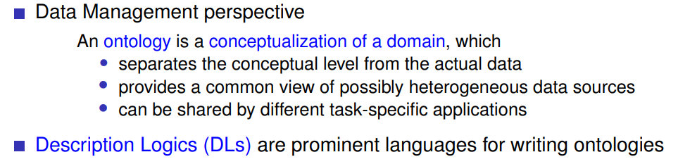
- Name some application areas of Ontologies.
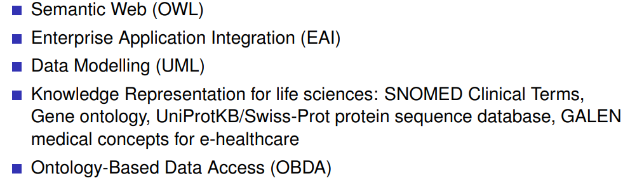
- What is SNOMED?
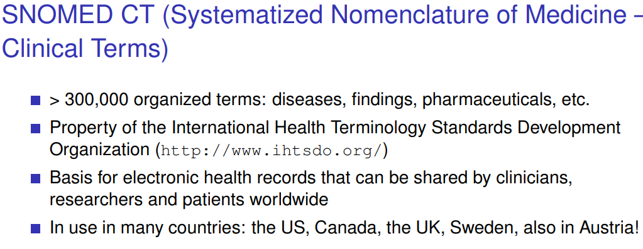
- How do Description Logics relate to First-order Logic?
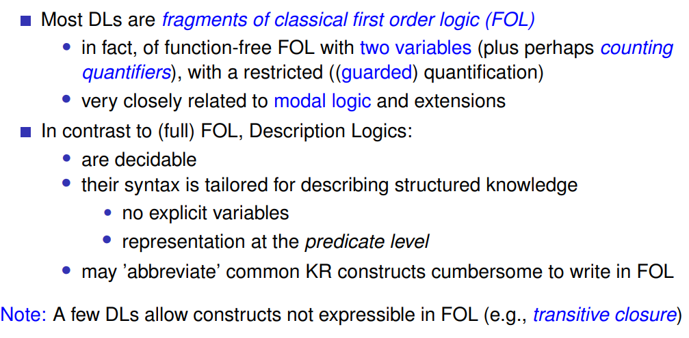
!
- What does the language of Description Logics usually comprise?
atomic classes/ unary predicates, atomic relations/binary preds and constants
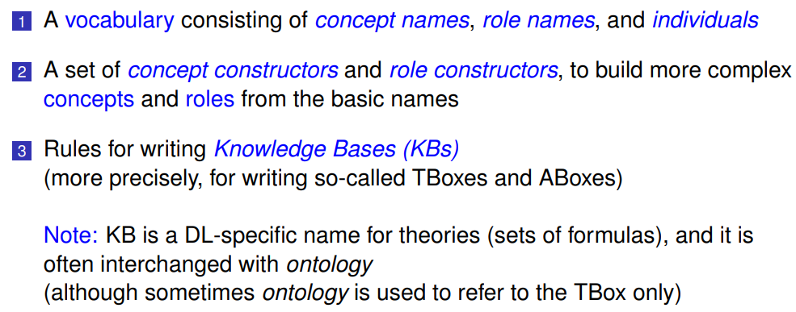
- Which concept / role constructors do DLs have beyond Boolean-style constructors?
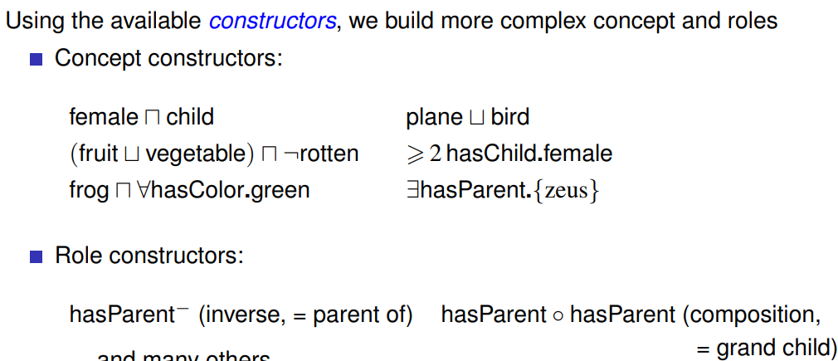
- How is a DL knowledge base usually composed? -> ABox and TBox
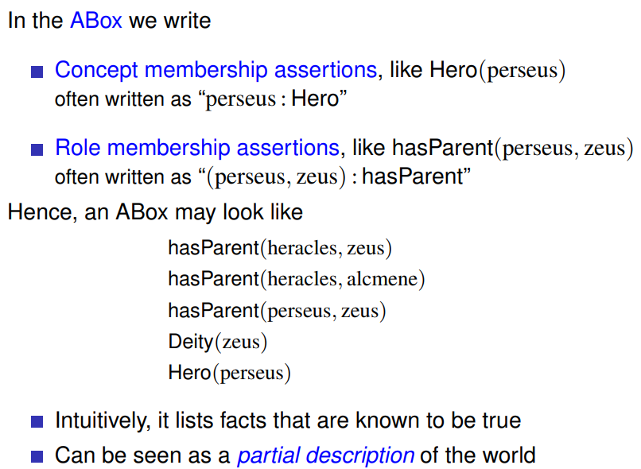
open-world perspective
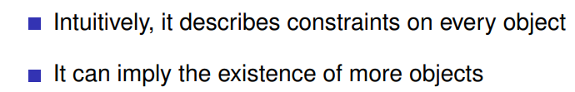
- Which forms of terminological axioms do you know?
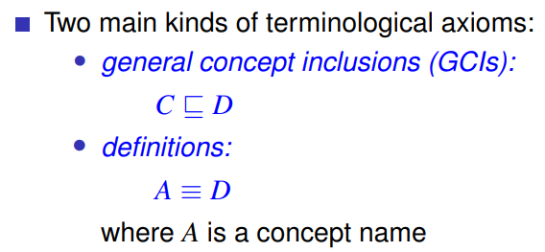
- How can the semantics of DLs be defined?
- How are interpretations in DL informally defined?
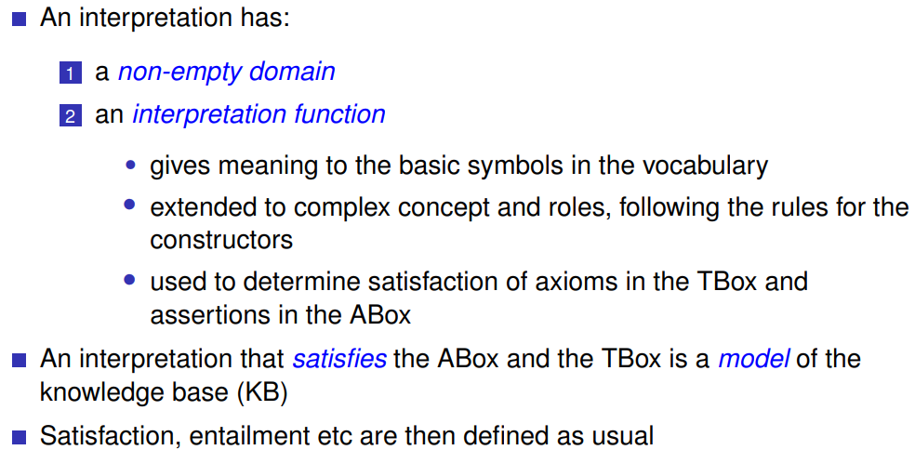

- Which concepts are in ALC defined by restriction, and which pitfall exists for the usage in practice?
ALC = mother of DLs, a concrete DL
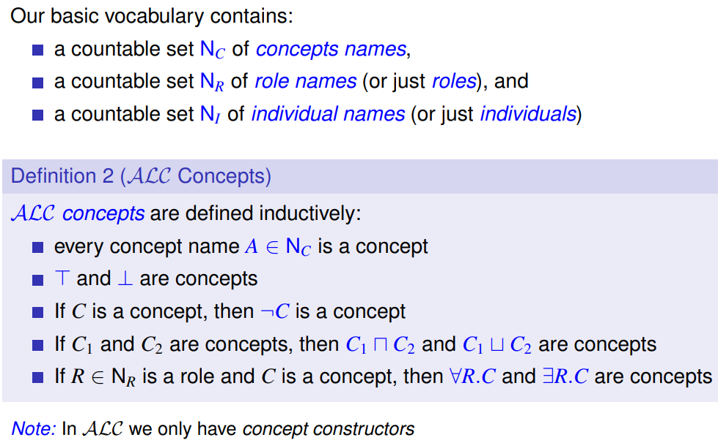

T = top concept, every concept belongs to this class
with role constructors: undecidability possible
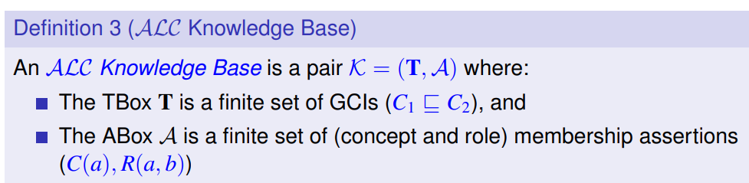
- How is satisfaction of an ALC knowledge base by an interpretation defined?
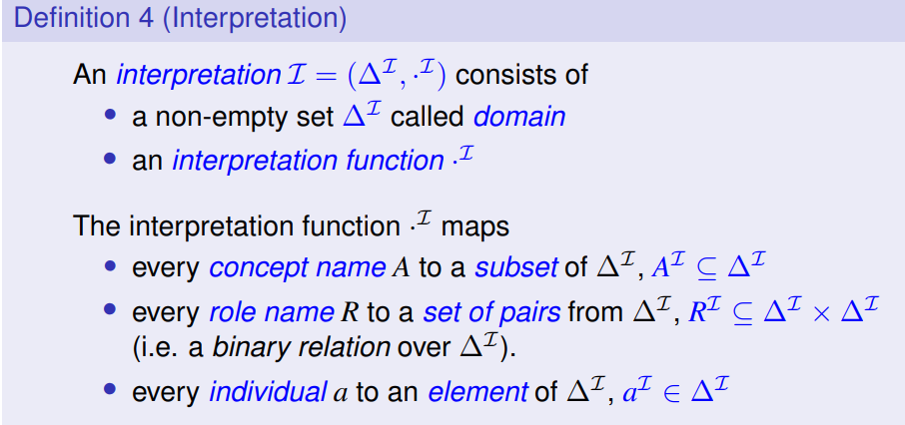
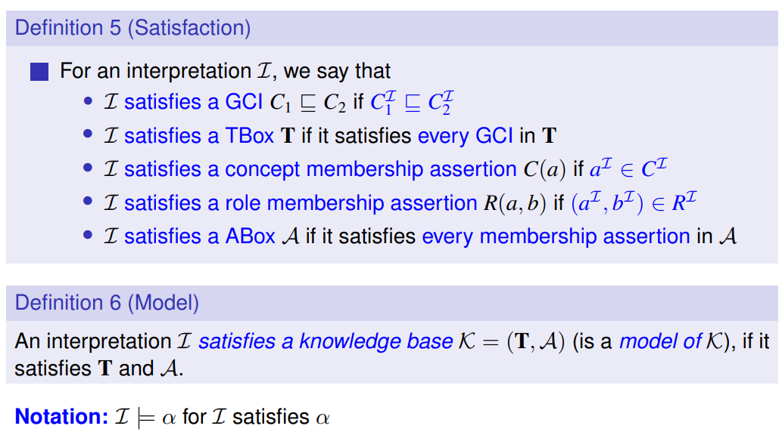
ask if opposite of what to check is existing
- Name standard reasoning problems in DL, and how they relate to Satisfiability testing.
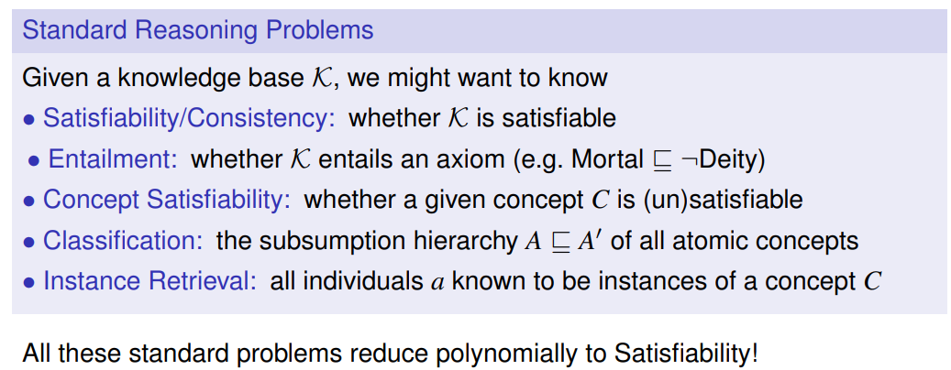
Satisfiability is the master problem!
to entail = zur Folge haben
subsumption = Unterordnung
- Name some non-standard reasoning tasks in DLs; can they be reduced to Satisfiability testing easily? -> ??
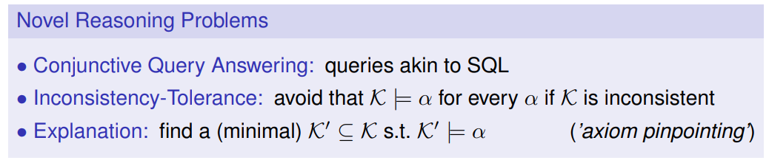
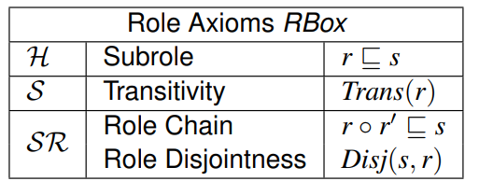
- What is SROIQ, and why is it important?
  - S: ALC + role transitivity
  - R: role box (role axioms, self-concepts)
  - O: nominals
  - I: inverse roles
  - Q: qualified cardinality restrictions
complexity of reasoning: 2NExpTime-complete (for both, concept/KB satisfiability; worst case)
nondeterministic exponential time
- What are lightweight DLs?
DLs that allow for low-cost reasoning since reasoning must be efficient, e.g.
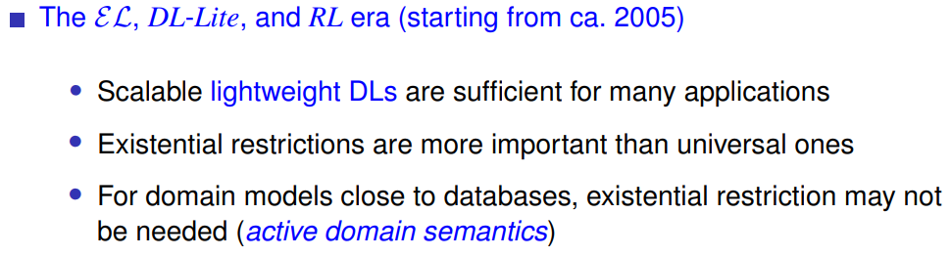
- What is the idea for the Description Logic EL?
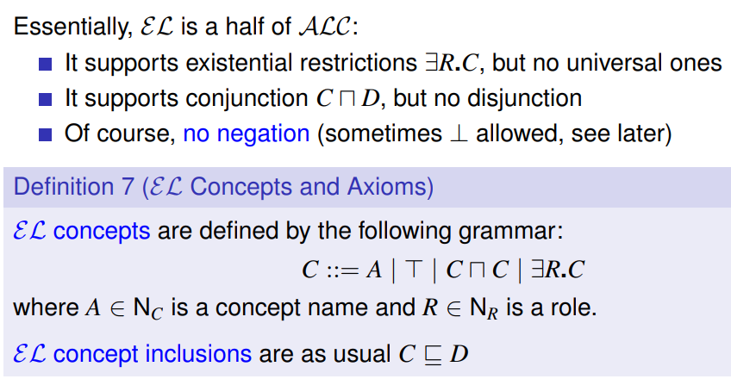
- Which normal form we can use for EL?
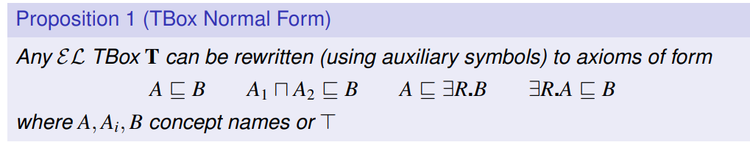
- What is the main idea for canonical model construction in EL?
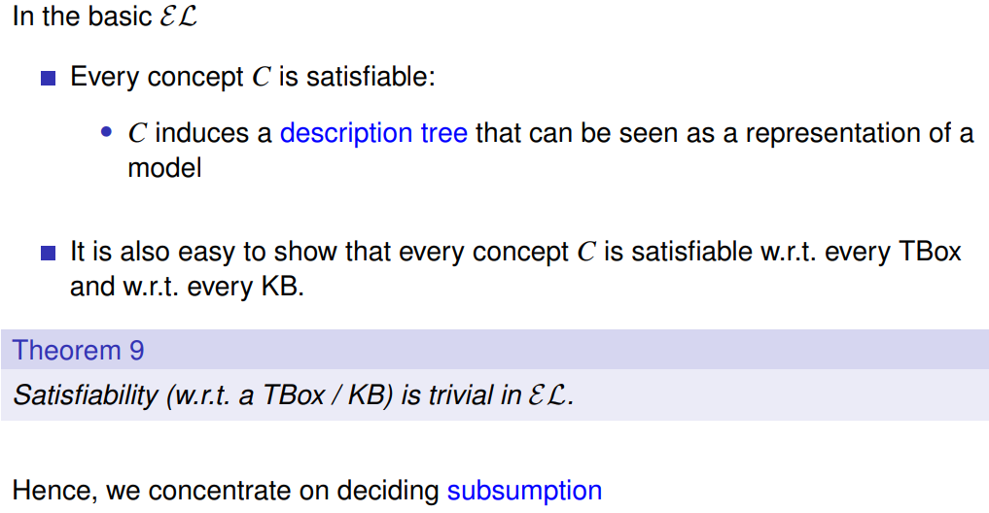
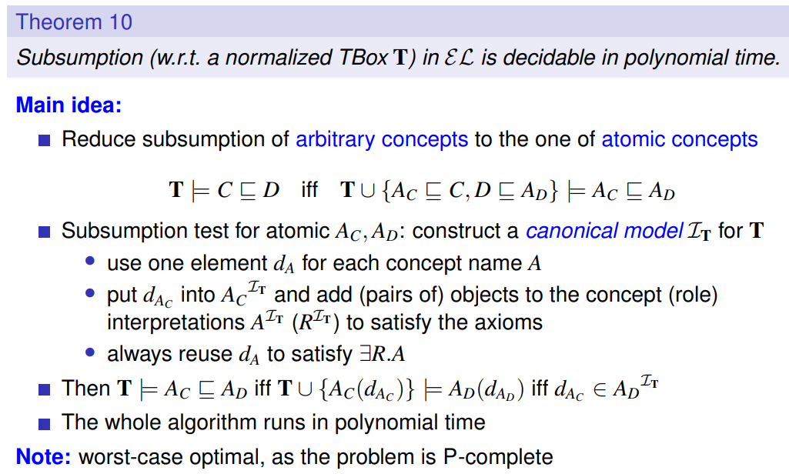
!
- How can Satisfiability testing be done for EL^\bot?
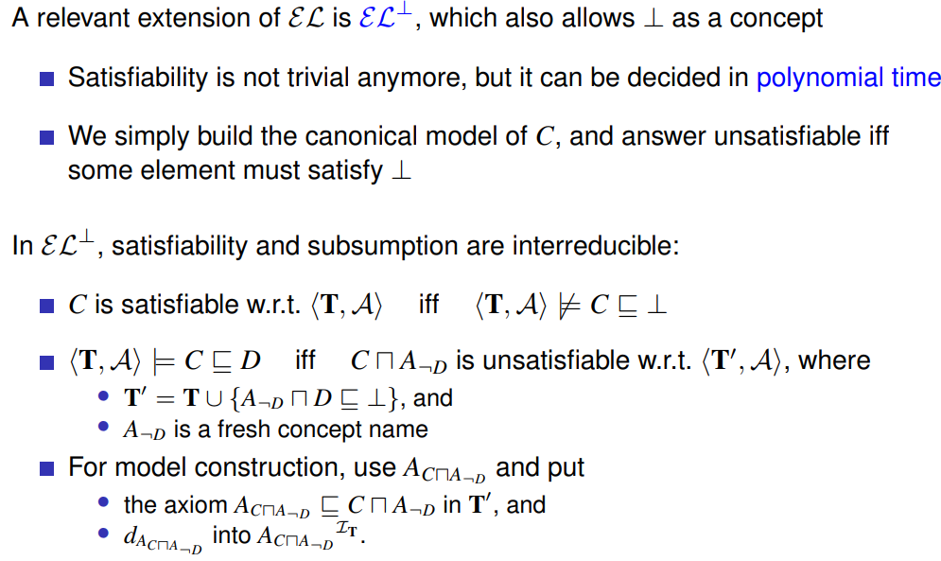
!
- What is EL^{++}?
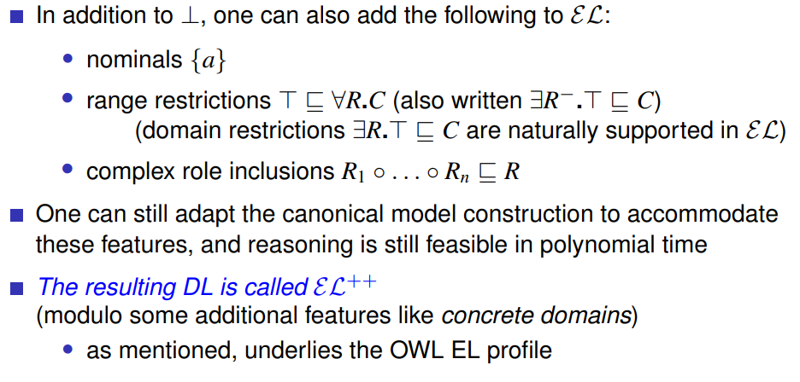
- What design rationale is behind DL-Lite?
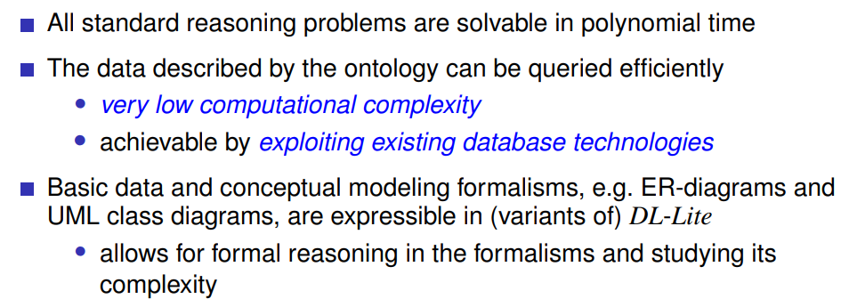
- Where has DL-Lite successfully been applied?
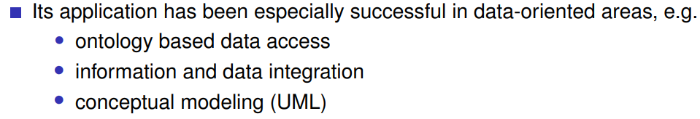
- How do axioms in DL-Lite look like?
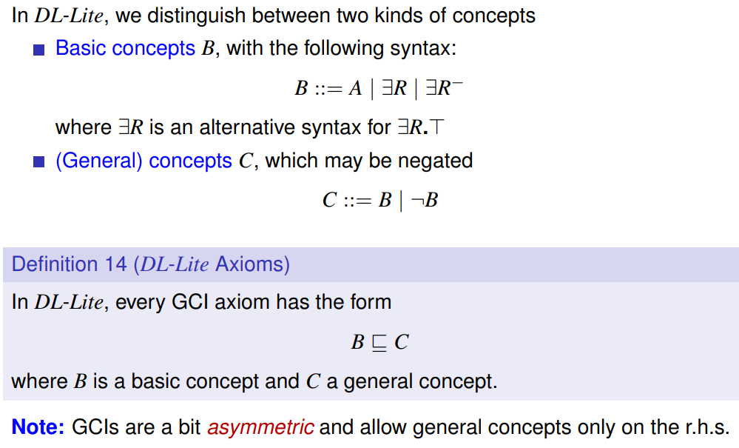
Inverse role

- What is the idea for the canonical model construction of DL-Lite?
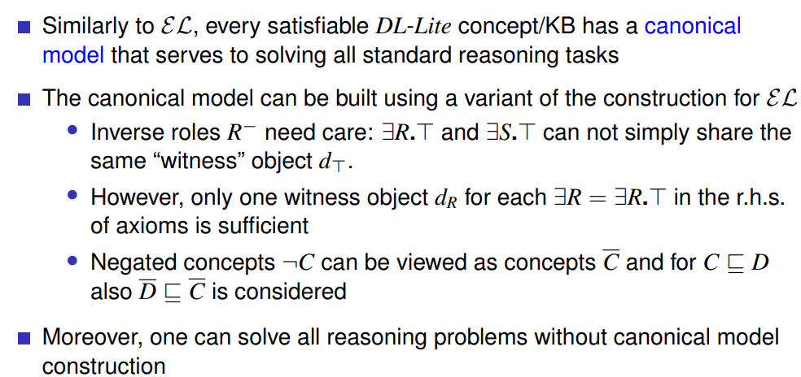
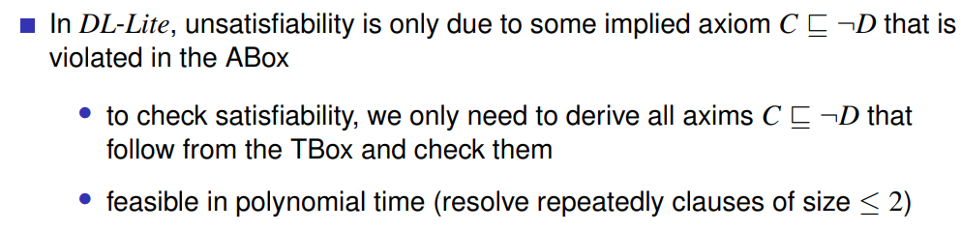
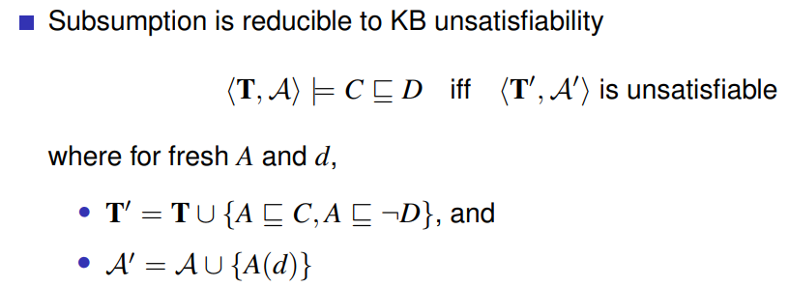
- What is data complexity, what is combined complexity?
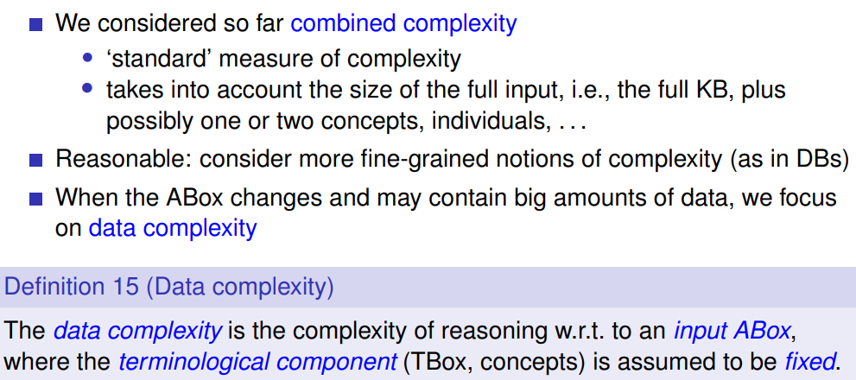
- What is the data complexity of EL, what of DL-Lite?
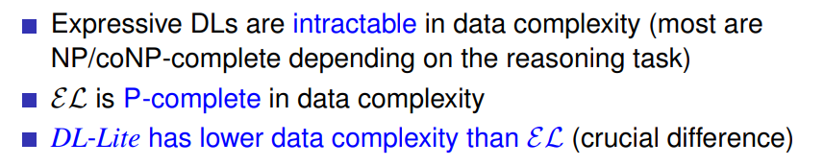
intractable = unloesbar/ unfuegsam
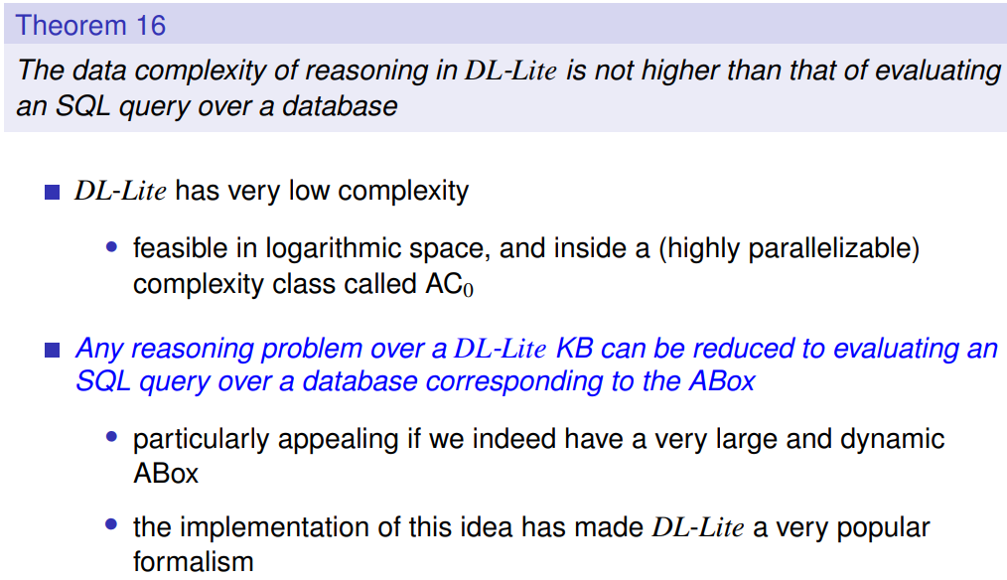
- What is OWL?
(World Wide Web Consortium)
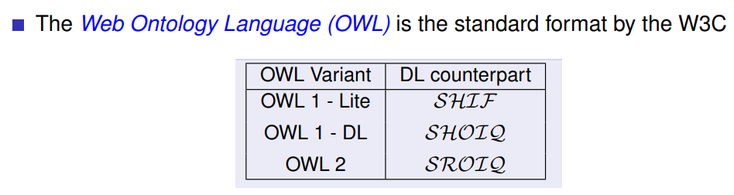
- Name the OWL-2 profiles and the underlying DLs.
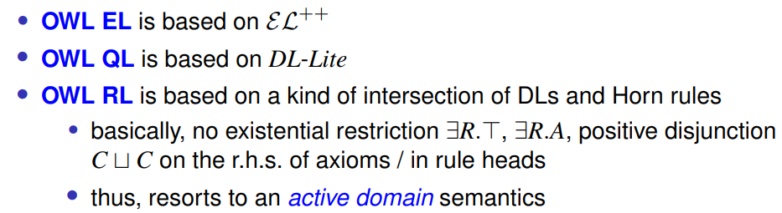
- Summary of this unit:
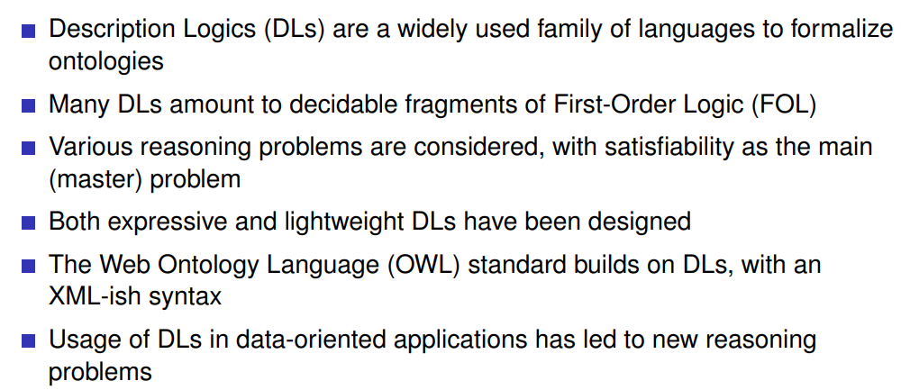

Existential Rules
- When modeling Description Logics in (pure) Datalog, for which axioms issues arise, i.e., it is not easily possible?
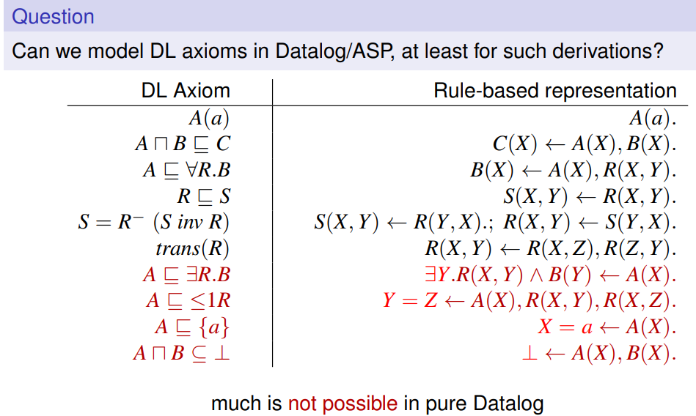
- How is negation handled in Datalog/ASP vs Description Logics?
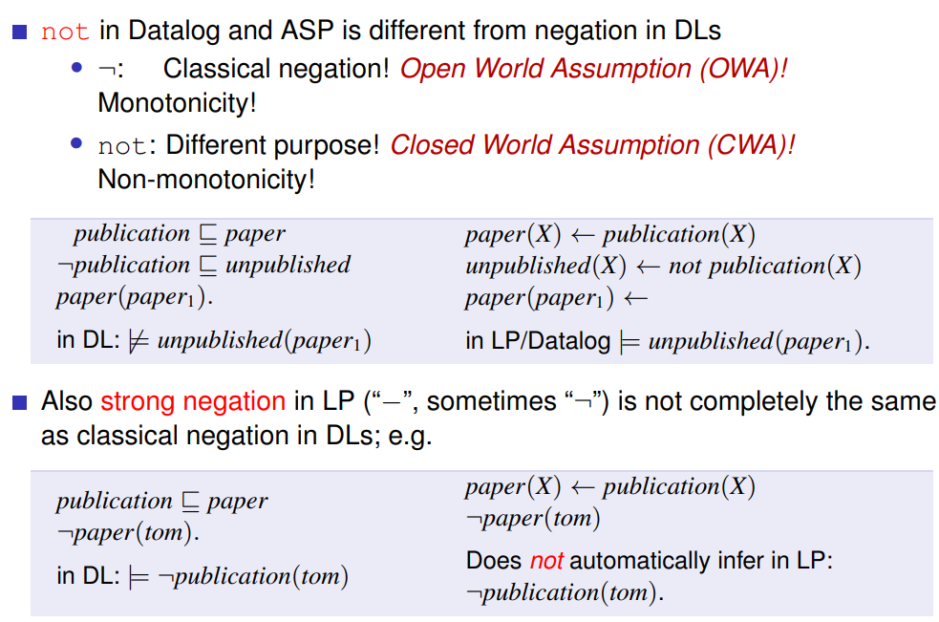

- What are the main differences between DLs and Datalog with respect to the intended usage?
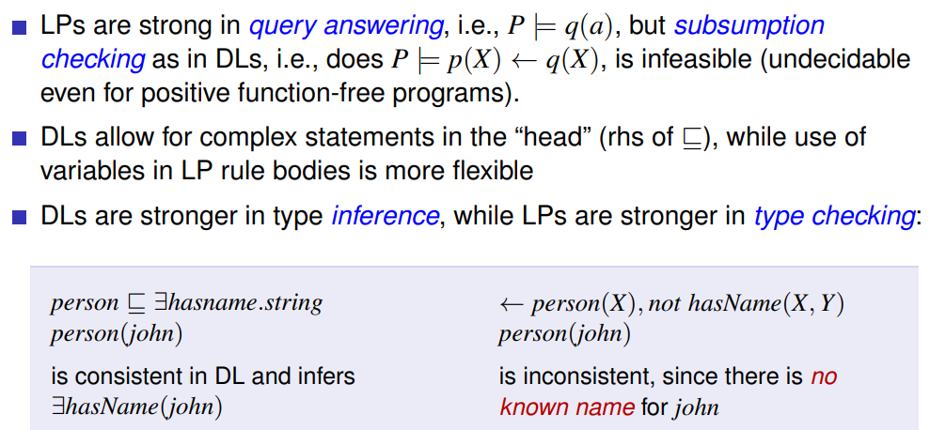
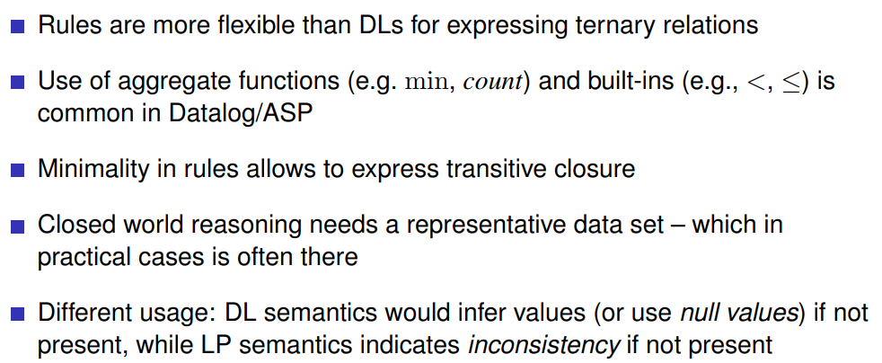
Summary:
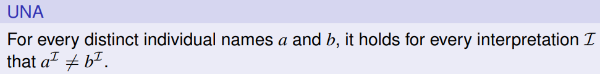
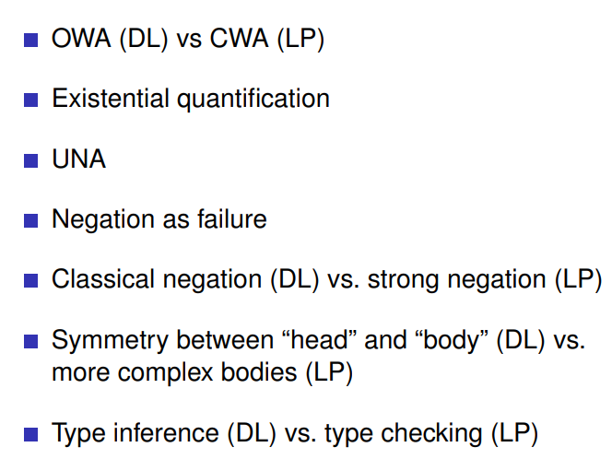
= Unique Name Assumption

- How can Datalog be extended to cater for modeling of the axioms that cannot be modeled in (pure) Datalog? What is the problem with such an extension?
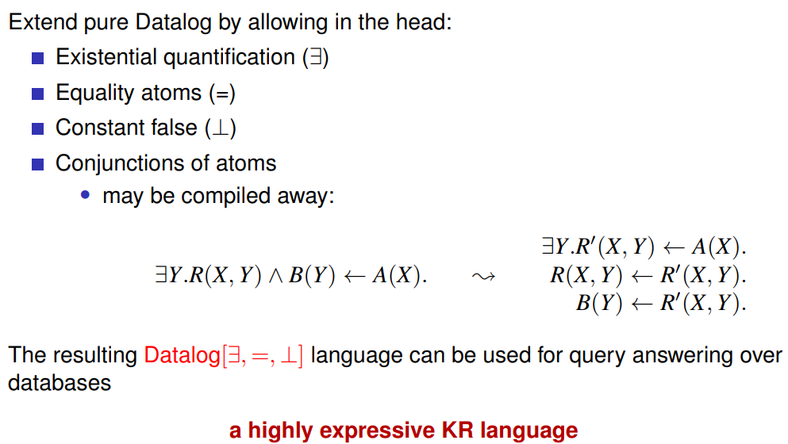
Problem:
KR = Knowledge Representation and Reasoning (?)
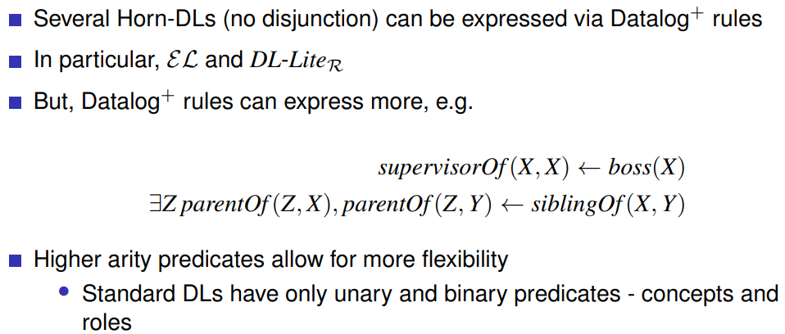
- What is the main reasoning service in Datalog^+, and how does it work?
(extensional data, Abox in DLs)
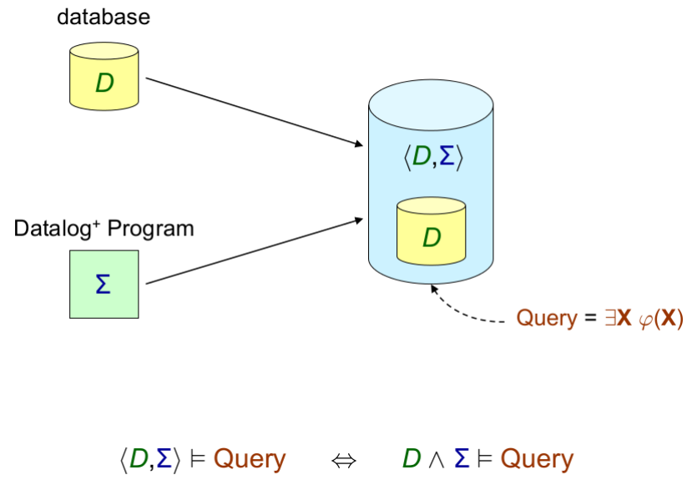
X .. should match values of data in database, phi .. formula
Evaluate query over union of them
(rules, Tbox in DLs)
Look at the example from the slides in detail!

- What is the idea of Datalog^{+/-}?
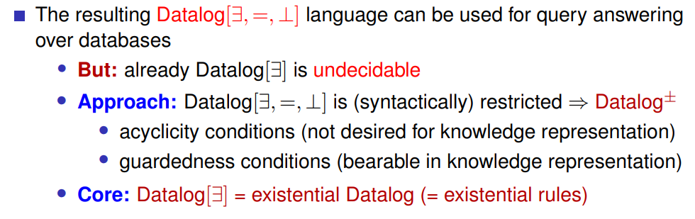
- What is the chase procedure and how does it work?
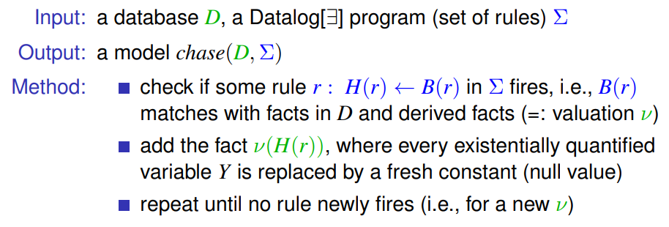
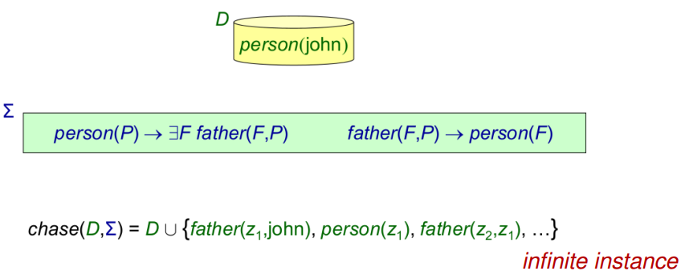 -> the chase might not terminate!
- What is a universal model, and how can it be exploited?
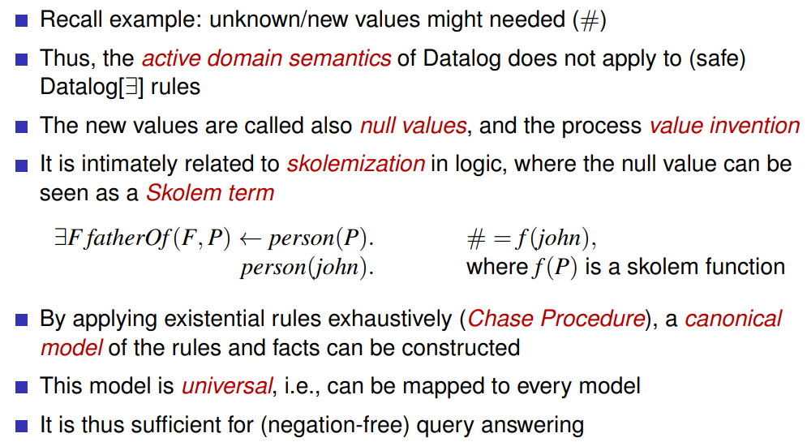
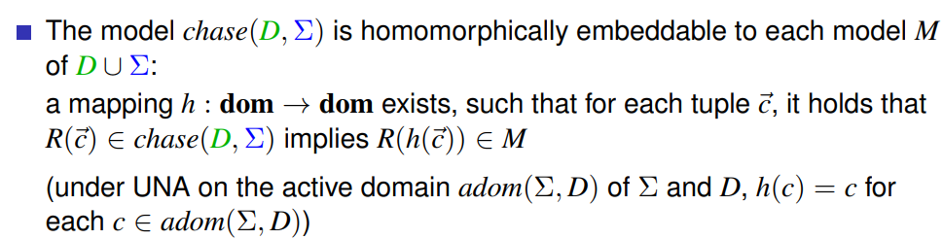
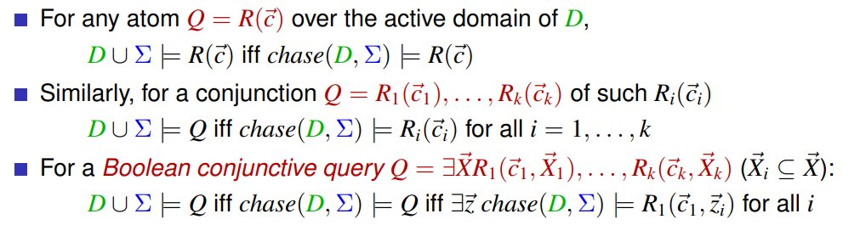
- What is the data resp. combined complexity of BCQs for pure Datalog, and how much does that go up in the worst case for the fragments of Datalog^+ that we considered?
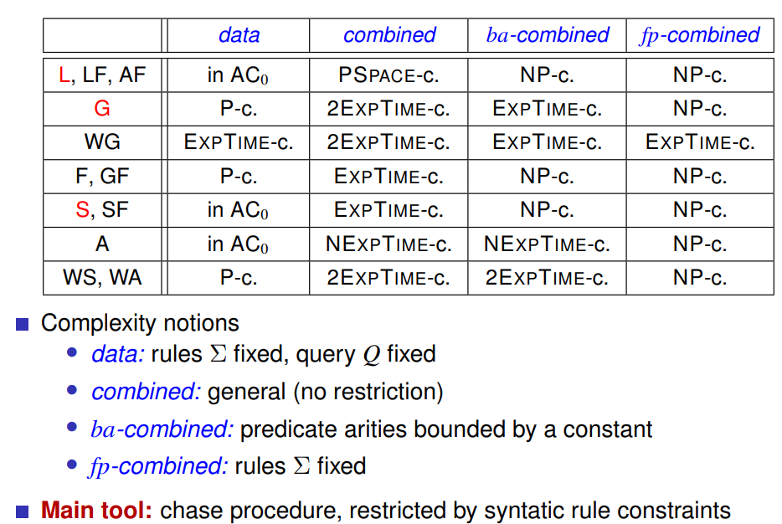
Pure Datalog: ExpTime-c.
- What is Linear Datalog, and what data complexity it has?
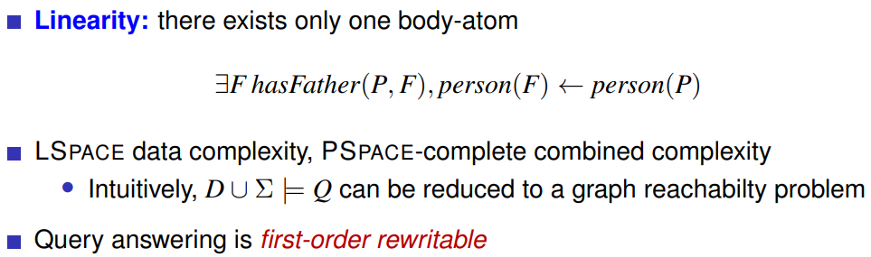
Log space/ polynomial space

- What is first-order rewritability resp. Datalog rewritability? Can you give examples?
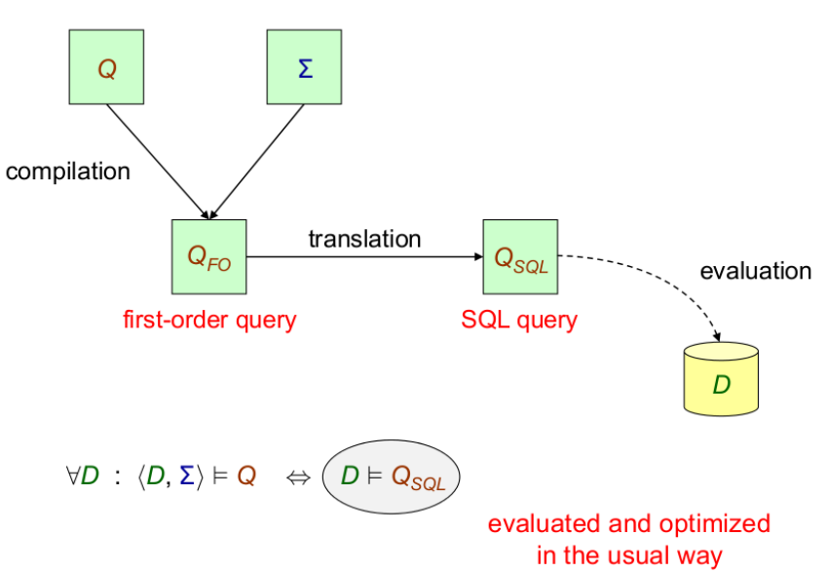
Database engine for
= formula in FOL
- What is guarded Datalog? How does it relate do DLs?
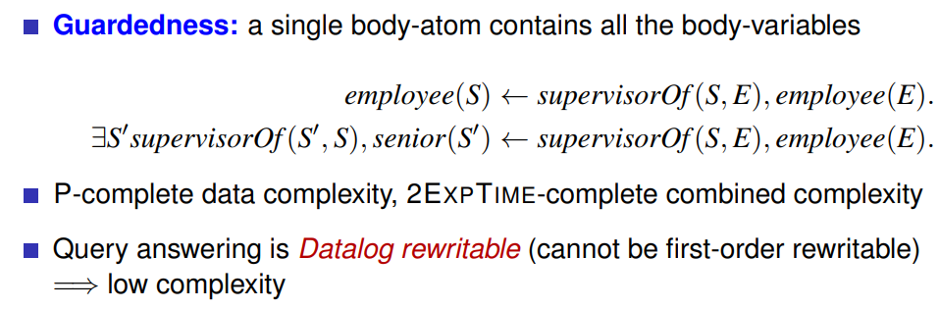
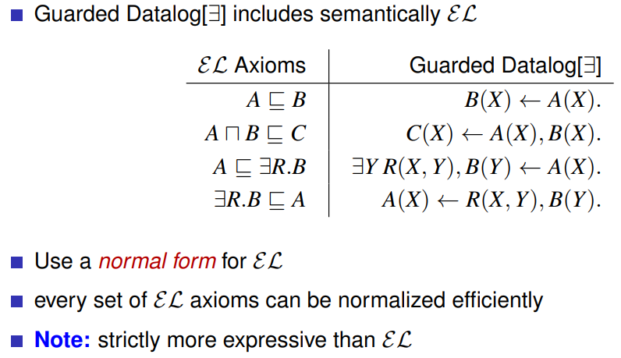

- What is Sticky Datalog? Is it more expressive than DL-Lite?
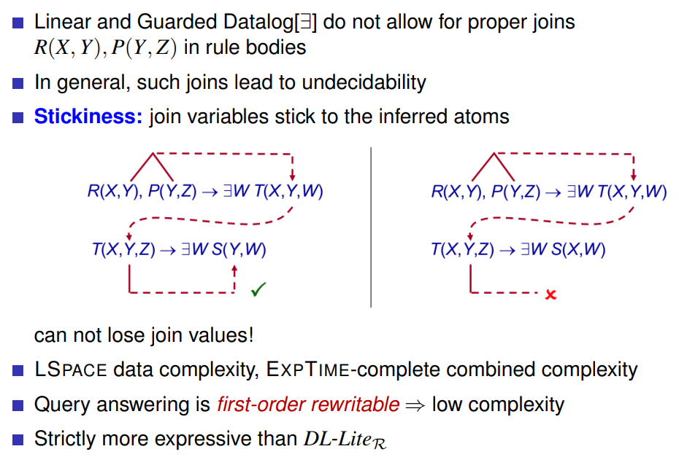
- Name some systems that implement reasoning for existential rules.
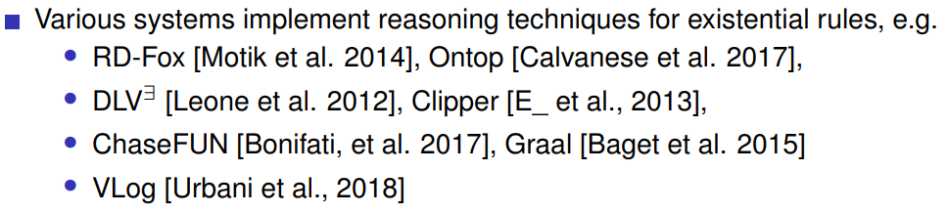
- Summary of this unit:
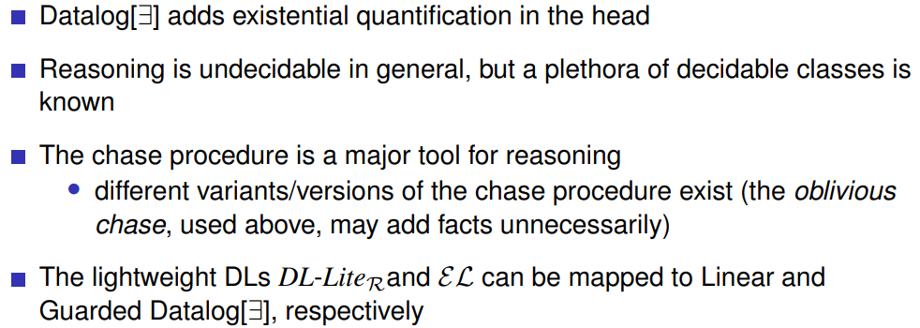

Hybrid Knowledge Bases
- What is a hybrid knowledge base?
- Which principled ways did we consider for giving a semantics to hybrid knowledge bases?
- What is the idea of
  - tight semantic integration?
  - full semantic integration?
  - loose coupling?
- Give some example(s), and say what advantages/disadvantages the types of combination have.
- What is informally dl-safety, what weak dl-safety? Why is it useful?
- What is the idea for non-monotonic dl-programs?
- Which constituents does an dl-atom have?
- How does a dl-program differ from an ordinary ASP program?
- How are dl-atoms informally evaluated, and how are informally answer sets defined for dl-programs?
- What is an FLP-answer set?
- What properties do answer sets of dl-programs enjoy?
- For what applications is the use of dl-programs handy?
- What is "uniform evaluation" of dl-programs, and why is considered? What issues arise with it?
- Describe the idea (steps) for the transformation of dl-programs over OWL2 RL ontologies into ASP, as used by DReW.
- Would the DReW transformation be applicable to Description Logics like ALC or SROIC?

Answer Set Programming - External Evaluation
- What are "inside" and "outside" ASP extensions? Can you give examples?
- What is embedded ASP?
- What is ASP + X, and what examples do you know?
- Which issues are especially important for the definition of a external information access from an ASP program?
- What is the notion of an external atom in HEX, and what constituents does it have?
- How is the semantics of an external predicate &g informally defined? What pragmatic assumptions are made in that, and what is/could be the motivation for that?
- How do HEX programs look like, and how are answer sets for a HEX program defined?
- Name some properties of answer sets that are lifted from ordinary ASP programs to HEX programs.
- Under which assumption about the complexity of evaluating external atoms are HEX programs not harder to evaluate than ordinary ASP programs?
- What is computation outsourcing, what information outsourcing? Give some examples.
- Describe some examples of application areas of HEX programs. Can you imagine one not in the list discussed?
- Name some implementation(s) of HEX programs.
- How is the black-box nature of external atoms countered in HEX?
- Give examples of properties of external predicates that can be exploited.
- How can value invention in HEX programs be handled?
- Name some formalisms related to HEX programs.
- Describe the differences to clingo (version 5).

ASP Stream Reasoning
- What is Streaming Data?
- What is Stream reasoning, and how does it differ from Temporal Reasoning?
- How is Stream reasoning different from Stream Processing?
- What is conceptually a window function? Which types of window functions occur in practice?
- What are the elements of the LARS language?
- How is satisfaction of a formula in LARS informally defined?
- What are LARS programs, and how is informally an answer stream defined?
- What features of answer sets are inherited to answer streams?
- What is nondeterminism of answer streams, and how can that be exploited?
- What is the complexity of deciding whether a LARS program has an answer stream over a given data stream?
- How does propositional LARS with sliding time-based windows compare to
  - first-order logic
  - second-order logic
  - regular languages?
- What is complexity-wise the difference between LARS and linear-time logic (LTL)?
- Name some implementations of LARS, and what features they have.
- What uses of LARS for Analysis of other Stream reasoning languages do you know?
- What is CQL, what is ETALIS?
- What is Complex Event Processing, and where is a principled difference between the semantics of LARS and the semantics of ETALIS?
- When can LARS answer streams capture ETALIS minimal models for integer timelines?
- What other ASP/Datalog like Streaming reasoning approaches do you know?

