Software Architekturen Ausarbeitung

Introduction
typically:
- wish-list
- concept
- changes deviate from concept
- results in big ball of mud

=> inspiration from civil architecture.

Architecture and Architecture disciplines. Structure + act of designing the structure

What is SW Architecture ?
Goals:
- provide orientation on architecture
- improve the quality of the software
- understand architectural thinking

- No details, just the load carrying parts, the main components
- From analysis of problem to realization of solution
- Makes complexity manageable
- decisions that have system-wide consequences

Definition:
- Set of principal design decisions about the system. principal == what the stakeholder decides is important.
- blueprint of construction and evolution
  - structure/behaviour/interaction/non-functional properties
- Implementation of high-level components. Architecture deals with abstraction, decomposition, composition, style, and aesthetics.

Temporal aspect
There is only one Architecture / Point in time.
Architecture will change over time, it can be Prescriptive or Descriptive (Vorschreibend oder Beschreibend).

Architectural evolution
In practice usualy direct changes, hence descriptive modification, although the correct way would be to modify the descriptive architecture first.

Deployment
- Physical placement on HW
- Type of deployment can be critical in assessing whether the system will be able to satisfy its requirements.
- assessment dimensions
  - processing power
  - memory consumption
  - bandwidth consumption

Elements
We don’t like monoliths. Software Architecture should be an interplay of processing, data (state) and interaction.

Components [processing + data]
Definition:
- encapsulates a subset of functionality and/or data
- accessible only through specified interfaces
- explicitly defined dependencies on execution context
- can be deployed independently.
- subject to composition

Provides application specific services.

Connectors [Interaction]
Definition: Regulates interaction among components. Usually procedure calls or shared data access. Connectors provide application independent interaction facilities.

Examples:
- Procedure call
- Shared memory
- message passing
- streaming
- …

Configurations [association between components connectors]
Instance of an architecture.

Styles [named collection of arch design decisions]
- applicable to development context
- constrain architectural decisions within context
- results in high(er) quality in resulting system

Can be viewed as design choices that regularly result in better solutions.

Patterns
- set of architectural design decisions (styles)
- applicable to a recurring design problem
- parametrized to account for different dev. contexts.

e.g. Three-tiered system pattern

A pattern is a problem-solution pair concentrating on the rationale of a design decision, whereas a style only describes components, connectors and their configurations. Therefore patterns are more concrete.

Architectural Models, Views, and Visualizations
- Model: describes some or all design decision
- Visualization: describes decisions for stakeholders
- View: subset of related decisions (filter)

Architectural Process
- Architectural design
- Architecture modeling and visualization
- Architecture-driven system analysis
- Architecture-driven system implementation
- Architecture-driven system deployment, runtime redeployment, and mobility
- Architecture-based design for non-functional properties, including security and trust
- Architectural adaptation

Software Architecture as a Discipline
- does not only encompass the architectural description
- but also the activities of the architect i.e. work with all stakeholders
  - Users
  - Testers
  - Managers
  - Vendors
  - Developers
  - Architects

Influences
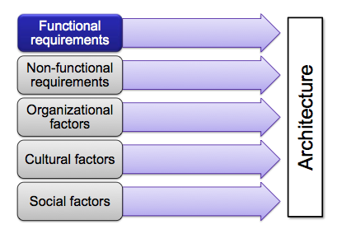

Tasks

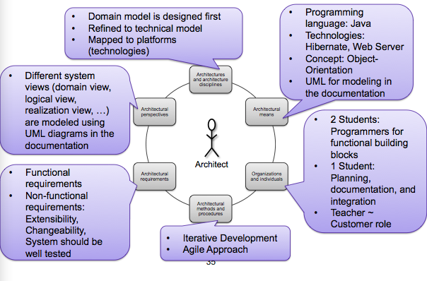

Architectural Refinement
- Domain architecture: reflects the problem space of the system (functional aspects)
- Technical architecture: domain-neutral, realizes non-functional req. (e.g. Security)
- Platform architecture: provides services for executing components (e.g. JEE)

Dependencies: 1 -> 2, 2 -> 3

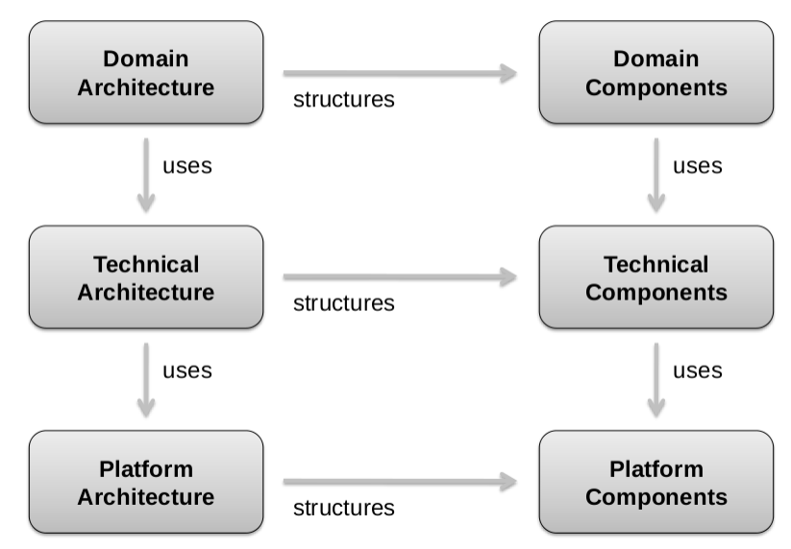

Architectural Requirements
System must be designed to fulfill its requirements. Requirements have different influence and must be properly balanced. Architectural requirements are forces that influence system design.

Definition
A requirement ...
.. is a capability of a system needed by a user of the system to solve a problem or reach a goal.
... is a capability of a system to fulfill a contract, a standard, a specification, or another formal document.

Properties:
- correct
- implementable
- unambiguous
- testable

Kinds of requirements
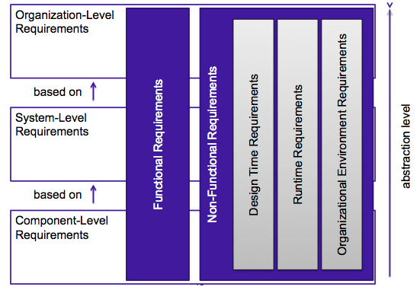

Non-functional requirements
Define expectations or criteria that can be used to judge the operation of a system.
- NFRs with direct implications: Performance, Extensibility, Reusability, etc.
- NFRs with indirect implications: Standards, conditions that must be reached (e.g. Budget, Legislatives, Policies, etc.)

Fulfilling the NFRs is essential to the acceptance of the functionality of the system. -> Should be considered early.

Architectural Principles
Help to develop design architectures which fulfill functional and non-functional requirements.

Coupling
Coupling measures the dependencies among the components by counting the relationships.
- coupling of classes
- coupling of runtime objects
- coupling of components
- coupling of hardware

The coupling of components should be kept as low as possible. (Loose coupling).

Cohesion
Cohesion measures the dependencies within a component.
Should be as high as possible.
Mostly loose coupling results in high cohesion of components. This results in:
- Understandability: Keeps the complexity of structures low
- Changeability: Increase the changeability of the architecture

Design for change
Means to plan for foreseeable changes when designing an architecture. E.g. requirements that are likely to arise by:
- Inconsistencies and unclear specification
- Experiences of other software

Risks:
- More work
- Change may not occur
- Higher resource consumption due to higher complexity

Separation of concerns
Different aspects of a problem should be separated from each other.
- Modularization
- Separation of requirements
- Separation of complex architecture into views
- Separation of organizational responsibilities
- Separation of processes
- Multi-dimensional separation (AOP)

Information Hiding
Present only necessary information to clients and hide the rest. Reduces complexity (e.g. Facade pattern)

Other principles
- Abstraction: make complex problems understandable
- Tracability
- Self documentation
- Incremental Evolution

Styles Adaption
Architectural style: Describe a family or class of architectures sharing a common pattern of structural organization.

- Dataflow System styles
  - Pipes and Filters
  - Batch Sequential
- Call-and-Return System styles
  - Main Program and Subroutines
  - Object-based architectures
  - Layered architectures
  - Event-based architectures
- Independent Component styles
  - Communicating
    - Processes Client / Server
    - Peer-to-peer
  - Event Systems
  - Implicit Invocation
- Virtual Machine styles
  - Interpreters
  - Rule-based Systems
- Data-Centered Systems (Repositories) styles
  - Databases
  - Hypertext systems
  - Blackboards

Examples for styles

Pipes and Filters
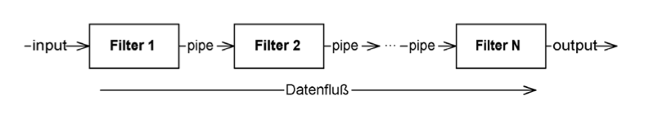

- Pipes: are connectors that move data between filters
- Filters: are components that transform streams by applying knowledge

Characteristics:
- Filters are independent and do not know each other
- Works only with streams (otherwise batch-sequential)
- Filters can only be combined with pipes

Layered architecture
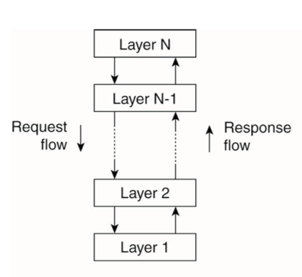
- Components are organized in a layered fashion.
- Layer N only has dependencies to Layer N-1.

Object-based architectures
Components are objects. They are connected through a RPC mechanism. Client-Server architectures are built out of this style.
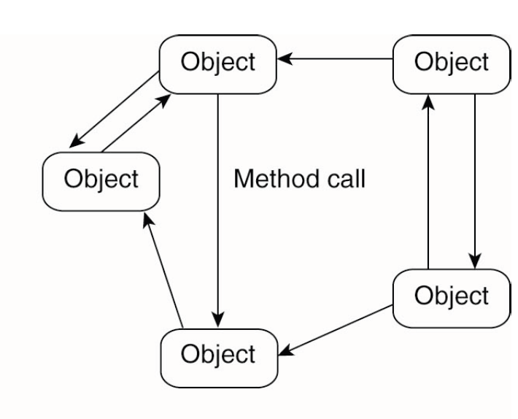
Layered and Object based architectures are the most important styles for distributed systems today (might change in future).

Data-centered architectures
Basic Idea
- Communication of components over a shared repository.
- Repository might be either (pro)active or passive (reactive)

Main features:
- … depends on the choice made for the shared repository
- how information is represented
- how events are handled
- how the shared repository behaves in response to interaction
- how processes interact with / through the shared repository

Examples:
- Many web based systems are largely data-centric
- Also, many distributed applications still work by sharing files around the network

Event-based architectures
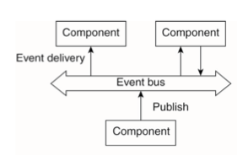
- Components communicate through event bus.
- Event bus is responsible for event distribution.
- Events can carry data.

Components are:
- referentially decoupled
- decoupled in space

Examples:
- Publish/Subscribe systems

Shared data-space architectures
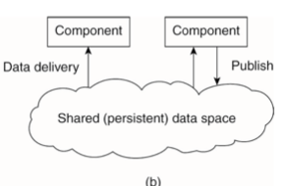
- Mixture of event-based and data-centric architectures.
- data can be stored and accessed along with related events.

Components:
- can communicate
- are additionally decoupled in time.

Example:
- Blackboard systems

Architecture vs. Middleware
Problem: Middleware commonly incorporates architectural styles. Therefore tends to be not adaptable to every application scenario.

Solution: seperation of mechanism and policies i.e. mechanism is implemented in the middleware, but behaviour can be changed by exchanging policies. But this approach can’t cope well with unpredictable change (unkown unknowns).

Recipe for adaptive software:
- separation of concerns (use AOP for non-functional properties)
- computational reflection -> reification (adapt after reflection)
- component-based design -> how are components selected?

Adapting Middleware
Unpredictable change. Any fixed solution / response may fail when facing an unpredictable modification. Interceptors represent a generic solution to adaption in terms of a naive mechanism.

Towards Adaptive Software
- Separation of concerns
  - Separating functional and non-f concerns
  - non-f properties like reliability, performance, security should be faced seperately (hard)
  - AOP SW dev deals w cross-cutting concerns
- Computational reflection
- Component-based design

Deployment Architecture and QoS

- Deployment Architecture: allocation of s/w components to h/w hosts
- h^{c} deployment architectures are possible for a given system
  - Many provide the same functionality
  - Provide different qualities of service (QoS)

There may be several (conflicting) QoS dimensions. E.g.: minimize latency and maximaze durability. There is no optimal deployment architecture. Preferences can be expressed in a utility function. (See slides, there is a bunch of .. weird pictures - slideset 2, slide 19-23).

Deployment Modeling & Configuration
Interaction paths vs. network connectivity

Modeling Architectural Elements
- Define sets that specify system elements and their properties
  - Set C of software components
    - C = {ResourcesMap, SendMessage, Display, ...}
  - Set CP of software component properties
    - CP = {size, reliability, ...}
  - Other sets
    - H of hardware nodes, N of network links, I of logical links, S of services, Q of QoS, U of users
    - HP of hardware params, NP of network link params, CP of software component params, IP of logical link params
- Define functions that quantify system properties
  - Function cParam:C×CP→R
    - cParam(ResourcesMap, size) = 150
  - Other functions
    - hParam, nParam, IParam, sParam

Modeling QoS Dimensions
Define QoS functions and users’ preferences in terms of utility.

QoS function: quantifies the achived level of QoS, the result is a qValue. The users preference is the accrued utility for given rate of change.

Modeling System constraints
PC = parameter constraints. PC={memory, bandwidth,...}. PC is a function on a binary value. (1 if satisfied). Functions can restrict locations of sw components. loc(a,b) - a can be deployed at location b. colloc is a function which describes the type of co-location of two components (must be on same host, must not be on same host, no restrictions).

Deployment Analysis
How to check whether a deployment is valid, how to compare deployments for quality or check whether a deployment meets a given set of criteria?

Deployment Analysis Strategies
- Different strategies with different strengths
- Most of them offer approximate solutions

- Mixed Integer Non-linear Programming (MINLP)
- Mixed Integer Linear Programming (MIP)
- Heuristic-based strategies
  - Greedy
  - Genetic
  - Decentralized

Towards Adaptive Software

Computational reflection
== ability to inspect oneself and possibly self-adapt behaviour.

- Reflection is at the core of modern programming languages like Java
- Observing the state of a program by the program itself
- Reification is changing the state of the program after reflection
- Observing own state related to the environment makes it possible to change behavior adaptively

Component-based design

Adaptation through composition
- Once an architecture is open, e.g., hot-pluggable a new behavior may be added by adding a component on the fly
- Once an architecture for open systems is available, the point is how to select a component that may add the required behavior to the system

Automatic Adaption

Main Idea
- Unpredictability of change makes guided adaptation essentially faulty Systems should be able to detect (relevant) change in the environment and consequently change / adapt
- This is the field of autonomic computing and of self-* systems
- What they all have incommon is a feedbackloop, perception and action mechanisms.
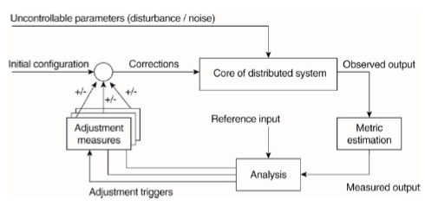

Towards (Self-) Adaptive Software Architectures

Challenges of today’s applications
- heterogeneity
- large-scale
- dynamic
- operate 24/7
- time to market
- cost pressure

Humans are ‘self learning’ and highly adaptive.

System Life Cycle - revisited
- Development Environment:
- Use Environment
- Use phase
- Maintenance

Adaptive Coupling
- Focus on structure and interaction rather than properties of the individual constituents
- Differing strengths in relationships (tight or loose coupling), this determines the overall system properties.
- Inner loop provides adaptivity by controlling the coupling strength
- Regulate emerging behaviour with policies
- Evolvement of user needs and context

The system design is changing wile its running. This requires run-time accessible and processable requirements and design-views:
- constraints
- models
- (partial) architectural configurations

Run-time sw development
- requires middleware support for requirements
  - stored in repositories
  - accessed via reflection or
  - aspect-oriented programming (dynamic aspects) or
  - protocols for meta-data exchange
  - "APIs" to change software artifacts

convergence of software development tools with middleware services (“re-engineering running software“)

new challenges: e.g., run-time testing and verification, e.g., see G2

Emerging techniques

- Control loop
  - adaptiveness
  - self-properties
  - autonomic computing
- SW evolution
  - convergence of design-time and run-time
  - run-time sw development
- Architectural dependability (eg p2p)
- Bio-inspired methods

MAPE

MAPE = Monitor Analyze Plan Execute
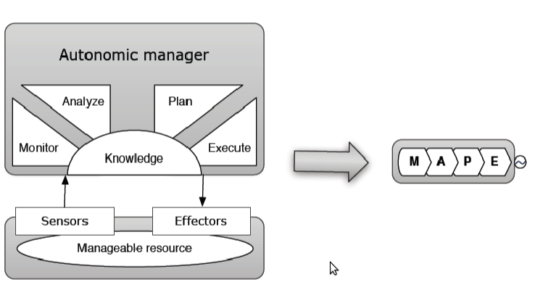

Distributed MAPE

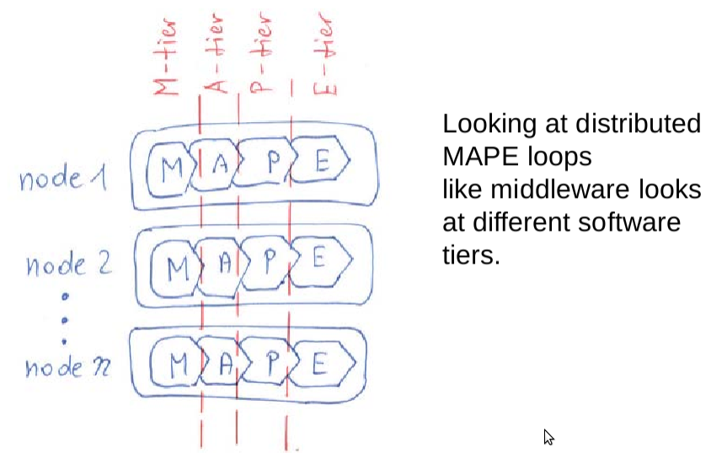

Decentralized MAPE pattern

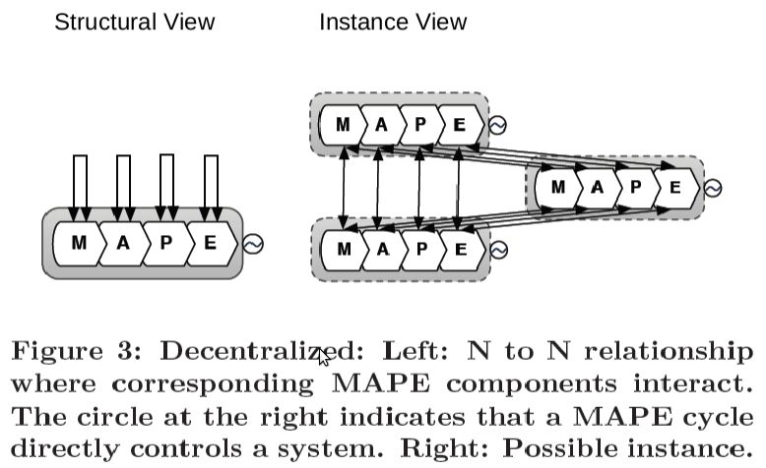

Master/Slave MAPE Pattern
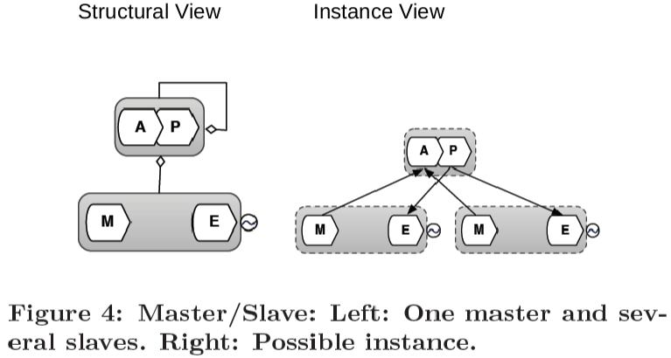

Regional Planner MAPE
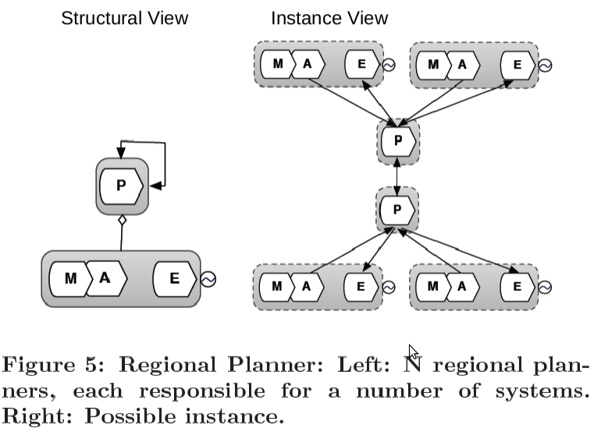

Information Sharing MAPE Pattern
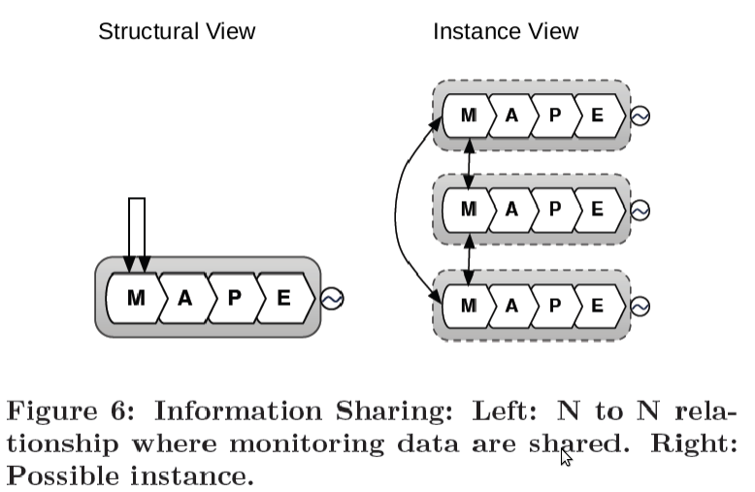

Self Healing

Application of self-healing

Support people w the complexity of current systems
- Avoid design errors
- Avoid configuration errors
- Replace failing service
- Handle service invocation transparently to keep system healthy
- Support service maintenance

Def: A self-healing system should recover from the abnormal (or “unhealthy”) state and return to the normative (“healthy”) state, and function as it was prior to disruption.

A system with self-healing properties can be identified as a system that comprises faulttolerant, self-stabilizing, and survivable system capabilities and, if needed, must be human supported.

Self-healing origins
- Fault-tolerant system: continues working at a reasonable degree in presence of faults
- self-stabilizing system: continously stabilizes the system from any problems
- survivable systems: survives everything

Self-healing research
- IBMs autonomic computing research envisions a layered structure that can manage itself to given high-level objectives from administrators
- Motivated by the amount spent on and overwhelming effort in system maintenance
- The research tries to cover all adaptable layers down to network and operating system
- Defines 4 properties for self managing systems (self-CHOP)
  - self-Configuring - ability to readjust itself “on-the-fly”
  - self-Healing - Discover, diagnose and react to disruptions
  - self-Optimization - maximize resource utilization to meet end-user needs
  - self-Protection - Anticipate, detect, identify, and protect itself from attacks

- Self-adaptive systems evaluate their behavior and adapt on system irregularities or when better functionality or performance is possible
- The research primarily covers the application and the middleware layers and focuses on the system as a whole.

Taxonomy:
- self-healing
  - What:
    - continuous availability by compensating the dynamics of a running system.
  - Why:
    - maintenance of health
    - survivability
  - How:
    - detecting disruptions
    - diagnosing - what is the root cause?
    - recovering - how to do it?
  - When:
    - closed-loop, permanently.
  - Who:
    - By the system itself
    - By the human administrator by configuration, e.g. set of policies
  - Where:
    - Complex, unpredictably behaving systems

Self-healing requirements

- Closed loop with sensor and effector interfaces
- Status knowledge and state recognition
- Failure classification
- Recovery policies
- Fitness and evolutionary aspects

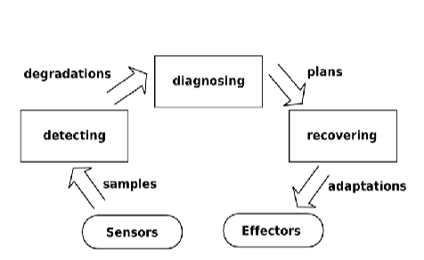

detecting: filters any suspicious status information
diagnosing: looks for the root cause and calculates appropriate recovery
recovery: applies the planned adaptions

self-healing states
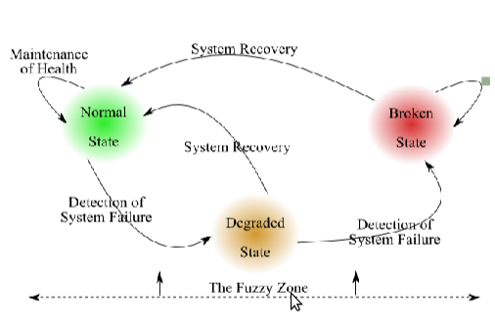
- Normal: Healthy system that signalizes intentional functioning of the system
- Degraded: System is in fuzzy transit zone. Drift from acceptable to failure. Recognizable by considerable loss of performance. Provides additional time for recovery.
- Broken: Unhealthy, unacceptable response (FAIL).

Failure classification
- Crash failure: undetectable malign interruption
- Fail-stop: detected benign interruption
- Transient: instantaneous transparent with side-effects
- Omission: message loss, transmission errors
- Performance: violation of constrains in execution time
- Arbitrary: any type of failure with no specific pattern

- Action policies: no learning, but immediate response is expected.
- Goal policies: define a set of desired states. Calculate set of actions for the transition from current (failed) to desired (working) state.
- Utility function policies: set of states is connected to a utility. Solver operates on history information, adaptation knowledge and comprehensive system awareness

Common recovery policies are: Replacement, balancing, isolation, persistence, redirection, relocation, diversity.

Fitness and evolution
- Current systems, especially self-* enhanced, are designed for long-term service.
Issues:
  - many requirements are not known a-priori but expose themselves and evolve over time
  - malicious failures might restrict parts of the system’s functionality to essential services
  - adaptation might reach its limits in resources
- Current solution: human assisted healing

Summary of self-healing
- Why is it required. What's the motivation?
  - Increasing complexity of current systems causes
  - ...escalating costs
  - ...overwhelming effort in system maintenance
  - ...system incomprehensibility
- How does self-healing work. What are the requirements?
  - Sensor and effector interfaces provide the essential awareness
  - (self and environment)
  - Closed loop with timely information flow
  - State recognition: healthy, degraded, unhealthy
  - Fault classification
  - Policies with recovery strategies

EXAMPLE - Self Adaption in Socially enhanced SOA
- Factory
  - a accepts and delegates tasks frequently
  - a processes few tasks and has a low task-queue
- Sink
  - d accepts too many tasks
  - d processes slow (capability vs. overload)
- Misbehavior impact
  - Produces unusual amounts of task delegations
  - Tasks miss their deadline
  - Leads to performance degradations of the entire network

(Mis)behavior monitoring
- Open System with varying participation
- All services use the communication infrastructure
- Interaction logging:
  - Log the exchanged messages and process their content
- Logs provide information on:
  - Task properties: id, tags, etc.
  - Type, skills, and interests of services

Similarity Service
- Cos-similarity to determine the similarity of two services’ profile vectors
- Trust mirroring: “similar minded” nodes tend to trust each other more than random nodes
- Trust teleportation: the past trust relation (u,w) “teleports” to others having similar interests.
  - Note: u and w have different profile, e.g., different roles

Misbehavior adaptation
-> b queue overload detected
-> find alternative/similar service
-> (i) 1st support b mirroring of trust
-> (ii) 2nd avoid b teleportation of trust

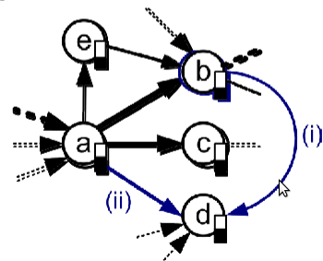

Self-adaptation concepts

- Feedback loop design for misbehavior healing
- MAPE loop of autonomic computing:
  - monitor interactions and queue threshold
  - analyze behavior and compare to misbehavior models
  - update behavior registry (part of knowledge)
  - plan adaptive actions
  - execute channel regulations and redirections

VieCure framework [wichtig weil Eigenbau!]
- Interaction logging updates monitoring db and behaviour registry
- Policy Store and Similarity Service determine the adaptions
- Admin tools allow to fine-tune the framework

Adaption - some conclusions
- Mixed Dynamic Systems require novel “programming model” composing HPS and SBS
- Identification of (mis)behavior patterns and protocols and composition primitives in Mixed Systems
- Non-intrusive adaptation of misbehavior with self-healing

MDA
A model is a pattern, plan, representation (especially in miniature), or description designed to show the main object or workings of an object, system, or concept.

Or: Models in sw development: In sw development a model is an abstract representation of a system.

Terms

- Models
  - Unified Modeling Language (UML)
  - Architecture Description Language (ADL)
  - Domain-specific Language (DSL)
- Model-driven Sw Development (MDSD)
  - Models are not only used for documentation, but as central artifacts
  - Also called Model-driven Development (MDD) or Modeldriven Engineering (MDE)
- Model-driven Architecture (MDA)
  - A specialization of MDSD
  - Defined using the Meta-object Facility (MOF)

Meta-modeling
- To be able to automatically process model data, it must be described precisely in a formal language
- to achieve this, models are typically described through models, which are then called meta-models
- A model is an instance of its meta-model
- The cascade of abstraction by creating a meta-model for models can be continued arbitrarily, leading to a number of modeling-levels

Modeling languages
- MM (Meta-models) are also used to describe ML (modeling languages)
- Meta-Models define the structure or abstract syntax of the modeling language
- in addition a concrete syntax is also needed (e.g. textual or graphical notation to create models)
- Finally, the modeling languages require semantics that describe the meaning of the models
  - Often the semantics are given informally
  - hence, these modeling languages are called semi-formal languages

Architecture Description Languages (ADL)
An ADL is a modeling language specifically designed to describe software and/or system architectures

Properties:
- Formal representation of the architecture on a very high abstraction level
- Readable by humans and machines
- Analyzable w.r.t. architectural properties ( consistency, completeness, performance etc.)
- Sometimes support for code generation

ADL Main concepts:
- Components:
  - specification of functional or non-functional aspects of architectural elements using interfaces
  - The exported and imported interfaces of a component are described.
- Connectors:
  - Components communicate via connectors that define how components interact with each other
  - Connectors can represent various communication means (e.g. RPC, HTTP, Pipes, etc.)
- Architectural Configuration:
  - Describes the architectural structure by defining how the components and connectors are connected with each other

ADL Main Concepts

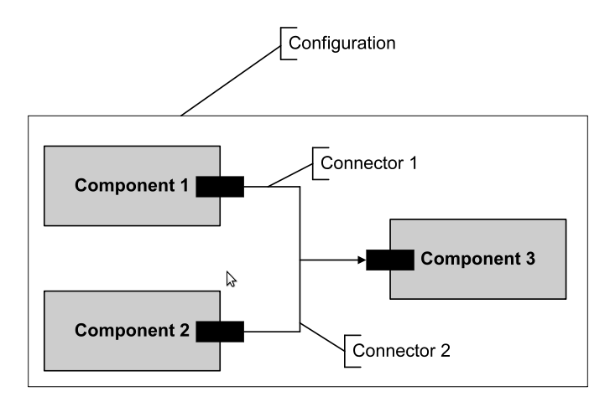
An example is on slide 3/12, but learning the language seems unreasonable.

UML Modeling Langugage (UML): MOF
- The Meta Object Facility provides basic meta-model elements to build meta-models
- The OMGs (Object Management Group) meta-model architecture defines 4 modeling levels
- is itself defined using the elements of the UML infrastructure
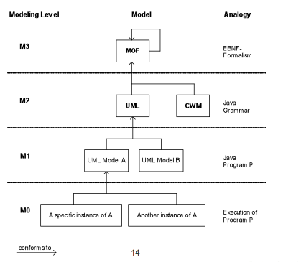

UML
- The UML specification itself is split into the UML Infrastructure and the UML Superstructure specifications
- The UML infrastructure defines elements used in both the meta-meta-model of UML (MOF) and the superstructure
- The UML meta-model (i.e., the language definition) is defined in the UML superstructure
  - The infrastructure is merged into the superstructure

Application of the UML Infrastructure in MOF and UML
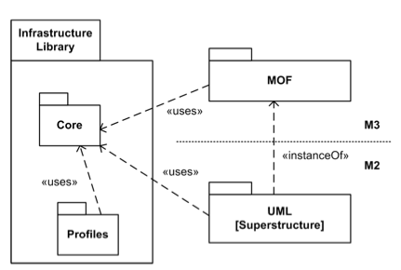

UML Diagram Overview
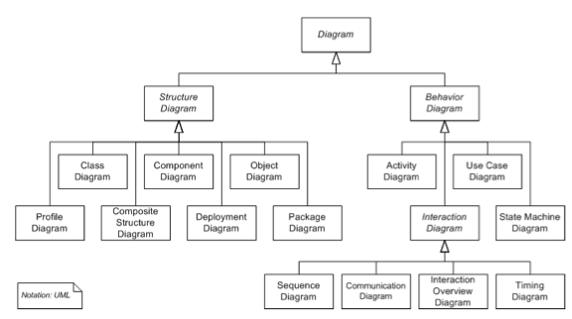

Example Component Model in UML2
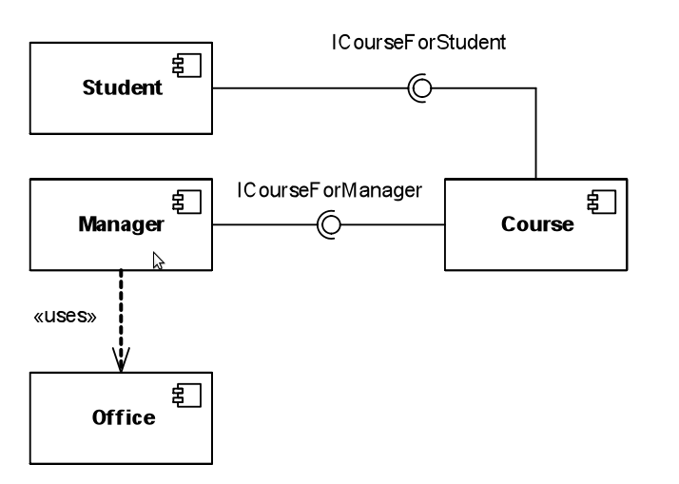

Modeling Architectures with UML
- UML supports modeling :
  - component & connectors view
  - import and export of interfaces
  - configurations
- little support for:
  - specific architectural properties (e.g. for analysis, as in ADLs )
  - modeling system integrations (lack of system integration concepts
    - desktop application, server application, hosted application...
    - messaging, queues, publish/subscribe...
    - databases, file systems...

According to the standard there are 2 ways to extend the language:
- hard extension produces an extension of the language meta-model. i.e. a new member of the UML family of languages is defined
- soft extension results in a profile which is a set of stereotypes, tag definitions and constraints based on existing UML elements with some extra semantics according to a specific domain.
- A stereotype can extend any element (meta-class) of the metamodel.
  - new types of classes, components, actors, ...
  - new types of relationships ...
  - new features like attributes
- (OCL) constraints can be used to formally define the semantics of the stereotypes meta-classes

Model-driven Software Development (MDD/MDSD)
- models as central artifacts (not only for documentation)
  - parts of the system are specified in models and the system is generated from these models
  - models must be precise and as expressive as possible
- Model driven Architecture (MDA) of the OMG is one specific flavour of MDD

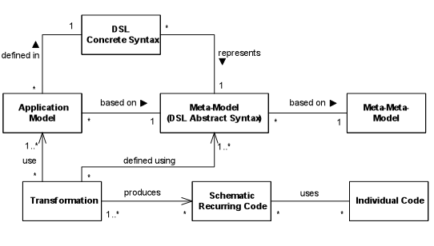

Domain-driven Design and Development
A domain is a bounded area of knowledge or interest
(e.g e-Banking, Embedded Software, Web-Based eBusiness Applications, Control Software for 4-Cylinder Diesel Engines, Astronomical Image processing Software).

- Domain Driven Design and Development means to make software development domain-related and not (just) SW-technology-related
  - Goal: Make software development in a certain domain more efficient
  - This is achieved by mapping (business) domain concepts into software artifacts using a domain model

- A domain model establishes a common model between the /business) domain and IT stakeholders

Domain-Specific Languages (DSLs)
- A DSL is a tailor-made (computer) language for a specific problem domain
  - DSLs differ from genral purpose languages (GPL), such as C, C#, Java, Perl, Ruby, or Tcl, that can be applied to arbitrary problem domains
  - DSLs are often not Turing complete and only provide abstractions suitable for one particular problem domain
- The specialization results in significant gains in expressiveness and ease of use
  - Often less less code is needed to achieve a result
  - Often DSL code is rather easy to read and comprehend

DSL Can be realized as
- An Embedded DSL (also called internal DSL) is defined as an extension to an existing GPL
  - It uses syntactic elements of the underlying GPL
  - It can directly access all features and tools of the host language
  - instead of using a generator, often embedded DSLs are interpreted
  - Typical examples of embedded DSLs are DSLs in scripting languages and dynamic languages, such as Ruby, Python, Tcl or Perl
- An External DSL is defined in a different format than the intended target language(s)
  - It can use all kinds of syntactical elements
  - DSL designers may define any possible syntax, be it textual or graphical
  - An external DSL is not bound to a certain host language or platform
  - It can be mapped to target platforms via transformations

MDSD : How it works
- Developer/designers develops models based on a meta-model
  - Often models and meta-models are expressed using a DSL
- Code generation (using templates) is used to transform the model into executable code
  - Alternatively the models can be interpreted
  - In most cases only the schematic, recurring code is generated, other code is written manually
  - In between, model-to-model transformations can happen

Example Generation Process

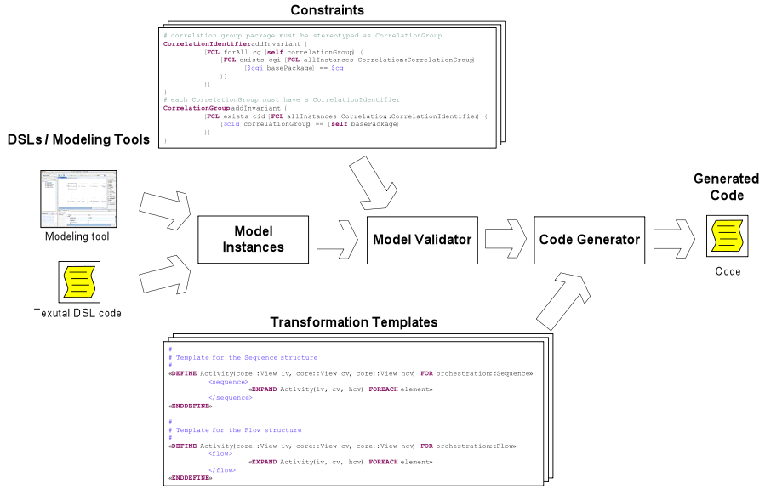

Feasibility
MDSD requires:
- Creating an infrastructure consisting of modeling tools, generators, platforms, etc.
- much effort for domain analysis

These efforts do usually not pay off for using the MDSD infrastructure only once. Multiple incarnations of an MDSD are more feasible.

Software Product Lines and System Families
- multiple incarnations of MDSD often leads to software product lines
  - Idea: identification of software system families
  - The members of the family have a number of technical and domain concerns in common
  - Often they rely on the same technical infrastructure
- Supporting reuse of:
  - components and frameworks
  - models, generators, transformations

Feasibility of MDSD
- MDSD requires:
  - Creating an infrastructure consisting of modeling tools, generators, platforms etc.
  - Much effort for domain analysis

SW Product Lines and System Families
- Multiple incarnations of MDSD often leads to sw product lines
  - Idea: Identification of sw system families
  - The members of the family have a number of technical and domain concerns in common
  - Often they rely on the same technical infrastructure
- Supporrting reuse of
  - components and frameworks
  - models, generators and transformations

Options for modeling architectures [slide 45]
- informal box-and-line diagrams (not precise enough for MDD)
- existing ADL that fits modeling needs (often not available)
- use/extend UML
- define custom architecture meta-model to define own DSL
  - enhances communication with stakeholders
  - supports architecture communication (glossary)
  - often clarifies architecture (by formalizing it)
  - serves as technology-neutral architecture definition

Benefits of a Custom Architecture Meta-model / DSL
- Communicating the architecture among stakeholders can be specifically spported and eased
- It can support architecture documentation
  - glossary of architecture concepts
  - glossary of the components, interactions etc.
- Formalizing often means clarifying
- Approach lends towards a technology-neutral architecture definition

Example: Incrementally Building an Architecture DSL
Goals:

- Incrementally define an Architecture DSL for an existing flight management system that evolved over 10-15 years.
- Reason: Define the building blocks (types of things) from which the actual system will be built.
- Abstract from technologies used in the system
- Distributed system, needs to be upgraded incrementally
- Versioning of components is required

Architectural views
View: A representation of a whole system from the perspective of a related set of concerns.

Viewpoint: A specification of the conventions for constructing and using a view. A pattern or template from which to develop individual views by establishing the purposes and audience for a view and the techniques for its creation and analysis.

Views
- make complex systems understandable
- only concentrate on certain aspects of system
- either support differenect stakeholders or tasks
- or different architectural abstraction levels
  - introduce zoom-factor for the models -> refine models in multiple levels e.g.
    - 1: organizational view
    - 2: system view
    - 3: component view

4+1 View Model
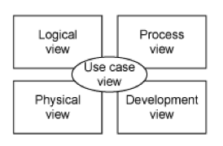
- Use case view
  - all architectural decisions are based on use cases and scenarios of the system in focus
  - foundation of all other architectural views
  - used for validating other views
  - by use case diagrams and use case specifications
- Logical view
  - describes the (object oriented) system in terms of logical abstractions
  - by class diagrams, component diagrams, sequence diagrams, etc.
- Development view
  - describes structure of modules, files, packages
  - by package diagram
- Process view
  - processes and communication among them
  - by activity diagrams
- Physical view
  - how system is installed and placed in a network
  - by deployment diagrams

View-based Modeling Framework (VbMF)

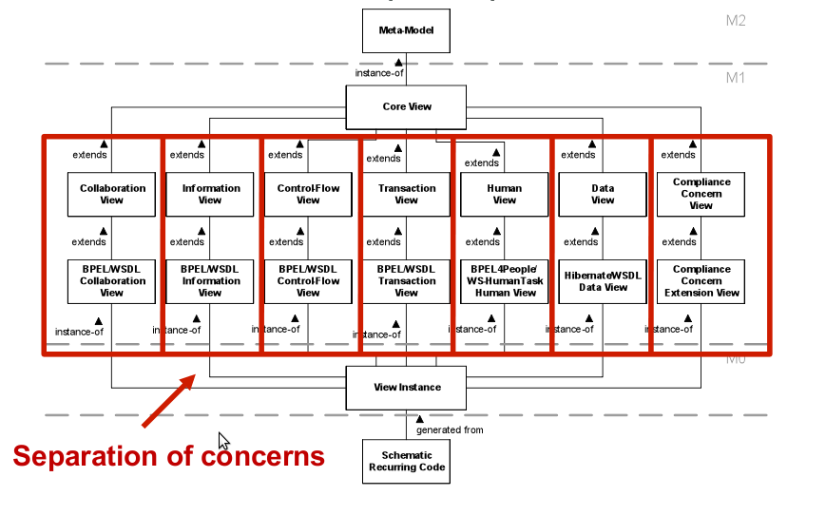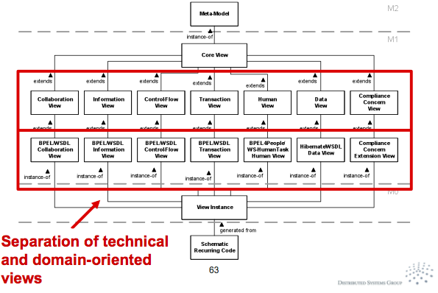

Cloud

Current Problems:
- Low utilization of servers
- High variability of OS/MW
- Highly customized, few standards

Server Virtualization
Run many physical systems as virtual machines on one physical hardware (“like-to-like”)

Virtual Machine Monitor
Sufficient criteria for VMM’s (Popek, Goldberg)
- Equivalence / Fidelity
  - A program running under the VMM should exhibit a bahaviour essentially identical to that demonstrated when running on an equivalent machine directly
- Resource control / Safety
  - The VMM must be in complete control of the virtualized resources
- Efficiency / Performance
  - A statistically dominant fraction of machine instructions must be executed without VMM intervention

Workload Mobility

Image versus Instance
An instance is a running manifestation of an Image.
There can exist multiple instances from one image.

Virtual Appliances
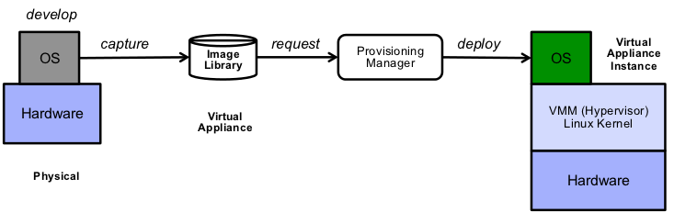

- Provisioning of resource instances based on standard resource representations
- Virtual Appliances (or Images) are packaging of virtual representations with reference to key components that enable the running instance
- For example
  - A linux virtual appliance is a read-only file-system that contains everything required to run (at least a part of) the service
  - Does not contain the kernel, only a reference to the kernel
  - Does contain a manifest describing the appliance
- Examples: AMI (Amazon Machine Image), OVF (Open Virtualization Format)

Workload Profiles
- Provision only what you need
- Scale up to peak as required
- Scale down to plateau and free up resources

Operational Styles
- Your Data Center <-> Pay for server and maintenance
- Your data center Virtualized <-> Pay les for servers and maintenance
- Somebody else’s Data Center <-> Rent servers, pay per usage

A Cloud Computing Model provides
- Internet-based access to virtualized resources
- Elastic scaling of virtualized resources
- Utility-based pricing model

Virtualization abstracts the behaviour of a system from its actual physical implementation
A virtualized resource behaves like the physical resource it emulates by leveraging the capabilities of the physical system such that it provides:
- fidelity (“feels like the real thing”)
- containment (“no conflicts with other virtual resources”)
- performance (“performs almost like the real thing”)

A System that implements a Cloud Computing Model provides a Service that
- provides acces to virtualized resources over the Internet
- provisions and de-provisions virtualized resources as required
- charges only based on actual consumption

Here is the challenge:
A Service is a means of delivering value to a client by facilitating outcomes the client wants to achieve without the ownership of associated costs & risks

Architectural Styles
- Infrastructure as a Service (IaaS)
  - Control over the whole resource
  - Client controls everything from the Operating System upwards
  - Client is responsible for choosing, installation and maintenance of the platform
- Platform as a Service (PaaS)
  - Usage of programming/runntime environments
  - flexible resource capabilities
  - maintenance of environment by service provider
  - client only implements and/or runs own software on given system
- Software as a Service (SaaS) [also Software on demand]
  - Provider host a collection of Software
  - Grants Client access to use the given software
  - Software components are installed and maintained by provider

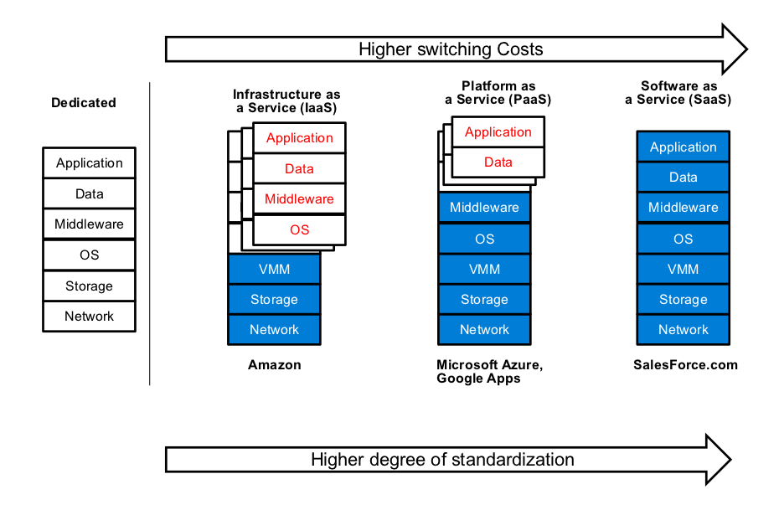

Operational Styles
Private Cloud
- Enterprise Data Center (One Client (Youself))
- Consolidated IT Infrastructure
  - Capital Expense reduction
  - Some operational efficiencies
Shared Private Cloud
- Managed Service Provider
  - Provides the service for different clients
- Hosted IT
  - Capital expense reduction
  - Outsourced service management with contractual SLA’s
Public Cloud
- Hosted IT
  - Capital expense reduction
  - Utility based costs
  - Best-effort SLA’s

NIST Definition of Cloud Computing (Not on the Slides)

Service Models:
- Cloud Software as a Service (SaaS). The capability provided to the consumer is to use the provider’s applications running on a cloud infrastructure. The applications are accessible from various client devices through a thin client interface such as a web browser (e.g., web-based email). The consumer does not manage or control the underlying cloud infrastructure including network, servers, operating systems, storage, or even individual application capabilities, with the possible exception of limited user-specific application configuration settings.
- Cloud Platform as a Service (PaaS). The capability provided to the consumer is to deploy onto the cloud infrastructure consumer-created or acquired applications created using programming languages and tools supported by the provider. The consumer does not manage or control the underlying cloud infrastructure including network, servers, operating systems, or storage, but has control over the deployed applications and possibly application hosting environment configurations.
- Cloud Infrastructure as a Service (IaaS). The capability provided to the consumer is to provision processing, storage, networks, and other fundamental computing resources where the consumer is able to deploy and run arbitrary software, which can include operating systems and applications. The consumer does not manage or control the underlying cloud infrastructure but has control over operating systems, storage, deployed applications, and possibly limited control of select networking components (e.g., host firewalls).

Deployment Models:
- Private cloud. The cloud infrastructure is operated solely for an organization. It may be managed by the organization or a third party and may exist on premise or off premise.
- Community cloud. The cloud infrastructure is shared by several organizations and supports a specific community that has shared concerns (e.g., mission, security requirements, policy, and compliance considerations). It may be managed by the organizations or a third party and may exist on premise or off premise.
- Public cloud. The cloud infrastructure is made available to the general public or a large industry group and is owned by an organization selling cloud services.
- Hybrid cloud. The cloud infrastructure is a composition of two or more clouds (private, community, or public) that remain unique entities but are bound together by standardized or proprietary technology that enables data and application portability (e.g., cloud bursting for load balancing between clouds).

Implications of Cloud Computing
- Do we need a new programming model?
- Do we need new IT management processes?
- How to move to Cloud?

Distributed Applciations

Scalability of Distributed Applications
- Consistency
  - Each client always has the same view of the data
- Availability
  - Each client can always read & write
- Partition Tolerance
  - System works well across network partitions
- CAP Theorem
  - You can only pick two!

Problems:
- Maintaining consistency is strength of RDBMS, but partition tolerance is not
- New Models (Amazon S3, noSQL solutions) prefer to focus on availability and partition tolerance with introducing a notion of eventually consistent

PaaS & SaaS offerings deal with the issues internally

Cloud Reference Architecture (IBM)

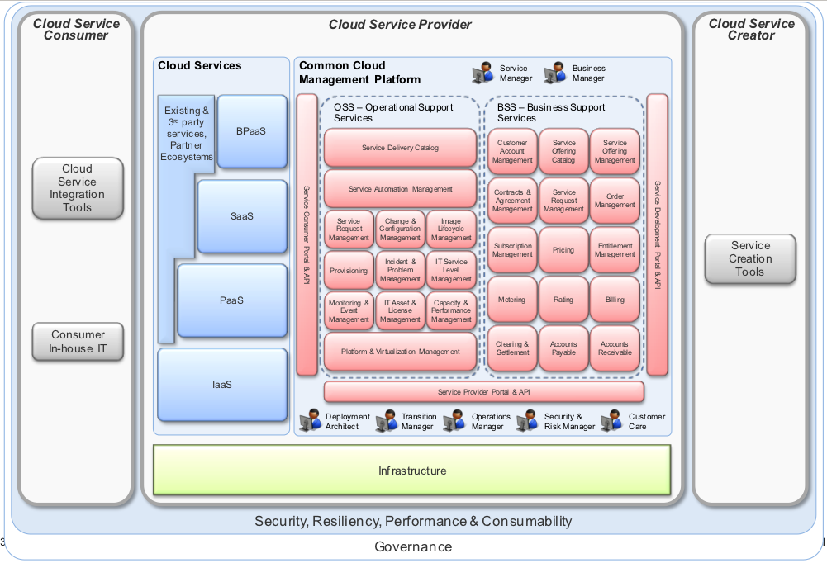

- Governance
  - Security, Resiliency, Performance & Consumability
    - Cloud Service Consumer
      - Cloud Service Integration Tools
      - Consumer In-house IT
    - Cloud Service Provider
      - Cloud Services
        - Existing & Third party services, partner ecosystems
        - BPaaS
        - SaaS
        - PaaS
        - IaaS
      - Common Cloud Management Platform
      - Infrastructure
    - Cloud Service Creator
      - Service Creation Tools

Moving to the Cloud
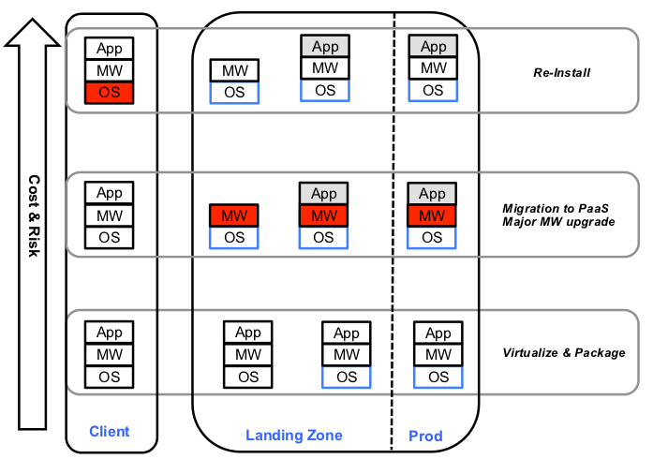

Use Cases:
- Basic Image Migration
- Image Migration & Standardization
- Image adjustment & standardization
- Application Migration
- Migration to a standardized Platform

Patterns [NOT REQUIRED!]
https://www.infosys.tuwien.ac.at/teaching/courses/SWA/forum/viewtopic.php?id=27

SOC - Open Research Questions [NOT REQUIRED!]

